Elementor design

The system gets as an input directory on local server and with csv files.
Each file contains a list of URLs,
The URL's would be written to a database, and a history of the invocations would be used in a dedicated table for each site.

The system would avoid scanning sites that were scanned less than 30 minutes from previous scan

Data model:
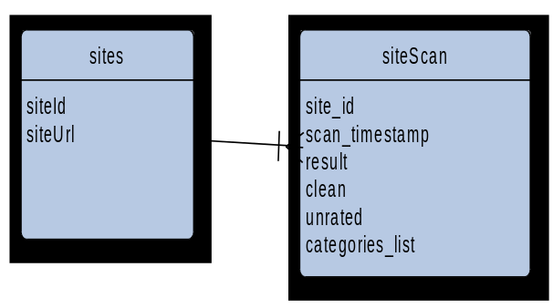

invocation: by request

The following is an AWS deployment:
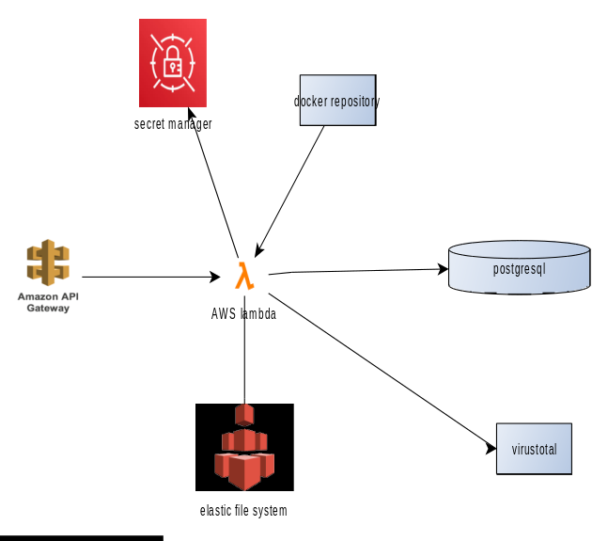

api gateway/lambda: The system would be deployed as AWS lambda
elastic file system: Since the data should be local, the system would use share file system as a persistent volume for the data
secret manager: the system would keep the database password and api keys on aws secert manager
postgresql/aurora: the system would store that data on postgresql as a service database

flow:
