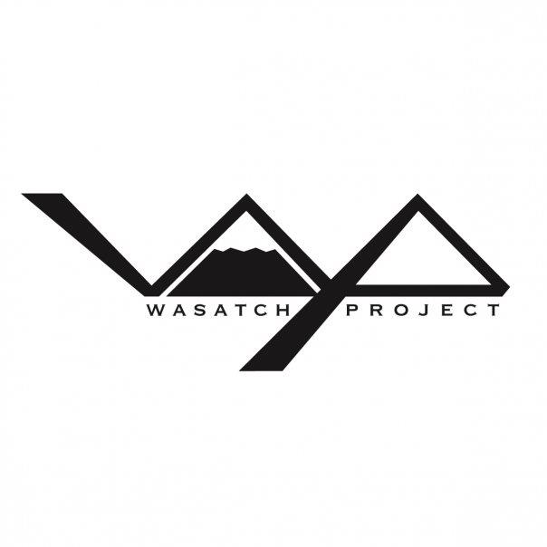

An informative website about the Wasatch Project for current and future student athlete members

personas:

WasatchProject.com will be the forefront for information about the mission of the Project. The mission, to create well rounded ski and snowboard athletes, on and off the hill. This information will be focused towards potential student athletes as well as their parents. In addition this resource will maintain the current information about each athlete and what they are doing in the ski and snowboard industry, to show future students what their experience will be like, as well as help current athletes stay in contact with each other.

comps:

Current student athlete of the Wasatch Project, looking in to the events going on and what other athlete as doing

High school student looking for a way to ski/snowboard more while getting a high school degree

Caring Mother interested in where her son/daughter is interested in transferring their secondary education to

**Alex the Athlete**

**Steve the Student**

**Martha the Mother**