Table of Contents
Schools 2
Basketball Boys/Girls 3
Volleyball Girls 5
Swimming By School 6
Swimming + Diving By Event 8
Soccer 9
Baseball 11
Softball 12
Track By School 14
Track + Field by Event 15

Deliverables

basketball_boys_usa_winter_17_18.csv
basketball_girls_usa_winter_17_18.csv
volleyball_usa_fall_17_18.csv
swimming_individual_performance_girls_winter_17_18_usa.csv
swimming_individual_performance_boys_spring_18_usa.csv
diving_individual_performance_boys_spring_18_usa.csv
diving_individual_performance_girls_winter_17_18_usa.csv
soccer_boys_winter_17_18_usa.csv
soccer_girls_winter_17_18_usa.csv
baseball_spring_17_18_usa.csv
softball_spring_17_18_usa.csv
track_individual_performance_boys_spring_18_usa.csv
track_individual_performance_girls_winter_17_18_usa.csv
field_individial_performance_boys_spring_18_usa.csv
field_individial_performance_girls_winter_17_18_usa.csv

Schools
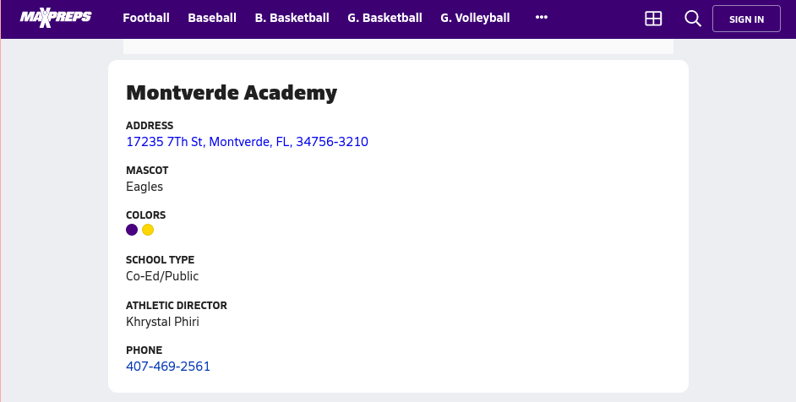
Column Name | Sample
School Name | Montverde Academy
Address | 17235 7th St
City | Montverde
State | FL
Zip | 34756-3210
Mascot | Eagles
School Type | Co-Ed/Public
Athletic Director | Khrystal Phiri
Phone | 407-469-2561

Basketball Boys/Girls
Sample Page: https://www.maxpreps.com/high-schools/montverde-academy-eagles-(montverde,fl)/basketball-winter-17-18/schedule.htm
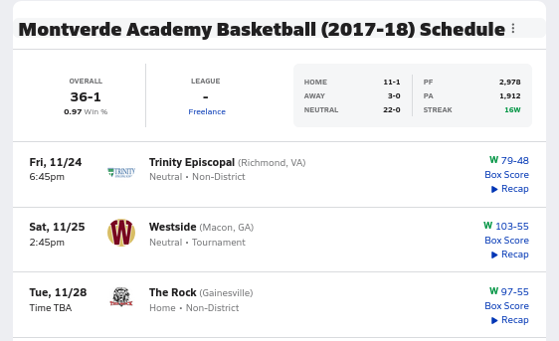

Column name | Sample entry | Sample entry
Team 1 | Montverde Academy | Montverde Academy
Team 1 Score | 79 | 103
Team 2 | Trinity Episcopal | Westside
Team 2 Score | 48 | 55
Result Team 1 | W | W
Home/Away for Team 1 | Neutral | Neutral
Team 1 City | Montverde | Montverde
Team 1 State | FL | FL
Team 2 City | Richmond | Macon
Team 2 State | VA | GA
Date | Fri, 11/24 | Sat, 11/25
District/Tournament/Non | Non-District | Tournament
Time | 6:45pm | 2:45pm

Volleyball Girls
Sample Page: https://www.maxpreps.com/high-schools/mount-notre-dame-(cincinnati,oh)/volleyball-fall-17/schedule.htm
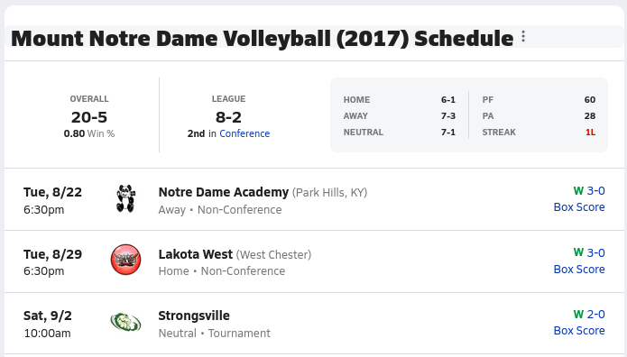
Column name | Sample entry | Sample entry
Team 1 | Mount Notre Dame | Mount Notre Dame
Team 1 Score | 3 | 2
Team 2 | Notre Dame Academy | Lakota West
Team 2 Score | 0 | 0
Result Team 1 | W | W
Home/Away for Team 1 | Away | Home
Date | Tue, 8/22 | Tue, 8/29
District/Tournament/Non | Non-Conference | Non-Conference
Time | 6:30pm | 6:30pm

Swimming By School
Sample Page: https://www.maxpreps.com/local/team/schedule.aspx?gendersport=girls,swimming&schoolid=c3d0b30b-6473-4b23-a241-055ab523ede8
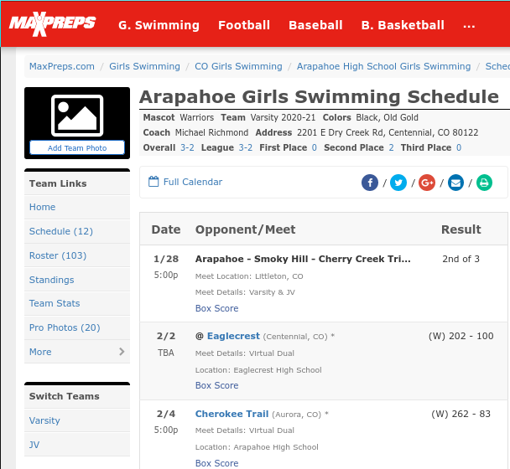

Column Name | Sample | Sample
Team 1 | Arapahoe | Arapahoe
Team 1 Score | n/a | 202
Team 2 | n/a | Eaglecrest
Team 2 Score | n/a | 100
W/L/T Team 1 | n/a | W
Meet Name | Arapahoe - Smoky Hill - Cherry Creek Tri Meet | n/a
Team 1 Place | 2nd | n/a
Size of Meet | 3 | n/a
Date | 1/28 | 2/2
Time | 5:00p | TBA

Swimming + Diving By Event
Sample Page: https://www.maxpreps.com/leaders/girls-swimming-winter-20-21/freeindividual500/stat-leaders.htm
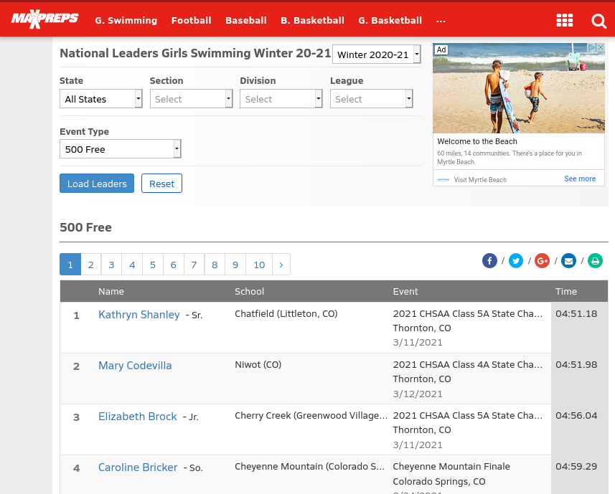
Column Name | Sample | Sample
Event Type | 500 Free | 500 Free
School Name | Chatfield | Niwot
School City | Littleton | n/a
School State | CO | CO
Athlete Name | Kathryn Shanley | Mary Codevilla
Ranking | 1 | 2
Event | 2021 CHSAA Class 5A State Championships | 2021 CHSAA Class 4A State Championships
Date | 3/11/2021 | 3/12/2021
Result Time | 04:51.18 | 04:51.98

Diving has same format except Result Time is replaced with Total Points

Soccer
Sample Page: https://www.maxpreps.com/high-schools/st-pauls-wolves-(covington,la)/soccer-winter-17-18/schedule.htm
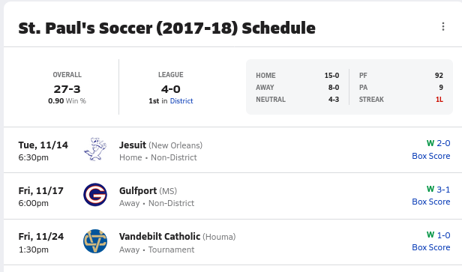

Column name | Sample entry | Sample entry
Team 1 | St. Pauls | St. Pauls
Team 1 Score | 2 | 3
Team 2 | Jesuit | Gulfport
Team 2 Score | 0 | 1
Result Team 1 | W | W
Home/Away for Team 1 | Home | Away
Team 1 City | Covington | Covington
Team 1 State | LA | LA
Team 2 Location | New Orleans
Date | Tue, 11/14 | Fri, 11/17
District/Tournament/Non | Non-District | Non-District
Time | 6:30pm | 6:00pm

Baseball
Sample Page: https://www.maxpreps.com/high-schools/valley-christian-warriors-(san-jose,ca)/baseball-spring-18/schedule.htm
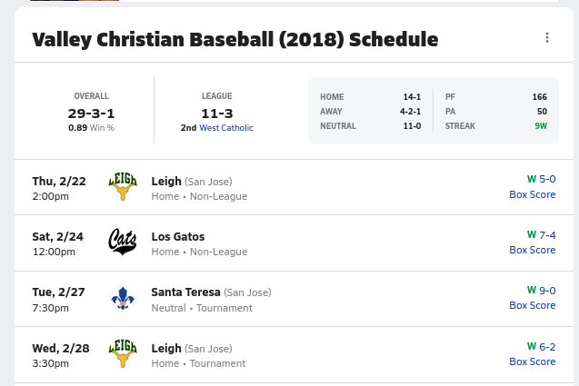

Column name | Sample entry | Sample entry
Team 1 | Valley Christian | Valley Christian
Team 1 Score | 5 | 7
Team 2 | Leigh | Los Gatos
Team 2 Score | 0 | 4
Result Team 1 | W | W
Home/Away for Team 1 | Home | Home
Team 1 City | San Jose | San Jose
Team 1 State | CA | CA
Team 2 City | San Jose | n/a
District/League | Non-League | Non-League
Date | Thu, 2/22 | Sat, 2/24
Time | 2:00pm | 12:00pm

Softball
Sample page: https://www.maxpreps.com/high-schools/norco-cougars-(norco,ca)/softball-spring-18/schedule.htm
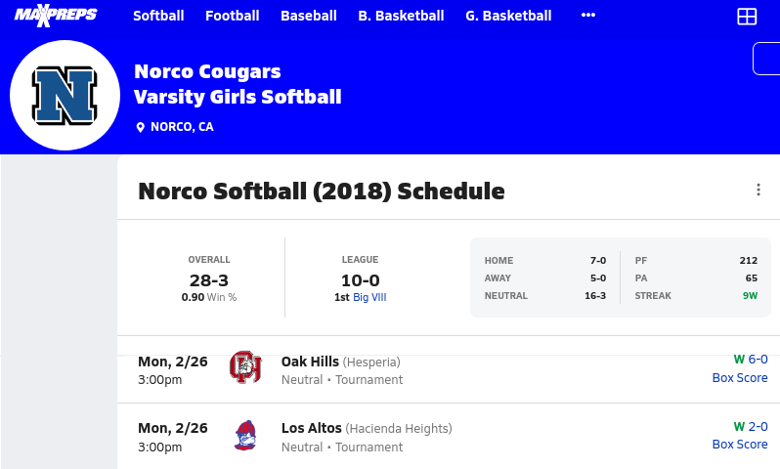
Column name | Sample entry | Sample entry
Team 1 | Norco | Norco
Team 1 Score | 6 | 2
Team 2 | Oak Hills | Los Altos
Team 2 Score | 0 | 0
Result Team 1 | W | W
Home/Away for Team 1 | Neutral | Neutral
Team 1 City | Norco | Norco
Team 1 State | CA | CA
Team 2 City | Hesperia | Hesperia
District/League | Tournament | Tournament
Date | Mon, 2/26 | Mon, 2/26
Time | 3:00pm | 3:00pm

Track By School
Most schools have no schedule/data available for track teams of either gender
Sample indexing pages: https://www.maxpreps.com/search/default.aspx?type=school&search=&state=tx&gendersport=girls,trackfield
https://www.maxpreps.com/search/default.aspx?type=school&search=&state=tx&gendersport=boys,trackfield
After going through the first page of teams, they all look like this:
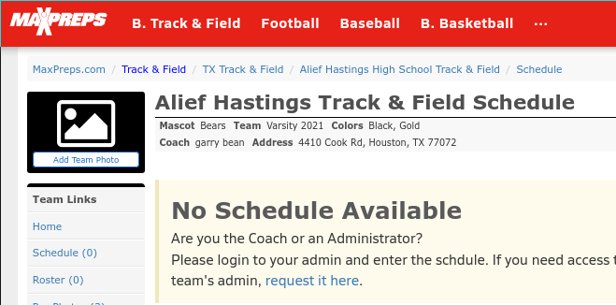

Track + Field by Event
Sample Page: https://www.maxpreps.com/leaders/track-field-spring-17/sprints,100+meter/stat-leaders.htm
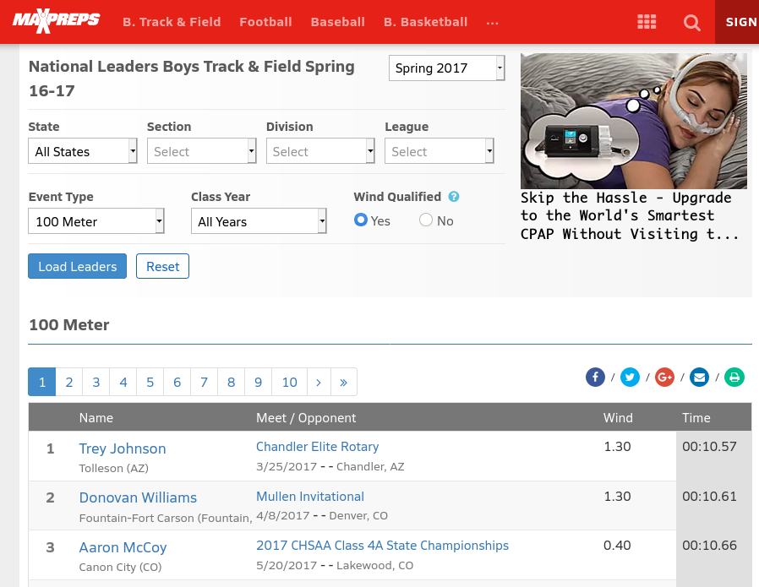
Sample athlete page: https://www.maxpreps.com/athlete/trey-johnson/wDj_rorJEeOzMAAmVebBJg/track-field/stats.htm#year=16-17
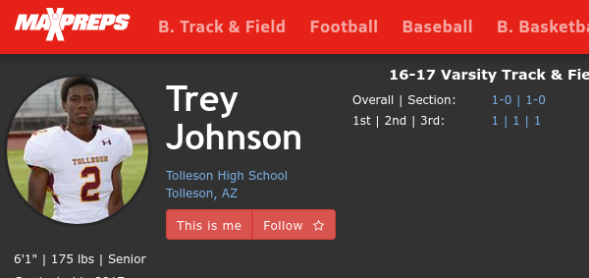

Column Name | Sample | Sample
Event Type | 100 Meter | 100 Meter
School Name | Tolleson | Fountain-Fort Carson
School City | Tolleson | Fountain
School State | AZ | CO
Athlete Name | Trey Johnson | Donovan Williams
Ranking | 1 | 2
Event | Chandler Elite Rotary | Mullen Invitational
Event City | Chandler | Denver
Event State | AZ | CO
Wind | 1.30 | 1.30
Date | 3/11/2021 | 3/12/2021
Result Time | 00:10.57 | 00:10.61

For field events, the format is the same, but the Result Time is replaced with heights for High Jump and Pole Vault and distances for Triple Jump, Long Jump and Shot Put

