Freestyle Job Shell Script
cd /var/www/html
rm -rf *
service httpd start
cp -r /root/.jenkins/workspace/Jenkins-Assignemnt-1/index.html .
chmod 644 index.html

Job Consol Output-
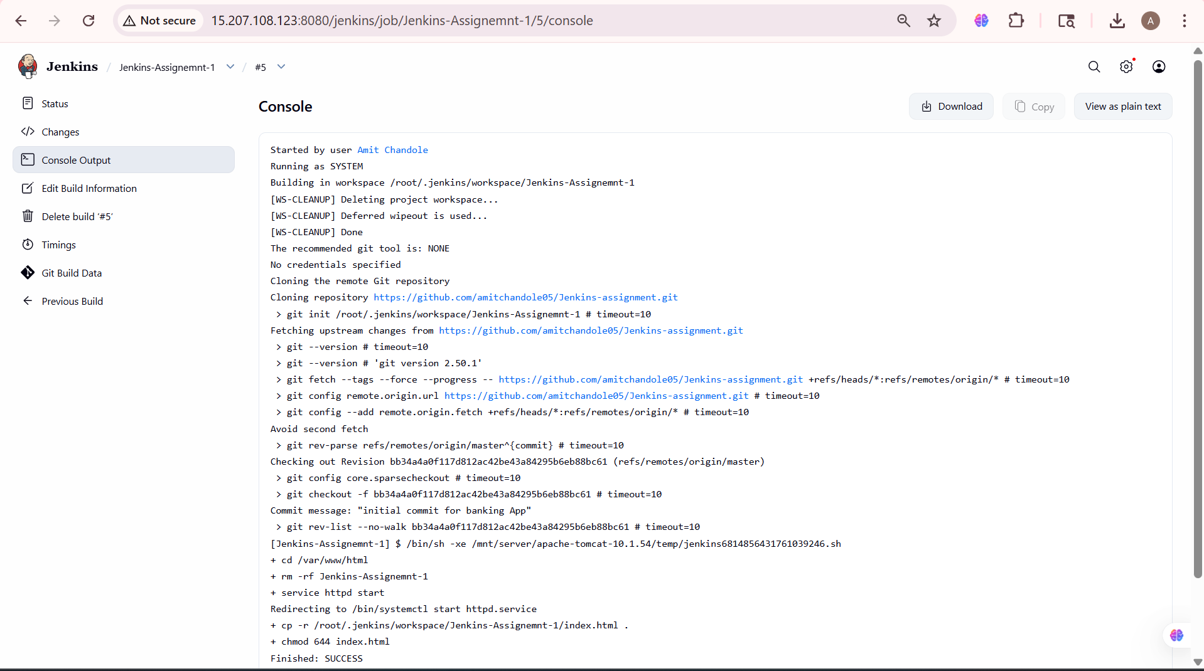

Accessing the Website
