Genesis Field App User Manual

LOGO HERE
Pages

Login Page
Login in with your email and password
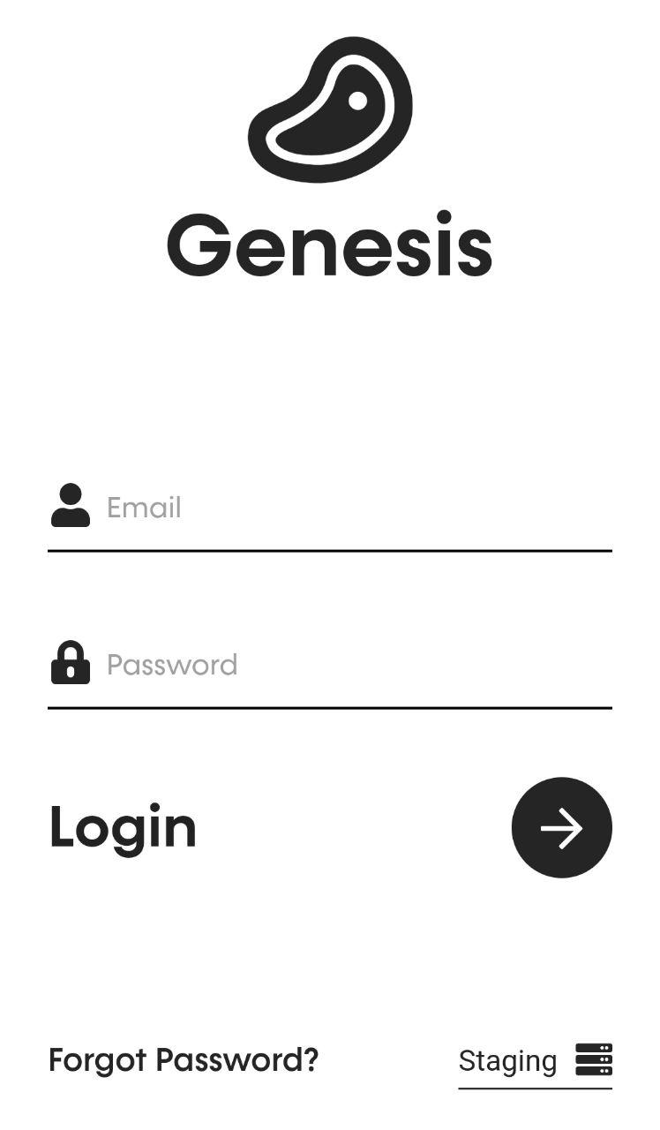

Mode Page

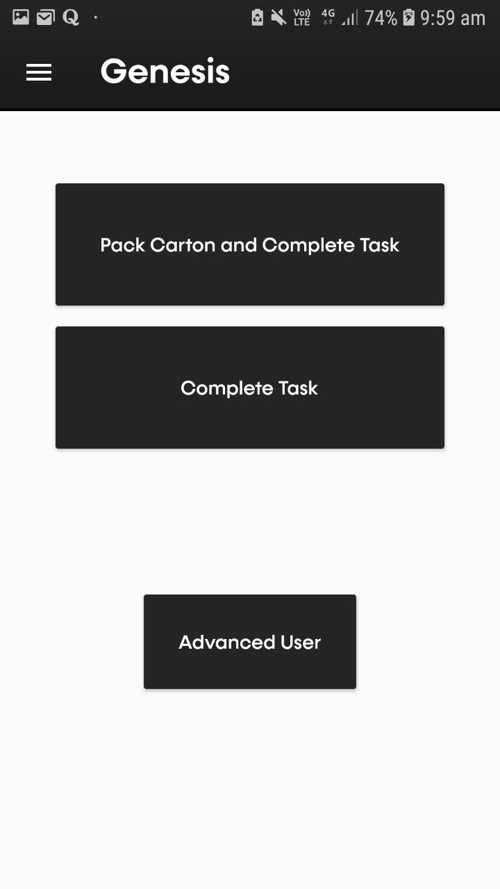

After logging in succesfully you will see a menu screen with three options:
- Pack Carton and Complete Task (pg. 3)
- Complete Task (pg. 4)
- Advanced User (pg. 5)

Profile Page
This Page is to view and update your details, like email, first name, last name. (pg. 6)
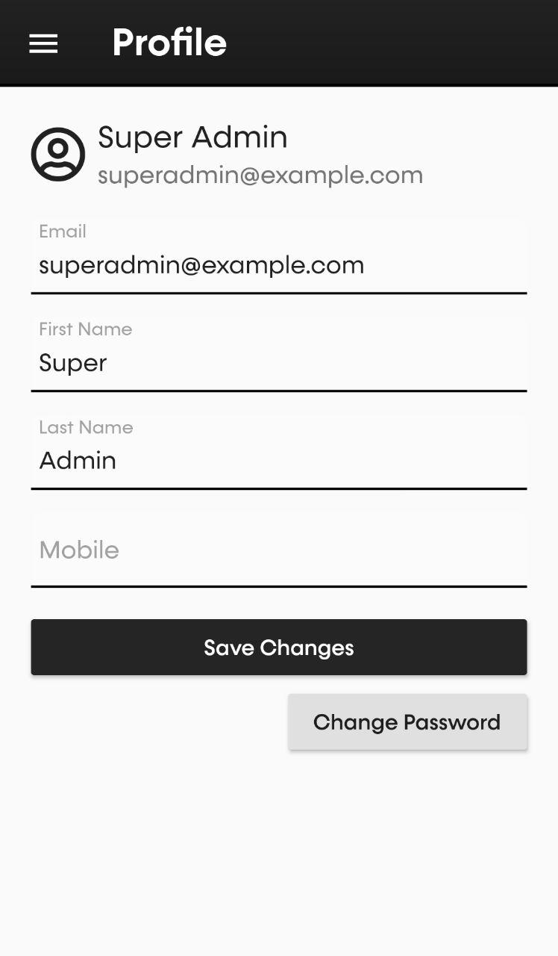

Settings Page
This page is for general prefrences like if you want to show a button for scanning or not, vibrate when scanning etc. (pg. 3)
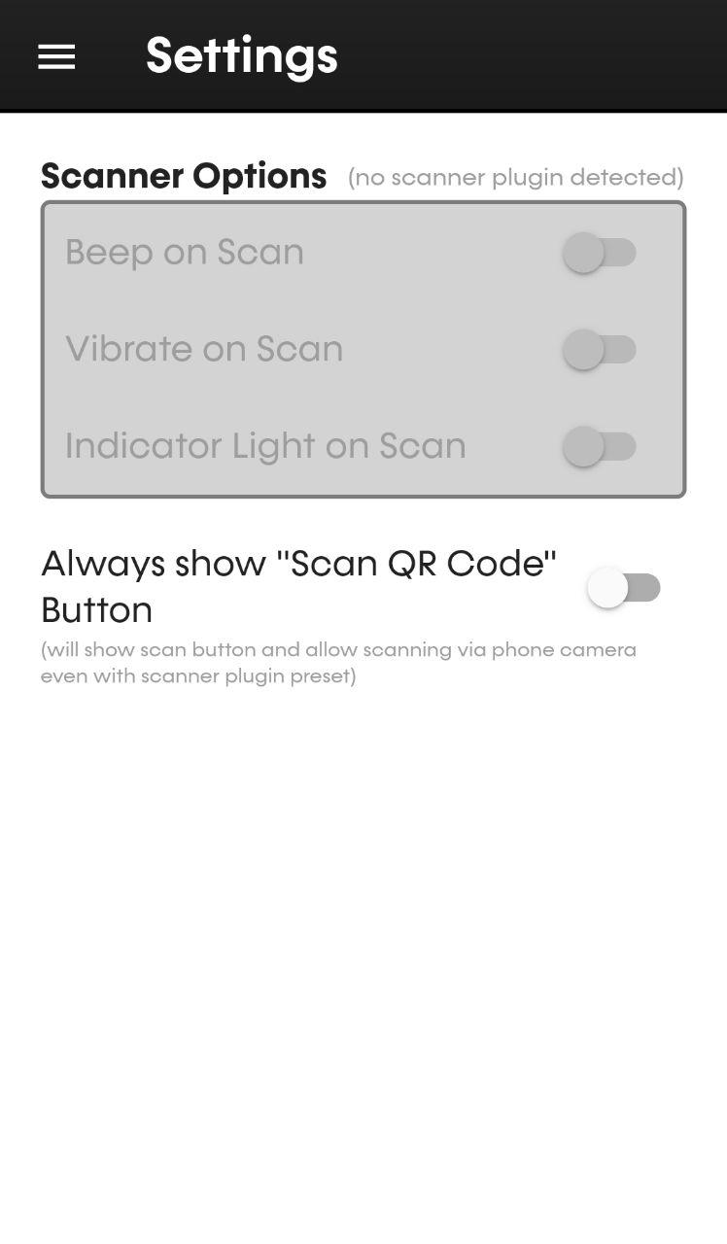
Pack Carton and Complete Task
In this mode you will be able to scan only one carton and many products.
First you will be prompted to select a Track Action and specify a memo (optional)
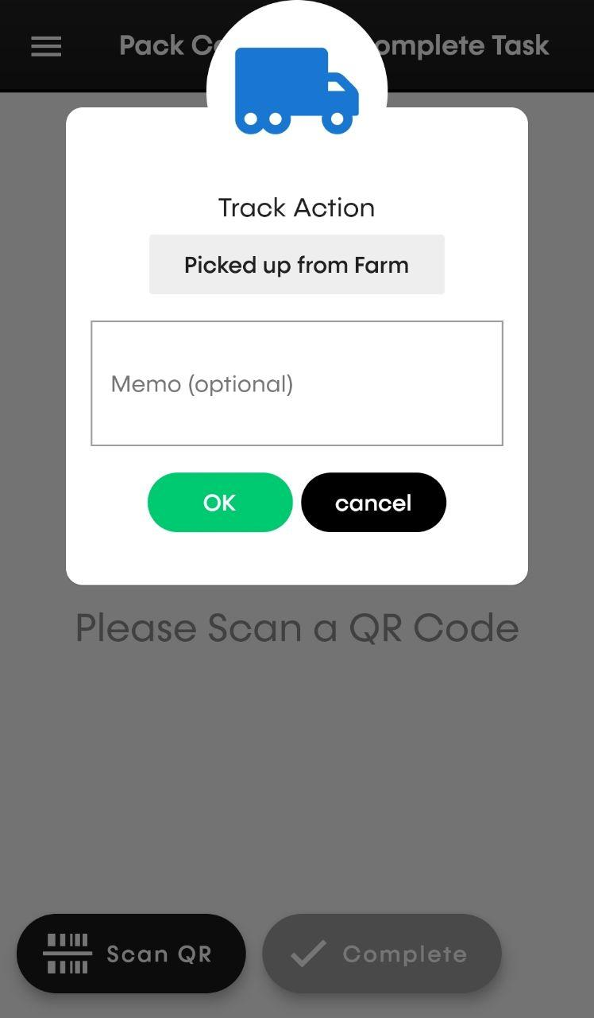

After selecting a Track Action and specifiying a memo you can now begin scanning.

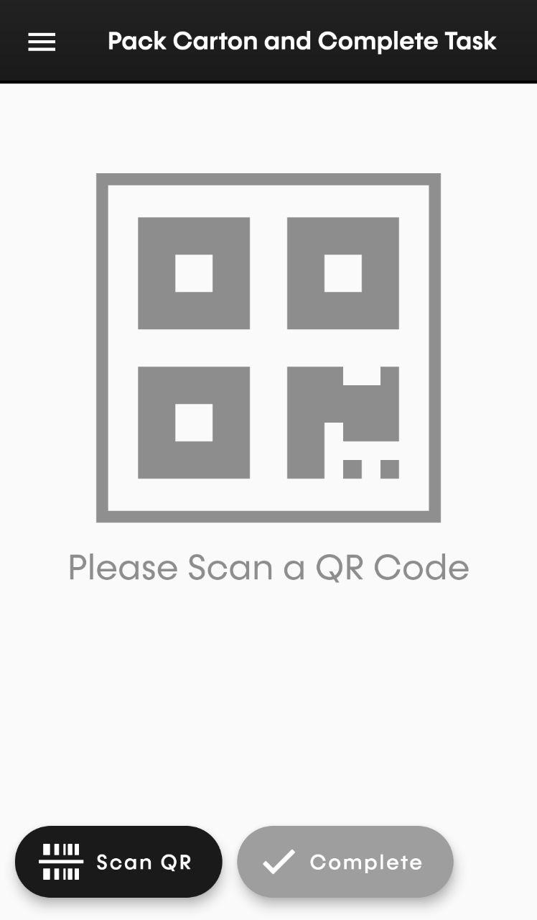

PDA
If you are using a PDA (ScanSKU Device) you can either use the “Scan QR” or point and hold scan buttons to scan a QR.

Phone
If you are using a phone, you can start scanning by tapping on the “Scan QR Code” button.

Taking photos
If you have selected a Track Action that requires a photo, after you scan a carton, you will be prompted to take a photo of the carton next to it’s QR Code. If the track action does not require a photo it will just add that scanned item to the list.
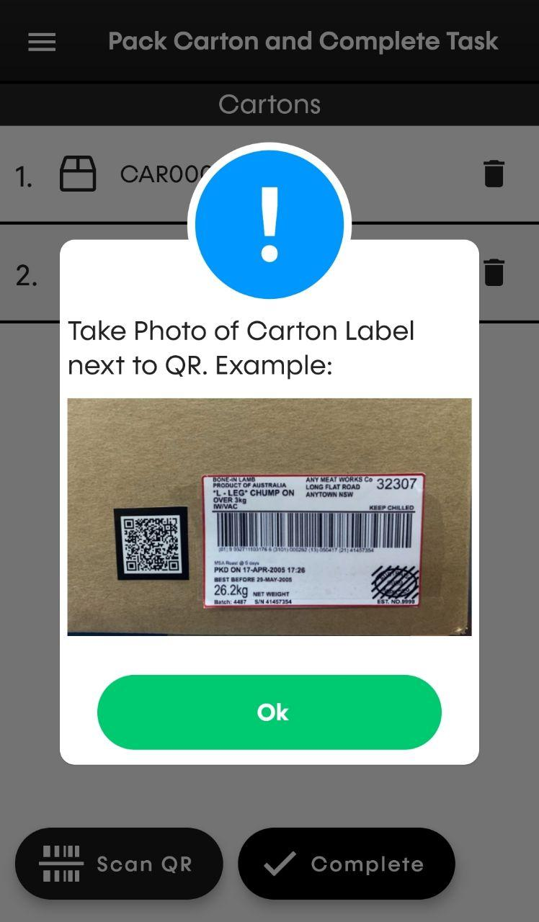

Then you will be prompted to take a picture a product next to the QR code.

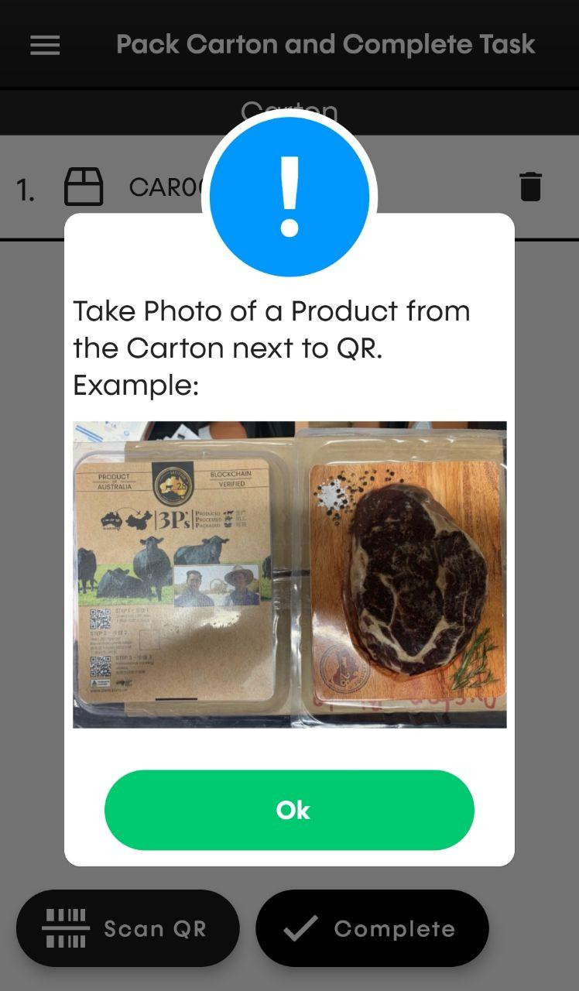

Removing/deleting items
Once you have finished scanning the carton and product(s), you might want to remove some.
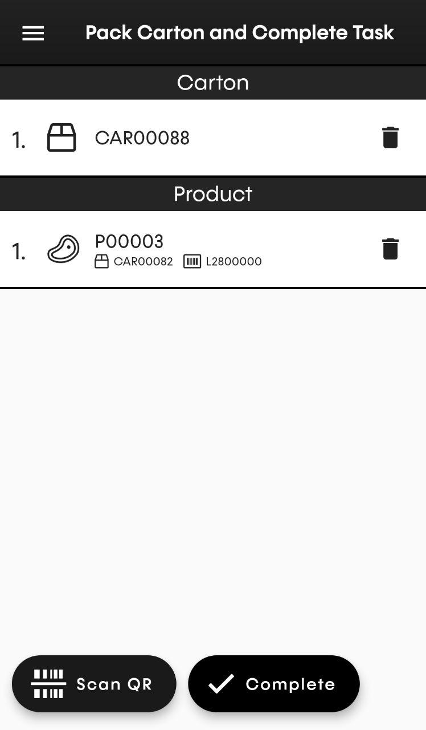

You can do so by pressing the bin icon or swiping the row.

Next Steps
Once you are sure you are finished scanning the carton and product(s), press the complete button. After pressing the complete button you will see a prompt with your selected Track Action and the items you have scanned, and cancel and ok buttons.
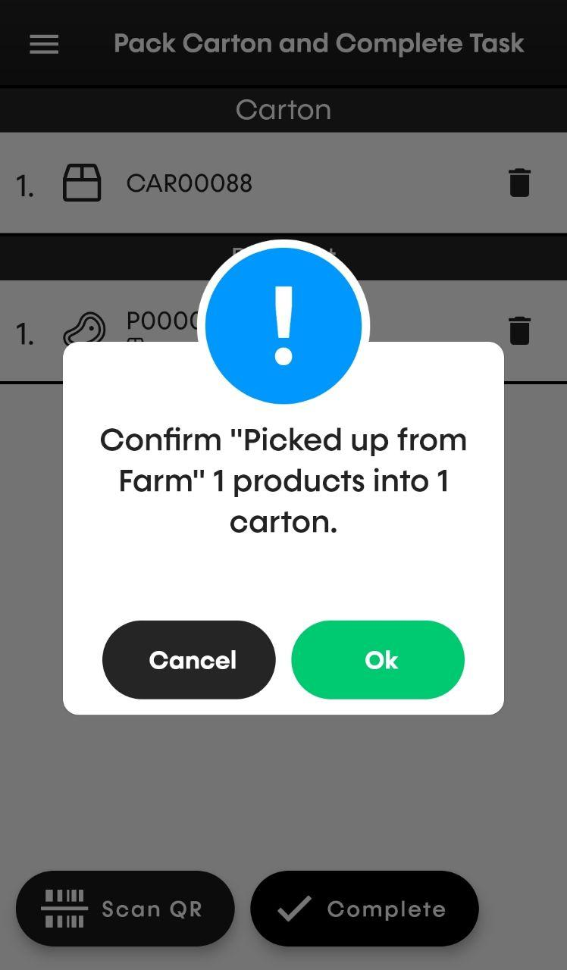

if you press cancel the prompt will just close.

If you press ok you will get another prompt to commit your track actions to the scanned items
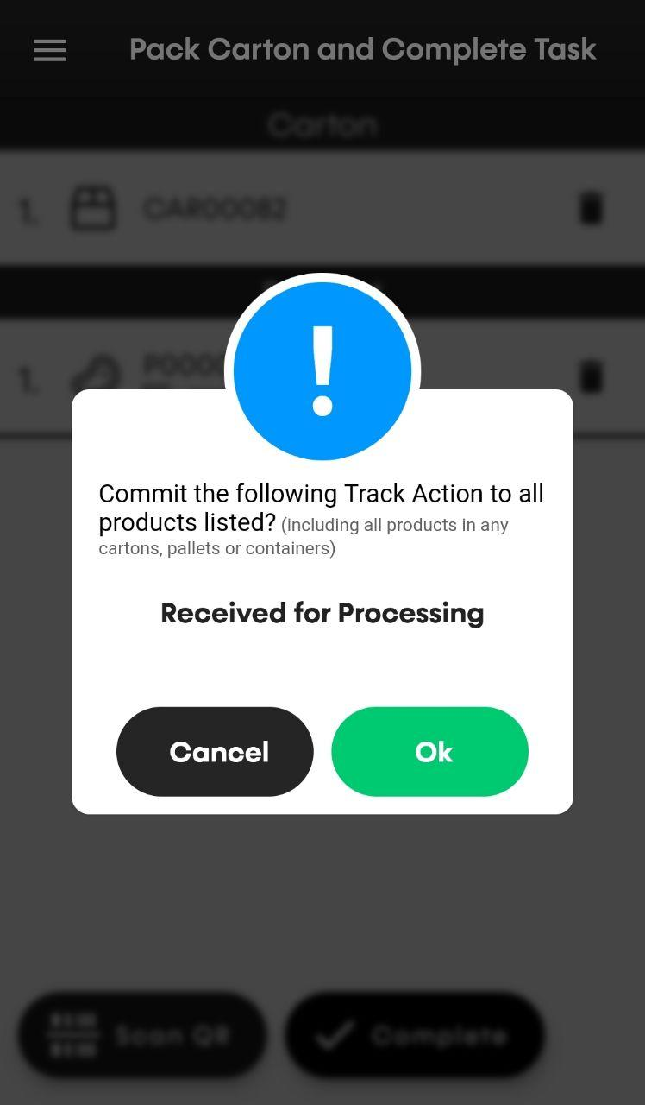

If everything is successful you will see a succes prompt.
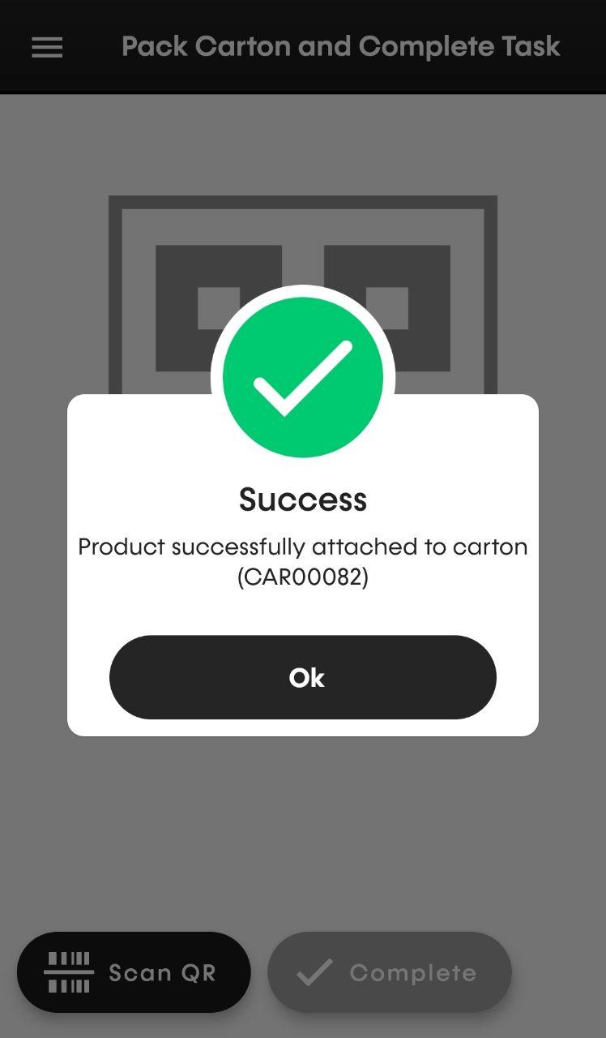

if something went wrong (eg. server down) you will see a error prompt
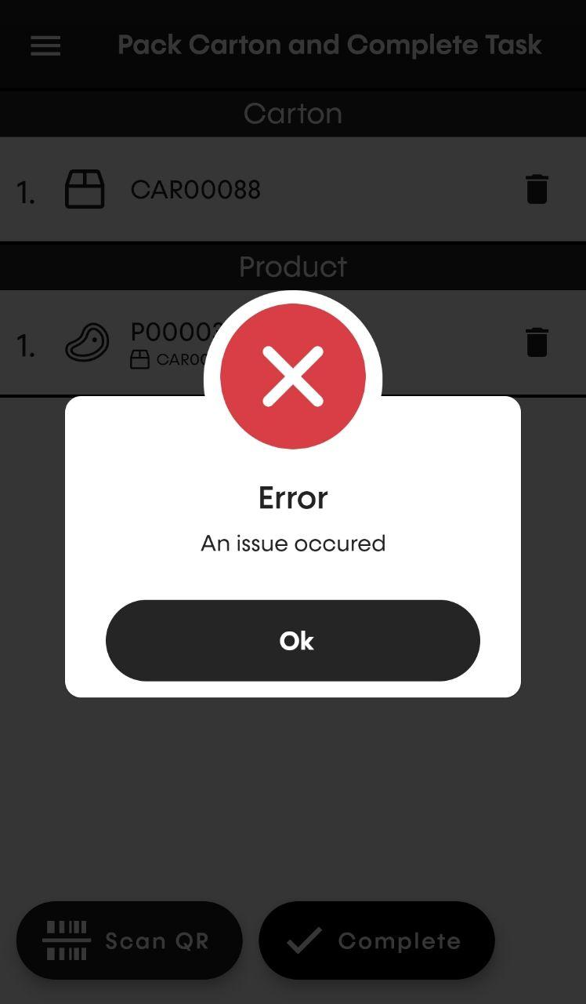

Complete Task
In this mode you will be able to scan any items you want.
First you will be prompted to select a Track Action and specify a memo (optional).

After selecting a Track Action and specifiying a memo you can now begin scanning.

PDA
If you are using a PDA (SKU Scanner Device) you can either use the “Scan QR” or point and hold scan buttons to scan an item.

Phone
If you are using a phone, you can start scanning by tapping on the “Scan QR Code” button.

Removing/deleting items
Once you have finished scanning the items, you might want to remove some.

You can do so by pressing the bin icon or swiping the row.
<arrow pointing to bin image here>

Next Steps
Once you are sure you are finished scanning the items, press the complete button. After pressing the complete button you will see a prompt with your selected Track Action and the items you have selected and cancel and ok buttons,
<confirm prompt image here>

if you press cancel the prompt will just close.

If you press ok you will get another prompt to commit your track actions to the scanned items
<confirm prompt image here>

If everything is successful you will see a succes prompt.
<success prompt image here>

if something went wrong (eg. server down) you will see a error prompt
<error prompt image here>

Advanced Mode
To access this mode you will have to provide a 4 digit pin (1234).
<pin login prompt image here>

In this mode you will be able to do any opperations that the app gives. The User Interface for this mode will be a a little bit different, on the bottom left you will see a cirlcular button
<arrow pointing at menu button image here>

If you tap on the button an array of options will show up
<opened circle menu image here>

based on the items that are scanned some of the options will be available and some will be disabled
<opened circle menu active image here>

Menu Options:

Track Action
for this option you can select a track action you want to apply to the scanned items

Bind
The Bind option is to Bind or attach an item to one another

Unbind
The Unbind option is to Unbind or dettach an item to one another

Clear List
To clear the llist of scanned items

