Reading Timestamp Counter

1.
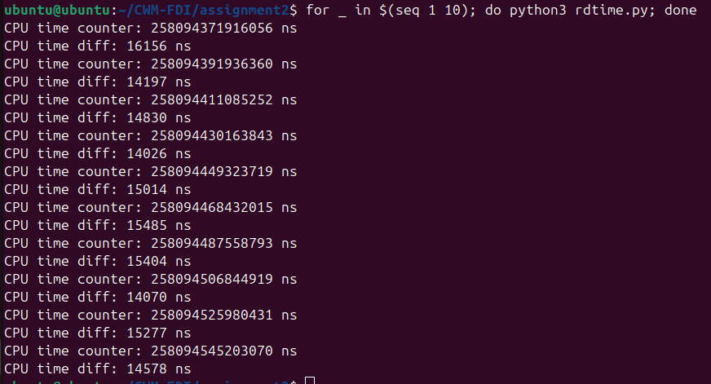
time gap between consecutive reads sits at around 15000ns (15 microseconds) across a range of around 2 nanoseconds

2.
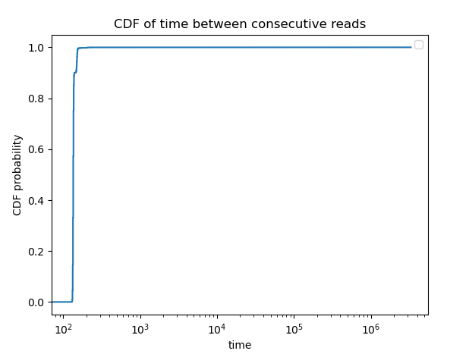

3.
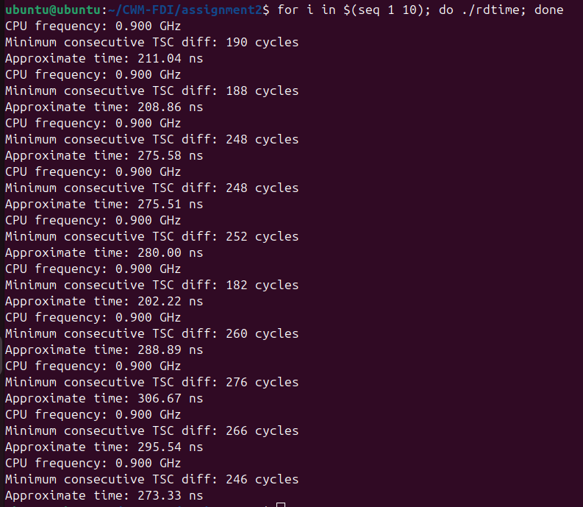

4.
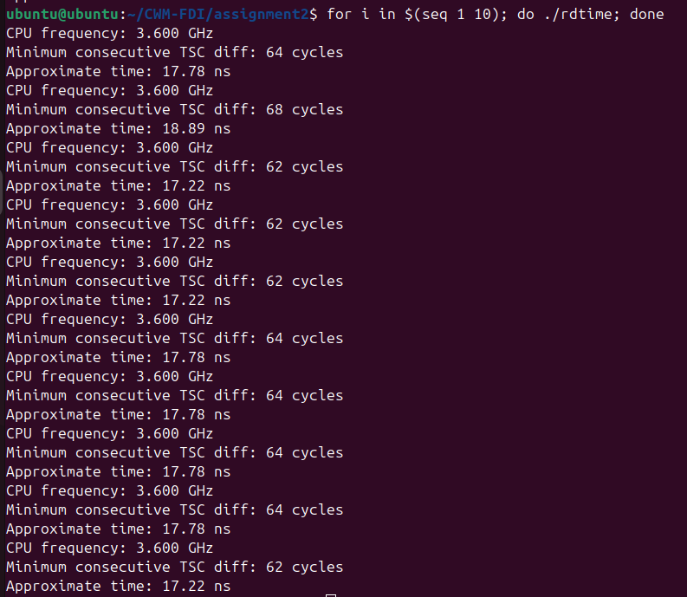

performance mode massively increased clock speed, and drastically reduced timed difference between reads.

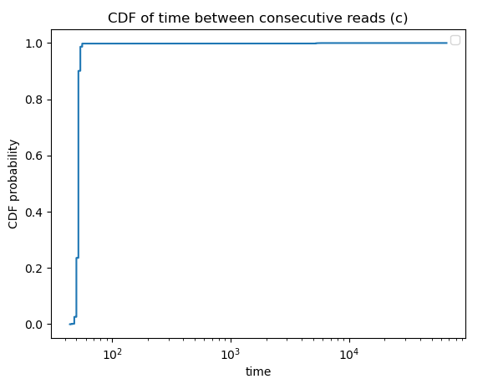
5.

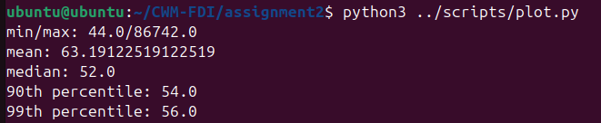

6. Now pinned to a single core
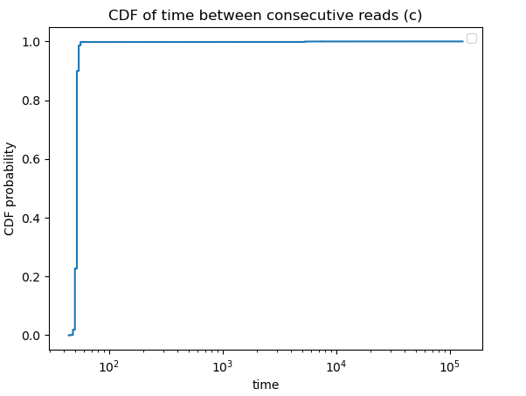

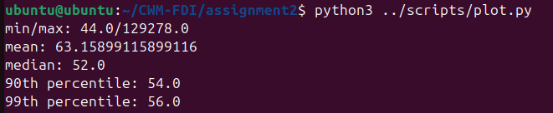
7. Looking at the two cases, pinning the program to one core vs not, we see the only real major difference is the max time taken, which is much larger (we also see a very slight mean time reduction). This could be because one core is subject to higher variance as other processes could get in the way, whereas on multiple cores the blockers are spread out so time difference is less affected by small local changes.

8. The mean times for the c code are much faster than the python code, but their min times are within the same order of magnitude – even close. This is an interesting result shows the way in which python has systematic execution overhead that gives similar best case scenarios to C, but much worse general execution times. Some reasons for this in python are garbage pauses, global interpreter lock contention, interpreter overhead and less efficient machine code than C.

9. The huge difference between mean and maximum measured times come from the rare tail events that occasionally occur as the code runs. These would be things like hardware interrupts and garbage collection (mentioned above), that essentially pause the running program and cause a spike in execution time for that iteration.
Ping Measurement
10.
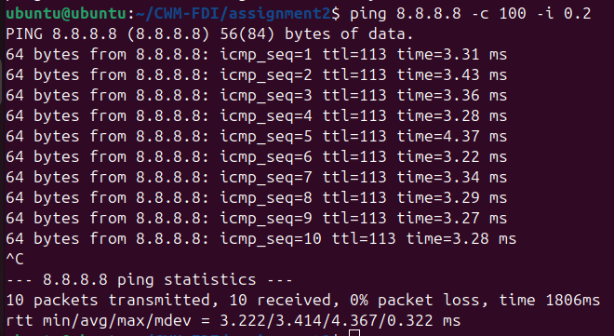

11.
Oxford
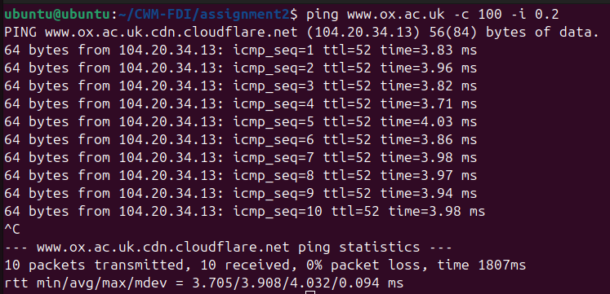
Stanford
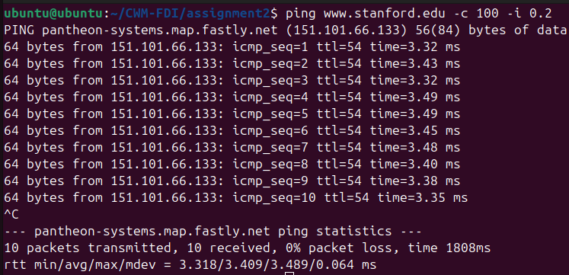
University of Singapore
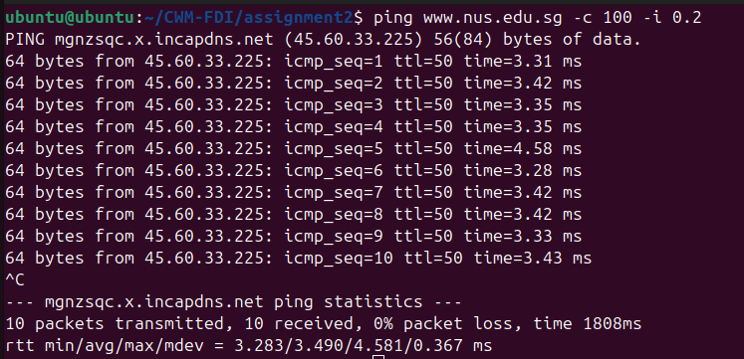

12. Lab machine to itself 10 times
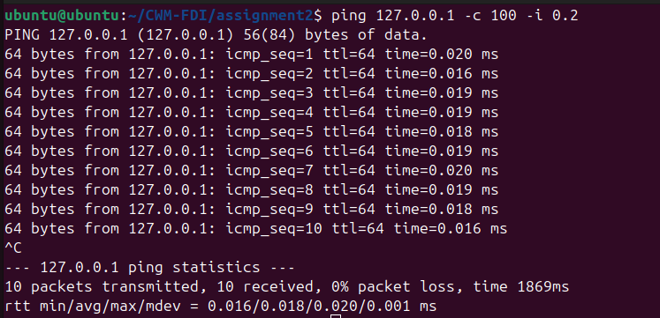

13. Lab machine to itself 100 times at 0.01s interval
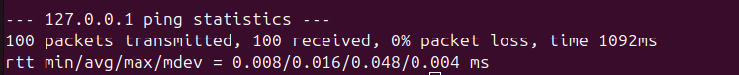
min and max are separated by 0.040ms, more than twice the mean value so this is a large range. The large max will be noise from context switches where the kernel temporarily schedules other tasks other than the ping command while it is running.

14. Lab machine to itself 10,000 times using flooding (-f)
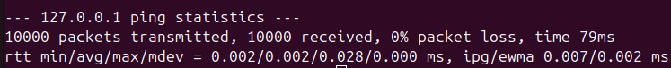

15. CDF’s of round trip times for different intervals
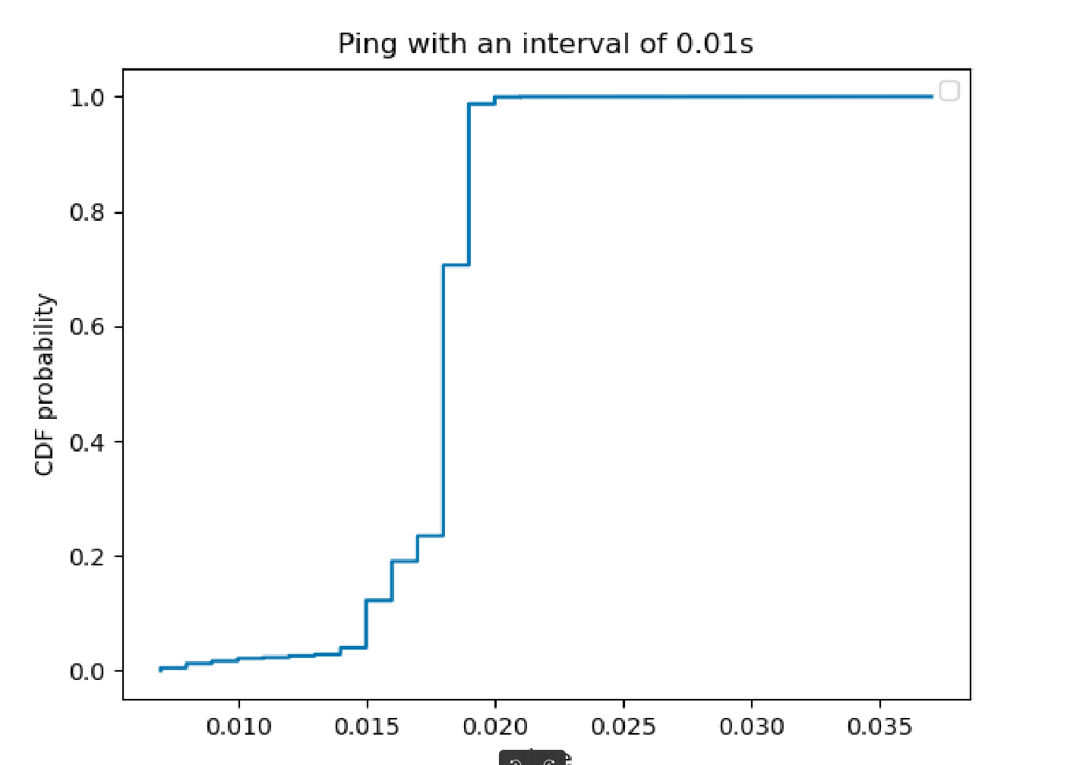
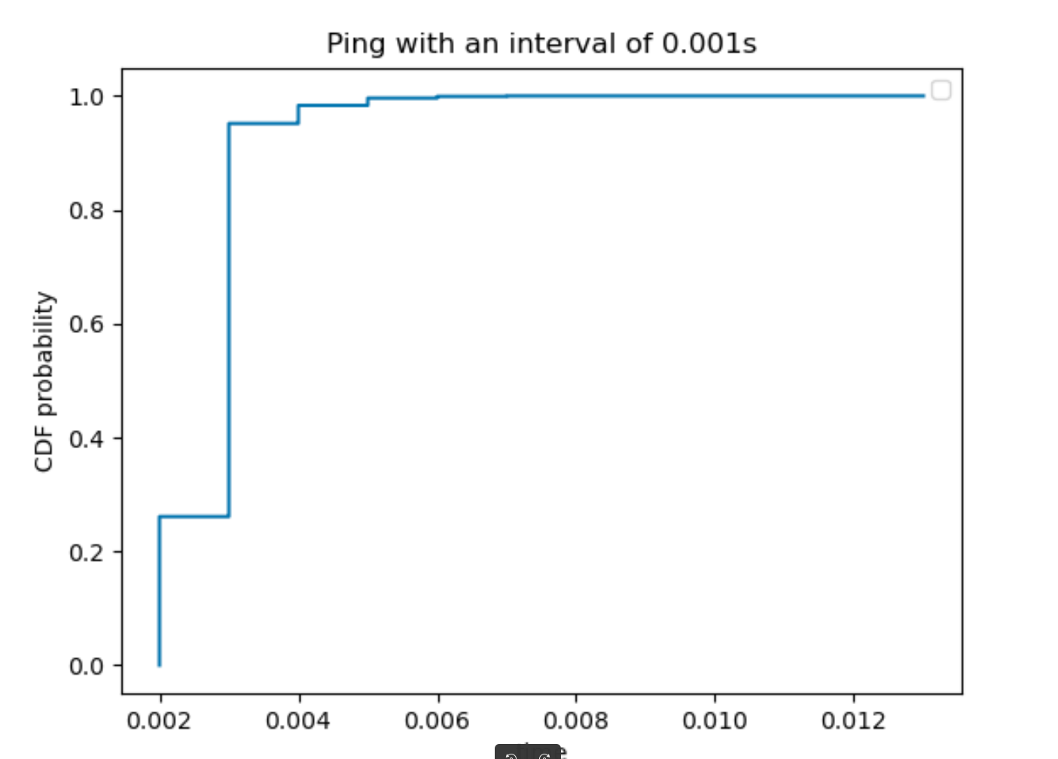
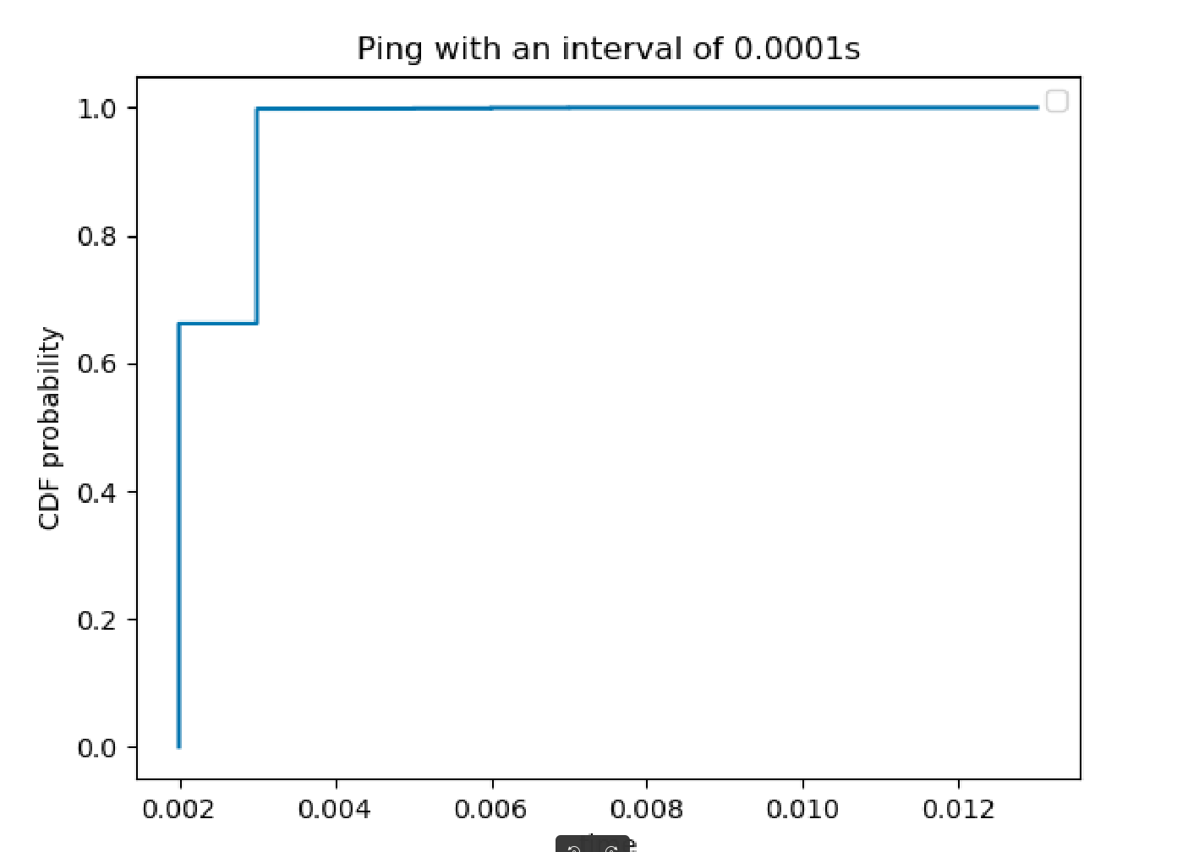

16.
From the above we can see the pattern that longer intervals seem to longer mean/ median round trip times. This is likely due to the fact that with shorter time periods, every ping hits the L1/L2 cache so look ups are cheap.

We can also see the shorter time period chart looks more angular as we only have a measurement precision of 3dp.

With longer intervals the pings have time to be evicted from the cache by other processes so kernel look ups are slower.

Performance
17.

