Basic Timing
1. using time and usr/bin/time to measure speed of matmul_slow.py
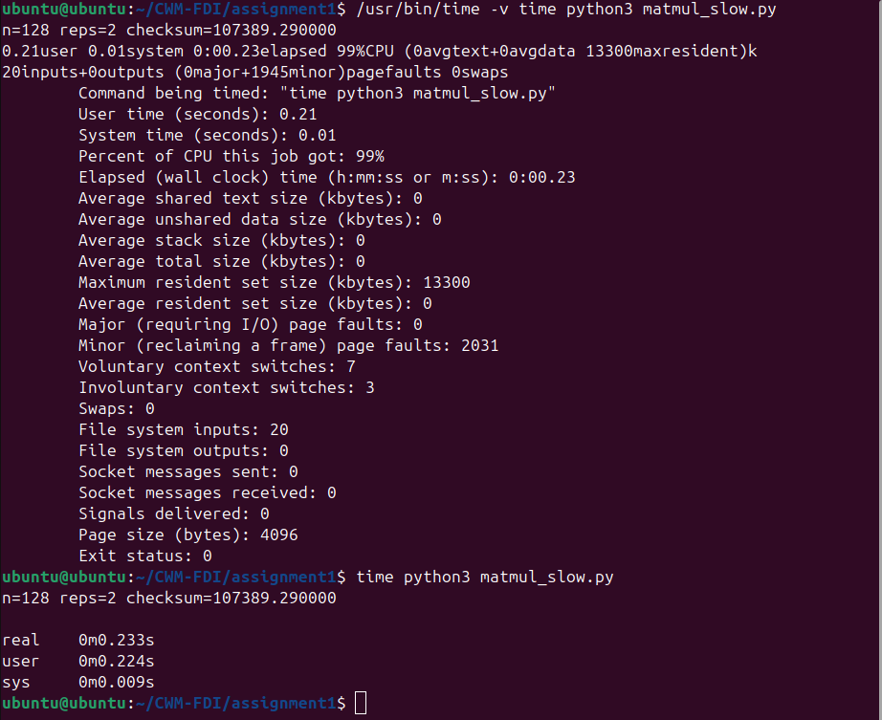
We can see that sys time is the lowest, then user, then real being the slowest.
These different metrics likely compare different speeds for different parts of the process.
- System time likely corresponds purely to time on the cpu (ie. time spent in the kernel)
- User time likely includes time for i/o, and external commands/ linking processes
- Real time could even include UI and frontend time in the terminal (Ie. full process - wall clock)

2.
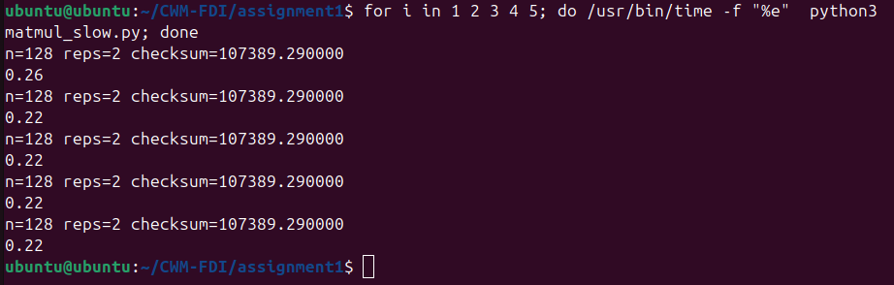
You would likely want to report the mean and standard deviation across many runs.

