Simple Measurements – Idleness
1.
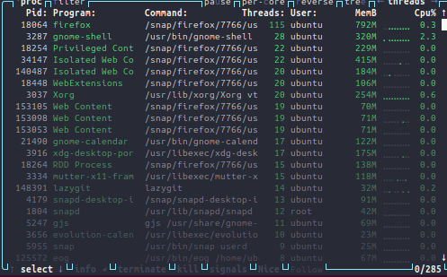

Top CPU users are firefox and gnome-shell (core GUI for linux environment), which makes sense as they are the most complex applications running currently.

To become a top user we would need to open more firefox tabs (consume more RAM) or, switch screens quickly to put load on the GUI interface.

2.
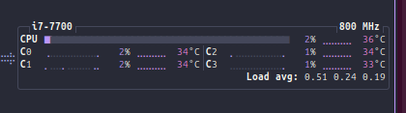

The CPU appears to never be idle as there are always background processes running even just to keep the screen on, or to be listening for keyboard inputs, or mouse clicks, or any other possible input/ change like wifi connection/ USB drive status. From the program list we can see that even when nothing is happening there are hundreds of programmes still running.
Resource Usage – Compute Power, Energy and Thermals
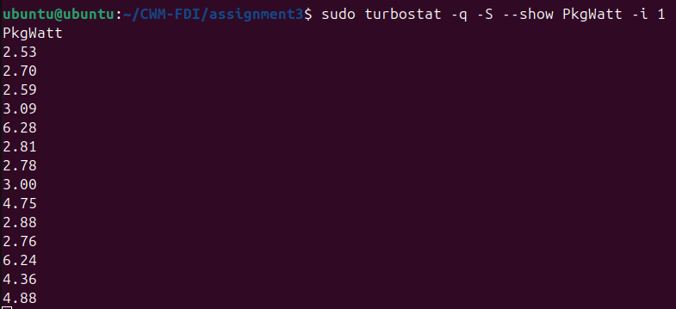
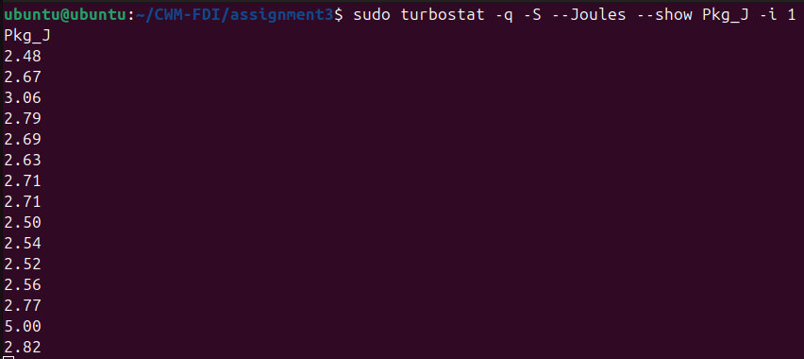
3. The baseline very much fluctuates over time, as the OS is continuously reallocating resources to whatever it feels requires them at that instant. Most interestingly, we see spikes whenever I switched windows the firefox/ libreoffice writer window (resource intensive), away from the terminals window (not resource intensive). This is likely the OS reallocating resources to the windows that need it to improve efficiency, ie. so that we are not running firefox at full capacity when we cannot even see it.

4.
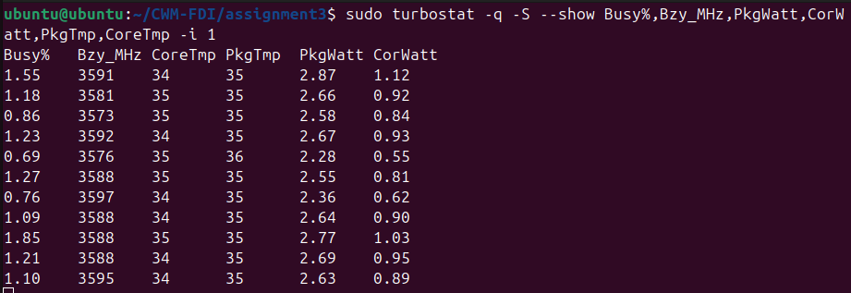
a)
b) the business metric compares pretty well, as we can see the idle % sitting at around 1%, matching the %CPU measurement in the diagram using btop from Q2 (sat at around 1-2%).
this tool shows more clearly how idleness varies over time, which the other tools htop/btop/ps aux make it harder to see.

5.
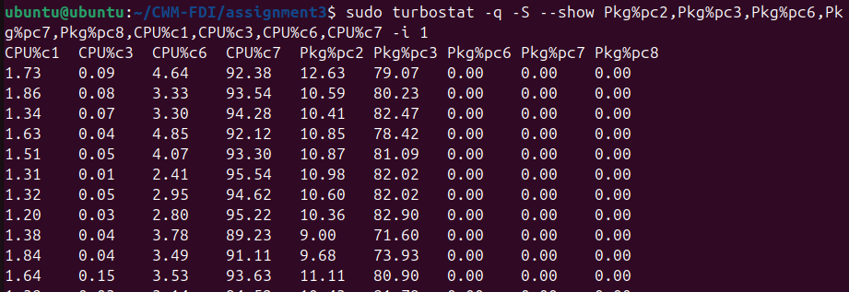
The Impact of Invoking New Commands
6.
a)
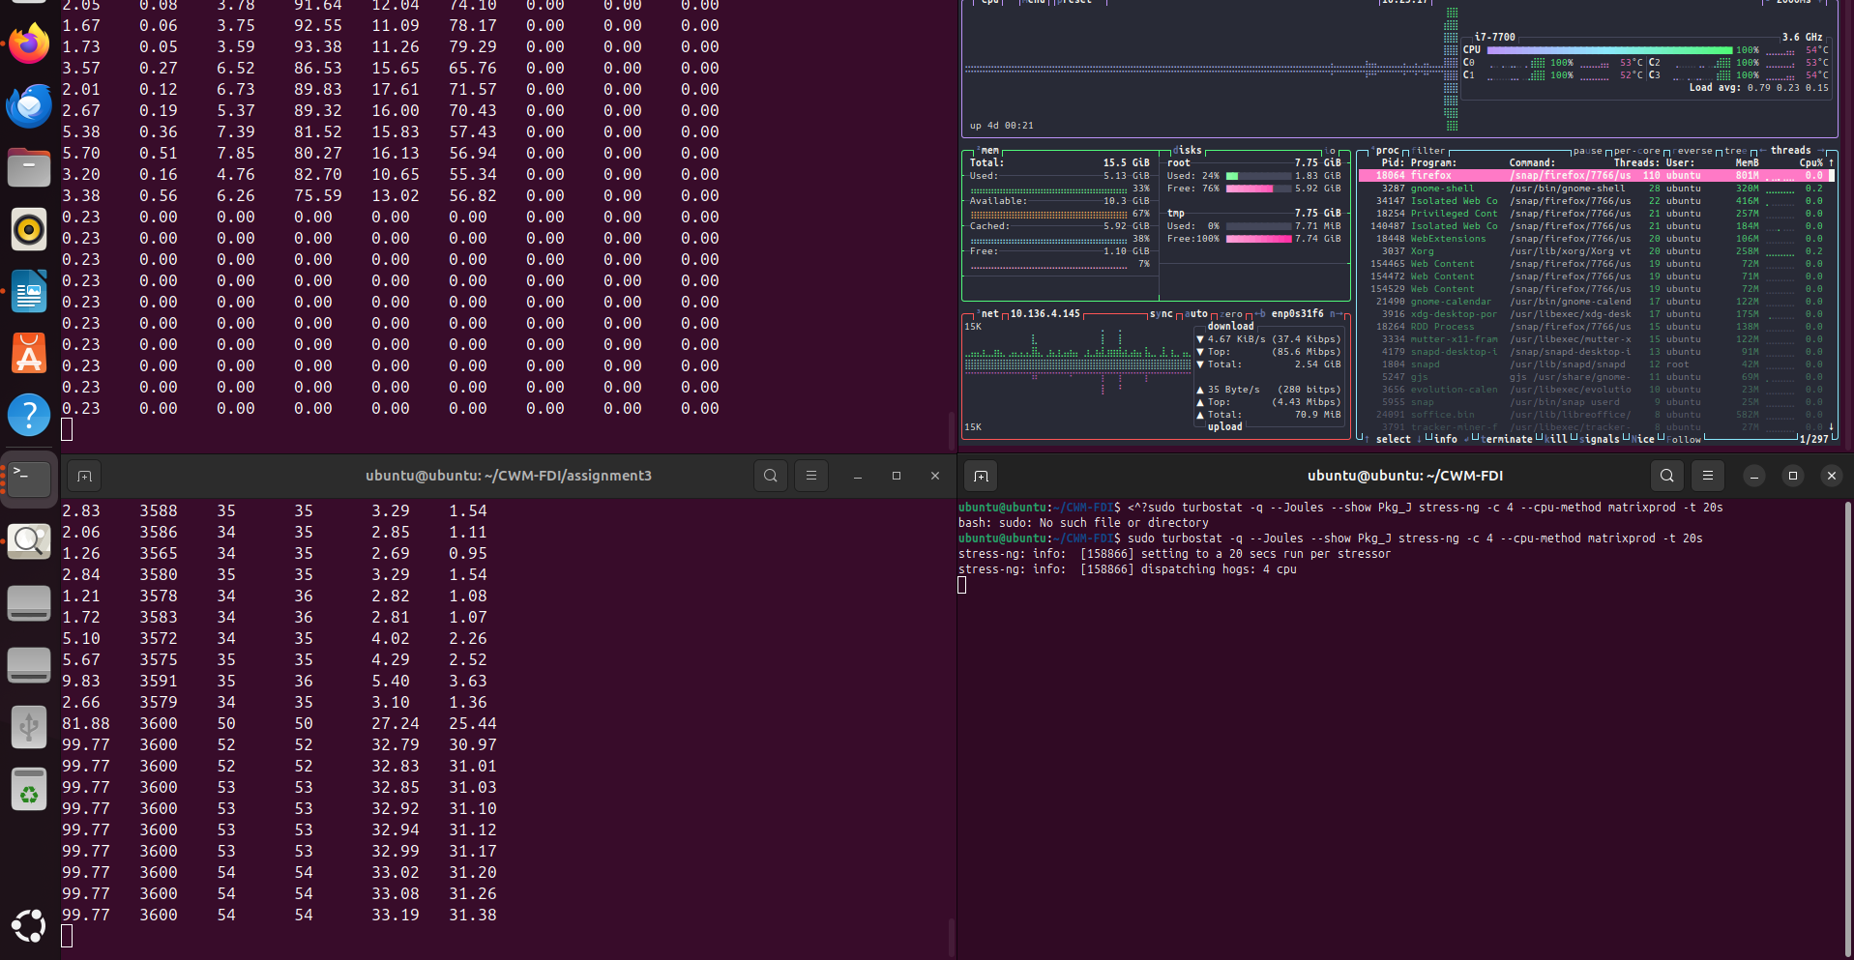
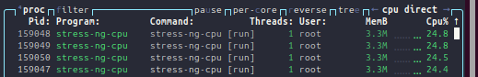
we can see the CPU usage % spiking massively to almost 100%, and we can see the power usage jumping up to 31W nearly

b)
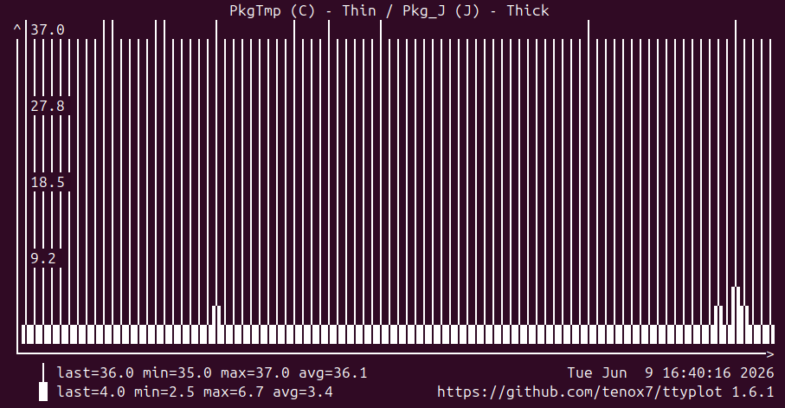

c) Idle joules sits at around 5J, similar to what the other tools showed, and much lower than what it was during stress testing. This under-utilization means we are wasting energy while sitting idle and it is not being used for anything - highly inefficient.

7.
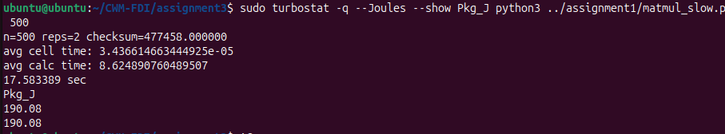
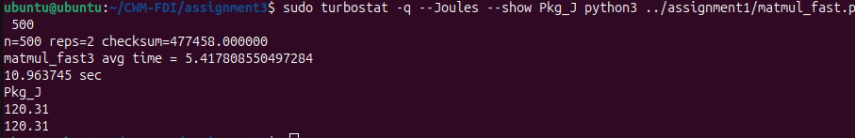
The fast version had an energy consumption of 120J, vs the 190J of the slow version. Initially my intuition was that we would trade program speed for efficiency, and the faster program would be less efficient, but now I see that speed and efficiency are linked, and the program is essentially faster precisely because it is more efficient.

8. Yes, there were packages and cores in deeper sleep states, fairly often.

Some possible downsides of deeper sleep is slower response times when those cores are actually then needed – deeper sleep may take longer to come out of. Applications where response times matter would be most adversely affected by sleep states, as the extra latency introduced by waking up from the sleep state really matters in those scenarios. Eg. games/ use facing applications etc.

9.
density vs cooling trade off where a higher utilization improves profit, but requires expensive cooling upgrades, and the thermals become the limiting factor as the profit curve flattens as increased utilization requires increased cooling and the cost of one cancels out the gains of the other

thermals currently limit scaling as thermal limits force discrete expansion steps like new buildings/ sits so there is a longer lead time than desired and prediction of future requirements becomes the main issue.

We can also tackle density and thermals by spreading out data centers in different locations, keeping per data center utilization lower and avoiding thermal issues, but this in turn increases complexity and operational friction.

Network Activity
10.
a) at 1Gb/s we would of course assume that it would take ~1s to transmit a 1Gb file at full data rate
b) in 1s, assuming the power draw of a 1Gb/s ethernet port is 0.3W per 1W of active power, we would assume 0.3J/ Gb
c) if the data has to pass through multiple machines, then we will be passing through multiple ethernet ports each with their own power draws which would sum along the chain leading to a m much lower energy efficiency of data transfer

would need to take into account any other possible energy use cases ie. loss in signal generation, usage in processing when moving between servers, etc...

11.
a)
b)
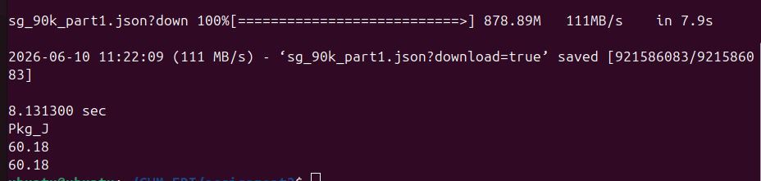
c)
theoretical results were 0.3J/ Gb and this was 60.18J/ 878.89 Mb, ie. 64J /Gb, which is over 200x worse than theory. This suggests that the dominant form of energy usage is not the port itself but the processing of the data once it arrives at the computer or any other form of energy use in the chain.

12.

For 480p we average at about 6W of CPU power usage
For 1080p we average at about 8W of CPU power usage
For 2160p, we average at about 20W of CPU power usage

We can clearly see a massive jump in power between 1080p and 2160p, compared to a relatively small power jump between 480p and 1080. This shows us that video streaming gets drastically less energy efficient as we increase the streaming quality.

Thought Experiments – Carbon Footprint

13.
Current carbon intensity in England is 122gCO2 / kWh ie. 33.89gCO2 / MJ
Carbon Intensity in Spain is 81gCO2 / kWh at Midday and 100gCO2 / kWh at midnight

The programmatic improvement gave us nearly 40% energy savings, which would be a massive improvement at scale. From these numbers above, we see that the carbon footprint add midday is lower than at midnight, so running programs during the day would have a lower footprint than at night, and running them in spain rather than in England, or more generally in countries that rely more heavily on green energy could further reduce the footprint of these programs.

14.

0.34 Wh/query * 2.5B queries/ day * 100gC02/kWh gives us:

85 metric tonnes of CO2/day
2550 metric tonnes of CO2/month
31000 metric tonnes of CO2/year

This is around 150x the cost of training GPT4 (100-200 tonnes of CO2)
This is equivalent to around 7000 tesla’s driven 50km/day continuously
This is around 2600-3000 times a typical household’s annual emmissions
0.2% of San Francisco’s annual footprint
236000 gaming desktops (150W) running 24/7
power/util chart -correlate with frequency, DVFS

