Software Requirements Specification

for

Compucom Tracker

Version 1.1 approved

Prepared by Rajesh Kumar Arora

Compucom Software Limited

1-Feb-2017

Table of Contents

Table of Contents ii

Revision History ii

1. Introduction 1

1.1 Purpose 1

1.2 Document Conventions 1

1.3 Intended Audience and Reading Suggestions 1

1.4 Project Scope 1

1.5 References 1

2. Overall Description 1

2.1 Product Perspective 1

2.2 Product Features 3

2.3 User Classes and Characteristics 3

2.4 Operating Environment 3

2.5 Design and Implementation Constraints 3

2.6 User Documentation 3

2.7 Assumptions and Dependencies 3

3. System Features 4

3.1 Server Side Feature 4

3.2 Client Side Feature 5

4. External Interface Requirements 6

4.1 User Interfaces 6

4.2 Hardware Interfaces 6

4.3 Software Interfaces 6

4.4 Communications Interfaces 6

5. Other Nonfunctional Requirements 6

5.1 Performance Requirements 6

5.2 Safety Requirements 6

5.3 Security Requirements 6

5.4 Software Quality Attributes 7

6. Other Requirements 7

Appendix A: Glossary 7

Appendix B: Analysis Models 7

Appendix C: Issues List 7

Revision History

|  |  |  |  |
| --- | --- | --- | --- |
| **Name** | **Date** | **Reason For Changes** | **Version** |
| Rajesh Kumar Arora | 28-Jan-2017 | Initial Creation | 1.0 |
| Rajesh Kumar Arora | 1-Feb-2017 | Updated the format and various feature requirments | 1.1 |
| Rajesh Kumar Arora | 2-Feb-2017 | Updated numbering till last level of sec-3 | 1.2 |

# Introduction

## Purpose

This document specify all the requirements for the development of Compucom Tracker software for gps tracking.

## Document Conventions

Every requirement statement is to have its own priority.

## Intended Audience and Reading Suggestions

This document is intended for developers, project managers, and testers, and documentation writers. This SRS contains all the requirements/features of Compucom Tracker. Sequence for reading the document, beginning with the overview sections and proceeding through the sections of your assigned task.

## Project Scope

Compucom Tracker will track the devices using their GPS location. It has wide scope of use in various business segments like logistics, travelling and identify resource locations.

Compucom Software Ltd. want to develop this software as a product as well as for their in-house use for tracking the resources (human and logistics)

## References

N.A.

# Overall Description

## Product Perspective

This product is a new, self-contained product.

Below diagram shows the major components of the overall system, subsystem interconnections, and external interfaces:

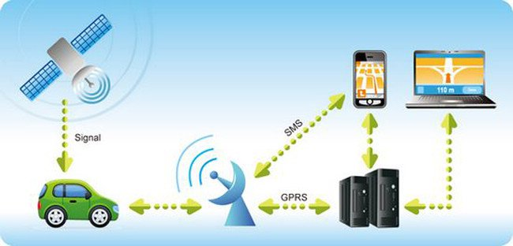

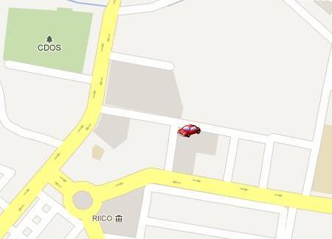

## Product Features

Compucom Tracker shall have the live tracking, history reporting, mobile notification and SMS integration feature.

## User Classes and Characteristics

There shall be two user categories for Compucom Tracker. One is Administrator user, who will have all the rights of the software including addition/deletion of group users and their tracker.

Second is the Group user, which will have the rights to add and manage its own trackers.

## Operating Environment

|  |  |
| --- | --- |
| Hardware | HP Intel Xeon X3430 @ 2.40 GHz  RAM 8GB |
| Networking | Development machines on domain through TCP/IP. |
| Development tools | Windows 7  Webserver: Apache 2.2.17 Database: MySQL 5.5.8 Language: PHP 5.3.5 / JAVA Script / HTML  Android Studio |
| Infrastructure/Facility | Printer |

## Design and Implementation Constraints

Since OTP generation is an additional cost factor, so a registered mobile number will be used to login in to the system as an unique resource id.

## User Documentation

Compucom Tracker User guide will have all the instructions to install the mobile app on the mobile phone and how to use this application on the server side.

## Assumptions and Dependencies

This software is based on the assumptions that the tracking device will be GPS enabled and will have the active internet connection.

# System Features

The Compucom Tracker is a GPS tracking system designed for tracking the location of the employees of an organization. The designed system shall provide multiple display view to the user, display live location of the employee’s device.

Registered user and unregistered user are categorized differently and user is grouped under the departments. The history of the location shall be kept in its database. The users can be intimated to activate the application or give instructions using SMS or notification facility

## Server Side Feature

The system shall provide the users a detailed description of the employee location and maintains the history in the database. The various modules on the server side are:

3.1.1 Description and Priority

It’s High priority feature that collects resource location from GPS enabled device and store information for further use.

3.1.2 Stimulus/Response Sequences

3.1.3 Functional Requirements

3.1.3.1 **User Registration**

3.1.3.1.1 The system shall be able to create a new user and allow the user to access the system.

3.1.3.1.2 The system shall be able to update the information regarding a specific user, and can even delete a user.

3.1.3.1.3 When the user registers, a request should be sent into the system for approval.

3.1.3.2 **Track Registration**

3.1.3.2.1 When the users register themselves on the Compucom tracker through their mobile phones, a request shall be sent to the system.

3.1.3.2.2 The system shall be able to register the user device to track their location.

3.1.3.2.3 The system shall be able to remove a user device.

3.1.3..3 **Live Tracking**

3.1.3..3.1 The system shall display the current position of the active devices on the map.

3.1.3..3.2 The system shall have the option to display the location of the device in three different kinds of views i.e. Google Earth, Satellite and Map.

3.1.3..3.3 The location of the device shall be stored in the database to maintain the history.

3.1.3.4 **History Module**

3.1.3.4.1 The system shall maintain the trip history of the device.

3.1.3.4.2 There shall be an option to specify the duration whose history would be shown.

3.1.3.4.3 The path of the device for the selected trip dates shall be displayed on the map.

3.1.3.5 **Dashboard for User Status Tracking**

3.1.3.5.1 The system shall be able to provide the last active date and location of the user devices.

3.1.3.5.2 The system shall provide a facility to filter the report by different group names.

3.1.3.5.3 The system shall show the users on the basis of last active day.

3.1.3.5.4 The system shall show the last active location of the user in the dashboard.

3.1.3.5.5 The system shall provide a SMS and Notification option to intimate the user to switch on their GPS and application for tracking.

3.1.3.6 **Trip Report**

3.1.3.6.1 The user shall select a device whose trip report he wish to see.

3.1.3.6.2 The system shall display the last location the device selected by the user.

3.1.3.6.3 The user can specify the report duration to the system for report generation.

3.1.3.7 **SMS Integration**

3.1.3.7.1 The System shall be able to send intimation to the user, using a paid SMS for enabling the tracker in user device.

3.1.3.8 **Mobile Notification**

3.1.3.8.1 The system shall be able to send a notification to the device that is being tracked.

3.1.3.8.2 The system shall edit the message which has to be sent on the device.

## Client Side Feature

The client side shall have a Mobile Application in their smart phones with GPS enabled to track resource location that can get mobile number as resource id. Application shall show notification send by the server on recent bases.

3.2.1 Description and Priority

Priority of feature is High that send GPS location of resource to the server. Priority of notification is medium.

3.2.2 Stimulus/Response Sequences

3.2.3 Functional Requirements

3.2.3.1 **Android App (Basic) Module**

3.2.3.1.1 The application shall ask the user to enter their mobile number for communication and tracking purpose.

3.2.3.1.2 There shall be an option to enable or disable the tracker.

3.2.3.1.3 The GPS of the device should be prompted to be enabled.

3.2.3.1.4 There should be an option for selection of the time interval after which the location is tracked.

3.2.3.1 **Notification Display Module**

3.2.3.1.1 When the system administrator sends a message to the user device via dashboard it should appear as a notification in the user device.

# External Interface Requirements

## User Interfaces

N.A.

## Hardware Interfaces

GPS enabled smartphone is required to communicate with the Compucom Tracker server.

## Software Interfaces

Android OS is required on Smartphone.

## Communications Interfaces

SMS gateway to send the SMS and Google APIs are required to send the notifications

# Other Nonfunctional Requirements

## Performance Requirements

N.A.

## Safety Requirements

N.A.

## Security Requirements

N.A.

## Software Quality Attributes

N.A.

# Other Requirements

N.A.

Appendix A: Glossary

GPS: Global Positioning System

Appendix B: Analysis Models

N.A.

Appendix C: Issues List

N.A.