Base Url - http://alloneseo.com/proteffin/
- Vendors Login
url: vendors_api/vendors_sign_up
Keyword (name, phone_number, password, user_name)

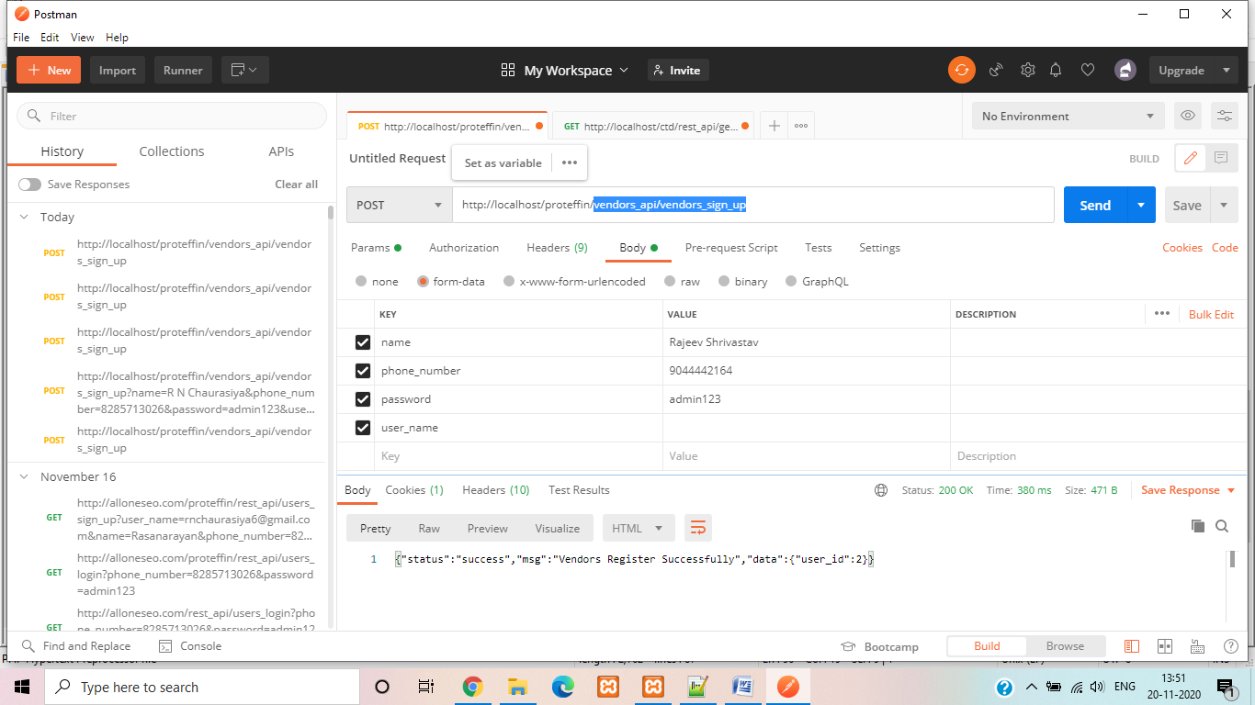

- Vendors Login
url: vendors_api/vendors_login
Keyword : (phone_number, password)

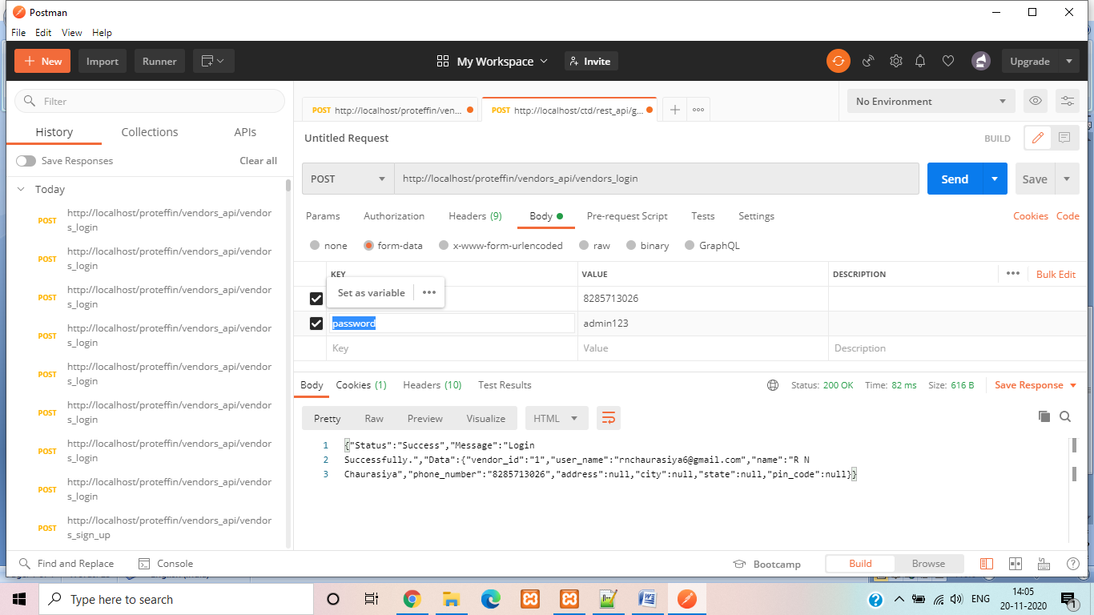

- State List
url: vendors_api/state_list
Keyword: (keyword)
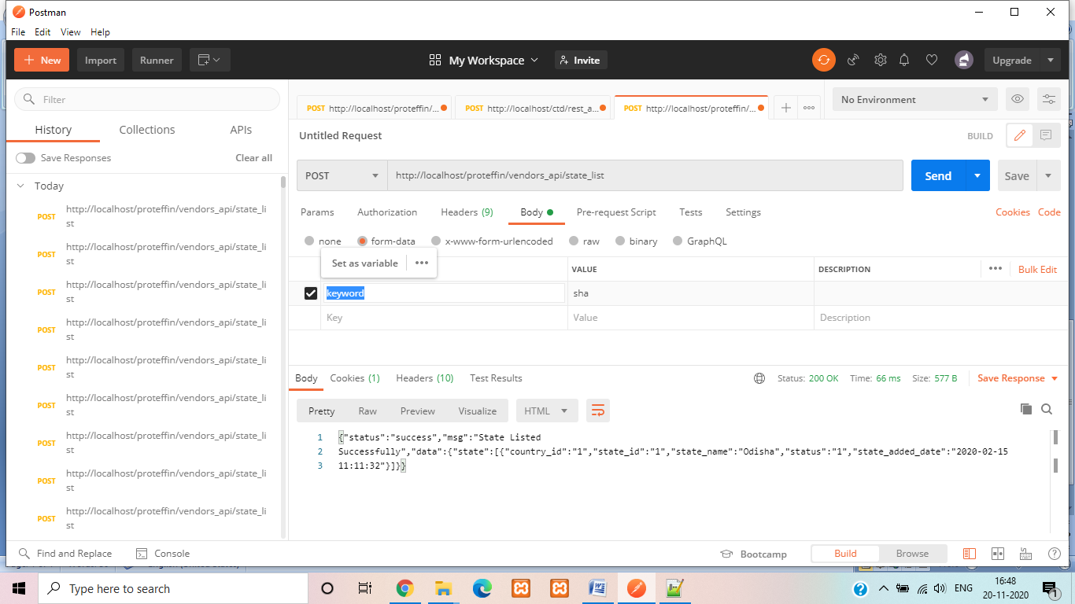
- City List
url: vendors_api/city_list
Keyword : (state_id, keyword)

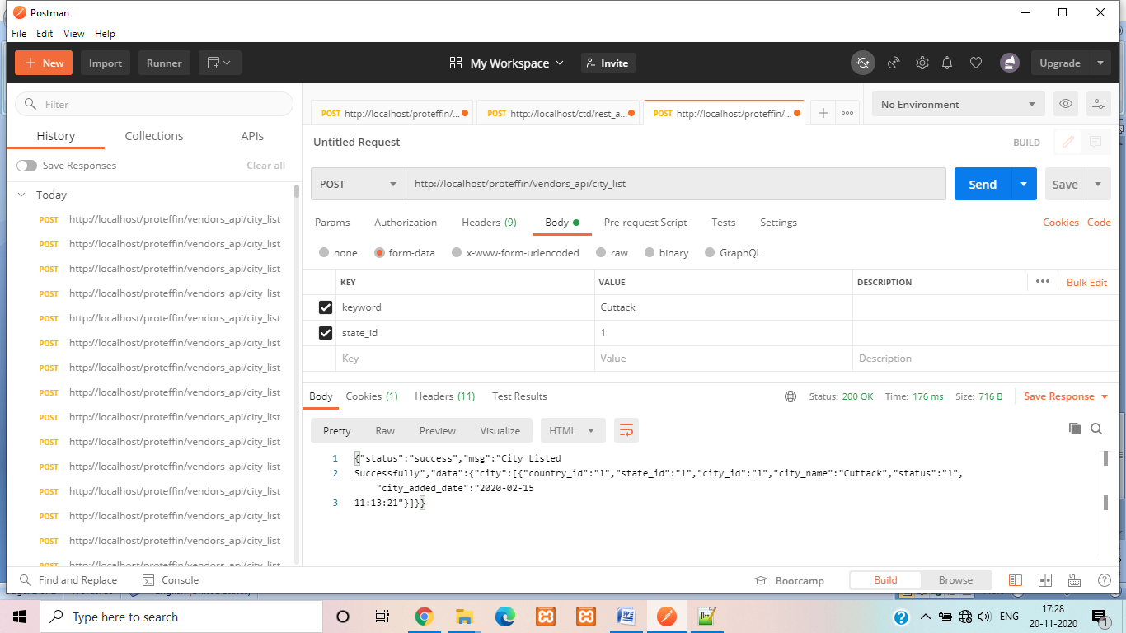
- Profile Update
url: vendors_api/profile_update
Keyword : (vendor_id, name, phone_number, user_name, address, location, city, state, pin_code, adhhar_card, pan_card, logo, bank_name, branch_name, ifsc_code, account_no, account_holder_name).

