**Amazon web services e-learning solution**

**Requirement**:

* Create an Architecture Diagram for an E-Learning Solution which should achieve the following:
  + Should Scale Seamlessly for upto 10MM Users
  + Should be able to Use Microservices Architecture
  + Must use AWS Components Only
  + MySQL Database
  + EC2 Containers

**Solution Architecture**:

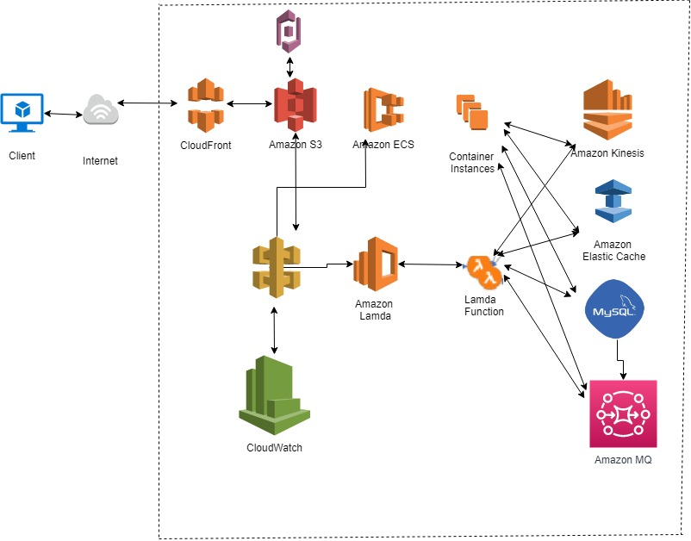

**Solution Description**:

The architecture above follows the well architected framework of amazon web services engulfing all the design principles of scalability, security, Operational excellence, High Availability.

The architectural components are mentioned below,

CloudFront: Cloudfront is a content delivery network for fast delivery of data directly from the edge location, hence providing the client a fast responsive application.

The Cloudfront distribution takes the data from origin S3 where some static website pages are hosted , S3 also keeps the log data of access login via cloudtrail.

The API gateway is used to develop the rest Api where the logic resides to trigger the lambda function on login of the user via the app/mobile .

cognito keeps the record and manager the users of the application.

Once lambda function is trigerred it goes to the main application tier that is located on elastic container services (using the fargate modal) . The e learning application ECS servers the customers end user application tier.

Since scalability on demand is required and a huge base of users has to be catered ,hence MySQL has been used ,hence the customer just has to work on the application and not worry about scaling the database or any read latency on the DB.

Amazon elasticache is the DB caching service utilising Memcached and offloads the work load traffic on the database.

Message queue is used to make sure not even a single message between the application is missed.the applications deployed on ECS.

Kinesis is used for real time data streamings.