**Student Registration**

*Basic Requirements*

1. Create a web Application and the packages as follows:

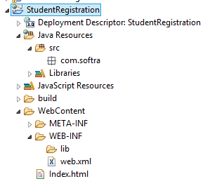

1. Use index.html to display the Student Registration form as follows

The form would submit the student data to the server using HTTP POST

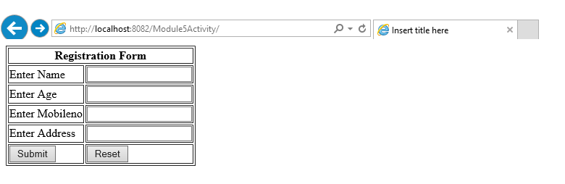

1. Create a java class Student in the package com.softra.model

(Declare variables and getter setters)

1. Create a servlet named **StudentRegistrationServlet** inside the

package **com.softra.controller**

(Read the index.html form parameters; assign the values to the Student Object. Store the Student object in the “**request**” scope and **forward** the request to the success.jsp page)

1. Create success.jsp to display the student information as follows

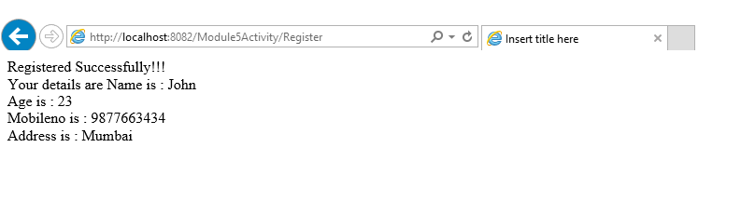

*Change in Requirements*

1. The Application needs to persist the registered Student Data in the RDBMS.

[The Servlet would read the configuration parameters and pass to a

Java Bean Class – StudentDao.java. The persistence logic would reside in Java Bean.

1. The database configuration parameters need to be configured in application scope so that every server side component (Servlets and JSPs) would be able to access it.
2. Modify the success.jsp so that it would use EL (Expression Language) and its implicit object/s to display the Student Information to End User.