AWS server Detail:-

I have done following assignment in aws server.
Detail of AWS server:-
1) MongoDB-Primary server :- 3.232.104.48
2) MongoDB-secondary server-1: 3.209.196.149
3) Mongo-DB-secondary server-2:- 54.86.120.86

Mongo DB setup:-

i have configured the server as per the following scenario.
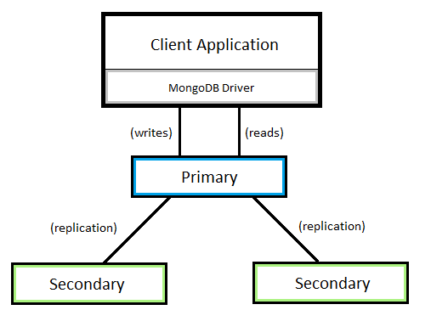

I have used the LVM concept to increase the size of the database as per the requirenment in all the server. Database location set to /data/mongodb in all the servers.
/data is mounted on LVM with the name data and Vg name is vg1.
I have used lvmresize script which is stored in optlvmresize.sh to automatically increase and decrease the lvm size which will run in every 5 min via contab.This script check the USE% of LVM(/dev/mappervg1-data) via command df -TH. Once data size reached the threshold set in the script it will automatically extend and reduce the size of the LVM.
I have also set different thresholds all servers so it will not reduce the size of lvm at a same time on all the servers. so there is no downtime.

I have used the following Documentation to setup mongoDB Replication .
https://docs.mongodb.com/manual/reference/replica-configuration/
https://computingforgeeks.com/how-to-setup-mongodb-replication-on-ubuntu-18-04-lts/

