Midea Group
Final Valuation Report R3
Institutional forecasting and valuation | 13 September 2026
Model information cutoff: 20 August 2026 | Valuation market-data date: 11 September 2026
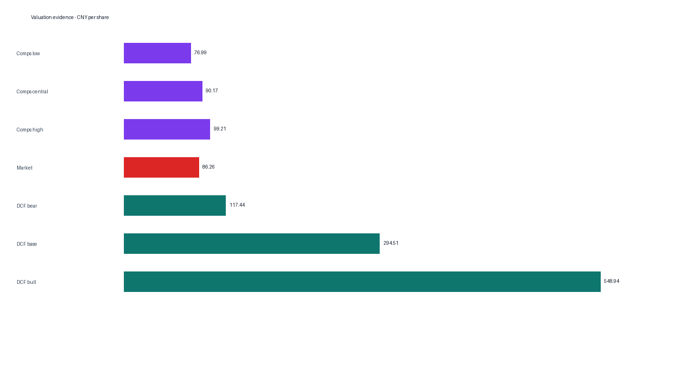

Executive view
The certified DCF base is CNY 294.51 per share versus CNY 86.26. Period-aligned trading comparables indicate CNY 76.99–99.21. The governed conclusion is DCF_INDICATES_UPSIDE_BUT_LOW_CONFIDENCE; risk is HIGH and confidence is LOW_TO_MEDIUM. No mechanical method average is used.
Method | Low | Central/Base | High
DCF | 117.43848226 | 294.51058279 | 548.93672533
Comps | 76.99490197 | 90.17128260 | 99.20698269

Method and governance
H1, H2, H3-A, G25 mechanics and forecast-driver authority remain frozen. A newly executed primary-evidence recomputation proved that the prior release omitted source-proven economic working-capital accounts and treated mixed current-asset residuals as operating. Attempt 005 rebuilds economic NWC from eight operating assets and seven operating liabilities, excludes income-tax payable because NOPAT uses accrual tax, and presents finance-company net investment as a separate FCFF adjustment. Share mechanics remain unchanged. No post-cutoff operating fact enters the forecast. Arithmetic identities remain exact-zero controls.

WACC
WACC is 5.2666% (range 5.0776%–7.0262%). It uses a 1.6899% RMB risk-free rate, 5.0728% China total ERP from Damodaran's 1 July 2026 dataset, beta 0.785484, pre-tax cost of debt 1.7292%, and certified market-value capital structure. The debt rate is a marginal market proxy from the ChinaBond AAA CP and Note 5Y curve; it is distinct from accounting effective interest expense.

DCF
The base case produces enterprise value RMB 2,054,275.7 million and equity value RMB 2,180,118.6 million. The terminal value contributes 88.8% of enterprise value. That concentration makes the output highly sensitive to WACC and terminal growth and is reflected in the low-to-medium confidence rating.
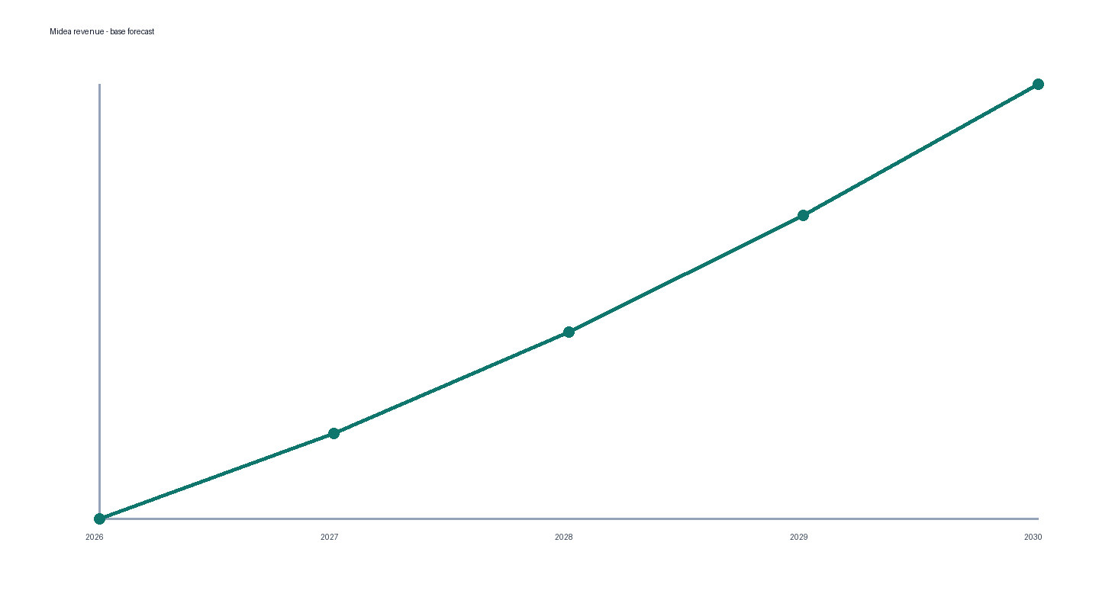

Period-aligned comparable companies
Peer multiples use source-native TTM results through the latest reported period available by the valuation date. They are applied to Midea LTM metrics reconstructed as 2025A minus 2025Q1 plus 2026Q1. P/B uses 2026Q1 parent equity. EV/EBITDA is retained as a reference peer statistic but excluded from implied valuation because compatible Midea Q1 depreciation and amortization is unavailable. Selected peer/Midea period-basis mismatches are zero.
Multiple | Selected | Use
EV/EBIT | 11.23x | Implied valuation
EV/EBITDA | 7.40x | Reference only
EV/Revenue | 1.06x | Implied valuation
P/B | 1.88x | Implied valuation
P/E | 17.57x | Implied valuation

Cash taxonomy and EV-to-equity bridge
Balance-sheet cash reconciles to cash-flow cash equivalents plus restricted cash, term deposits, and an other taxonomy residual. The residual is a separately identified classification difference; the full reconciliation difference is not described as only restricted cash and term deposits. The EV-to-equity bridge adds excess cash after a source-reproduced minimum operating-cash reserve, CNY 155,362.528 million of current treasury products, and other non-operating investments; it deducts debt, NCI, and the CNY 706.439 million trading financial liability. Receivables financing remains in operating NWC and is not added again.

Synthesis
DCF remains the primary intrinsic method and indicates substantial upside. Period-aligned comps sit around or below market, while the DCF is terminal-value heavy. Reverse DCF indicates lower cash flow than the base forecast. The evidence supports a directional DCF upside signal with low confidence rather than a blended fair-value point estimate.

Certification status
Financial-model certification: PASS. Internal release certification: PASS upon package verification. Independent-role verification: PASS upon detached-root and cleanroom execution. True external certification remains PENDING_EXTERNAL_REVIEW until an external party verifies the final bytes.

Key risks and catalysts
- Terminal-value concentration
- China appliance cycle
- Margin and working-capital execution
- Commodity and FX volatility
- International competition
- Capital-allocation and M&A risk
- Sustained smart-home mix improvement
- Building-technology growth
- Industrial-technology recovery
- FCFF conversion
- Disciplined capital returns

Limitations
Peer fundamentals are provider-reported source-native measures and are not fully cross-GAAP restated. Peer period ends differ within the permitted TTM/latest-quarter framework. Market inputs are frozen at 11 September 2026. The package is designed for offline verification and does not fetch live data.

