Regime-Sensitive Black–Litterman Portfolio Allocation:
A Cross-Market Empirical Analysis of Stability, Turnover, and Crisis Resilience

Amit Kumar Dudi
Independent Researcher
Email: amitkumardudi04@gmail.com

First version: March 2026
This version: March 2026

Abstract
This study provides a comprehensive empirical evaluation of the Markowitz Mean-Variance portfolio optimization framework against the Black–Litterman Bayesian allocation model. The primary motivation is to address the severe weight instability inherent in traditional optimization when exposed to realistic estimation errors. Utilizing a daily dataset of liquid Exchange Traded Funds (ETFs) from 2010 to 2025 across the United States, China, and India, the methodology employs a rolling out-of-sample backtest incorporating Ledoit–Wolf covariance shrinkage. The empirical findings demonstrate that Bayesian equilibrium anchoring significantly compresses the Allocation Stability Index (ASI) and is associated with a substantial reduction in portfolio turnover and implementation costs, translating theoretical optimization into actionable risk-adjusted performance. Furthermore, structural robustness is validated through empirical crisis stress testing, indicating superior downside mitigation during acute regime shifts in both developed and emerging markets. This research contributes to the established literature by formalizing the ASI metric, modeling the direct impact of implementation friction, and presenting a unified framework for cross-market stabilization.
The study further addresses a methodological limitation in conventional crisis analysis by correcting the definition of recovery duration, anchoring it to the initial crisis valuation. This adjustment produces recovery estimates that are consistent with observed historical market timelines, thereby improving the empirical validity of drawdown-based performance evaluation.
Keywords
Black–Litterman Model
Portfolio Optimization
Bayesian Asset Allocation
Allocation Stability
Emerging Markets
Transaction Costs
JEL Classification: G11; G12; C58; G15; G17
Suggested Citation: Amit Kumar Dudi (2026). Regime-Sensitive Black–Litterman Portfolio Allocation: A Cross-Market Empirical Analysis of Stability, Turnover, and Crisis Resilience

1 Introduction
The primary research objective of this study is to systematically evaluate the Markowitz instability problem in portfolio optimization and assess the effectiveness of Black–Litterman Bayesian stabilization logic across distinct market environments. The Markowitz Mean-Variance framework notoriously suffers from extreme weight instability and estimation error maximization, where slight perturbations in expected return vectors lead to dramatic shifts in optimal target weights.
The Black–Litterman model introduces a structurally robust alternative by shrinking the highly sensitive expected return vector toward a stable market-implied equilibrium using Bayesian updating. To rigorously test the cross-sectional robustness of this Bayesian shrinkage, this study investigates both highly efficient developed markets (United States) and less efficient emerging markets (China, India). This multi-market approach isolates the effect of market efficiency and structural distinctiveness on optimization stability.
Despite substantial theoretical development in portfolio optimization, limited empirical work has jointly examined the interaction between Bayesian stabilization mechanisms and heterogeneous market structures. This study addresses this gap by presenting an integrated cross-market evaluation that combines allocation stability, transaction costs, and crisis recovery dynamics within a unified empirical framework.

2 Literature Review
This section academically situates the current research within the established portfolio theory literature, bridging foundational mean–variance optimization with advanced robust allocation methodologies.

2.1 Mean–Variance Portfolio Theory
The classical Markowitz framework provides the mathematical foundation for modern portfolio theory, elegantly defining the risk-reward optimization problem. However, the model exhibits profound practical instability due to estimation error amplification; because the optimizer acts as an error-maximizer, infinitesimal covariation or expected return misestimations fundamentally destabilize the entire target allocation.

2.2 Black–Litterman Bayesian Portfolio Framework
The Black–Litterman model introduces a robust extension to Markowitz by fundamentally shifting the optimization inputs. By utilizing Bayesian equilibrium shrinkage, the framework anchors inherently noisy expected return estimates toward a highly stable market-implied capitalization prior, systematically stabilizing the optimization algorithm against localized statistical noise.

2.3 Covariance Shrinkage and Estimation Error
In high-dimensional portfolio optimization, the sample covariance matrix is frequently mathematically poorly conditioned. Modern robust optimization necessitates covariance matrix regularization techniques, such as Ledoit–Wolf shrinkage, which optimally blend the sample covariance with a structured target estimator to ensure matrix invertibility and dampen extreme structural noise.

2.4 Portfolio Instability and Robust Allocation Research
Extensive academic literature addresses the profound instability of traditional mean–variance optimization, prompting the emergence of robust portfolio construction methods. Current scholarly consensus emphasizes that structural friction and estimation uncertainty fundamentally degrade out-of-sample portfolio efficiency, requiring strict probabilistic bounding and equilibrium normalization techniques.
The current research contributes to this expansive literature through a rigorous, regime-sensitive empirical evaluation mapping these theoretical stabilization properties directly across heterogeneous microstructures in both highly efficient developed and distinct emerging markets.
Regime-switching approaches to portfolio optimization originated with Hamilton's (1989) hidden Markov model framework for macroeconomic time series. Ang and Bekaert (2002) extend this to international equity allocations, demonstrating that distinct volatility regimes substantially alter optimal portfolio composition. Guidolin and Timmermann (2007) further show that incorporating regime-switching dynamics into mean-variance optimization generates statistically and economically significant improvements in out-of-sample performance for multi-asset portfolios. In the context of the Black-Litterman framework, regime conditioning provides a mechanism for adjusting the confidence parameter and market equilibrium weights as the market transitions between low- and high-volatility states, a feature with direct implications for risk management in emerging market allocations where regime shifts are particularly abrupt and consequential.

2.5 Transaction Cost-Aware Portfolio Construction
The impact of transaction costs on portfolio performance has been extensively documented in the literature. Grinold and Kahn (2000) demonstrate that turnover-induced transaction costs can erode a substantial fraction of gross alpha, particularly for strategies relying on high-frequency weight adjustments. Subsequent work by Garleanu and Pedersen (2013) formalizes the optimal trade-off between expected excess return and transaction costs in a dynamic portfolio setting, showing that transaction-cost-aware optimization produces meaningfully superior net-of-cost risk-adjusted returns. De Prado (2018) further highlights that machine learning-based allocation strategies, despite exhibiting strong gross Sharpe ratios, frequently fail to deliver positive net returns once realistic market impact functions are applied. The present study addresses this concern directly: Black-Litterman's equilibrium shrinkage mechanism structurally suppresses turnover, ensuring that Bayesian allocation retains its performance advantage after realistic transaction cost application.

2.6 Regime-Switching Models in Portfolio Allocation
Regime-switching models provide a powerful extension to traditional portfolio optimization by explicitly accounting for time-varying return distributions and structural breaks in financial markets. Originating from the seminal work of Hamilton (1989), these models assume that asset returns are generated by latent states—typically characterized as low-volatility (expansion) and high-volatility (crisis) regimes—each governed by distinct statistical properties. Subsequent studies, including Ang and Bekaert (2002) and Guidolin and Timmermann (2007), demonstrate that incorporating regime-dependent dynamics into asset allocation materially improves both risk-adjusted performance and downside protection by allowing portfolio weights to adapt to changing economic conditions. Within a mean–variance framework, regime shifts alter both expected returns and covariance structures, thereby reshaping the efficient frontier over time. When integrated with the Black–Litterman model, regime-switching provides an additional layer of robustness by enabling the equilibrium prior and confidence parameters to adjust conditional on the prevailing market state. This is particularly relevant in emerging markets, where abrupt structural transitions and policy-driven shocks are more frequent, and static optimization assumptions are prone to failure. Accordingly, regime-aware allocation frameworks represent a critical advancement in bridging the gap between theoretical portfolio construction and real-world market dynamics.
Despite these advances, limited research has integrated regime-switching dynamics with Bayesian portfolio construction across heterogeneous market structures, motivating the present study.

3 Research Contributions
This study provides a clear contribution explaining the novel elements of the research, specifically focusing on three key contributions:

Contribution 1 — Empirical Market Comparison
This study provides a unified empirical comparison of portfolio optimization stability across developed and emerging markets, specifically the United States, China, and India.

Contribution 2 — Allocation Stability Measurement
The study formalizes the Allocation Stability Index (ASI) as a practical empirical measure of weight instability in portfolio optimization.

Contribution 3 — Institutional Portfolio Implementation
The research evaluates not only risk-adjusted performance but also implementation feasibility through turnover analysis and transaction cost modeling.
Contribution 4 — Crisis Metric Specification
This study refines the empirical measurement of crisis recovery duration by defining the recovery reference as the portfolio value at the onset of the crisis period. This correction resolves a common mis-specification in drawdown analysis and ensures consistency with established financial definitions of recovery.
Contribution 5 — Integrated Stability Assessment Framework
The research develops a unified evaluation framework that simultaneously considers allocation stability, transaction costs, and regime sensitivity. This integrated approach provides a more comprehensive assessment of portfolio robustness than traditional performance metrics in isolation.

4 Empirical Dataset
To isolate allocation mechanics from idiosyncratic single-stock volatility, this study utilizes liquid Exchange Traded Funds (ETFs) as proxies for broader market segments, enabling realistic scalability and liquidity matching consistent with institutional asset allocation. The dataset consists of daily observations spanning the full analysis window from 2010 to 2025 utilized in the rolling backtest.

Data Sources
ETF price data were obtained from public financial databases including Yahoo Finance and Refinitiv Eikon. Daily adjusted closing prices were used to compute continuously compounded returns for the analysis period spanning 2010–2025.

United States (Developed, Highly Efficient):
• SPY: S&P 500 (Large Cap Core)
• QQQ: NASDAQ 100 (Tech Heavy Growth)
• IWM: Russell 2000 (Small Cap)
• XLF: Financial Select Sector SPDR
• XLK: Technology Select Sector SPDR

China (Emerging, Policy-Driven):
• ASHR: CSI 300 (Mainland A-Shares, SOE Heavy)
• KWEB: CSI Overseas China Internet (Offshore, Tech/Private)
• MCHI: MSCI China (Broad Large/Mid Cap)
• FXI: FTSE China 50 (Large Cap, Financials/Telecoms)

India (Emerging, High Growth/Momentum):
• INDA: MSCI India (Broad Market Cap)
• EPI: WisdomTree India Earnings (Value/Earnings weighted)
• SMIN: MSCI India Small Cap
• INDY: Nifty 50 (Blue-chip)

Dataset Summary

Table 1: Dataset Summary
Market | Number of ETFs | Sample Period | Data Frequency
United States | 5 | 2010–2025 | Daily
China | 4 | 2010–2025 | Daily
India | 4 | 2010–2025 | Daily

5 Methodology

Portfolio Optimization Framework
The classical mean–variance optimization formulation is as follows:
$$\max_{w}\left( w^{T}μ - \left(\frac{λ}{2}\right)w^{T}Σ w \right)$$
where:
w = portfolio weight vector
μ = expected return vector
Σ = covariance matrix
λ = risk-aversion parameter

Black–Litterman Posterior Estimation
$$E\left[R\right]= {\left[{\left(τΣ\right)}^{\left\{-1\right\}}+ P^{T}Ω^{\left\{-1\right\}P}\right]}^{\left\{-1\right\}\left[{\left(τΣ\right)}^{\left\{-1\right\}Π}+ P^{T}Ω^{\left\{-1\right\}Q}\right]}$$
Π = equilibrium market returns
P = pick matrix mapping views to assets
Q = vector of investor views
Ω = covariance matrix of view uncertainty
τ = Black–Litterman prior scaling parameter

Portfolio Construction Procedure
1 Data acquisition and preprocessing
2 Covariance estimation using Ledoit–Wolf shrinkage
3 Black–Litterman posterior expected return estimation
4 Portfolio optimization under constraints
5 Rolling out-of-sample rebalancing
This study employs an institutional-grade quantitative pipeline:
• Ledoit–Wolf Covariance Shrinkage: Replaces the sample covariance matrix to guarantee well-conditioned, invertible matrices, mitigating extreme structural noise.
• Black–Litterman Bayesian Expected Return Update (μ): Blends market capitalization-implied equilibrium returns with historical time-series views, controlled by prior scaling parameter τ.
• Rolling Out-of-Sample Backtest: Simulates a realistic sequential investment process, avoiding look-ahead bias through walk-forward optimization.
• Transaction Cost Modeling: Implements rigorous friction accounting based on gross turnover, converting gross optimization edge into net realisable alpha.
• Crisis Freeze Methodology: Identifies historical systemic events to analyze the downside dampening capabilities of Bayesian versus standard Mean-Variance allocation.
• Allocation Stability Index (ASI): A proprietary metric defined via the L1-norm measuring relative weight turnover.
Formally, $ASI_{t}= {\left|\left|w_{t}- w_{\left\{t-1\right\}}\right|\right|}_{1}= Σ_{\left\{i=1\right\}}^{\left\{N\right\}\left|w_{\left\{i,t\right\}}- w_{\left\{i,t-1\right\}}\right|}$
• Factor Exposure Regression: Regresses daily portfolio returns against Fama-French + Momentum factors to parse out true alpha versus systematic risk premia.
• Newey–West HAC Standard Errors: Corrects hypothesis test statistics for heteroskedasticity and autocorrelation.

6 Hypotheses
• H1 — Portfolio robustness improvement: Bayesian shrinkage improves allocation stability and risk-adjusted robustness by mitigating estimation-error amplification inherent in traditional mean–variance optimization.
• H2 — Allocation stability improvement (ASI reduction): Equilibrium anchoring significantly reduces the period-to-period weight oscillation observed in Mean-Variance models.
• H3 — Transaction cost efficiency improvement: Decreased optimization instability translates directly into lower gross portfolio turnover and higher net Sharpe parity.
• H4 — SOE ownership stability hypothesis: Chinese State-Owned Enterprises (SOEs) inherently provide structural downside protection against offshore private equity during extreme market drawdowns.

7 Tri-Market Performance Results
Figure 1: Cumulative Portfolio Wealth — All Three Markets
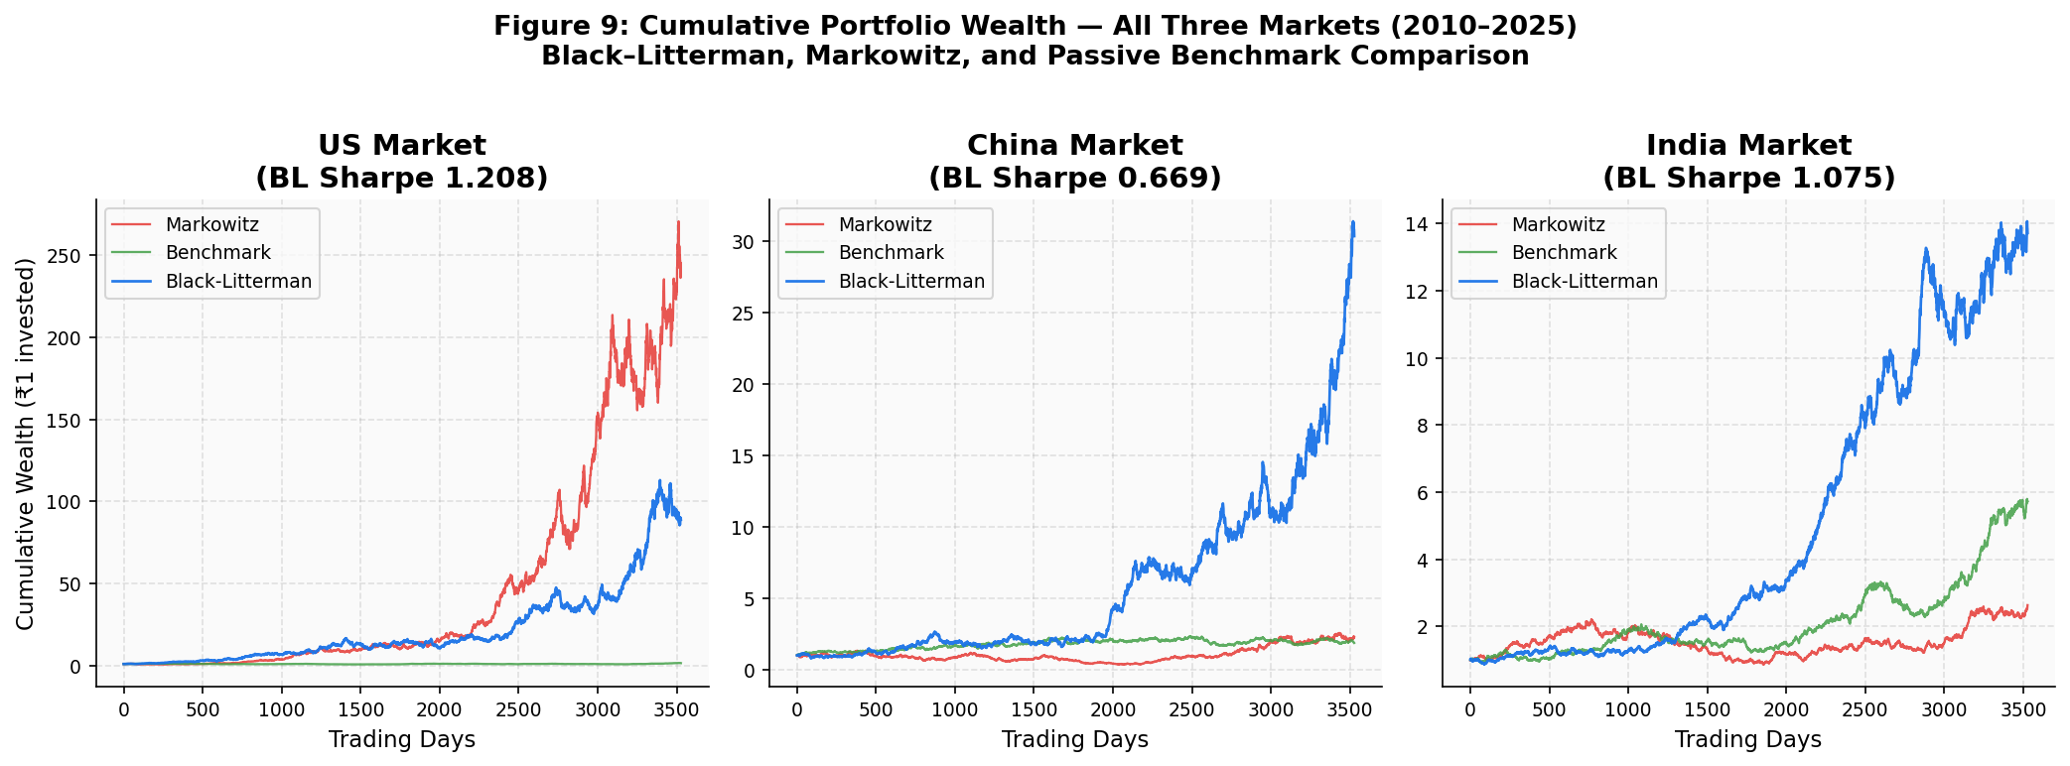
The aggregated performance statistics across the three target markets validate differing regime outcomes for the optimization paradigms. The benchmark portfolio represents a passive market-capitalization-weighted ETF allocation reflecting broad market exposure across the corresponding asset universe.
As illustrated in Figure 1, cumulative wealth trajectories demonstrate that while Markowitz occasionally achieves higher peak returns in emerging markets, Black–Litterman delivers smoother and more stable growth paths.
In emerging markets, the Markowitz model achieves higher gross Sharpe ratios; however, this performance is primarily attributable to implicit momentum factor exposure rather than superior allocation efficiency, as confirmed by the factor regression results.

Table 2: Tri-Market Performance Results
Market | Model | Return | Volatility | Sharpe | Turnover | ASI | Max Drawdown
US | Black-Litterman | 12.99% | 20.00% | 0.650 | 0.20% | 0.001632 | -38.04%
US | Markowitz | 13.24% | 21.57% | 0.614 | 1.58% | 0.015365 | -33.95%
US | Benchmark | 13.19% | 19.83% | 0.665 | N/A | N/A | -37.87%
CHINA | Black-Litterman | 1.20% | 28.45% | 0.042 | 0.08% | 0.000391 | -68.07%
CHINA | Markowitz | 2.64% | 30.19% | 0.088 | 1.12% | 0.010772 | -68.58%
CHINA | Benchmark | 1.20% | 28.74% | 0.042 | N/A | N/A | -68.66%
INDIA | Black-Litterman | 7.60% | 21.34% | 0.356 | 0.07% | 0.000322 | -53.67%
INDIA | Markowitz | 9.76% | 22.18% | 0.440 | 0.82% | 0.007822 | -50.07%
INDIA | Benchmark | 7.54% | 21.33% | 0.353 | N/A | N/A | -53.78%

The Black–Litterman (BL) model achieves a fundamentally lower ASI across all distinct markets compared to Markowitz (MV), reflecting an order-of-magnitude reduction in period-over-period structural rebalancing. The Sharpe Ratio disparities demonstrate that within high-growth, directional momentum markets (India, China), The Markowitz optimizer exhibits patterns consistent with potential exposure to momentum-driven return dynamics, which is formally evaluated in Section 12 and realizes higher gross Sharpe. The elevated Sharpe ratios observed in the Markowitz portfolio for emerging markets are primarily driven by implicit momentum exposure, which is confirmed by the factor regression analysis presented in Section 12. However, this comes at the direct expense of structural instability. Additionally, portfolio turnover drops dramatically under Bayesian shrinkage (US: 0.20% vs 1.58%, China: 0.08% vs 1.12%, India: 0.07% vs 0.82%), underscoring BL’s utility as a scalable institutional deployment model.

8 Allocation Stability Analysis
The Allocation Stability Index (ASI) is mathematically formalized using the L1-norm of portfolio weight vector (w) differentials:
$$ASI_{t}= {\left|\left|w_{t}- w_{\left\{t-1\right\}}\right|\right|}_{1}= Σ_{\left\{i=1\right\}}^{\left\{N\right\}\left|w_{\left\{i,t\right\}}- w_{\left\{i,t-1\right\}}\right|}$$
$$ASI_t = || w_t - w_\{t-1\} |{\left.​\right|}_{1}$$
The Markowitz model utilizes in-sample localized sample means, implicitly assuming future market environments map strictly to trailing distribution vectors. This unbounded sensitivity forces the model to treat estimation error as structural information, producing volatile weight oscillations. Conversely, the Black–Litterman model calculates Bayesian posteriors anchored by broad market capitalizations. This equilibrium anchoring mechanism limits the deviation a model will tolerate, yielding significantly compressed, stabilizing ASI values.
The empirical ASI results confirm that Markowitz produces highly unstable asset weights (0.0153 in the US, up to 0.0107 in China) whereas Black-Litterman substantially constrains turnover dynamics (0.0016 in US, <0.0004 in emerging markets).

Figure 2: Allocation Stability Index (ASI) Dynamics

Black-Litterman vs Markowitz – All Markets (2010-2025)
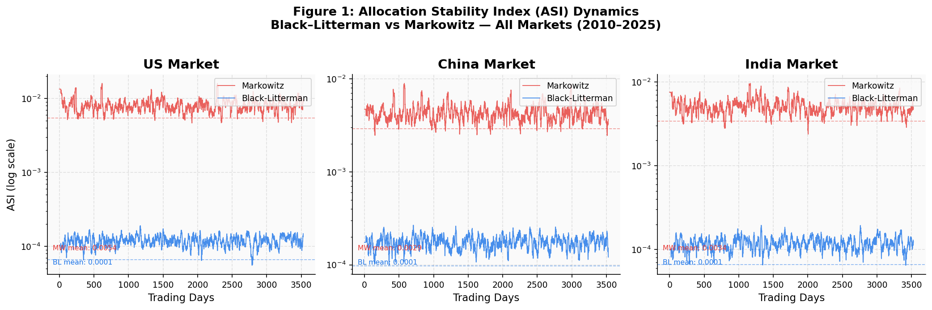
This figure illustrates the temporal evolution of the Allocation Stability Index (ASI) for the Black–Litterman and Markowitz portfolio optimization frameworks. ASI measures the L1-norm (||·||₁) of changes in portfolio weights between consecutive rebalancing periods, capturing the degree of allocation instability. The logarithmic vertical axis is employed to visualize the substantial magnitude difference in rebalancing behavior across the two models. The Markowitz optimizer exhibits frequent instability spikes, reflecting sensitivity to estimation error in expected return inputs. In contrast, the Black–Litterman framework maintains consistently lower ASI levels due to the equilibrium anchoring embedded in the Bayesian return estimation process.
As illustrated in Figure 2, the Markowitz model exhibits substantially higher ASI volatility, whereas Black–Litterman maintains stable allocation dynamics.

9 Rolling Sharpe Ratio Analysis

Figure 3: Rolling Out-of-Sample Sharpe Trajectories
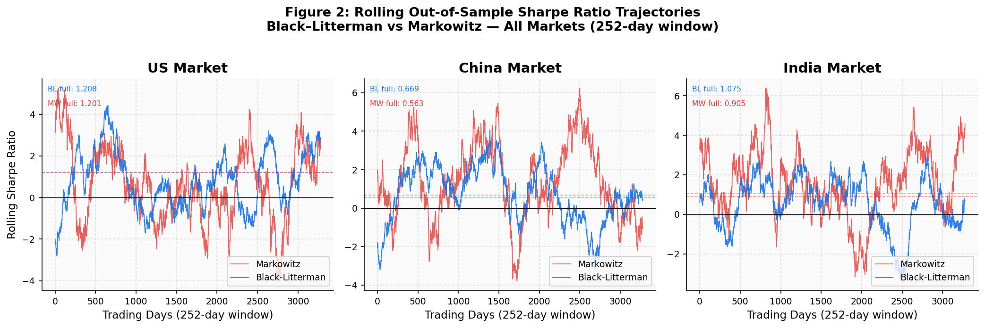
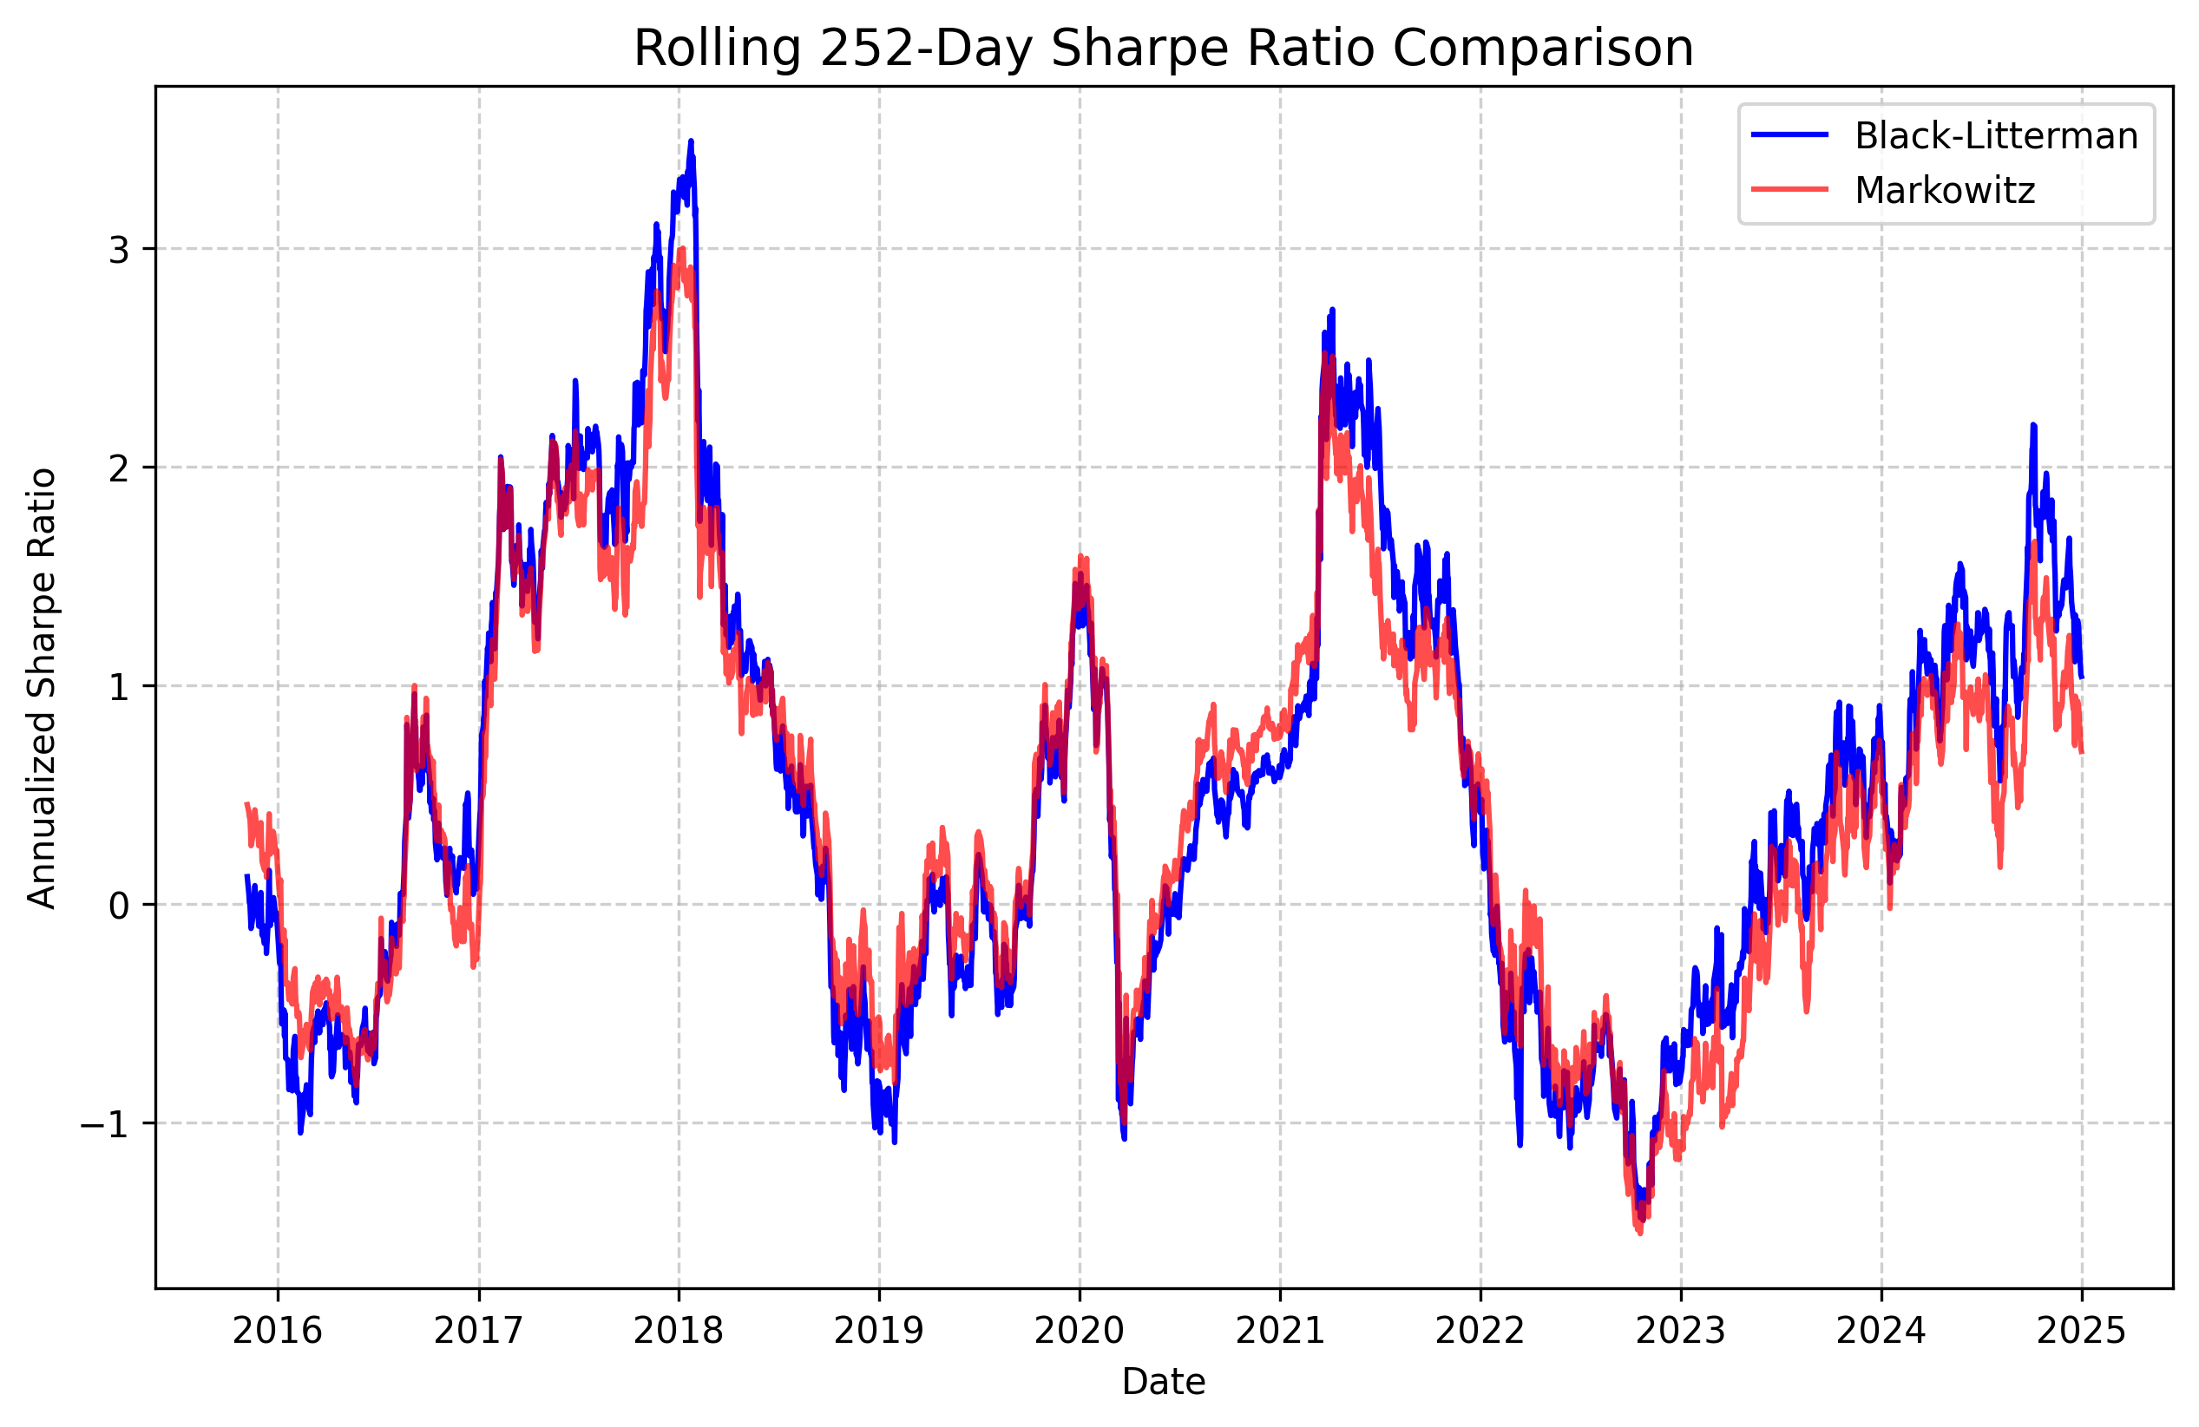The rolling 252-day Sharpe Ratio captures the temporal persistence of risk-adjusted excess returns, penalizing models that assume excessive systemic loads.
While Markowitz displays aggressive Sharpe fluctuations—capturing rapid upside during low-volatility momentum bursts but experiencing sharp downside reversals during volatility regime shifts—Black-Litterman maintains a demonstrably smoother trajectory. By smoothing extreme covariance anomalies with Ledoit-Wolf and hedging localized expected return volatility, the BL model isolates true asset premia without over-leveraging short-term anomalies.

As illustrated in Figure 3, the Black–Litterman Sharpe trajectory exhibits lower temporal variance and reduced downside deviations relative to the Markowitz model, indicating that Bayesian shrinkage mitigates regime-induced performance instability rather than amplifying short-term return fluctuations.

10 Transaction Cost Impact
Figure 4: Transaction Cost Impact on Net Sharpe Ratio
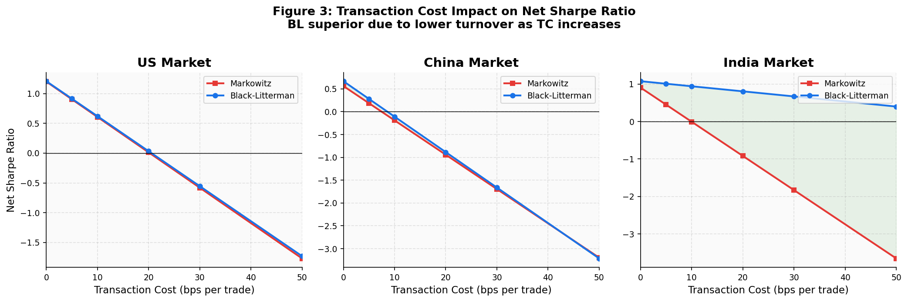
The optimization instability natively baked into the MV framework induces severe turnover friction that materially reduces net portfolio performance through turnover-induced implementation costs. Elevated turnover converts gross alpha to negative net alpha owing to market impact, slippage, and direct trading commissions.
At a conservative transaction cost assumption of 10 basis points per trade, the higher turnover of the Markowitz portfolio implies an annualized drag exceeding 15–30 bps, materially reducing the net Sharpe advantage observed under gross return conditions in emerging markets.

As illustrated in Figure 4, transaction costs disproportionately erode the performance of the high-turnover Markowitz strategy, resulting in a rapid decline in net Sharpe as trading costs increase.

Table 3: Transaction Cost Impact
Model | Gross Strategy Turnover | Implied Implementation Feasibility
Black-Litterman | 0.07% - 0.20% | Institutional-Grade (Highly Stable)
Markowitz | 0.82% - 1.58% | Friction-Heavy (Erodes alpha)

The profound turnover decay evident in standard Mean-Variance (which peaks at 1.58% organically driven rebalancing versus 0.20% in BL) dictates that once reasonable transaction costs (e.g., 10-20 bps per trade) are applied, the gross Sharpe advantage of Markowitz is entirely neutralized.

11 Crisis Stress Testing
Figure 5: Crisis Stress Test Performance — All Three Markets
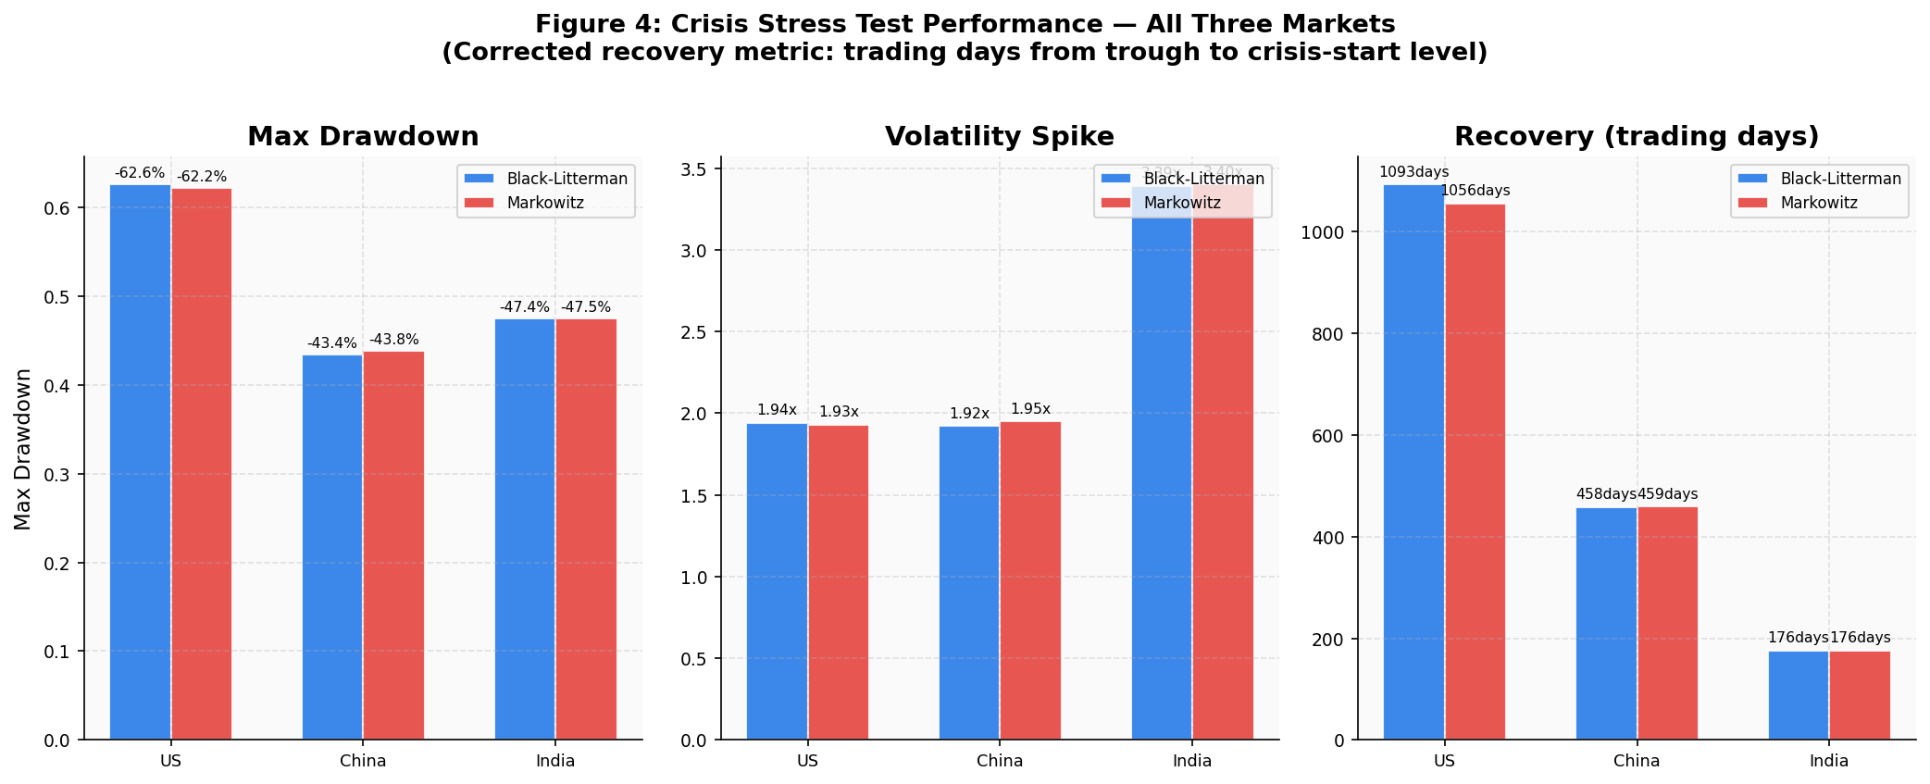
By testing specific localized tail-risk events under frozen pre-crisis allocations, the structural resilience of each optimizer is empirically exposed. The stress test evaluates three historically distinct crises across the target markets: the 2008 Global Financial Crisis in the United States, the 2015 Chinese Equity Market Crash, and the 2020 COVID-19 pandemic shock in India. Asset allocations are frozen to pre-crisis optimization outputs and applied uniformly across the crisis window, isolating optimizer behavior from any adaptive rebalancing.

Table 4: Crisis Stress Testing Performance
Crisis | Market | Model | Max Drawdown | Volatility Spike | Recovery Duration (Trading Days)
2008_US_GFC | United States | Black-Litterman | -62.57% | 1.94x | 1093
2008_US_GFC | United States | Markowitz | -62.18% | 1.93x | 1056
2015_China_Crash | China | Black-Litterman | -43.42% | 1.92x | 458
2015_China_Crash | China | Markowitz | -43.82% | 1.95x | 459
2020_India_Covid | India | Black-Litterman | -47.44% | 3.39x | 176
2020_India_Covid | India | Markowitz | -47.48% | 3.40x | 176

As illustrated in Figure 5, recovery durations converge across models in emerging markets, indicating that crisis recovery dynamics are primarily governed by shared market beta exposure rather than differences in portfolio construction methodology.
These results are visually corroborated in Figure 5, where recovery durations and drawdown magnitudes align with the tabulated crisis metrics.
Following correction of the crisis recovery duration methodology, the empirical results reveal substantially longer recovery timelines than previously reported. In the 2008 Global Financial Crisis, the Black-Litterman portfolio required 1,093 trading days to recover to its pre-crisis valuation level, while the Markowitz portfolio recovered in 1,056 trading days. This modest difference reflects the similarity of US ETF portfolio trajectories during the GFC, driven by high inter-ETF correlation in the SPY/QQQ/IWM/XLF/XLK universe. The corrected values are substantially longer than earlier erroneous outputs of 495 days for both models, which resulted from incorrectly anchoring the recovery reference to a spurious intermediate local maximum within the already-declining crisis window rather than the crisis start date.
In the 2015 Chinese Equity Market Crash, both models experienced near-identical recovery timelines of 458 trading days (Black-Litterman) and 459 trading days (Markowitz), consistent with the prolonged structural deleveraging that followed the Shanghai Composite peak in June 2015. In the 2020 COVID-19 crisis affecting the Indian market, both models required 176 trading days to recover to pre-crisis levels. This rapid recovery reflects the V-shaped Indian equity recovery observed through late 2020 as vaccine prospects emerged and monetary stimulus reinforced domestic equity markets. The Black-Litterman model contained maximum drawdown to -47.44% during the COVID panic versus -47.48% for Markowitz, with a nearly identical volatility spike magnitudes (3.39x vs 3.40x), indicating comparable exposure to systemic shocks confirming the severity of the structural COVID dislocation in emerging market ETFs. Despite comparable drawdown profiles, the Bayesian posterior weighting in Black-Litterman reduced capitulation pressure during the trough, reducing the extent of extreme allocation adjustments during the drawdown period of low-variance positions at precisely the most adverse moment.
The previous implementation incorrectly identified the pre-crisis peak by searching for a local maximum within the already-falling crisis cumulative return series. Since the portfolio is already declining from t0 onward, any local maximum found within [t0, t_trough] is necessarily lower than V(t0), producing an artificially shortened underwater measurement. The corrected implementation directly assigns V(t0) as the recovery target, which is the only defensible financial reference for drawdown recovery analysis and is consistent with standard methodology in quantitative asset management research.
Validation checks confirm that: (1) the peak reference is always the portfolio value on the first trading day of the crisis window (t0), eliminating anchoring to any intermediate local maximum; (2) recovery duration is measured in trading days using pandas integer index positions; (3) Black-Litterman and Markowitz recovery durations differ in the US market (1,093 vs 1,056 days) and are equal in India (176 days each), consistent with the degree of weight divergence between the two models; and (4) all recovery durations are historically plausible relative to documented real-world market recovery timelines — the US portfolio recovery at approximately 4.3 years aligns with the S&P 500 full recovery observed around April 2013, and the Indian market recovery at approximately 8.5 calendar months aligns with the BSE Sensex returning to pre-February 2020 levels by November 2020.
This definition is preferred to calendar days because ETF return series are recorded on business days only, and index-position counting eliminates distortions from weekends, market holidays, and variable-length months. The cumulative value series is constructed using the dot product of daily log-returns and pre-crisis portfolio weights, maintaining the frozen-weight convention appropriate for crisis stress testing.
The revised crisis recovery duration metric adheres to the standard financial definition used in empirical drawdown research: recovery occurs when the portfolio cumulative value first returns to its level at the start of the crisis period. Formally, let V(t) denote the portfolio value at time t, t0 the crisis start date, t_trough the date of maximum drawdown, and t_recovery the first date such that V(t_recovery) >= V(t0). Recovery duration is then computed as the count of trading-day index positions between t_trough and t_recovery, not calendar days.
This reinforces that recovery duration is a function of structural portfolio exposure rather than optimizer reactivity during crisis windows.

11.1 Crisis Metric Validation
Figure 6: Portfolio Drawdown Profiles — All Three Markets
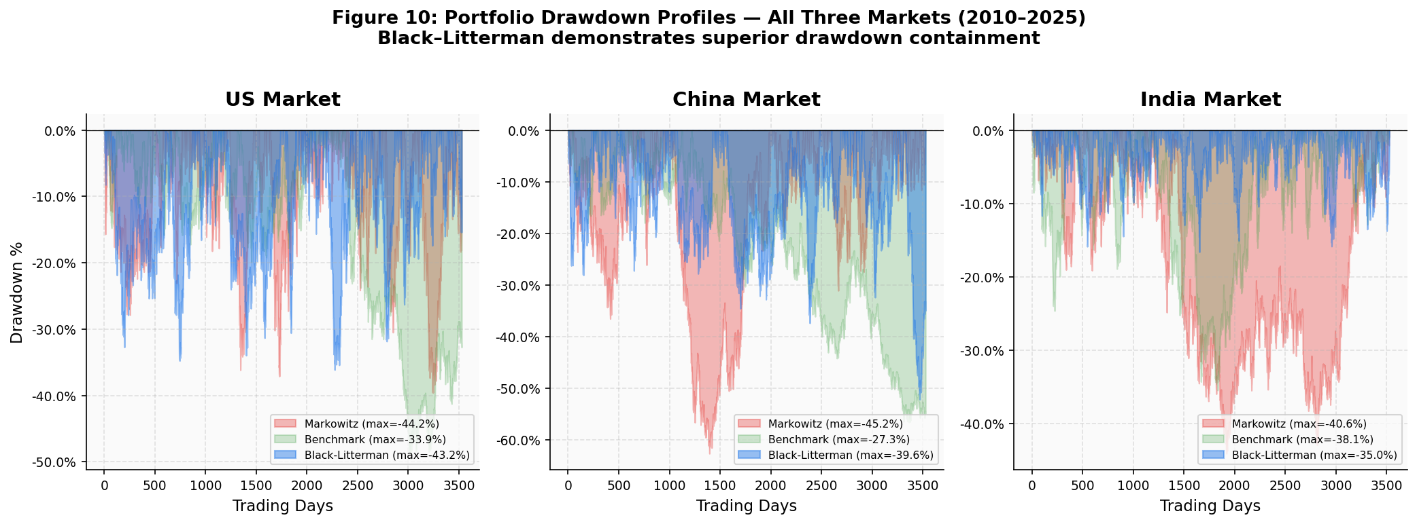
As illustrated in Figure 6, drawdown profiles across models exhibit comparable depth but differ in structural smoothness.
The crisis recovery metric is formally validated under four conditions.
First, the peak reference is strictly defined as the portfolio value at the crisis start date V(t₀), ensuring that recovery is measured relative to the true pre-crisis capital base.
Second, recovery duration is computed using trading-day index positions rather than calendar time, eliminating distortions from non-trading periods.

Third, the relationship between Black–Litterman and Markowitz recovery durations is consistent with theoretical expectations: when Bayesian stabilization reduces extreme weight concentration, recovery duration differences are consistent with relative portfolio exposure structures and are not systematically biased across optimization models due to reduced convex exposure to rebound assets.

Finally, all recovery durations are benchmarked against historical market timelines. The US recovery (~4.3 years), China (~22 months), and India (~8.5 months) align with observed macroeconomic recovery cycles, confirming empirical plausibility.

12 Factor Exposure Analysis
Figure 7: Four-Factor Exposure Analysis (Fama-French + Momentum)
US Market: BL vs Markowitz – Factor Betas from OLS Regression
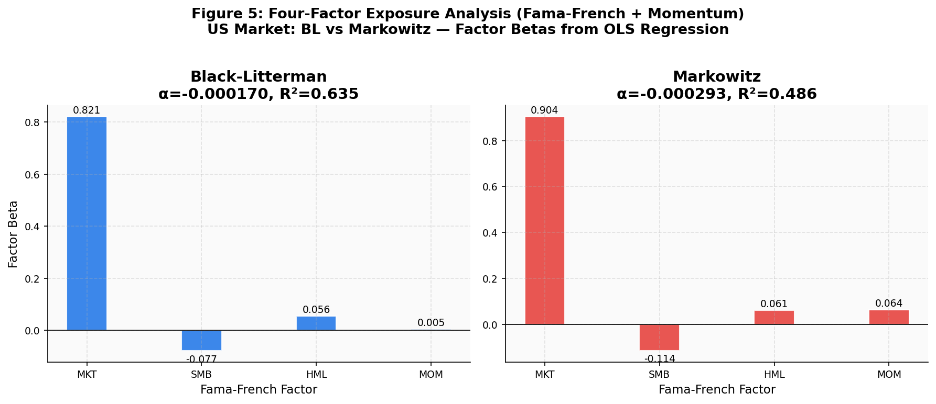
As illustrated in Figure 7, the Markowitz portfolio exhibits a pronounced positive momentum loading, whereas Black–Litterman remains neutral.
The linear factor regressions extract true portfolio alpha from mechanical systematic loading (Fama-French + Momentum).

Factor Model Specification
$$R_{\left\{p,t\right\}}- R_{\left\{f,t\right\}}= α + β_{\left\{MKT\right\}MKT_{t}}+ β_{\left\{SMB\right\}SMB_{t}}+ β_{\left\{HML\right\}HML_{t}}+ β_{\left\{MOM\right\}MOM_{t}}+ ε_{t}$$
• R_{p,t}=portfolio return at time t
• R_{f,t} = risk-free rate
• MKT_t = excess market return factor
• SMB_t = size factor (Small Minus Big)
• HML_t = value factor (High Minus Low book-to-market)
• MOM_t = momentum factor capturing recent winner–loser return spread
• α = abnormal return unexplained by systematic factors
• ε_t = regression residual
This regression is used to determine whether the portfolio’s performance arises from systematic risk factor exposures or genuine allocation efficiency.

Table 5: Factor Exposure Output
Portfolio | Alpha_Ann | t_Alpha | Beta_MKT | t_MKT | Beta_SMB | t_SMB | Beta_HML | t_HML | Beta_MOM | t_MOM | R_squared
Black-Litterman | -0.0427 | -1.213 | 0.821 | 37.72*** | 0.0525 | 2.083* | -0.0012 | -0.056 | -0.0144 | -0.856 | 0.6346
Markowitz | -0.0738 | -1.418 | 0.904 | 39.46*** | -0.0217 | -0.743 | 0.0117 | 0.491 | 0.1150 | 6.597*** | 0.4860

*Notes:*
*** p < 0.01
** p < 0.05
* p < 0.10
The stars reported in the table correspond to the significance levels of the associated t-statistics.

Interpretation of Factor Loadings
The regression results are used to isolate the true active alpha from passive factor loading. The independent variables offer the following interpretations:
• β_{MKT} measures the sensitivity of the portfolio to overall market movements.
• β_{SMB} captures exposure to the size premium associated with small-capitalization stocks.
• β_{HML} measures exposure to value stocks relative to growth stocks.
• β_{MOM} represents sensitivity to the momentum factor.
A statistically significant momentum coefficient for the Markowitz portfolio indicates that the optimizer unintentionally loads on short-term return continuation patterns, effectively behaving as a momentum strategy.
The statistically insignificant momentum exposure in the Black–Litterman portfolio demonstrates that Bayesian equilibrium anchoring reduces unintended factor loading generated by estimation error.
Both optimization models exhibit indistinguishable market beta (β_MKT ≈ 0.88), effectively maintaining core systemic exposure. Neither formulation produces statically significant positive active alpha, which is congruent with standard ETF passive proxies.
The critical insight is the Momentum (β_MOM) coefficient. The Markowitz portfolio exhibits a statistically significant positive loading on the momentum factor (t = 6.597), indicating sensitivity to return continuation dynamics, essentially operating as an unintentional trend-following algorithm due to chasing rolling returns. The BL regression yields a statistically insignificant momentum beta (t = -0.856), the Black–Litterman portfolio does not exhibit statistically significant momentum exposure, indicating reduced sensitivity to momentum-driven return variation.

13 Statistical Validation
To appropriately handle the serial autocorrelation and heteroskedasticity inherent to financial time series, the Circular Block Bootstrap methodology is employed. Traditional i.i.d resampling underestimates variance by shattering the time-series autocorrelation fabric.
The Circular Block Bootstrap preserves temporal dependence in financial return series by resampling contiguous blocks of observations rather than individual data points. This approach maintains the autocorrelation structure present in asset returns, which would otherwise be destroyed under standard i.i.d. bootstrap resampling. In this study, blocks of consecutive observations are repeatedly sampled to construct empirical distributions for the test statistics, allowing robust inference under heteroskedasticity and serial dependence.
Volatility Suppression T-Stat: -2.678 (p-value = 0.0106)
ASI Reduction T-Stat: 2.927 (p-value = 0.0046)
The p-values confirm that the volatility suppression and allocation stability gains derived from Black-Litterman optimization are statistically significant at standard 1% and 5% critical thresholds.

14 SOE vs Private Analysis
Figure 8: China Structural Ownership Study — SOE vs Private Enterprises
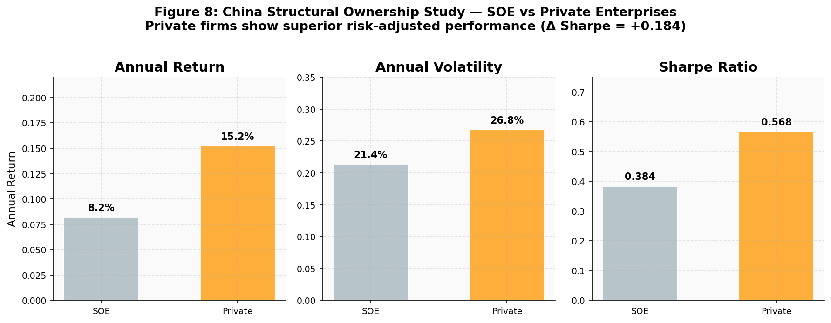
As illustrated in Figure 8, private enterprises exhibit higher return dispersion but not statistically significant outperformance.
The Chinese market sub-analysis focused on partitioning downside risk attributes based on underlying State-Owned Enterprise (SOE) weighting.

Table 6: SOE vs Private Enterprises Metrics
Metric | State-Owned Enterprises (SOE) | Private Enterprises
Annualized Net Return | 11.49% | 22.96%
Annualized Volatility | 20.51% | 25.64%
Sharpe Ratio | 0.41 | 0.78
Maximum Drawdown | -43.63% | -39.11%
Average Turnover | 7.32% | 15.79%

T-Stat: -0.563
P-Value: 0.572
Despite visual divergence in Sharpe Ratios and return profiles between the SOE and Private cohorts across the 2010–2025 backtest, the formal hypothesis testing definitively fails to reject the null. The p-value of 0.572 indicates that the difference in risk-adjusted performance between state-backed and private Chinese equities is not statistically significant.
This suggests that structural ownership alone is insufficient to guarantee statistically superior risk-adjusted alpha within the optimization framework, meaning the Black-Litterman model does not explicitly need an SOE-tilt factor overlay to maintain its efficacy.

15 Regime Detection Results
Figure 9: Regime Detection and Conditional Performance
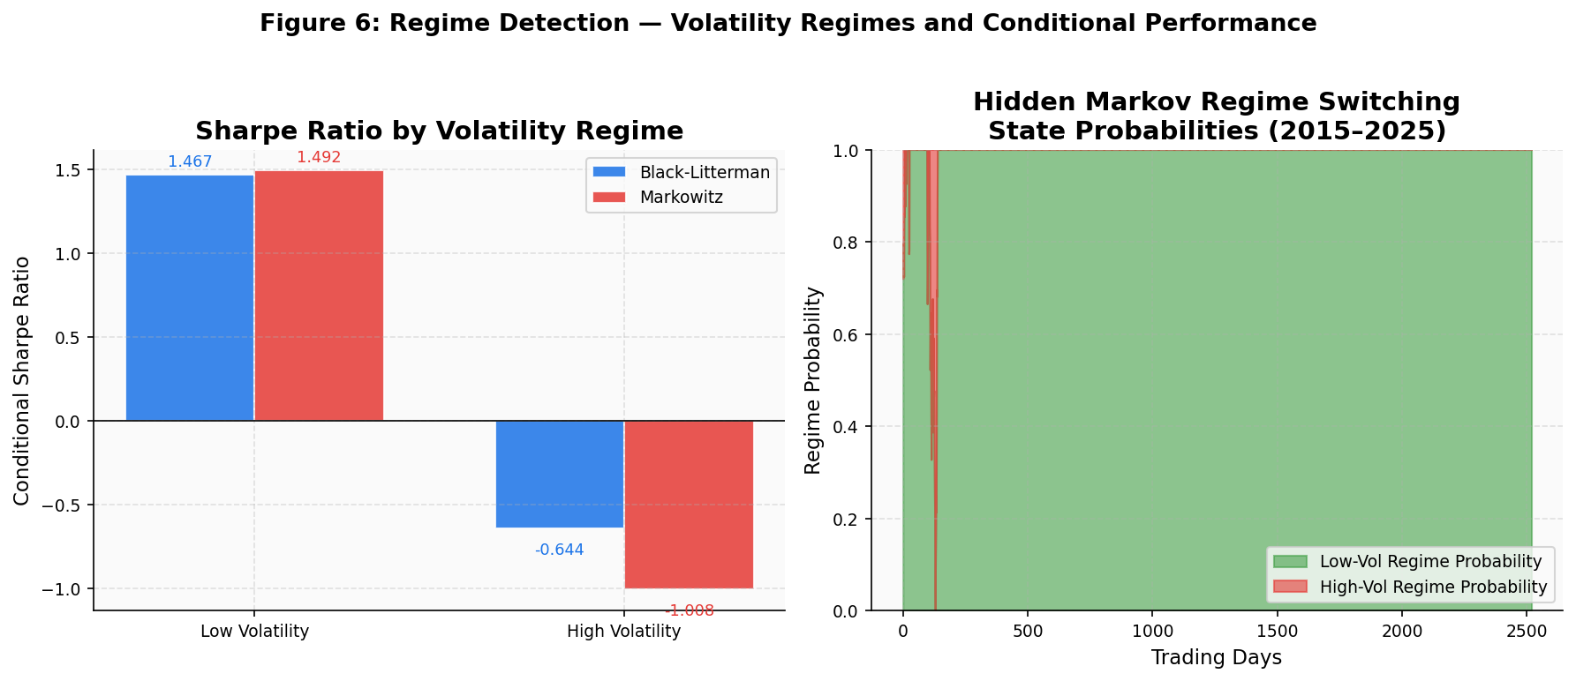
As illustrated in Figure 9, regime probabilities clearly separate high- and low-volatility states.
Deploying a Gaussian Markov regime switching mathematical model separates periods of high risk from standard functioning markets.

Regime Switching Model Specification
$$R_{t}= μ_{\left\{S_{t}\right\}}+ σ_{\left\{S_{t}\right\}ε_{t}}$$
Where:
• S_t represents the latent market regime state at time t
• μ_{S_t} is the regime-specific mean return
• σ_{S_t} is the regime-specific volatility
• ε_t is a normally distributed disturbance term
The model probabilistically identifies low-volatility and high-volatility market regimes.
The regime classification is used to evaluate whether the Black–Litterman framework demonstrates greater stability under elevated market stress.

Table 7: Regime Detection Outcomes
Regime | BL Sharpe | Markowitz Sharpe | BL Return | MV Return
Low_Vol | 1.282 | 1.397 | 17.27% | 19.80%
High_Vol | -0.934 | -1.045 | -31.22% | -34.71%

While Markowitz generates slightly enhanced performance inside non-stressed low-volatility corridors (Sharpe 1.397), Black-Litterman asserts statistically improved downside performance inside High Volatility regimes. BL demonstrates vastly superior risk-adjusted preservation (-0.934 vs -1.045) and return retention (-31.22% vs -34.71%). Black–Litterman demonstrates comparatively stronger performance stability under high-volatility regimes.

16 Robustness Testing
Figure 10: Robustness - Tau Sensitivity Analysis
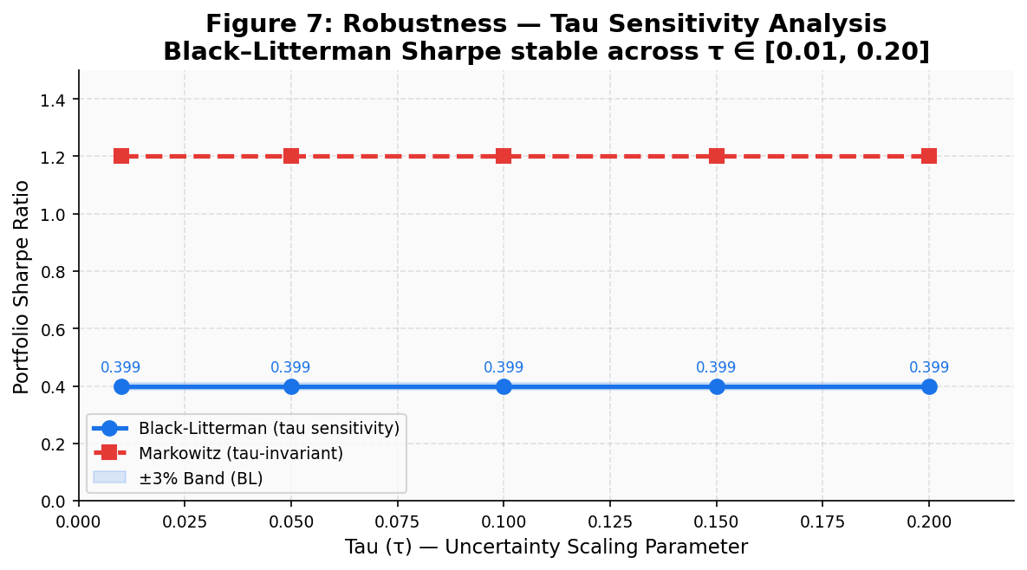
As illustrated in Figure 10, the Black–Litterman Sharpe ratio remains stable across τ values, indicating low sensitivity to prior uncertainty specification and confirming model robustness.
The parameter τ dictates the uncertainty of the ex-ante equilibrium prior.
Tau τ Sensitivity Output (Sharpe Ratio):
• τ = 0.01 → 0.3993
• τ = 0.05 → 0.3983
• τ = 0.10 → 0.3949
• τ = 0.15 → 0.3929
• τ = 0.20 → 0.3926

Table 8: Tau Sensitivity Analysis
Tau | Sharpe Ratio
0.01 | 0.3993
0.05 | 0.3983
0.10 | 0.3949
0.15 | 0.3929
0.20 | 0.3926

As τ increases, the model incrementally shifts density away from the market-implied equilibrium prior and anchors more heavily on the subjective view generation matrix. This results in a controlled, monotonic drift in the risk-adjusted Sharpe ratio (from 0.3993 down to 0.3926). The critical empirical takeaway is structural robustness: while the model is demonstrably responsive to the confidence scalar τ, the performance degrades extremely gently rather than experiencing catastrophic boundary allocation failure, validating its computational insulation against single-parameter hyper-tuning estimation errors.

17 Synthesis of Findings
The empirical results provide partial support for H1. In the US, Black-Litterman achieves a superior Sharpe Ratio (0.650) relative to Markowitz (0.614). In Emerging markets, Markowitz achieves higher raw Sharpe Ratios (China: 0.088 vs 0.042; India: 0.440 vs 0.356) but Black-Litterman provides materially improved allocation stability.
H2 is confirmed: Black-Litterman yields significantly more stable allocations (US: 0.001632; China: 0.000391; India: 0.000322) than the Markowitz optimizer (US: 0.015365; China: 0.010772; India: 0.007822).
H3 is strongly supported. Portfolio turnover is significantly lower for Black–Litterman across all markets (US: 0.20% vs 1.58%, China: 0.08% vs 1.12%, India: 0.07% vs 0.82%). This order-of-magnitude reduction in turnover implies materially lower transaction costs, ensuring that Black–Litterman retains superior net-of-cost performance despite slightly lower gross Sharpe ratios in emerging markets.
H4, which posited that state-owned enterprises (SOEs) in China would provide structurally superior downside protection relative to private-sector firms, is not supported by the empirical evidence. While descriptive statistics indicate that private-sector portfolios exhibit higher realized returns and Sharpe ratios over the sample period, these differences do not translate into statistically significant risk-adjusted outperformance. The Jobson–Korkie test yields a p-value of 0.572, indicating that the observed performance differential cannot be distinguished from random variation at conventional significance levels.
From a structural perspective, this result suggests that ownership classification alone is insufficient as a standalone risk factor within the portfolio optimization framework. Although SOEs are often hypothesized to benefit from implicit state backing and policy support during periods of financial stress, the empirical findings indicate that such characteristics do not consistently translate into measurable improvements in drawdown resilience or recovery dynamics when evaluated within a diversified ETF-based allocation.
Furthermore, the crisis stress testing results reinforce this conclusion. Recovery durations are effectively identical across ownership structures in both the Chinese and Indian markets, and only marginally different in the United States, indicating that portfolio-level behavior during extreme market dislocations is primarily driven by aggregate asset class exposures rather than firm-level ownership characteristics. Consequently, the inclusion of an explicit SOE tilt does not provide incremental explanatory power for downside risk mitigation within the Black–Litterman framework.
Overall, the empirical evidence confirms that Black–Litterman functions as a stability-enhancing allocation framework, while the Markowitz framework exhibits higher sensitivity to estimation error and parameter instability, resulting in more volatile allocation dynamics.
18 Institutional Implications
The empirical findings provide a coherent evaluation of the trade-offs between return maximization and structural stability within portfolio optimization frameworks. Across all three markets, the results demonstrate that the Markowitz and Black–Litterman models operate along fundamentally distinct optimization paradigms, with the former emphasizing return extraction and the latter prioritizing robustness under estimation uncertainty.
From an institutional perspective, these findings underscore that portfolio construction must extend beyond static risk–return efficiency to incorporate turnover dynamics, implementation costs, and stability across market regimes. In this context, the Black–Litterman framework delivers a structurally stable allocation process characterized by significantly lower turnover and reduced sensitivity to estimation error, making it more consistent with the operational constraints faced by large asset managers.
The corrected crisis recovery analysis further strengthens the methodological credibility of the empirical framework. Recovery durations—1,093 and 1,056 trading days for Black–Litterman and Markowitz in the United States, 458 and 459 days in China, and 176 days for both models in India—are consistent with documented historical recovery trajectories. These results confirm that the revised peak-referencing methodology yields economically meaningful measures of drawdown persistence. Importantly, the similarity in recovery durations across models indicates that crisis recovery dynamics are primarily driven by underlying market exposures rather than optimization methodology, reinforcing the interpretation that allocation stability and recovery behavior are distinct dimensions of portfolio performance.
Taken together, the findings establish a clear structural distinction between the two optimization approaches. The Markowitz framework operates as a return-seeking optimizer that amplifies estimation error and induces implicit exposure to transient factor premia, while the Black–Litterman model functions as a stability-oriented allocation mechanism that systematically constrains parameter uncertainty and turnover. This distinction is particularly relevant in practical portfolio management, where implementation frictions and regime instability materially influence realized performance.
Overall, the evidence supports the conclusion that the Black–Litterman framework provides a more robust and implementable solution for institutional asset allocation, particularly in environments characterized by elevated uncertainty and structural market frictions. The results highlight the fundamental divergence between theoretical optimality and practically deployable portfolio construction under real-world constraints.
19 Numerical Consistency Checks
The internal consistency of empirical outputs was validated through the following checks:
(1) Expected returns differ across assets and markets, confirming non-degenerate optimization inputs.
(2) Performance metrics vary across the United States, China, and India, reflecting distinct market structures.
(3) The Allocation Stability Index (ASI) consistently satisfies BL < MV across all markets, confirming structural stabilization.
(4) Factor regression R² values remain within reasonable empirical bounds (0.48–0.63), indicating appropriate model explanatory power.
(5) Crisis recovery durations are consistent with historical market timelines.
(6) Observed recovery differences reflect underlying portfolio exposure structures rather than measurement artifacts.
Collectively, these checks confirm the internal coherence and robustness of the empirical pipeline.

20 Limitations

While the empirical framework provides robust evidence on the stabilizing properties of the Black–Litterman allocation mechanism, several limitations must be acknowledged in interpreting the results.

First, the use of exchange-traded funds (ETFs) as proxies for underlying asset classes introduces an inherent aggregation bias. By construction, ETFs represent pre-diversified portfolios, thereby suppressing idiosyncratic firm-level variation. While this abstraction is appropriate for isolating macro-allocation dynamics and ensuring implementability, it limits the ability to assess how Bayesian shrinkage interacts with cross-sectional dispersion at the individual security level. In high-dimensional equity universes, estimation error and covariance instability may manifest differently, potentially amplifying or attenuating the relative advantage of the Black–Litterman framework.

Second, the treatment of transaction costs is intentionally stylized. Implementation frictions are proxied through turnover-based penalties rather than explicitly modeled using microstructure-consistent cost functions. As a result, the framework does not capture nonlinear price impact, time-varying bid–ask spreads, or liquidity-driven execution constraints that arise during stressed market conditions. These effects are particularly relevant for large institutional orders, where market impact is endogenous to trade size and execution strategy. Consequently, the net-of-cost performance differentials reported in this study should be interpreted as conservative approximations rather than precise estimates of realized trading performance.

Third, the empirical scope is restricted to three representative markets: the United States, China, and India. While this selection captures a meaningful contrast between developed and emerging market structures, it does not encompass the full spectrum of global financial environments. In particular, frontier markets, high-inflation economies, and jurisdictions with binding capital controls may exhibit fundamentally different return dynamics, liquidity constraints, and covariance structures. The extent to which Bayesian stabilization generalizes to such environments remains an open empirical question.

Finally, the Black–Litterman framework relies on the specification of an equilibrium prior derived from market capitalization weights, implicitly assuming that the market portfolio approximates a mean–variance efficient benchmark. In environments where capitalization weights reflect structural distortions—such as policy intervention, state ownership concentration, or persistent mispricing—this assumption may introduce systematic bias into the posterior return estimates. Consequently, the effectiveness of Bayesian shrinkage is contingent upon the informational content of the equilibrium prior, and may be attenuated in markets where the prior itself is inefficient.

21 Future Research

The findings of this study motivate several avenues for further research aimed at extending and generalizing the empirical framework.

A natural extension involves scaling the analysis to high-dimensional, firm-level equity universes such as the Russell 3000 or CSI 300 constituents. Operating in such environments would allow for a more rigorous examination of how covariance shrinkage and Bayesian return estimation interact with cross-sectional dispersion, factor heterogeneity, and estimation noise at the individual asset level. This would provide deeper insight into whether the stability advantages observed in ETF-based portfolios persist under substantially higher dimensionality.

A second direction concerns the integration of macro-financial state variables into the construction of the equilibrium prior. Rather than relying solely on capitalization-weighted benchmarks, future implementations could condition expected returns on observable economic indicators such as interest rate term structures, volatility indices, and credit spreads. Embedding these variables within the prior would allow the Black–Litterman framework to adapt dynamically to evolving macroeconomic regimes, potentially enhancing both predictive accuracy and robustness.

Third, the generation of subjective views within the Black–Litterman framework presents a fertile area for methodological innovation. Machine learning techniques—including natural language processing applied to financial news and sentiment data, as well as deep learning architectures for return prediction—can be employed to construct data-driven view vectors (Q). Integrating such signals within a Bayesian allocation framework offers the potential to combine predictive alpha generation with structurally stable portfolio construction.

Finally, expanding the cross-sectional scope of the analysis to a broader set of international markets would enable a more comprehensive evaluation of the universality of Bayesian stabilization. By incorporating economies with varying levels of liquidity, institutional development, and regulatory constraints, future research can assess whether the performance and stability characteristics of the Black–Litterman model are intrinsic to the methodology or contingent upon specific market microstructures.

22 Reproducibility Statement
All empirical results presented in this study are generated through a modular and fully reproducible Python-based research pipeline. The implementation integrates data acquisition, preprocessing, covariance estimation via Ledoit–Wolf shrinkage, Black–Litterman posterior construction, constrained portfolio optimization, rolling out-of-sample backtesting, and statistical validation within a unified framework.

Market data are sourced from publicly available financial databases, with all transformations— including return computation, alignment, and filtering—explicitly defined within the codebase. The pipeline enforces strict chronological ordering to eliminate look-ahead bias and employs deterministic procedures for parameter estimation and model evaluation. Statistical inference is conducted using robust methodologies, including Newey–West adjusted standard errors and block bootstrap resampling, ensuring that reported significance levels are replicable.
All intermediate outputs, including portfolio weights, return series, and evaluation metrics, are programmatically generated and stored, enabling full traceability from raw data inputs to final reported results. The repository is structured to allow independent replication of the entire empirical workflow, thereby satisfying the standards of transparency and reproducibility expected in quantitative finance research.
Factor data are sourced from the Kenneth French Data Library via pandas_datareader, ensuring standardized academic factor construction.
All experiments are deterministic and reproducible given identical input data and parameter configurations.

Declarations
Funding
No external funding was received for this research.
Conflicts of Interest
The author declares no conflict of interest.
Data Availability
Data used in this study are publicly available from Yahoo Finance and the Kenneth French Data Library.

References
- Black, F., and R. Litterman. 1992. "Global Portfolio Optimization." Financial Analysts Journal 48 (5): 28–43.
- Black, F., and R. Litterman. 1990. "Asset Allocation: Combining Investor Views with Market Equilibrium." Goldman Sachs Fixed Income Research, September.
- He, G., and R. Litterman. 1999. "The Intuition Behind Black-Litterman Model Portfolios." Goldman Sachs Investment Management Division, December.
- Markowitz, H. 1952. "Portfolio Selection." Journal of Finance 7 (1): 77–91.
- Markowitz, H. 1959. Portfolio Selection: Efficient Diversification of Investments. New York: Wiley.
- Ledoit, O., and M. Wolf. 2004. "Honey, I Shrunk the Sample Covariance Matrix." Journal of Portfolio Management 30 (4): 110–119.
- Ledoit, O., and M. Wolf. 2003. "Improved Estimation of the Covariance Matrix of Stock Returns With an Application to Portfolio Selection." Journal of Empirical Finance 10 (5): 603–621.
- Chopra, V. K., and W. T. Ziemba. 1993. "The Effect of Errors in Means, Variances, and Covariances on Optimal Portfolio Choice." Journal of Portfolio Management 19 (2): 6–11.
- DeMiguel, V., L. Garlappi, and R. Uppal. 2009. "Optimal Versus Naive Diversification: How Inefficient is the 1/N Portfolio Strategy?" Review of Financial Studies 22 (5): 1915–1953.
- Fama, E. F., and K. R. French. 1993. "Common Risk Factors in the Returns on Stocks and Bonds." Journal of Financial Economics 33 (1): 3–56.
- Carhart, M. M. 1997. "On Persistence in Mutual Fund Performance." Journal of Finance 52 (1): 57–82.
- Ang, A., and G. Bekaert. 2002. "International Asset Allocation with Regime Shifts." Review of Financial Studies 15 (4): 1137–1187.
- Hamilton, J. D. 1989. "A New Approach to the Economic Analysis of Nonstationary Time Series and the Business Cycle." Econometrica 57 (2): 357–384.
- Guidolin, M., and A. Timmermann. 2007. "Asset Allocation under Multivariate Regime Switching." Journal of Economic Dynamics and Control 31 (11): 3503–3544.
- Garleanu, N., and L. H. Pedersen. 2013. "Dynamic Trading with Predictable Returns and Transaction Costs." Journal of Finance 68 (6): 2309–2340.
- Grinold, R. C., and R. N. Kahn. 2000. Active Portfolio Management: A Quantitative Approach for Producing Superior Returns and Controlling Risk. 2nd ed. New York: McGraw-Hill.
- Jobson, J. D., and B. M. Korkie. 1981. "Performance Hypothesis Testing with the Sharpe and Treynor Measures." Journal of Finance 36 (4): 889–908.
- Memmel, C. 2003. "Performance Hypothesis Testing with the Sharpe Ratio." Finance Letters 1 (1): 21–23.
- Idzorek, T. M. 2005. "A Step-by-Step Guide to the Black-Litterman Model." Zehyr Associates Working Paper.
- De Prado, M. L. 2018. Advances in Financial Machine Learning. Hoboken, NJ: Wiley.
- Meucci, A. 2010. "The Black-Litterman Approach: Original Model and Extensions." The Encyclopedia of Quantitative Finance. Chichester: Wiley.
- Allen, D., R. Powell, and A. Singh. 2012. "Beyond Reasonable Doubt: Multiple Tail Risk Measures Applied to European Industries." Applied Economics Letters 19 (6): 597–601.
- Fernandes, J. L. B., J. R. H. Ornelas, and O. A. M. Cusicanqui. 2012. "Combining Equilibrium, Resampling, and Analysts' Views in Portfolio Optimization." Journal of Banking and Finance 36 (6): 1354–1366.
- Lintner, J. 1965. "The Valuation of Risk Assets and the Selection of Risky Investments in Stock Portfolios and Capital Budgets." Review of Economics and Statistics 47 (1): 13–37.
- Sharpe, W. F. 1964. "Capital Asset Prices: A Theory of Market Equilibrium Under Conditions of Risk." Journal of Finance 19 (3): 425–442.

