Black–Litterman vs. Markowitz:
Stability, Turnover, and Crisis Dynamics
Across Global Markets
Amit Kumar Dudi
Department of Computer Science and Engineering
SRM Institute of Science and Technology
India
(Proposed affiliation; author confirmation pending.)
amitkumardudi04@gmail.com
First version: March 2026
Revised version: 31 October 2026
Final revision candidate
NOT APPROVED FOR SSRN UPLOAD

Abstract
This study compares Black-Litterman (BL) and historical-mean Markowitz allocation in small US-listed ETF baskets providing exposure to the United States, China and India. The revised experiment uses 252-session rolling estimation windows, Ledoit-Wolf covariance shrinkage, long-only fully invested portfolios, rebalancing every 63 sessions and self-financing buy-and-hold accounting between trades. BL uses an explicitly equal-weight equilibrium proxy and a mild historically derived view tilt. Periodically rebalanced equal-weight allocation provides a direct benchmark for this anchoring choice. Additional comparisons impose matched 40% maximum target weights and evaluate proportional trading costs of 0, 5, 10 and 20 basis points per unit of drift-adjusted L1 turnover. At 10 basis points, BL has substantially lower target instability and turnover than unrestricted Markowitz, but its returns and Sharpe ratios are nearly those of rebalanced 1/N. Risk-adjusted rankings between BL and Markowitz vary across markets. Matched concentration limits substantially reduce Markowitz concentration and instability; US and China Sharpe ratios improve, whereas India's declines. No statistically significant Sharpe-ratio differences were established under the specified paired bootstrap procedure. Cost rankings depend on whether performance is measured by arithmetic annualized return or compounded terminal wealth. Separate historical crisis tests are event-specific, and US factor and fixed-tau diagnostics retain their separate source provenance. The contribution is a transparent comparison of stabilization, concentration and implementation trade-offs across the three ETF baskets; the evidence does not establish universal BL superiority, incremental value over 1/N or causal benefits of Bayesian updating.
Keywords: Black–Litterman; mean–variance optimization; allocation stability; ETF portfolios; trading turnover; bootstrap inference.
AI assistance disclosure: OpenAI ChatGPT and Codex assisted research code and workflows, validation and statistical-output review, tables and figures, and manuscript drafting and editing. Human verification and policy clearance have not been attested. This candidate is NOT APPROVED FOR SSRN UPLOAD.

1 Introduction
The primary research objective of this study is to evaluate portfolio-weight instability in mean-variance optimization and assess the effectiveness of Black-Litterman equilibrium anchoring across distinct investment baskets. The Markowitz framework defines a clear risk-return allocation problem, but the inputs used by an investor are estimates rather than known population quantities. Optimizing against noisy expected returns can produce concentrated targets and substantial changes in allocation as an estimation window advances. The distinction between an optimal portfolio conditional on inputs and a reliably implemented investment rule motivates this comparison (Markowitz, 1952; Markowitz, 1959; Chopra and Ziemba, 1993).
Black-Litterman changes expected-return inputs by combining a prior return vector with views and their uncertainty (Black and Litterman, 1992; He and Litterman, 1999). In this application, the prior is reverse-engineered from an equal-weight allocation under a specified risk-aversion parameter. This is a transparent equilibrium proxy, not an observed capitalization-weighted market portfolio. The views are a small tilt toward rolling historical means, not independently elicited analyst forecasts. Lower instability is therefore partly a consequence of the chosen anchor and uncertainty scale. The empirical question is whether that stabilization is accompanied by investment performance that exceeds a simple, similarly implemented alternative.
Portfolio comparisons also depend on constraints and trading rules. A highly concentrated historical-mean optimizer is a demanding but incomplete benchmark for a strongly anchored allocation. We retain that unrestricted long-only comparison and add a predefined 40% target cap for both optimized strategies. Rebalanced 1/N separates the effect of maintaining diversified weights from any incremental value of the BL posterior. Both checks are motivated by the importance of constraints and estimation error in empirical portfolio evaluation (DeMiguel, Garlappi, and Uppal, 2009; Jagannathan and Ma, 2003).
Implementation friction matters because changes in target weights are not identical to trades. Between scheduled rebalances, asset returns change the weights of fixed holdings. The amount traded at the next rebalance depends on those drifted holdings as well as the new target. We therefore distinguish allocation stability, actual modeled L1 turnover, initial deployment and proportional trading costs. We also distinguish arithmetic annualized mean return from compounded terminal wealth. Neither low turnover nor a higher arithmetic mean alone establishes superior net investment growth.
The United States, China and India provide three distinct sets of equity exposures. All instruments are US-listed, USD-denominated ETFs. The study does not identify a causal effect of national market efficiency, ownership structure or local microstructure: the samples differ in length, ETFs overlap in holdings and all returns are measured from the same listing market. The cross-market contribution is an empirical comparison under common calculation rules, not an experiment that isolates institutional differences among countries.
The March 2026 version motivated the same stability and implementation questions but contained numerical and interpretive inconsistencies. This revision replaces its empirical record with separately verified results, adds 1/N and matched-constraint comparisons, specifies the accounting conventions and weakens claims not supported by the uncertainty estimates. The original version remains a historical record; its reported numbers are not presented as independently reproduced.

2 Literature review

2.1 Mean-variance estimation and covariance shrinkage
Mean-variance portfolio selection provides the mathematical foundation for the optimization problem studied here (Markowitz, 1952; Markowitz, 1959). The practical concern is sensitivity to estimated inputs. Chopra and Ziemba examine how errors in means, variances and covariances affect portfolio choice; this motivates assessing allocations and implementation behavior in addition to a portfolio's realized mean and volatility (Chopra and Ziemba, 1993). It does not imply that every historical-mean optimizer must underperform every stabilized alternative.
Covariance shrinkage is one response to estimation uncertainty (Ledoit and Wolf, 2003; Ledoit and Wolf, 2004a). The executable estimator in this study shrinks centered covariance estimates toward a scaled identity target, corresponding to the Ledoit-Wolf formulation described in their Journal of Multivariate Analysis article (Ledoit and Wolf, 2004b). Shrinkage is used identically for BL and Markowitz. Consequently, differences between the two strategies cannot be attributed to one model receiving covariance shrinkage while the other does not. The present ETF universes are small, so this application should not be treated as a direct test of large-dimensional asymptotic results.

2.2 Equilibrium anchoring and investor views
The equilibrium-return perspective in Black-Litterman is related to the role of market equilibrium in asset pricing (Sharpe, 1964; Lintner, 1965; Black and Litterman, 1992). Reverse optimization supplies a neutral expected-return starting point conditional on the specified covariance, reference weights and risk aversion. It does not establish that an arbitrary ETF proxy is the true market portfolio or that its implied expected returns are correctly calibrated.
He and Litterman explain how views alter an equilibrium-based allocation, while Idzorek discusses the treatment of view confidence (He and Litterman, 1999; Idzorek, 2004). Meucci provides a broader presentation of the original model and its extensions (Meucci, 2010). These contributions distinguish an allocation framework from the empirical validity of any particular prior or forecast. In this study, the equal-weight reference and historically constructed views are explicit modeling assumptions whose implications must be assessed against 1/N.
Fernandes, Ornelas and Cusicanqui combine equilibrium, resampling and analyst views in a portfolio methodology (Fernandes, Ornelas, and Cusicanqui, 2012). That work places this paper's concern with diversification and allocation stability in an established literature. The present revision does not implement their resampling-based portfolio-construction model. Nor does it claim to invent the L1 distance between allocations; the label Allocation Stability Index is used as a descriptive summary of that established distance.

2.3 Equal weighting constraints and costs
The out-of-sample comparison with 1/N is central to determining whether estimation-intensive procedures add investment value (DeMiguel, Garlappi, and Uppal, 2009). Constraints can also affect estimated portfolio risk and concentration (Jagannathan and Ma, 2003). These findings motivate two controls here: common rebalancing and accounting for 1/N, and identical upper bounds for BL and Markowitz. A comparison that changed the optimizer's constraints for only one strategy would conflate expected-return estimation with portfolio feasibility.
Turnover and implementation costs are established components of active portfolio management (Grinold and Kahn, 2000). Gârleanu and Pedersen model dynamic trading when returns are predictable and trading is costly (Gârleanu and Pedersen, 2013). Their optimization problem is not implemented here: our strategies optimize gross mean-variance utility and then apply a common proportional-cost accounting rule. The cost analysis is therefore sensitivity analysis of fixed trading decisions, rather than a claim to estimate an optimal execution policy or an institution's realized market impact.

2.4 Regimes factors and performance inference
Hamilton's regime-switching framework and subsequent asset-allocation applications show why changing return distributions deserve attention (Hamilton, 1989; Ang and Bekaert, 2002; Guidolin and Timmermann, 2007). Our main strategy instead uses a training-only volatility rule to select tau. A separately retained Markov analysis uses full-sample smoothed states for ex-post description. Those states are not inputs to the trading simulation, and no claim of real-time regime prediction follows from them.
The US diagnostic uses the Fama-French factors and a momentum factor in the spirit of four-factor performance analysis (Fama and French, 1993; Carhart, 1997). Inference uses HAC covariance estimates (Newey and West, 1987). The coefficients describe exposures conditional on this specification; they do not identify a causal investment mechanism or explain untested China and India portfolios.
Sharpe comparisons require uncertainty estimates. Classical tests include those of Jobson and Korkie and Memmel (Jobson and Korkie, 1981; Memmel, 2003). Ledoit and Wolf discuss robust performance inference and a studentized time-series bootstrap (Ledoit and Wolf, 2008). Our retained empirical procedure is a different, explicitly approximate paired circular-block bootstrap with percentile intervals and empirical-mean-centered p-values. It is not described as an implementation of their studentized method, and its finite-sample limitations remain part of the interpretation.

3 Research questions and contribution
The first question is whether equilibrium-anchored BL produces smaller changes in target allocations and lower drift-adjusted turnover than unrestricted historical-mean Markowitz. These are separate implementation outcomes: targets can remain constant while trades are required to offset price drift.
The second question is whether the resulting return, Sharpe and drawdown differences are economically meaningful and supported by statistical uncertainty. Rebalanced equal weighting provides a direct comparison for the chosen prior. The third question is whether a common concentration constraint reduces the apparent differences between the optimized strategies. The fourth concerns the effect of proportional costs on arithmetic net returns and compounded wealth. Finally, standalone crisis tests, US factor estimates and fixed-tau results describe selected risk and specification sensitivities without being recast as prospective trading evidence.
The contribution is an empirical cross-market assessment under traceable data, constraints and accounting conventions. It links target stability to actual modeled trading and compares optimization stabilization with a simple diversified rule. The evidence supports conclusions about this specified implementation. It does not constitute a new L1 stability measure, a proof of Bayesian superiority, a causal national-market comparison or an ownership-based downside-protection study. The earlier SOE/private empirical section is withdrawn from the revised results because its original stock-level inputs cannot be verified.

4 Dataset and investment assumptions
Table 1 identifies the ETF universes, currency, common price histories and out-of-sample coverage. The United States basket contains SPY, QQQ, IWM, XLF and XLK; China contains ASHR, KWEB, MCHI and FXI; India contains INDA, EPI, SMIN and INDY. These are exposures through US-listed instruments rather than direct local-currency national equity returns. Sector and broad-market ETFs overlap, so neither the number of tickers nor the market labels imply independent underlying holdings.
The revised study uses Yahoo Finance provider-adjusted closing prices obtained through yfinance with auto_adjust=False and an explicit Adj Close field. These series are provider proxies incorporating dividend and split adjustments; they are not a record of executable intraday prices or an independently reconstructed distribution-reinvestment strategy. No Refinitiv input is used in the verified revised experiment. Data are aligned on common observed dates within each basket, without forward or backward filling. Missing required tickers, ambiguous raw-close substitution, duplicate dates, invalid prices and nonfinite observations are not silently accepted.
The main request begins on 2010-01-01 and ends before 2025-01-01. Common price histories begin later for China and India because their ETF baskets have different observed availability. The OOS windows are 2011-01-04 to 2024-12-31 in the US, 2014-11-07 to 2024-12-31 in China, and 2013-02-13 to 2024-12-31 in India. The corresponding samples contain 3521; 2553; and 2991 return observations. No 2025 trading observations are included.

Table 1A. Dataset: instruments and common adjusted-price histories
Market | ETF universe | Currency | Common price start | Common price end | Prices N
US | SPY,QQQ,IWM,XLF,XLK | USD (US-listed ETFs) | 2010-01-04 | 2024-12-31 | 3774
China | ASHR,KWEB,MCHI,FXI | USD (US-listed ETFs) | 2013-11-06 | 2024-12-31 | 2806
India | INDA,EPI,SMIN,INDY | USD (US-listed ETFs) | 2012-02-09 | 2024-12-31 | 3244
Source: Phase 1 dataset provenance, carried into Phase 3 Table 1. Yahoo Finance Adj Close, USD-denominated US-listed ETFs; common observed dates within each basket. Prices are provider-adjusted dividend/split proxies. No missing-price filling.
Table 1B. Dataset: rolling OOS samples and benchmark definitions
Market | OOS start | OOS end | Returns N | Strategy benchmark | Passive ETF reference
US | 2011-01-04 | 2024-12-31 | 3521 | 1/N, same universe and 63-session schedule | S&P 500 ETF proxy (SPY adjusted-close total return; portfolio constituent)
China | 2014-11-07 | 2024-12-31 | 2553 | 1/N, same universe and 63-session schedule | CSI 300 ETF proxy (ASHR; also in the portfolio universe)
India | 2013-02-13 | 2024-12-31 | 2991 | 1/N, same universe and 63-session schedule | Broad India ETF proxy (INDA adjusted-close total return; portfolio constituent)
Source: Phase 3 Table 1. Passive references are portfolio constituents, not independent stand-alone broad-market replications. Later China/India starts reflect observed instrument availability plus the training window.

The common price sample is distinct from the rolling OOS sample, because the first estimation window does not earn simulated strategy returns. All three primary strategies within a market use identical OOS dates and the same initial deployment date. Cross-market terminal wealth must not be interpreted as performance over a common horizon. SPY, ASHR and INDA remain separately identified passive ETF references in the dataset record; the primary research benchmark introduced in this revision is rebalanced 1/N, not a relabeling of the original manuscript's generic benchmark row.
Frozen input snapshots and their retrieval metadata are retained locally with SHA-256 fingerprints. Phase 4 uses the committed Phase 3 tables and figures rather than obtaining a new market-data vintage. Exact input, source-run and output identities are described in Section 10. The separate crisis-history request permits a US 2008 stress test and is not silently added to the main 2010-requested rolling experiment.

5 Methodology

5.1 Returns and common mean-variance objective
For asset i and session t, the adjusted-price simple return is defined by Equation (1). Investment wealth is compounded from simple returns; log returns are not substituted into this accounting.
$r_{i,t}=\frac{P_{i,t}}{P_{i,t−1}}−1$ (1)
Both optimized strategies maximize the same annual-unit utility in Equation (2), subject to full investment, nonnegative weights and a common maximum target weight u. Risk aversion lambda is 3. The unrestricted long-only case uses u=1; the robustness scenario uses u=0.4. Markowitz estimates annual expected returns by multiplying the training-window mean daily simple return by 252. The common objective differs between strategies through expected returns, not a model-specific penalty or covariance estimator.
${\text{max}}_{w}\left(w^{T}μ−\frac{λ}{2}w^{T}Σw\right)\text{s.t.}1^{T}w=1,0≤w_{i}≤u$ (2)

5.2 Covariance estimation and units
Ledoit-Wolf covariance is estimated from centered daily training returns and annualized by 252. Equation (3) summarizes the shrinkage form: S is the centered daily empirical covariance, delta is the estimated shrinkage intensity, N is the number of assets and I is the identity matrix. The target scale is the average variance, not an independently estimated factor covariance.
$Σ=252\left(\left(1−δ\right)S+δ\frac{\text{tr(S)}}{N}I\right)$ (3)
Expected-return vectors and covariance matrices are therefore on compatible annual scales in utility, reverse optimization and posterior construction. Annualized realized volatility is a separate descriptive metric based on daily sample standard deviation. Covariance shrinkage addresses one component of estimation uncertainty; it does not ensure accurate expected returns or establish general out-of-sample superiority.

5.3 Equal-weight equilibrium proxy
Equation (4) defines the implied prior. The reference weights are equal across ETFs. They are not historical ETF AUM weights, observed capitalization weights or a reconstruction of the original paper's claimed market portfolio. The prior should be interpreted as the return vector that rationalizes the chosen proxy under the assumed covariance and lambda.
$Π=λΣw_{eq},w_{eq}=\frac{1}{N}$ (4)
This distinction is economically important. The experiment evaluates a deliberately diversified anchor, not an empirical test of whether market capitalization contains superior equilibrium information. The mathematical framework can accommodate other priors, but the missing original dated capitalization inputs are not replaced by fabricated historical observations.

5.4 Views posterior and tau rule
Absolute views use an identity pick matrix and a mild historical-return tilt, as summarized in Equation (5). The blend b equals 0.10. Omega is diagonal with entries equal to ten times the corresponding annualized variances, with a 10⁻¹² numerical floor in the executable construction. Its dependence on annualized variance, and independence from tau, are retained from the verified specification.
$P=I,Q=Π+0.10\left(μ_{hist}−Π\right),Ω_{ii}=\text{max}\left(10Σ_{ii},{10}^{−12}\right)$ (5)
The posterior mean follows the Gaussian conditioning expression in Equation (6), equivalent to the familiar precision representation on nonsingular inputs. The implementation solves the conditioning system rather than taking explicit matrix inverses. P maps asset returns into view portfolios; Q is the view-return vector; Omega expresses view uncertainty; tau scales prior uncertainty. These are model inputs, not observed evidence of investor foresight.
$μ_{BL}=Π+τΣP^{T}{\left(Ω+PτΣP^{T}\right)}^{−1}\left(Q−PΠ\right)$ (6)
Within each 252-session training window, a 60-session rolling standard deviation is computed for each asset. The latest cross-asset average volatility is compared with the median of the cross-asset averages available inside that same training window. Tau is 0.01 when the latest value exceeds that median and 0.05 otherwise. Only prior observations enter the decision. A smaller tau gives less weight to the historical tilt relative to the prior in this construction. The rule was not selected in Phase 4 to improve performance.
The small blend and comparatively large view uncertainty produce strong anchoring. This is a substantive reason to compare the strategy with 1/N rather than attributing every low-turnover outcome to an independently informative Bayesian forecast. The main tau rule is not the ex-post Markov classifier, and fixed-tau diagnostics in Section 6.8 are separate runs rather than observations of a single adaptive strategy.

5.5 Rolling portfolio accounting
Each decision uses 252 completed sessions and applies the resulting weights to the next holding interval of up to 63 sessions. Training excludes the current holding-period return. The final interval may contain fewer than 63 observations. Long-only portfolios remain fully invested in the ETF basket after modeled fees; there is no interim rebalancing between scheduled decisions.
Let h_t denote weights entering session t after any scheduled trade. Equation (7) gives the gross portfolio return and the subsequent drift of fixed holdings. New targets replace those drifted weights only on a rebalance date.
$r_{p,t}={h_{t}}^{T}r_{t},{h_{i,t+1}}^{−}=\frac{h_{i,t}\left(1+r_{i,t}\right)}{1+r_{p,t}}$ (7)
At rebalance k, the L1 traded-weight convention is the sum of absolute differences between the new target and drifted pretrade weights. Initial deployment from cash has L1 purchased weight 1, reported separately from subsequent rebalance averages.
$T_{k}={\left\|w_{k}−{h_{k}}^{−}\right\|}_{1},T_{initial}=1$ (8)
For a cost rate c per unit of L1 turnover, the wealth fraction removed is cTₖ on a trade date and zero otherwise. Equation (9) applies the fraction before the first holding-period asset return. Costs are not subtracted twice and are not estimated from successive target vectors without considering drift.
$1+{r_{p,t}}^{\text{net}}=\left(1+r_{p,t}\right)\left(1−cT_{k}\right)\text{on trade dates}$ (9)
This is a proportional weight-turnover cost convention. It differs from half-L1 turnover or one-way-notional conventions, and it does not solve an implicit brokerage-dollar fee-funding equation. The implemented trading targets are obtained from gross utility, not from a transaction-cost-aware optimization objective. These qualifications define the experiment rather than alleging that modeled costs equal actual commissions, spreads or market impact.

5.6 Allocation stability and realized performance
Equation (10) defines mean target-weight ASI across K rebalance decisions. The first undefined target difference is excluded. ASI is an established L1 allocation distance used descriptively here, not a proprietary mathematical innovation or an independently tested significance statistic.
$\text{ASI}=\frac{1}{K−1}\sum_{k=2}^{K}{{\left\|w_{k}−w_{k−1}\right\|}_{1}}$ (10)
Equation (11) reports the arithmetic annualized mean, annualized sample volatility and zero-risk-free-rate Sharpe. The overbar on r denotes the daily net sample mean and s_r its sample standard deviation. A zero risk-free rate is the main performance convention; it differs from the actual RF subtraction used in the US factor regression.
$μ_{ann}=252r̄,σ_{ann}=\sqrt{252}s_{r},\text{SR}=\frac{μ_{ann}}{σ_{ann}}\text{(RF = 0)}$ (11)
Equation (12) defines compounded net wealth and maximum drawdown from initial NAV 1, including a loss on the first OOS observation. The arithmetic annual mean is not a compounded growth rate. A positive arithmetic annualized mean can coexist with terminal wealth below 1. Direct modeled fee expenditure is the sum of pretrade net NAV times the relevant fee fraction, in units of initial NAV; it is not the gross-minus-net terminal wealth difference, which also includes investment growth forgone.
$W_{0}=1,W_{t}=W_{t−1}\left(1+{r_{p,t}}^{\text{net}}\right),\text{MDD}={\text{min}}_{t}\left(\frac{W_{t}}{{\text{max}}_{\text{0≤s≤t}}W_{s}}−1\right)$ (12)

5.7 Equal weighting and matched concentration
The 1/N portfolio is deployed at the identical initial date and reset to equal weights at the identical 63-session rebalance schedule. Its holdings drift between trades under Equation (7), and it pays the same modeled initial and subsequent costs. Its target ASI is zero, but its actual traded turnover need not be zero. It is therefore a periodic allocation rule, not a permanently static vector applied to every day's return.
The 40% target cap is predefined, not searched for using realized performance. Feasibility follows from N times the maximum weight being at least 1 for all baskets. The additional comparison applies the same bound to BL and Markowitz, while retaining their common covariance, risk aversion, windows, return data and accounting. The constraint governs targets at trades; weights can drift above 40% afterward. Concentration is summarized by maximum target weight and mean target HHI, the sum of squared weights. End-of-day concentration is separately identified in the source evidence.

5.8 Transaction-cost sensitivity
The cost scenarios are 0, 5, 10 and 20 basis points per unit of the existing L1 convention. For fixed targets and holding intervals, cost rates do not affect gross asset returns, the optimizer inputs or drifted weight ratios. Gross portfolio paths and trading decisions can therefore be reused while changing only the multiplicative fee factors. Table 4 reports both return and wealth metrics and separately identifies direct modeled fees. A reduction in fees is not itself proof that one strategy delivers higher net return or higher terminal wealth.

5.9 Paired statistical uncertainty
At net 10 basis points, BL is compared with Markowitz and 1/N on identical complete OOS dates within each market. Twenty-session contiguous blocks are sampled with circular wrapping and common indices for each strategy pair. The procedure uses 2,000 replications and seed 42. Each draw produces an annualized Sharpe difference. The 95% interval is the percentile interval of those bootstrap differences; Equation (13) records the retained approximate two-sided probability, centered on the bootstrap mean.
$p̂=\frac{1}{B}\sum_{b=1}^{B}{1\{|}d^{*b}−d̄*|≥|d_{obs}|\}$ (13)
Here d_obs is the observed BL-minus-comparator Sharpe difference, d*b is its value in draw b, B is the number of draws, and the overbar denotes their empirical mean. The procedure is an approximate centered-bootstrap diagnostic, not an exact finite-sample test and not the studentized procedure of Ledoit and Wolf. Undefined Sharpe statistics are rejected. P-values are unadjusted across the reported comparisons. The cap-inactive BL/1N rows repeat the same return comparison and are not independent corroboration. Intervals containing zero do not establish exact strategy equivalence. The original manuscript's volatility and ASI test inputs have not been recovered; those historical tests are not replaced by new claims of their reproduction.

5.10 Standalone historical crisis tests
The crisis evaluations retain Phase 1's separate frozen-holdings buy-and-hold convention. For each selected event, the last target observed strictly before the requested crisis start is purchased before the first event return at gross initial NAV 1. Holdings then drift without interim trades through the recovery observation period. This is a standalone stress portfolio, not the adaptive strategy's actual drifted holdings frozen at the crisis boundary, and it is not part of the main rolling OOS performance sample.
Equation (14) gives the fixed-holdings wealth path. Crisis-window drawdown uses the running maximum including the pre-return NAV of 1. The trough is the date of maximum drawdown within the event window. Recovery is the first subsequent return to crisis-start NAV 1; duration is the difference in trading-index positions from that trough to recovery. It is not time from crisis start or recovery to a previously attained peak. Peak-based recovery is a legitimate different question, so the crisis-start definition is not described as the only defensible financial convention.
$W_{t}=\sum_{i}{w_{i,0}}\frac{P_{i,t}}{P_{i,0}},R_{rec}=\text{pos}\left(t_{rec}\right)−\text{pos}\left(t_{trough}\right)\text{; recovery target W = 1}$ (14)
Unrecovered cases remain censored rather than receiving a zero or arbitrary duration. Table 6 retains the verified summary outcomes; verified daily crisis curves are not available in the archived evidence, so no crisis wealth figure is reconstructed. Legacy weighted sums of daily log returns are not treated as equivalent to self-financing buy-and-hold wealth.

5.11 US factor and fixed-tau diagnostics
The Phase 1 US regression estimates daily portfolio excess return on US market excess return, SMB, HML and momentum, with an intercept, as in Equation (15). Kenneth French source percentages are divided by 100 and matched by exact trading date; future factor values are not backfilled. OLS coefficients are accompanied by Newey-West/HAC inference with a maximum lag of 5. Daily alpha and its arithmetic annualization by 252 are identified separately.
$r_{p,t}−{RF}_{t}=α+β_{MKT}{MKT}_{t}+β_{SMB}{SMB}_{t}+β_{HML}{HML}_{t}+β_{MOM}{MOM}_{t}+ε_{t}$ (15)
These are retained Phase 1 regressions of that run's US net strategy returns, not new regressions of Phase 2 capped or 1/N portfolios. Their source sample and factor fingerprints are recorded. They are not extended to China and India. The same provenance distinction applies to the five existing US fixed-tau scenarios. Ex-post smoothed Markov states remain descriptive and are not used to select allocations or to establish statistically superior regime protection.

5.12 AI-assisted research workflow
AI-assisted workflow documentation: OpenAI ChatGPT and Codex supported code inspection and development, validation/test preparation, empirical workflows, output interpretation drafts, research documentation and manuscript drafting. Tables and plots were produced by versioned Python scripts from recorded inputs and outputs; the retained eight figures are data-derived visualizations, not generative image synthesis. Source commits, configurations and result hashes identify the executed calculations in Section 10. Complete earlier tool/model build identifiers and the extent of independent human review are not established by those computational manifests. The author must resolve these documentation and oversight gaps before submission; the full disclosure appears in the declarations.

6 Empirical results

6.1 Principal strategy comparison
Table 2 reports the three strategies at net 10 basis points with the unrestricted long-only target bound. Figure 1 uses their actual daily net returns. All strategies within a panel share the same sample and deployment date; the three market panels do not share a common horizon.

Table 2. Principal net performance at 10 bps per L1 turnover
Market | Model | Net ann. return | Ann. volatility | Sharpe | Max drawdown | Mean L1 turnover | Target ASI | Terminal NAV
US | BL | 15.4148% | 19.1023% | 0.806964 | -35.0693% | 0.028735 | 0.009409 | 6.6680
US | MV | 15.8896% | 21.3455% | 0.744400 | -31.1532% | 0.802868 | 0.805060 | 6.6878
US | 1/N | 15.4183% | 19.0911% | 0.807620 | -35.0716% | 0.026123 | 0.000000 | 6.6732
China | BL | 5.8193% | 28.7549% | 0.202377 | -64.2506% | 0.035751 | 0.001479 | 1.1893
China | MV | 4.5276% | 30.2822% | 0.149513 | -65.2639% | 0.707290 | 0.712407 | 0.9950
China | 1/N | 5.8210% | 28.7625% | 0.202381 | -64.2611% | 0.035848 | 0.000000 | 1.1893
India | BL | 10.8720% | 21.5867% | 0.503642 | -49.7382% | 0.017249 | 0.002346 | 2.7502
India | MV | 13.2072% | 22.6253% | 0.583735 | -47.5871% | 0.583411 | 0.585259 | 3.5308
India | 1/N | 10.8700% | 21.5862% | 0.503564 | -49.7414% | 0.017618 | 0.000000 | 2.7496
BL = Black-Litterman; MV = historical-mean Markowitz; 1/N = periodically rebalanced equal weighting. Source: frozen Phase 3 publication CSV; underlying Phase 2 experiment. Market-specific OOS: US 2011-01-04–2024-12-31; China 2014-11-07–2024-12-31; India 2013-02-13–2024-12-31. Arithmetic annual return; zero-RF Sharpe. Turnover excludes initial deployment; ASI excludes the first undefined target difference. Initial NAV = 1; initial turnover = 1 is separately charged. Drawdown includes initial capital. No 40% cap.

Figure 1. Compounded net wealth at 10 bps
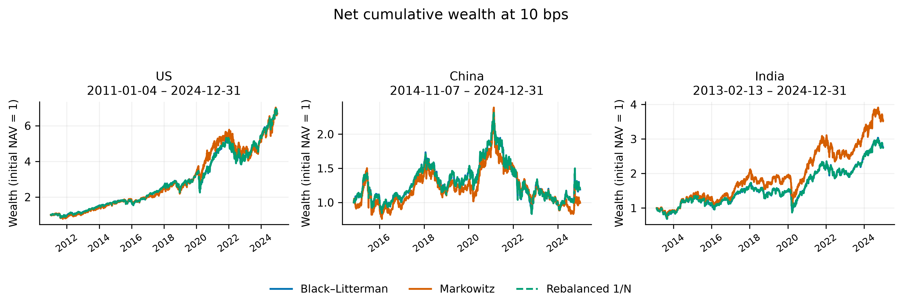
BL = Black-Litterman; MV = historical-mean Markowitz; 1/N = periodically rebalanced equal weighting. Source: frozen Phase 3 publication CSV; underlying Phase 2 experiment. Market-specific OOS: US 2011-01-04–2024-12-31; China 2014-11-07–2024-12-31; India 2013-02-13–2024-12-31. Net wealth includes initial deployment costs and begins from NAV 1. Arithmetic mean and terminal wealth rankings can differ. The embedded image is the unchanged verified Phase 3 PNG.

In the US, BL's annualized arithmetic net return is 15.4148%, compared with 15.8896% for Markowitz and 15.4183% for 1/N. BL's Sharpe is 0.806964, versus 0.744400 and 0.807620. BL therefore has higher descriptive Sharpe than unrestricted Markowitz, but a marginally lower Sharpe than 1/N. Its maximum drawdown, -35.0693%, is worse than Markowitz's -31.1532%. These outcomes do not show universal downside superiority.
In China, the annualized arithmetic net returns are 5.8193% for BL, 4.5276% for Markowitz and 5.8210% for 1/N. Their Sharpes are 0.202377, 0.149513 and 0.202381. BL outperforms unrestricted Markowitz on these descriptive metrics, while nearly matching 1/N. The basket experiences substantial drawdowns under all three rules. The country label does not identify a causal policy or ownership explanation for those paths.
In India, Markowitz has a higher annualized arithmetic net return, 13.2072%, and Sharpe, 0.583735, than BL's 10.8720% and 0.503642. The corresponding 1/N values are 10.8700% and 0.503564. BL and 1/N are again very close, while BL's drawdown is worse than unrestricted Markowitz's. This market is a direct counterexample to a universal BL performance claim.

6.2 Target stability and trading turnover
Figures 2 and 3 separate target ASI from drift-adjusted traded turnover. BL's mean ASI is 0.009409 in US, 0.001479 in China and 0.002346 in India. Markowitz's corresponding values are 0.805060, 0.712407 and 0.585259. These are large descriptive differences in optimizer target behavior. No new significance test of ASI or volatility is inferred from them.
Figure 2. Mean target-weight allocation instability
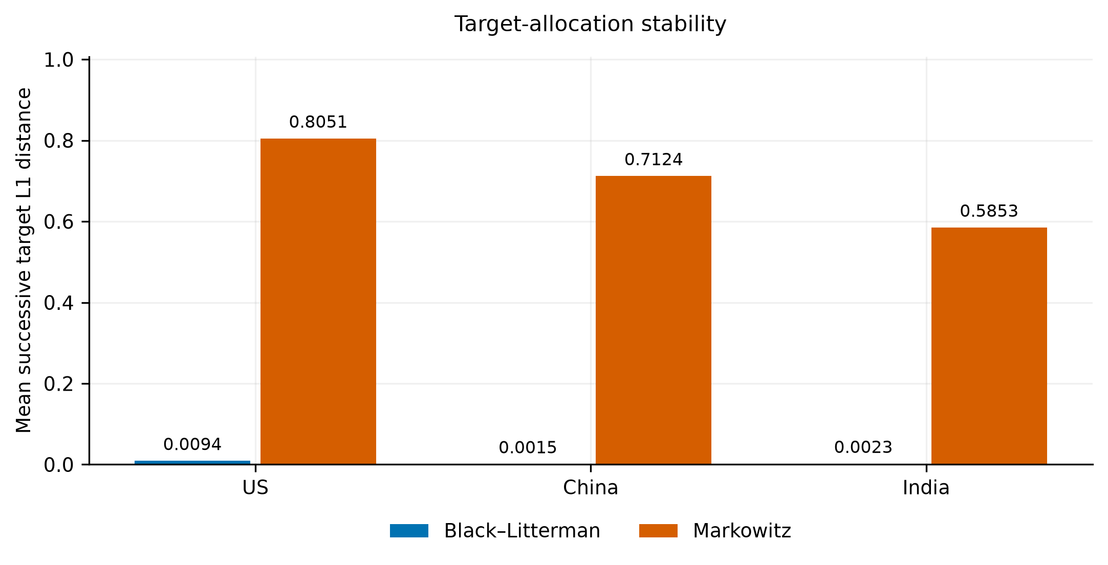
BL = Black-Litterman; MV = historical-mean Markowitz; 1/N = periodically rebalanced equal weighting. Source: frozen Phase 3 publication CSV; underlying Phase 2 experiment. Market-specific OOS: US 2011-01-04–2024-12-31; China 2014-11-07–2024-12-31; India 2013-02-13–2024-12-31. ASI is a mean L1 distance between successive targets, not the amount traded. The embedded image is the unchanged verified Phase 3 PNG.
Average subsequent rebalance L1 turnover is 2.87% versus 80.29% in US; 3.58% versus 70.73% in China; and 1.72% versus 58.34% in India. BL therefore trades much less than unrestricted Markowitz under the modeled convention. Initial cash deployment is excluded from these averages and charged separately.
Figure 3. Mean subsequent rebalance L1 turnover
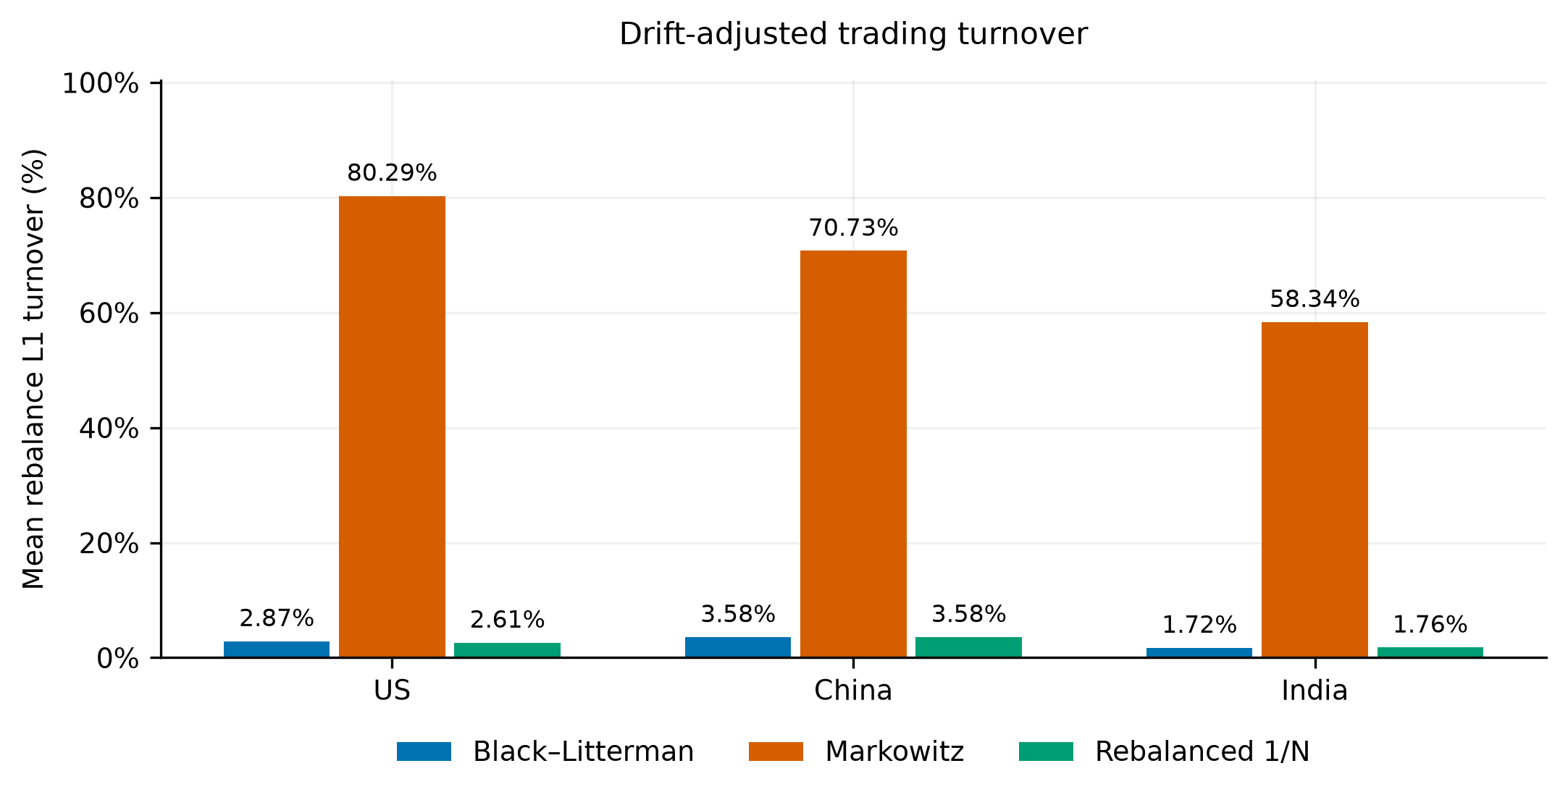
BL = Black-Litterman; MV = historical-mean Markowitz; 1/N = periodically rebalanced equal weighting. Source: frozen Phase 3 publication CSV; underlying Phase 2 experiment. Market-specific OOS: US 2011-01-04–2024-12-31; China 2014-11-07–2024-12-31; India 2013-02-13–2024-12-31. Dimensionless weight turnover. Initial cash deployment is excluded from the displayed subsequent rebalance means. The embedded image is the unchanged verified Phase 3 PNG.
Rebalanced 1/N illustrates why target stability does not imply no trading. Its ASI is zero, yet its turnover is 2.61%, 3.58% and 1.76%. It trades less than BL in the US and only slightly more in China and India. Strong equilibrium anchoring therefore explains a specific comparison with a concentrated optimizer, not a general implementation advantage over every simple allocation rule.

6.3 Matched concentration robustness
Table 3 and Figure 4 apply the same predefined 40% maximum target weight to both optimized strategies. BL's cap is inactive in the realized samples, so its capped and unrestricted paths coincide. Markowitz's mean target HHI declines from 0.877790 to 0.358195 in US, from 0.884217 to 0.353842 in China and from 0.875524 to 0.358635 in India.

Table 3. Matched concentration constraints at 10 bps
Market | Model | Target cap | Net ann. return | Sharpe | Mean L1 turnover | Target ASI | Mean target HHI | Max target weight
US | BL | 100.00% | 15.4148% | 0.806964 | 0.028735 | 0.009409 | 0.200054 | 20.99%
US | MV | 100.00% | 15.8896% | 0.744400 | 0.802868 | 0.805060 | 0.877790 | 100.00%
US | BL | 40.00% | 15.4148% | 0.806964 | 0.028735 | 0.009409 | 0.200054 | 20.99%
US | MV | 40.00% | 15.7193% | 0.797938 | 0.414349 | 0.409051 | 0.358195 | 40.00%
China | BL | 100.00% | 5.8193% | 0.202377 | 0.035751 | 0.001479 | 0.250002 | 25.31%
China | MV | 100.00% | 4.5276% | 0.149513 | 0.707290 | 0.712407 | 0.884217 | 100.00%
China | BL | 40.00% | 5.8193% | 0.202377 | 0.035751 | 0.001479 | 0.250002 | 25.31%
China | MV | 40.00% | 5.3984% | 0.194447 | 0.357818 | 0.351323 | 0.353842 | 40.00%
India | BL | 100.00% | 10.8720% | 0.503642 | 0.017249 | 0.002346 | 0.250003 | 25.31%
India | MV | 100.00% | 13.2072% | 0.583735 | 0.583411 | 0.585259 | 0.875524 | 100.00%
India | BL | 40.00% | 10.8720% | 0.503642 | 0.017249 | 0.002346 | 0.250003 | 25.31%
India | MV | 40.00% | 12.1747% | 0.555011 | 0.269045 | 0.263175 | 0.358635 | 40.00%
BL = Black-Litterman; MV = historical-mean Markowitz; 1/N = periodically rebalanced equal weighting. Source: frozen Phase 3 publication CSV; underlying Phase 2 experiment. Market-specific OOS: US 2011-01-04–2024-12-31; China 2014-11-07–2024-12-31; India 2013-02-13–2024-12-31. HHI is the sum of squared target weights. The 40% cap applies only at target formation; holdings drift between trades. BL cap is inactive. Return changes, maximum end-of-day weights and end-of-day HHI remain available in the source CSV.

The cap also reduces Markowitz target ASI and rebalance turnover. Capped turnover becomes 41.43%, 35.78% and 26.90%. This demonstrates that the instability contrast is sensitive to reasonable portfolio constraints rather than being an immutable distinction between two optimization paradigms.
Figure 4. Matched 40% concentration robustness
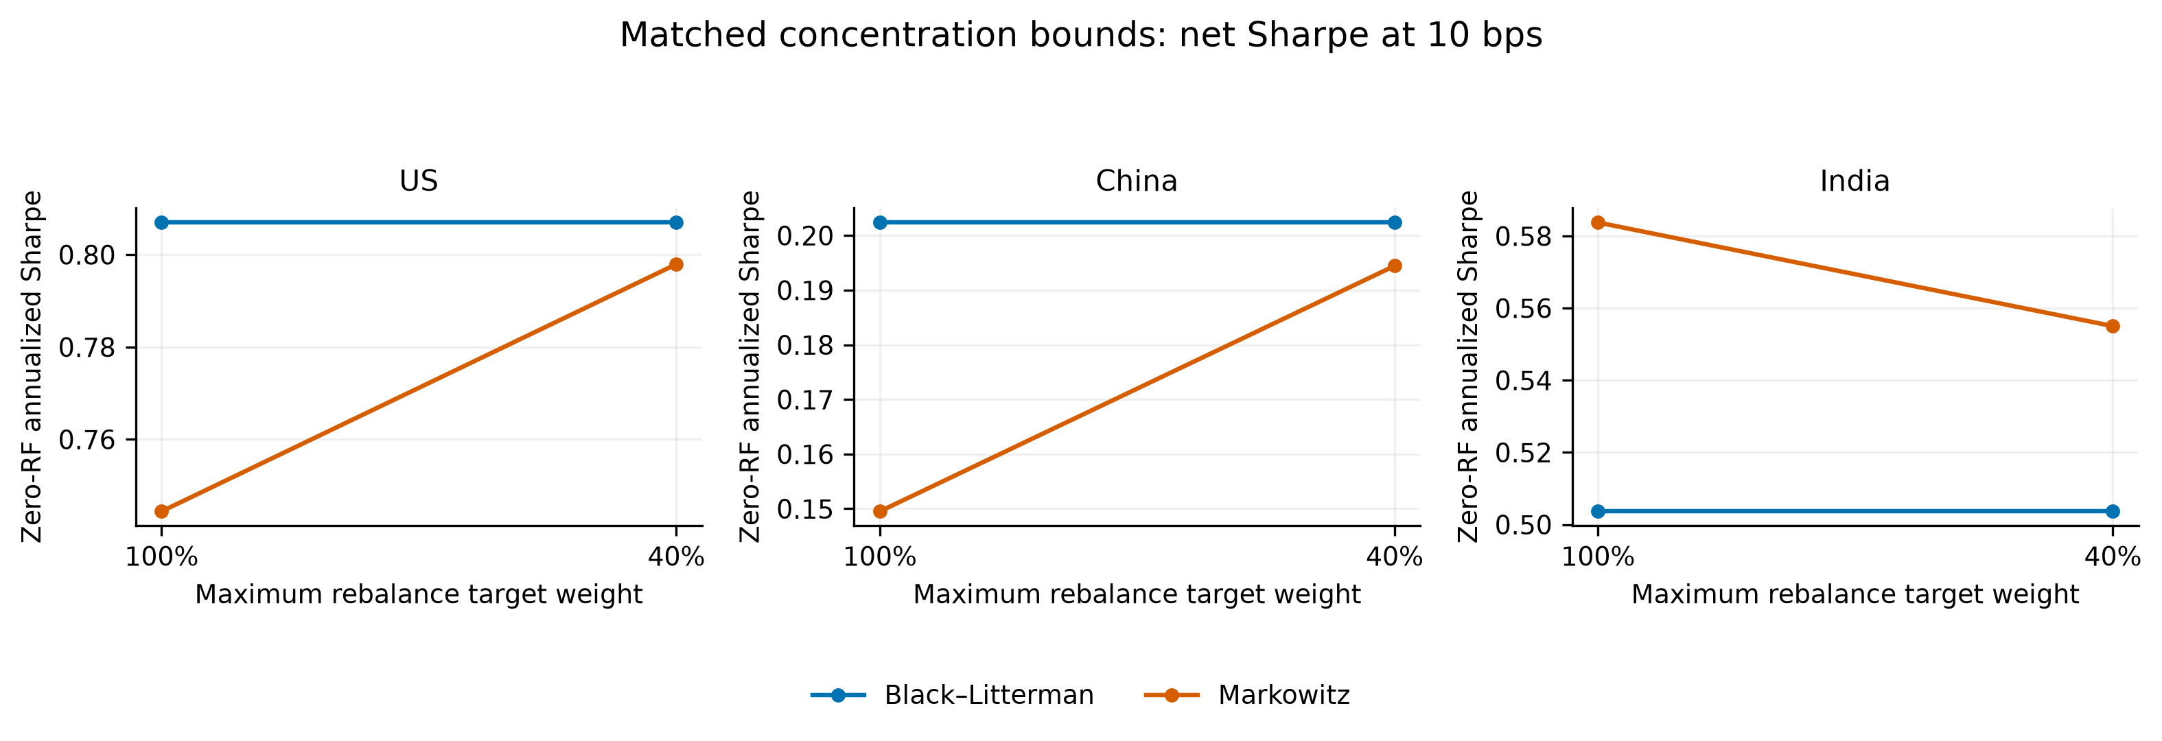
BL = Black-Litterman; MV = historical-mean Markowitz; 1/N = periodically rebalanced equal weighting. Source: frozen Phase 3 publication CSV; underlying Phase 2 experiment. Market-specific OOS: US 2011-01-04–2024-12-31; China 2014-11-07–2024-12-31; India 2013-02-13–2024-12-31. Net 10 bps; target cap applies at trades and may be exceeded by later drift. The embedded image is the unchanged verified Phase 3 PNG.

Capped Markowitz Sharpe rises to 0.797938 in US and 0.194447 in China, but declines to 0.555011 in India. The matched-cap BL-minus-Markowitz differences are smaller in US and China. These are descriptive robustness results, not an optimized cap choice or a claim that every concentration restriction improves performance.

6.4 Transaction costs and investment growth
Table 4 separates gross and net arithmetic annual returns, direct modeled fee expenditure and terminal wealth for the four cost rates. Both optimized cap scenarios and the primary 1/N benchmark are represented. Figure 5 illustrates terminal wealth for the unrestricted primary strategies. No portfolio optimization is repeated merely to change the cost assumption.

Table 4A. Cost sensitivity: arithmetic annualized net return
Market | Model | Target cap | Gross ann. return | 0 bps / L1 | 5 bps / L1 | 10 bps / L1 | 20 bps / L1
US | BL | 100.00% | 15.4334% | 15.4334% | 15.4241% | 15.4148% | 15.3963%
US | MV | 100.00% | 16.2137% | 16.2137% | 16.0517% | 15.8896% | 15.5654%
US | BL | 40.00% | 15.4334% | 15.4334% | 15.4241% | 15.4148% | 15.3963%
US | MV | 40.00% | 15.8900% | 15.8900% | 15.8047% | 15.7193% | 15.5486%
US | 1/N | 100.00% | 15.4358% | 15.4358% | 15.4271% | 15.4183% | 15.4009%
China | BL | 100.00% | 5.8433% | 5.8433% | 5.8313% | 5.8193% | 5.7953%
China | MV | 100.00% | 4.8185% | 4.8185% | 4.6730% | 4.5276% | 4.2367%
China | BL | 40.00% | 5.8433% | 5.8433% | 5.8313% | 5.8193% | 5.7953%
China | MV | 40.00% | 5.5500% | 5.5500% | 5.4742% | 5.3984% | 5.2468%
China | 1/N | 100.00% | 5.8450% | 5.8450% | 5.8330% | 5.8210% | 5.7969%
India | BL | 100.00% | 10.8872% | 10.8872% | 10.8796% | 10.8720% | 10.8567%
India | MV | 100.00% | 13.4475% | 13.4475% | 13.3274% | 13.2072% | 12.9668%
India | BL | 40.00% | 10.8872% | 10.8872% | 10.8796% | 10.8720% | 10.8567%
India | MV | 40.00% | 12.2899% | 12.2899% | 12.2323% | 12.1747% | 12.0596%
India | 1/N | 100.00% | 10.8854% | 10.8854% | 10.8777% | 10.8700% | 10.8546%
BL = Black-Litterman; MV = historical-mean Markowitz; 1/N = periodically rebalanced equal weighting. Source: frozen Phase 3 publication CSV; underlying Phase 2 experiment. Market-specific OOS: US 2011-01-04–2024-12-31; China 2014-11-07–2024-12-31; India 2013-02-13–2024-12-31. All 60 source cost scenarios appear in each panel; 15 strategy/market/cap combinations × four rates. Gross paths and targets are held fixed across rates. Panel C sums pretrade net NAV × fee fraction; it is not the gross-minus-net terminal-wealth difference.

Table 4B. Cost sensitivity: compounded terminal nav, initial nav 1
Market | Model | Target cap | 0 bps / L1 | 5 bps / L1 | 10 bps / L1 | 20 bps / L1
US | BL | 100.00% | 6.6852 | 6.6766 | 6.6680 | 6.6508
US | MV | 100.00% | 6.9969 | 6.8407 | 6.6878 | 6.3918
US | BL | 40.00% | 6.6852 | 6.6766 | 6.6680 | 6.6508
US | MV | 40.00% | 7.0117 | 6.9288 | 6.8468 | 6.6857
US | 1/N | 100.00% | 6.6895 | 6.6814 | 6.6732 | 6.6570
China | BL | 100.00% | 1.1922 | 1.1908 | 1.1893 | 1.1864
China | MV | 100.00% | 1.0246 | 1.0097 | 0.9950 | 0.9662
China | BL | 40.00% | 1.1922 | 1.1908 | 1.1893 | 1.1864
China | MV | 40.00% | 1.1885 | 1.1795 | 1.1705 | 1.1527
China | 1/N | 100.00% | 1.1922 | 1.1907 | 1.1893 | 1.1864
India | BL | 100.00% | 2.7552 | 2.7527 | 2.7502 | 2.7452
India | MV | 100.00% | 3.6326 | 3.5813 | 3.5308 | 3.4316
India | BL | 40.00% | 2.7552 | 2.7527 | 2.7502 | 2.7452
India | MV | 40.00% | 3.2245 | 3.2026 | 3.1808 | 3.1376
India | 1/N | 100.00% | 2.7546 | 2.7521 | 2.7496 | 2.7446
BL = Black-Litterman; MV = historical-mean Markowitz; 1/N = periodically rebalanced equal weighting. Source: frozen Phase 3 publication CSV; underlying Phase 2 experiment. Market-specific OOS: US 2011-01-04–2024-12-31; China 2014-11-07–2024-12-31; India 2013-02-13–2024-12-31. All 60 source cost scenarios appear in each panel; 15 strategy/market/cap combinations × four rates. Gross paths and targets are held fixed across rates. Panel C sums pretrade net NAV × fee fraction; it is not the gross-minus-net terminal-wealth difference.

Table 4C. Cost sensitivity: direct modeled trading fees in units of initial nav
Market | Model | Target cap | 0 bps / L1 | 5 bps / L1 | 10 bps / L1 | 20 bps / L1
US | BL | 100.00% | 0.000000 | 0.002726 | 0.005447 | 0.010877
US | MV | 100.00% | 0.000000 | 0.068525 | 0.135064 | 0.262378
US | BL | 40.00% | 0.000000 | 0.002726 | 0.005447 | 0.010877
US | MV | 40.00% | 0.000000 | 0.034086 | 0.067652 | 0.133253
US | 1/N | 100.00% | 0.000000 | 0.002568 | 0.005131 | 0.010247
China | BL | 100.00% | 0.000000 | 0.001444 | 0.002886 | 0.005766
China | MV | 100.00% | 0.000000 | 0.016250 | 0.032277 | 0.063671
China | BL | 40.00% | 0.000000 | 0.001444 | 0.002886 | 0.005766
China | MV | 40.00% | 0.000000 | 0.009495 | 0.018920 | 0.037562
China | 1/N | 100.00% | 0.000000 | 0.001447 | 0.002893 | 0.005779
India | BL | 100.00% | 0.000000 | 0.001108 | 0.002216 | 0.004428
India | MV | 100.00% | 0.000000 | 0.029079 | 0.057674 | 0.113440
India | BL | 40.00% | 0.000000 | 0.001108 | 0.002216 | 0.004428
India | MV | 40.00% | 0.000000 | 0.010799 | 0.021514 | 0.042697
India | 1/N | 100.00% | 0.000000 | 0.001120 | 0.002239 | 0.004474
BL = Black-Litterman; MV = historical-mean Markowitz; 1/N = periodically rebalanced equal weighting. Source: frozen Phase 3 publication CSV; underlying Phase 2 experiment. Market-specific OOS: US 2011-01-04–2024-12-31; China 2014-11-07–2024-12-31; India 2013-02-13–2024-12-31. All 60 source cost scenarios appear in each panel; 15 strategy/market/cap combinations × four rates. Gross paths and targets are held fixed across rates. Panel C sums pretrade net NAV × fee fraction; it is not the gross-minus-net terminal-wealth difference.

Figure 5. Compounded terminal wealth across modeled cost rates
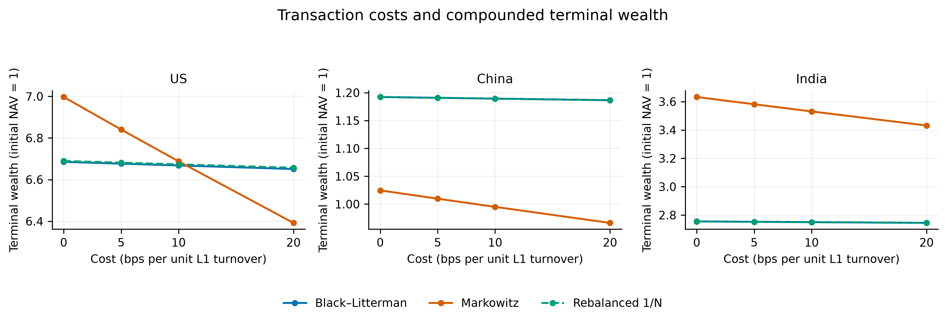
BL = Black-Litterman; MV = historical-mean Markowitz; 1/N = periodically rebalanced equal weighting. Source: frozen Phase 3 publication CSV; underlying Phase 2 experiment. Market-specific OOS: US 2011-01-04–2024-12-31; China 2014-11-07–2024-12-31; India 2013-02-13–2024-12-31. Rates are basis points per unit of L1 turnover. The plotted outcome is compounded terminal NAV, not annualized arithmetic return; see Table 4A for arithmetic returns. The embedded image is the unchanged verified Phase 3 PNG.

For US unrestricted Markowitz, the net arithmetic annualized return changes from 16.2137% at zero costs to 15.5654% at 20 basis points. BL changes from 15.4334% to 15.3963%. At 20 basis points, Markowitz still has the higher arithmetic annual return, but its terminal NAV of 6.3918 is below BL's 6.6508 and 1/N's 6.6570. There is no contradiction: a sample arithmetic mean and a product of daily growth factors summarize different aspects of the return path.
In China, unrestricted Markowitz's 20-bps arithmetic mean is 4.2367%, while its terminal NAV is 0.9662, below the initial 1. BL and 1/N finish close to each other and above that value. In India, unrestricted Markowitz remains ahead of BL on both arithmetic annual return and terminal wealth at the highest tested cost: 12.9668% and 3.4316, versus 10.8567% and 2.7452. Lower BL turnover therefore does not establish a universal net-performance ranking.
The cost fractions are a specified sensitivity grid, not empirically measured spreads or an estimated institutional implementation frontier. Direct fee totals are expressed relative to initial NAV over different sample lengths; they should not be compared as annual cost rates or interpreted as a fraction of a common terminal portfolio. The original manuscript's broad assurance that reasonable costs entirely neutralize Markowitz's advantage is replaced by these metric- and market-specific results.

6.5 Paired Sharpe differences
Table 5 reports observed differences, percentile intervals and approximate two-sided probabilities at 10 basis points. Figure 6 displays the six primary comparisons and the three distinct matched-cap BL-Markowitz comparisons. The repeated inactive-cap BL/1N results remain identified in the table rather than counted as additional independent findings.

Table 5. Paired bootstrap uncertainty for net Sharpe differences
Market | BL versus | BL target cap | Sharpe difference | 95% CI lower | 95% CI upper | Two-sided p | Paired N
US | MV | 100.00% | 0.062564 | -0.136167 | 0.277879 | 0.5370 | 3521
US | 1/N | 100.00% | -0.000656 | -0.001556 | 0.000285 | 0.1725 | 3521
US | MV | 40.00% | 0.009026 | -0.107492 | 0.141051 | 0.8905 | 3521
US | 1/N | 40.00% | -0.000656 | -0.001556 | 0.000285 | 0.1725 | 3521
China | MV | 100.00% | 0.052864 | -0.215295 | 0.320003 | 0.6915 | 2553
China | 1/N | 100.00% | -0.000004 | -0.000377 | 0.000382 | 0.9835 | 2553
China | MV | 40.00% | 0.007930 | -0.091777 | 0.100244 | 0.8725 | 2553
China | 1/N | 40.00% | -0.000004 | -0.000377 | 0.000382 | 0.9835 | 2553
India | MV | 100.00% | -0.080092 | -0.213058 | 0.064457 | 0.2735 | 2991
India | 1/N | 100.00% | 0.000079 | -0.000176 | 0.000304 | 0.5070 | 2991
India | MV | 40.00% | -0.051369 | -0.113396 | 0.013004 | 0.1110 | 2991
India | 1/N | 40.00% | 0.000079 | -0.000176 | 0.000304 | 0.5070 | 2991
BL = Black-Litterman; MV = historical-mean Markowitz; 1/N = periodically rebalanced equal weighting. Source: frozen Phase 3 publication CSV; underlying Phase 2 experiment. Market-specific OOS: US 2011-01-04–2024-12-31; China 2014-11-07–2024-12-31; India 2013-02-13–2024-12-31. Net 10 bps. Strategy A is BL. MV comparator has the same cap; equal weights already satisfy either cap. Circular paired 20-session blocks; 2,000 draws; seed 42. Percentile intervals and empirical-mean-centered approximate probabilities, unadjusted for multiplicity. Duplicated cap-inactive BL–1/N rows are not independent evidence. All intervals include zero; none of the unadjusted p-values is below 0.05.

Figure 6. Paired bootstrap Sharpe differences and 95% intervals
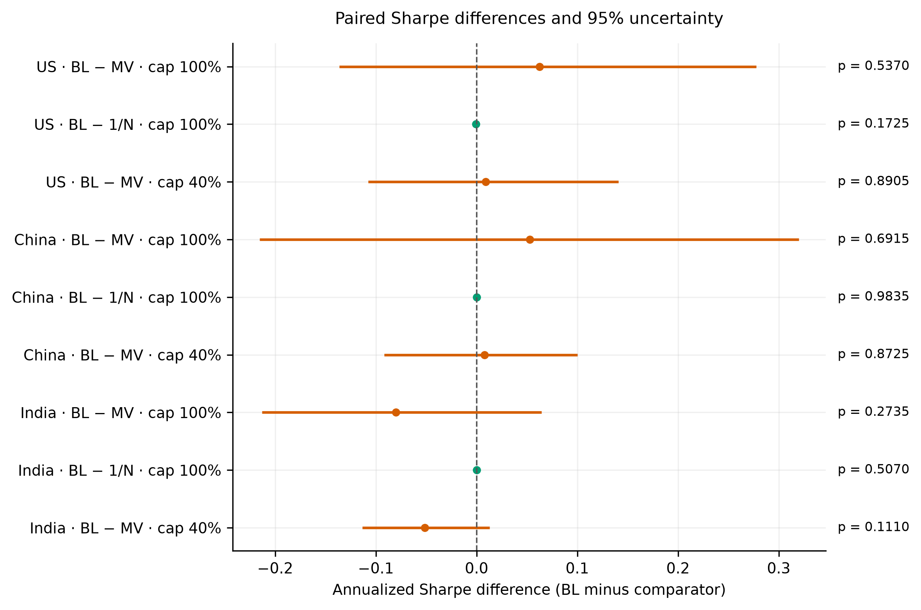
BL = Black-Litterman; MV = historical-mean Markowitz; 1/N = periodically rebalanced equal weighting. Source: frozen Phase 3 publication CSV; underlying Phase 2 experiment. Market-specific OOS: US 2011-01-04–2024-12-31; China 2014-11-07–2024-12-31; India 2013-02-13–2024-12-31. Net 10 bps. Percentile paired circular-block intervals, approximate centered probabilities and unadjusted comparisons; all intervals include zero. See Table 5. The embedded image is the unchanged verified Phase 3 PNG.

The unrestricted BL-minus-Markowitz Sharpe differences are 0.062564, 0.052864 and -0.080092, with p-values 0.5370, 0.6915 and 0.2735. The BL-minus-1/N probabilities are 0.1725, 0.9835 and 0.5070. The matched-cap BL-Markowitz probabilities are 0.8905, 0.8725 and 0.1110.
No statistically significant Sharpe-ratio differences were established under the specified paired bootstrap procedure. All reported intervals include zero, and no unadjusted p-value is below 0.05. This does not establish exact equivalence, validate a causal mechanism or demonstrate that all economically relevant differences are zero. It limits how strongly this experiment can support superiority claims. These results also cannot be substituted for the original manuscript's unreproduced volatility and ASI tests.

6.6 Historical crisis behavior
Table 6 retains the primary Phase 1 standalone frozen-holdings stress results. US GFC buy-and-hold drawdown is -52.1204% for BL and -46.9902% for Markowitz. The corresponding trough-to-crisis-start-NAV recovery durations are 277 and 273 trading-index positions. BL is worse on both descriptive outcomes in that event.

Table 6. Standalone historical frozen-holdings stress tests
Market | Model | Event start | Event end | Event N | Max drawdown | MDD trough | Recovery date | Recovery sessions
US | BL | 2008-08-01 | 2009-03-09 | 151 | -52.1204% | 2009-03-09 | 2010-04-14 | 277
US | MV | 2008-08-01 | 2009-03-09 | 151 | -46.9902% | 2008-11-20 | 2009-12-22 | 273
China | BL | 2015-06-01 | 2016-02-01 | 170 | -36.9642% | 2016-01-28 | 2017-07-26 | 376
China | MV | 2015-06-01 | 2016-02-01 | 170 | -49.7631% | 2016-01-28 | 2020-11-04 | 1202
India | BL | 2020-02-18 | 2020-05-01 | 53 | -42.5592% | 2020-03-23 | 2020-11-06 | 160
India | MV | 2020-02-18 | 2020-05-01 | 53 | -41.7125% | 2020-03-23 | 2020-11-09 | 161
Source: Phase 1 primary buy-and-hold stress summaries, frozen in Phase 3 Table 6. Gross wealth starts at NAV 1 before the first event return; last pre-event targets are purchased and then held through recovery. MDD uses the running wealth peak including initial capital. Recovery targets crisis-start NAV 1, not the running peak; duration counts trading-index positions from the crisis-window MDD trough. Separate from the main rolling OOS results; no verified daily crisis curve is supplied.

For the China event, BL's drawdown is -36.9642% versus -49.7631%, with recovery durations of 376 versus 1202. In India, drawdowns are -42.5592% versus -41.7125%, and recovery durations are 160 versus 161. The event pattern is mixed; it does not support universal crisis protection.
The fixed-holdings design deliberately excludes adaptive trading during each stress evaluation. It therefore cannot show that a strategy reduces capitulation-driven allocation changes during the crisis, nor does comparison with an index's historical recovery date validate these portfolio-specific results. Daily frozen-holdings curves were not retained in the verified archive, so no crisis curve is inserted. The summary evidence and its source limitations are preserved rather than reverse-engineering a visually plausible path.

6.7 US factor exposures
Table 7 and Figure 7 present Phase 1's US four-factor diagnostic. Market beta is 1.063528 for BL and 1.148195 for Markowitz. No direct cross-strategy test of beta equality is supplied, so the estimates are not called statistically indistinguishable. The US BL SMB coefficient is positive and its HML coefficient is positive in the retained fit; the Markowitz size loading is negative, while its HML coefficient has substantial statistical uncertainty. Full coefficients and HAC inference are reported rather than inferring their signs from a figure alone.

Table 7. US four-factor exposures: separate Phase 1 diagnostic
US model | Term | Coefficient | HAC t | HAC p | Annual alpha | R-squared
BL | Alpha | 0.000019 | 0.8392 | 0.4013 | 0.4868% | 0.985504
BL | MKT | 1.063528 | 247.3788 | <0.0001 | — | 0.985504
BL | SMB | 0.073759 | 11.9759 | <0.0001 | — | 0.985504
BL | HML | 0.031096 | 4.9280 | <0.0001 | — | 0.985504
BL | MOM | 0.004003 | 0.7363 | 0.4616 | — | 0.985504
MV | Alpha | -0.000045 | -0.5553 | 0.5787 | -1.1363% | 0.882366
MV | MKT | 1.148195 | 108.5657 | <0.0001 | — | 0.882366
MV | SMB | -0.047236 | -2.0183 | 0.0436 | — | 0.882366
MV | HML | -0.021556 | -0.7831 | 0.4336 | — | 0.882366
MV | MOM | 0.224115 | 16.1816 | <0.0001 | — | 0.882366
Source: Phase 1 US net strategy series and Kenneth French daily factors, frozen in Phase 3 Table 7. Sample 2011-01-04–2024-12-31; N = 3,521; HAC maximum lags = 5. Daily portfolio excess returns subtract actual RF; source factor percentages divided by 100. Alpha coefficient is daily; annual alpha = 252 × daily intercept and is shown only on Alpha rows. Other coefficients are dimensionless. No capped or 1/N regressions and no China/India regressions are inferred.

Figure 7. US four-factor exposure coefficients
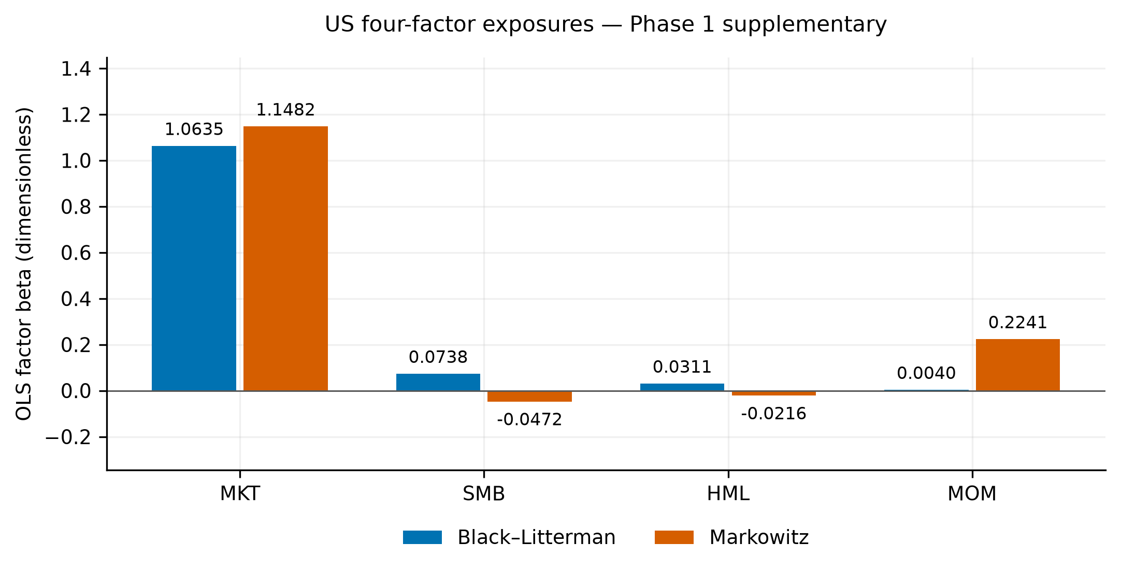
Source: Phase 1 US diagnostic through frozen Phase 3 Figure 08 and Table 7. US 2011-01-04–2024-12-31, N = 3,521; daily excess-return regression, HAC lag 5. Exposures are conditional associations, not causal mechanisms. The figure shows coefficient point estimates; HAC statistics are provided in Table 7. The embedded image is the unchanged verified Phase 3 PNG.
The momentum coefficient is 0.004003 for BL, with HAC p=0.4616, and 0.224115 for Markowitz, with p<0.0001. The latter is a statistically strong conditional US loading, not proof that optimization causally generates a momentum strategy or that it explains China/India performance.
BL's arithmetic annualized alpha is 0.4868%, with p=0.4013; Markowitz's is -1.1363%, with p=0.5787. Neither establishes positive active alpha under this regression. The model's R-squared and statistical associations are conditional descriptive evidence. These estimates were not refitted to the Phase 2 capped or 1/N paths, even though the principal experiments use the same frozen price vintage and OOS coverage.

6.8 Fixed-tau sensitivity
Table 8 and Figure 8 retain the five verified Phase 1 US fixed-tau settings. Sharpe changes from 0.807438 at tau 0.01 to 0.803797 at tau 0.20. The small decline is descriptive of this uncertainty scale, view construction, ETF basket and sample. It is not a search for the best tau or a demonstration of general robustness outside the tested values.
Table 8. US fixed-tau sensitivity: separate Phase 1 diagnostic
Fixed tau | US net Sharpe | OOS start | OOS end | Returns N
0.01 | 0.807438 | 2011-01-04 | 2024-12-31 | 3521
0.05 | 0.806660 | 2011-01-04 | 2024-12-31 | 3521
0.10 | 0.805679 | 2011-01-04 | 2024-12-31 | 3521
0.15 | 0.804723 | 2011-01-04 | 2024-12-31 | 3521
0.20 | 0.803797 | 2011-01-04 | 2024-12-31 | 3521
Source: Phase 1 fixed-tau US runs, frozen in Phase 3 Table 8. Net 10 bps per L1, zero-RF Sharpe, equal-weight proxy; Omega = 10 × diagonal annualized covariance, independent of tau. Each row is a fixed setting, not a realization of the adaptive main rule. Only these five tested settings support the interpretation.
Figure 8. US fixed-tau net Sharpe sensitivity
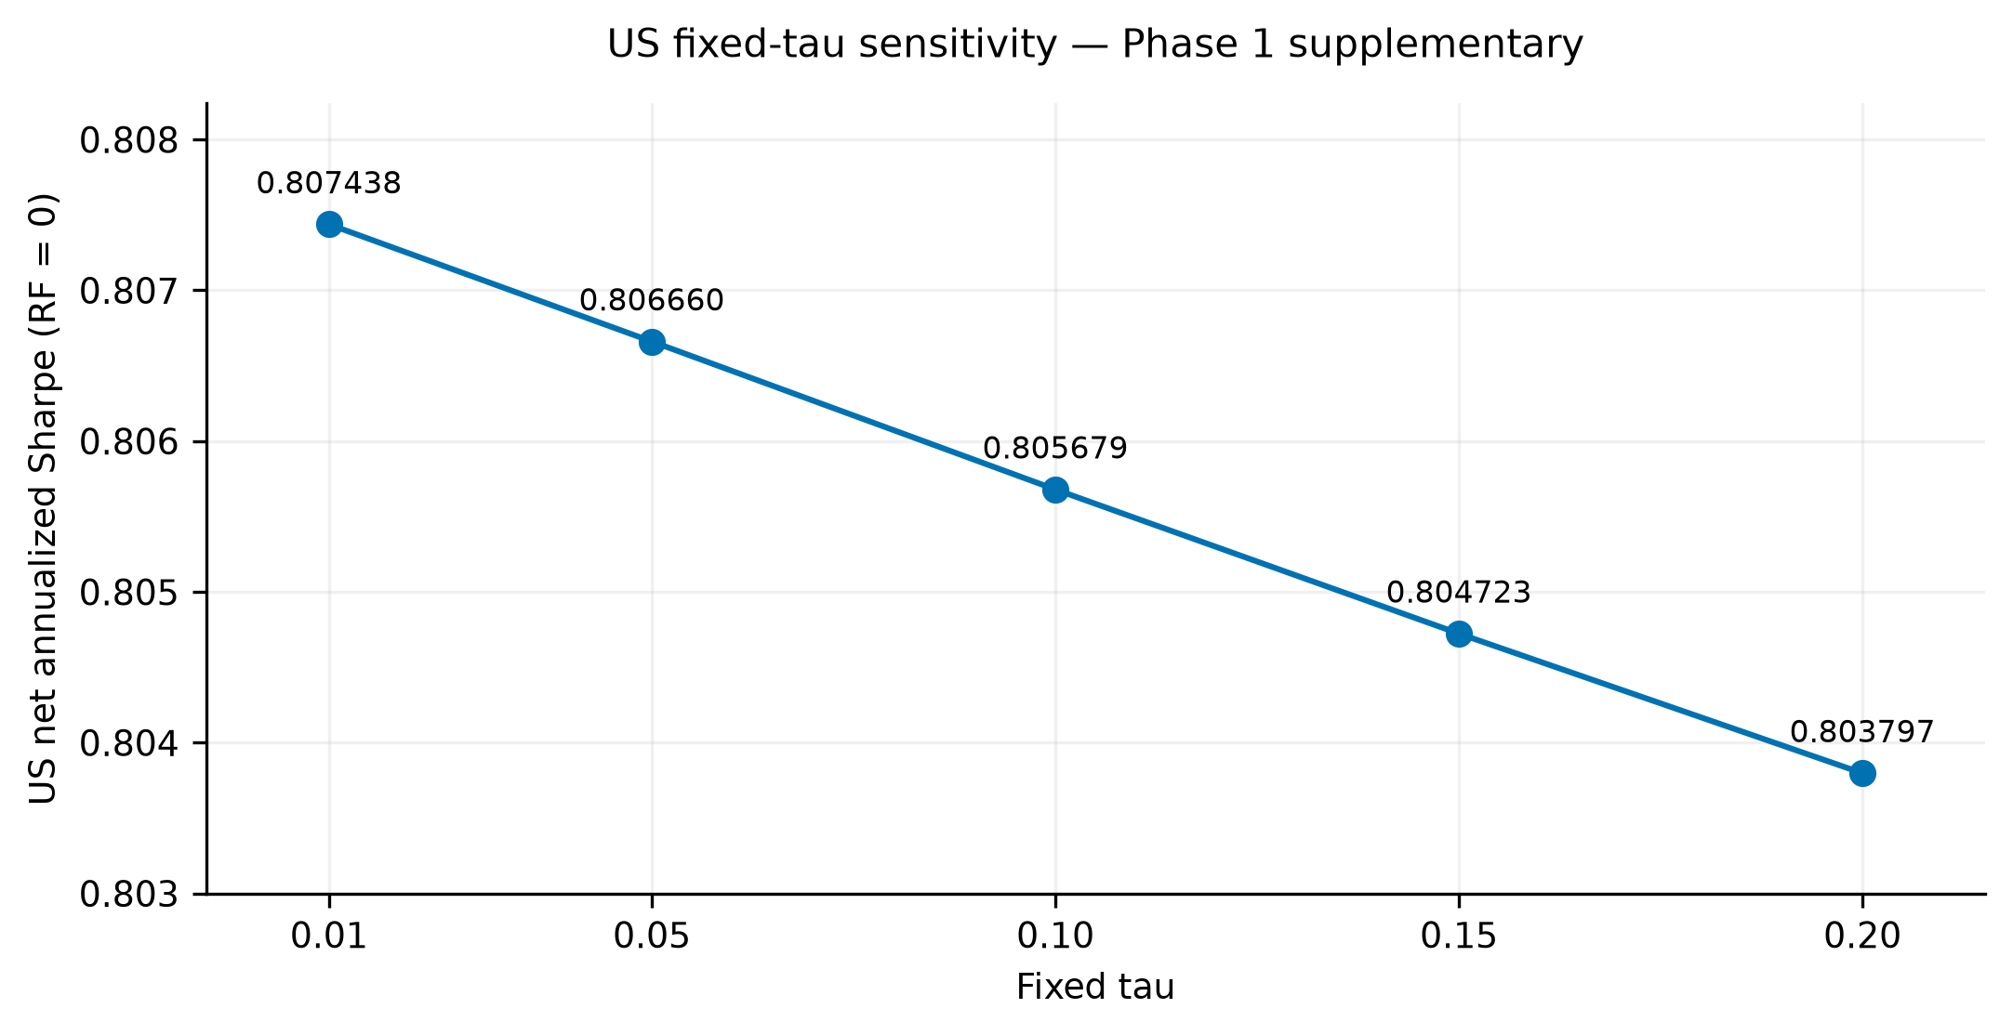
Source: Phase 1 fixed-tau US diagnostic through frozen Phase 3 Figure 09 and Table 8. US 2011-01-04–2024-12-31, N = 3,521; net 10 bps, zero-RF Sharpe. Fixed settings differ from the adaptive main rule. The embedded image is the unchanged verified Phase 3 PNG.
Omega is independent of tau in these runs, so tau does not mechanically cancel from the posterior update. The five fixed scenarios are separate from the main trailing-volatility adaptive rule. The close-to-1/N behavior in the principal experiment remains a limitation on interpreting small fixed-tau differences as evidence of incremental predictive skill.

7 Discussion and implementation implications
The clearest implementation result is lower target instability and turnover for equilibrium-anchored BL relative to unrestricted historical-mean Markowitz. This supports the practical value of examining allocation mechanics rather than ranking methods by a single return statistic. It does not establish that the BL framework, regardless of prior and views, intrinsically suppresses trades or dominates alternative estimators.
The 1/N comparison changes the interpretation of stabilization. In these baskets, a recurring equal-weight target produces very similar investment outcomes without estimating a historical-mean view tilt. BL's strong equal-weight anchor therefore explains much of the observed behavior. Stabilizing an optimization input is not the same as generating incremental investment alpha, and failure to reject a Sharpe difference is not proof that the procedures are equivalent. The appropriate claim is narrow: this specified anchored implementation is far more stable than the unrestricted comparator and has not demonstrated superior performance over 1/N.
Matched concentration constraints identify another alternative explanation. Capped Markowitz is less concentrated and trades less, with improved US and China Sharpe, though reduced India Sharpe. The results show why an empirical claim about the benefit of expected-return shrinkage depends on the feasible set used by the comparator. They do not justify choosing a cap after observing performance or treating the predefined 40% setting as universally optimal.
For implementation, the distinction between trading and target changes remains important. A stable target still requires trades as holdings drift. The simulation charges initial deployment, models proportional costs consistently and separates fee expenditure from investment growth. It does not establish capacity, execution quality or institutional feasibility at any asset scale. Microstructure costs can be nonlinear and endogenous to order size, liquidity and stress; none is estimated here. The original institutional-grade language is therefore replaced by a discussion of modeled trade-offs.
The crisis and factor results are complementary diagnostics, not causal explanations of the main comparison. Event-specific frozen portfolios can recover to their starting capital at different times because they have different holdings. US factor coefficients summarize one specified return series and risk model. Neither diagnostic establishes universal downside protection, an ownership mechanism or prospective regime timing. These distinctions are necessary to keep a cross-market descriptive study from claiming more identification than its design supplies.

8 Limitations
The ETF universes contain only four or five instruments and overlapping exposures. They are useful for a transparent allocation exercise but do not represent a high-dimensional stock-selection problem or every investable opportunity in the named countries. ETF aggregation suppresses firm-level variation, so results cannot be generalized directly to constituent-level covariance estimation, ownership effects or other market structures.
The instruments are US-listed and USD-denominated. Provider-adjusted histories are return proxies subject to vendor revisions, not local-currency national-index series or executable prices. Different observed histories generate unequal effective samples, preventing a common-horizon cross-market ranking. Survivorship and universe-selection effects are not eliminated by consistent arithmetic or verified code.
The BL prior is an equal-weight proxy. Its views are a mild historical-return tilt, and risk aversion, uncertainty scaling and tau rules are assumed rather than estimated as optimal investor preferences. Strong anchoring may account for much of the stability and near-1/N performance. These results do not assess independent analyst forecasts, observed capitalization priors or all alternative BL specifications.
Transaction costs are intentionally stylized. The model does not capture time-varying bid-ask spreads, nonlinear price impact, taxes, financing, execution constraints or liquidity stress. The assumed fees are not necessarily conservative bounds on actual implementation costs. The weight-turnover convention also differs from other reported turnover definitions, so rates cannot be transferred mechanically to an institutional trading-cost forecast.
Inference uses one predefined block length, replication count, seed and approximate centering convention. Percentile intervals and unadjusted multiple comparisons do not guarantee exact finite-sample coverage. Selected historical events are not a representative distribution of future crises, and the retained summary archive does not contain verified daily frozen-holdings curves. Descriptive drawdown differences have no associated test of superior downside protection.
The factor model is US-only. Its return convention subtracts the actual factor-library RF, while headline Sharpe assumes zero RF. Ex-post Markov smoothing is not a trading rule and cannot support real-time regime prediction. Fixed-tau sensitivity covers only five scenarios under the retained specification. Original March price/factor vintages, dated capitalization priors, ownership records and some original test artifacts remain unavailable. These gaps prevent exact reproduction of that historical empirical record, without invalidating the narrower revised-study findings supported by the frozen evidence.

9 Future research
Future work should distinguish the information content of independently sourced views from the diversification induced by the reference allocation. Broader universes and clearly documented contemporaneous priors would help assess whether the near-1/N result persists beyond these ETF baskets. A common-period international design could separate horizon effects from differences in exposures more directly.
Execution-aware portfolio choice and genuinely prospective regime evaluation are separate research projects, not completed components of this revision. An ownership study would require real dated classifications and stock-level return histories; no inference about SOE or private-company protection is retained from the unavailable original inputs. These directions identify limits of the present contribution rather than implying that a more complicated model must improve realized performance.

10 Reproducibility and revision history
The repository is https://github.com/amitdudi04/regime-sensitive-black-litterman-tri-market-study. The Phase 3 evidence freeze is commit da5d40acfc0e71cac51f0fd8bc288606c6c7aa71 on research/revised-paper-phase3-final-results. Its generation source is recorded as 69112e3abc1997df04387e916e04285cb6cbf87d. Phase 2 principal evidence comes from run ff8cacdc-95f8-458e-8d71-d12efbd9a9f9, executed at af84ddfbc93edc7a5143c654d6319d67e3139eef and frozen on 7553cf8bff59a4f3d8bad7d15b779707fc533fa1. Phase 1 supplementary evidence retains run 693ec4b2-0e95-4367-afef-904dbac8f9c3, executed at f7f96e3c6646e7b171c43b8bb6e8a5b129053609 and archived on completed Phase 1 commit 598fe0d3c0a7cd7ebaf5709ae62b7c6735b92a0d.
The verified numerical environment uses Python 3.12 with observed dependency versions pinned in requirements-phase1-lock.txt. Run manifests record exact versions, configuration, request/effective dates, retrieval timestamps, frozen price checksums, aligned factor fingerprints and output hashes. The revised calculation convention uses Adj Close simple returns, common observed dates and the constraints and fee definitions described above. Manuscript generation reads the eight CSV tables and verified figures directly; numerical prose is linked to source cells rather than entered independently.
The completed validation sequence includes independent financial identities, new-experiment accounting checks and publication-level table/figure consistency checks. These are software and internal-consistency evidence, not proof that a selected empirical model is economically optimal. No backtest, bootstrap distribution or market-data download is repeated to prepare this manuscript. Synthetic test fixtures used in earlier software checks are distinct from empirical research reruns.
Raw vendor snapshots remain local and are not redistributed as part of the public paper. Public data access does not by itself establish a right to redistribute vendor histories. A lawful fresh acquisition may differ from the frozen vintage; exact rerun claims require matching source bytes and configuration. Portfolio return paths and decisions are included in the preserved evidence package for tracing the generated figures. Reproducing the revised frozen experiment, obtaining internally consistent new downloads and reproducing the March paper are three different claims.
Revision note dated 31 October 2026: this revision updates portfolio accounting documentation, sample definitions, equal-weight benchmarking, matched concentration comparisons, cost sensitivity and statistical interpretation. Empirical values differ from the March 2026 version. The revised study uses a clearly specified equal-weight equilibrium proxy and verified ETF windows; missing original inputs prevent a unique attribution of every historical numerical difference. The original manuscript and transcribed tables remain unchanged for historical reference. This substantive revision candidate has not been submitted or approved as an SSRN revision.

11 Conclusion
In the evaluated ETF baskets, equilibrium-anchored BL produces substantially lower target-weight instability and modeled turnover than unrestricted historical-mean Markowitz. That finding is economically useful as a description of allocation behavior, but it does not establish general investment superiority. BL performs nearly like periodically rebalanced equal weighting, and a reasonable matched concentration cap materially reduces the comparator's instability.
Risk-adjusted results vary across markets, trading costs affect implementation outcomes and arithmetic-return rankings need not match compounded-wealth rankings. No statistically significant Sharpe-ratio differences were established under the specified paired bootstrap procedure. The crisis outcomes are event-specific, while US factor and fixed-tau diagnostics remain limited to their stated samples and designs. The contribution is a transparent empirical assessment of stabilization and implementation trade-offs, with unfavorable and insignificant findings retained. It supports careful benchmark and constraint selection rather than a universal preference for one portfolio model.

Declarations
Funding: a current declaration has not been attested by the author. Competing interests: a current declaration has not been attested by the author. No present absence of funding or relevant relationships is asserted in this candidate.
Data and code availability: Research source code, configurations, generated results, tables, figures and provenance manifests are public at https://github.com/amitdudi04/regime-sensitive-black-litterman-tri-market-study. Revised-study publication evidence is frozen at commit da5d40acfc0e71cac51f0fd8bc288606c6c7aa71; its publication-generation source is 69112e3abc1997df04387e916e04285cb6cbf87d. On 31 October 2026, the three frozen Yahoo Finance adjusted-price snapshots and processed Kenneth French US daily factor cache were found locally and their byte-level SHA-256 hashes matched archived metadata. These vendor-derived inputs are not included in the public package and are not redistributed here; permission is not presumed. Readers may independently acquire provider observations subject to applicable terms, but later downloads can differ from the frozen vintage. Exact reproduction requires matching input bytes and configuration; the public package alone does not supply those input bytes. Original March price/factor vintages, capitalization priors, ownership records and certain test artifacts remain unavailable. The revised specification is not an exact reproduction of the March numerical record.

Generative AI assistance and research oversight
OpenAI ChatGPT and Codex assisted source-code review, financial-model validation support, numerical testing, empirical workflow development, statistical-output review, research documentation, figure and table generation, and manuscript drafting and editing. The assistance included methodological explanations and interpretation drafts, extending beyond language polishing. The empirical values were taken from frozen, script-generated outputs; missing data, ownership records and historical results were not fabricated. The developer of these tools is OpenAI. Model and build identifiers for all earlier sessions are not fully recorded in the research manifests and must not be inferred from the tools' names.
Human-author oversight: completion of independent author verification of the revised methods, code, outputs, references and interpretations has not been attested. Responsibility remains with the human author; AI tools cannot assume authorship or accountability. Policy compatibility requires resolution of whether the documented assistance supported, rather than replaced, the author's own intellectual contribution. This candidate is NOT APPROVED FOR SSRN UPLOAD.

References
Ang, A., and G. Bekaert. 2002. International Asset Allocation With Regime Shifts. Review of Financial Studies 15(4): 1137-1187. https://doi.org/10.1093/rfs/15.4.1137
Black, F., and R. Litterman. 1992. Global Portfolio Optimization. Financial Analysts Journal 48(5): 28-43. https://doi.org/10.2469/faj.v48.n5.28
Carhart, M. M. 1997. On Persistence in Mutual Fund Performance. Journal of Finance 52(1): 57-82. https://doi.org/10.1111/j.1540-6261.1997.tb03808.x
Chopra, V. K., and W. T. Ziemba. 1993. The Effect of Errors in Means, Variances, and Covariances on Optimal Portfolio Choice. Journal of Portfolio Management 19(2): 6-11. https://doi.org/10.3905/jpm.1993.409440
DeMiguel, V., L. Garlappi, and R. Uppal. 2009. Optimal Versus Naive Diversification: How Inefficient Is the 1/N Portfolio Strategy? Review of Financial Studies 22(5): 1915-1953. https://doi.org/10.1093/rfs/hhm075
Fama, E. F., and K. R. French. 1993. Common Risk Factors in the Returns on Stocks and Bonds. Journal of Financial Economics 33(1): 3-56. https://doi.org/10.1016/0304-405X(93)90023-5
Fernandes, J. L. B., J. R. H. Ornelas, and O. A. M. Cusicanqui. 2012. Combining Equilibrium, Resampling, and Analyst's Views in Portfolio Optimization. Journal of Banking & Finance 36(5): 1354-1361. https://doi.org/10.1016/j.jbankfin.2011.11.023
Gârleanu, N., and L. H. Pedersen. 2013. Dynamic Trading with Predictable Returns and Transaction Costs. Journal of Finance 68(6): 2309-2340. https://doi.org/10.1111/jofi.12080
Grinold, R. C., and R. N. Kahn. 2000. Active Portfolio Management: A Quantitative Approach for Producing Superior Returns and Controlling Risk. 2nd ed. New York: McGraw-Hill. https://catalogue.library.cern/literature/vrk80-07j88
Guidolin, M., and A. Timmermann. 2007. Asset Allocation under Multivariate Regime Switching. Journal of Economic Dynamics and Control 31(11): 3503-3544. https://doi.org/10.1016/j.jedc.2006.12.004
Hamilton, J. D. 1989. A New Approach to the Economic Analysis of Nonstationary Time Series and the Business Cycle. Econometrica 57(2): 357-384. https://doi.org/10.2307/1912559
He, G., and R. Litterman. 1999. The Intuition Behind Black-Litterman Model Portfolios. Goldman Sachs Investment Management, December. https://people.duke.edu/~charvey/Teaching/BA453_2002/GS_The_intuition_behind.pdf
Idzorek, T. M. 2004. A Step-by-Step Guide to the Black-Litterman Model: Incorporating User-Specified Confidence Levels. Zephyr Associates, July 20 draft. https://people.duke.edu/~charvey/Teaching/BA453_2005/Idzorek_onBL.pdf
Jagannathan, R., and T. Ma. 2003. Risk Reduction in Large Portfolios: Why Imposing the Wrong Constraints Helps. Journal of Finance 58(4): 1651-1683. https://doi.org/10.1111/1540-6261.00580
Jobson, J. D., and B. M. Korkie. 1981. Performance Hypothesis Testing with the Sharpe and Treynor Measures. Journal of Finance 36(4): 889-908. https://doi.org/10.1111/j.1540-6261.1981.tb04891.x
Ledoit, O., and M. Wolf. 2003. Improved Estimation of the Covariance Matrix of Stock Returns with an Application to Portfolio Selection. Journal of Empirical Finance 10(5): 603-621. https://doi.org/10.1016/S0927-5398(03)00007-0
Ledoit, O., and M. Wolf. 2004a. Honey, I Shrunk the Sample Covariance Matrix. Journal of Portfolio Management 30(4): 110-119. https://doi.org/10.3905/jpm.2004.110
Ledoit, O., and M. Wolf. 2004b. A Well-Conditioned Estimator for Large-Dimensional Covariance Matrices. Journal of Multivariate Analysis 88(2): 365-411. https://doi.org/10.1016/S0047-259X(03)00096-4
Ledoit, O., and M. Wolf. 2008. Robust Performance Hypothesis Testing with the Sharpe Ratio. Journal of Empirical Finance 15(5): 850-859. https://doi.org/10.1016/j.jempfin.2008.03.002
Lintner, J. 1965. The Valuation of Risk Assets and the Selection of Risky Investments in Stock Portfolios and Capital Budgets. Review of Economics and Statistics 47(1): 13-37. https://doi.org/10.2307/1924119
Markowitz, H. 1952. Portfolio Selection. Journal of Finance 7(1): 77-91. https://doi.org/10.1111/j.1540-6261.1952.tb01525.x
Markowitz, H. M. 1959. Portfolio Selection: Efficient Diversification of Investments. Cowles Foundation Monograph 16. New York: Wiley. https://cowles.yale.edu/sites/default/files/2022-08/d0168.pdf
Memmel, C. 2003. Performance Hypothesis Testing with the Sharpe Ratio. Finance Letters 1: 21–23. https://www.bundesbank.de/en/christoph-memmel
Meucci, A. 2010. The Black-Litterman Approach: Original Model and Extensions. Extended author manuscript, version October 12. SSRN 1117574. https://doi.org/10.2139/ssrn.1117574
Newey, W. K., and K. D. West. 1987. A Simple, Positive Semi-Definite, Heteroskedasticity and Autocorrelation Consistent Covariance Matrix. Econometrica 55(3): 703-708. https://doi.org/10.2307/1913610
Sharpe, W. F. 1964. Capital Asset Prices: A Theory of Market Equilibrium under Conditions of Risk. Journal of Finance 19(3): 425-442. https://doi.org/10.1111/j.1540-6261.1964.tb02865.x

