Is the 15 minute maximum duration on Lambda a limitation for us?

Probably, so not using Lambda. Lambda will handle the polling for you, and it will probably be cheaper and easier to maintain. "Keeping everything in the cluster" isn't really a good plan in my opinion but if Lambda is not fit for our purpose we will have to use Fargate.

I would like to add that you have a lot less control over concurrency when running in Lambda. If there is a backlog building in SQS, Lambda is going to scale up concurrency.
If your Lambda functions are for example doing queries against a slow database and cannot keep up, the response of your system will be to do _more_ queries, slowing the database further, until everything grinds to a halt. Well, not really, because even in this thrashing state AWS will pound harder and harder, while your DBA is begging you to make it stop. Only you can't, because Lambda do as Lambda do.
If that's not an issue I'd prefer Lambdas because most part of the SQS integration is done in infrastructure, and for the budget of a Fargate task running 24/7 you should be able to pay for a lot of Lambda invocations.

We will be using Fargate as it seems likely that we will be encountering limitations in lambda.

Preliminary Architecture
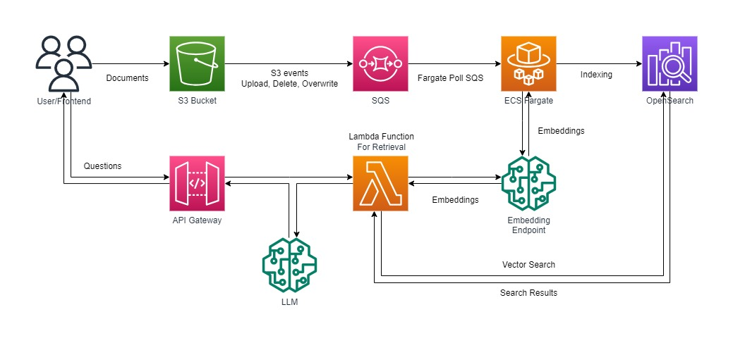
Scaling with Fargate
You can increase or decrease your desired task count by integrating Amazon ECS on Fargate with Amazon CloudWatch alarms and Application Auto Scaling.

When using the Amazon ECS service scheduler for running web and other long-running applications, you will be able to launch up to 500 tasks in under a minute per service, 16X faster than last year. Previously you would have waited for nearly 15 minutes to scale an application to 500 tasks at steady state. When running one-time or periodic batch jobs using ECS RunTask API, Fargate now allows customer accounts to burst up to 100 On-Demand or Spot tasks, with a sustained task launch rate of 20 tasks per second, 20X faster than last year. For example, if you run a batch job with 1,200 On-Demand tasks, you can now launch your job in under a minute, while previously it would have taken about 20 minutes. Similarly, EKS Fargate customers will now observe up to 20X faster scaling when using the Platform Versions referenced in the .

When a metric emits real 0 values to CloudWatch , Application Auto Scaling can scale in to 0 when there is no traffic to your application. To have your scalable target scale in to 0 when no requests are routed it, the scalable target's minimum capacity must be set to 0.

Final Architecture
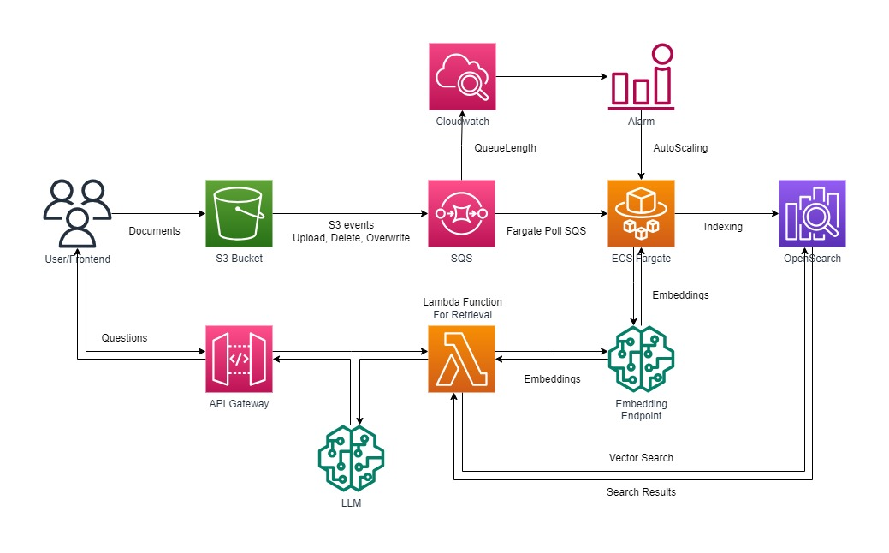
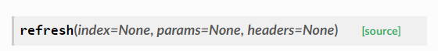
Refresh can be done on demand

References:
1. Fargate Scaling Guide
2. AutoScaling Guide

