DBT

Dbt is an open-source command line tool that helps analysts and engineers transform data in their warehouse more effectively.

Dbt enables analytics engineers to transform data in their warehouses by writing select statements, and turns these select statements into tables and views. dbt does the transformation (T) in extract, load, transform (ELT) processes – it does not extract or load data, but is designed to be performant at transforming data already inside of a warehouse. dbt has the goal of allowing analysts to work more like software engineers, in line with the dbt viewpoint.
dbt uses YAML files to declare properties. seed is a type of reference table used in dbt for static or infrequently changed data, like for example country codes or lookup tables), which are CSV based and typically stored in a seeds folder.
Easy framework to initialize install.
SQL + Jinja.
Have someone manage DBT everyone else just needs SQL.
Advantages:
- Its open source
- Comes with version control
- Doesn’t require specific skill.
- Testing built in
- Well documented
Disadvantages:
- SQL based
- no debugging functionality
- just a T(ETL)

Created as a result of shift towards ELT
But:
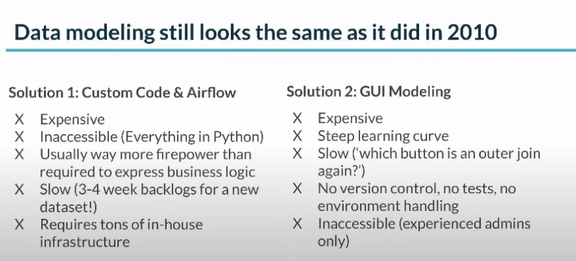
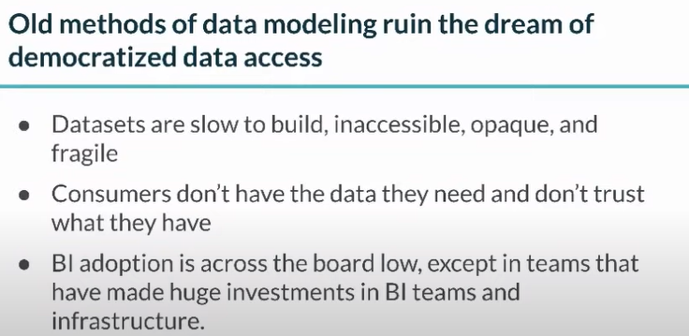

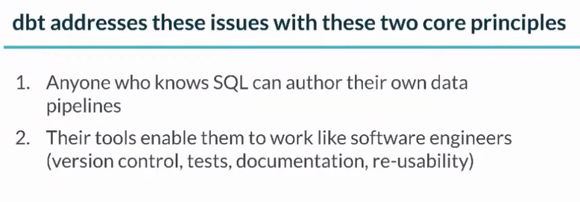
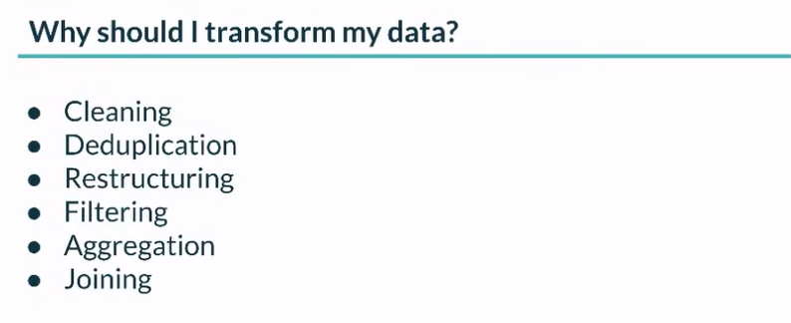

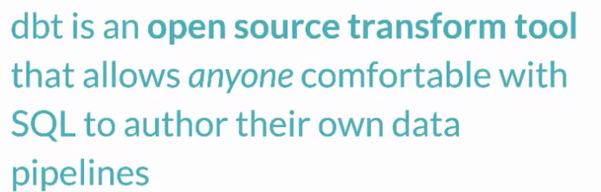

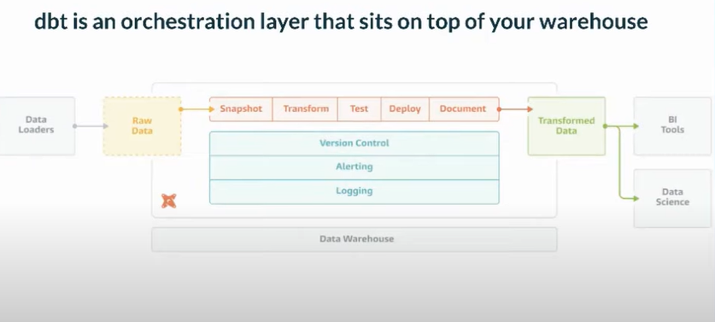
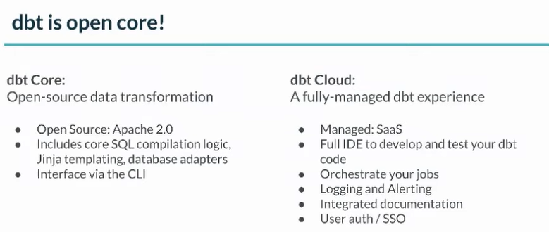

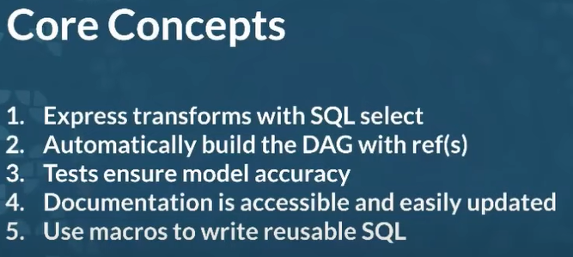

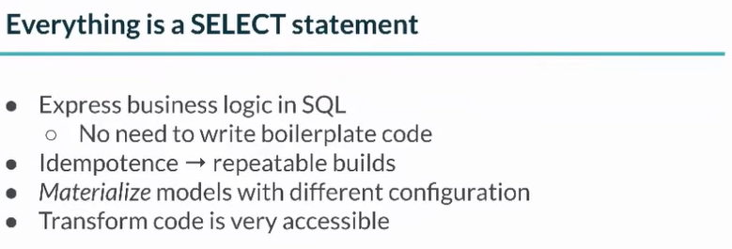
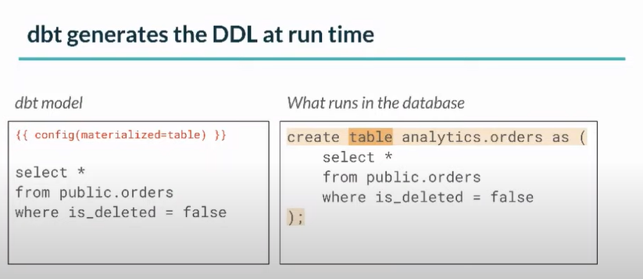

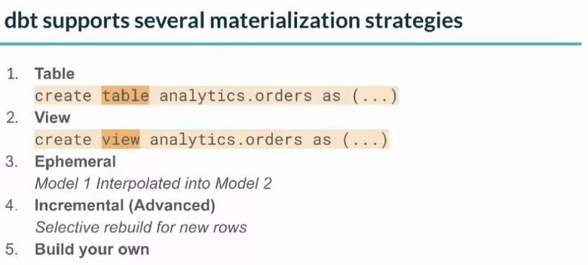
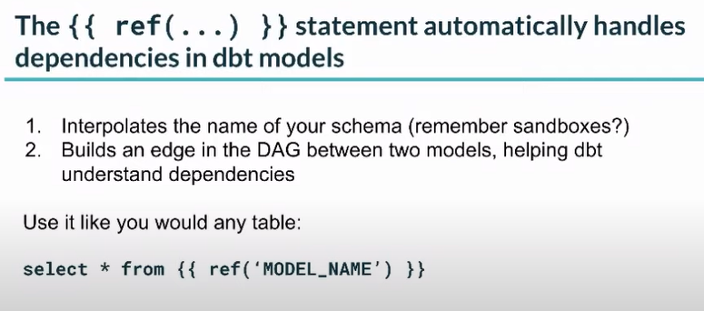
model_name → table or view

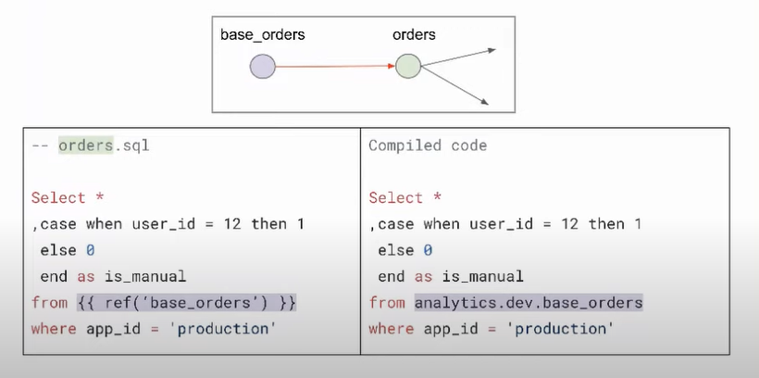

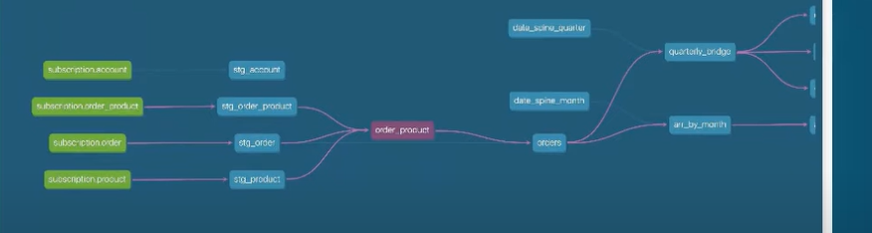
lineage graphs



