Make user able to run ‘sudo’ command:
Add user in a ‘wheel’ group for root previlage
=> usermod –aG wheel <UserName>

Run 'sudo' command as a user(like Ubuntu).
Enter into root:
=> su - root
=> nano /etc/sudoers

# under 'Allow root to run any command anywhere' add
<username> ALL=(ALL) ALL

Rough_notes_day_2.txt assignments:

Assignment 1 :- Install all the dependencies for making centOS full screen

To make full screen, one need to run ‘Guset Additions CD image...’ It is under ‘Devices’ of Virtualbox window. It also has some dependency which need to be install.

step 1: Update repository before installing any dependency
=> sudo yum update

step 2: Install ‘Guest Additions CD image’ dependency
=> sudo yum install dkms gcc make kernel-devel bzip2 binutils patch libgomp glibc-headers glibc-devel kernel-headers -y

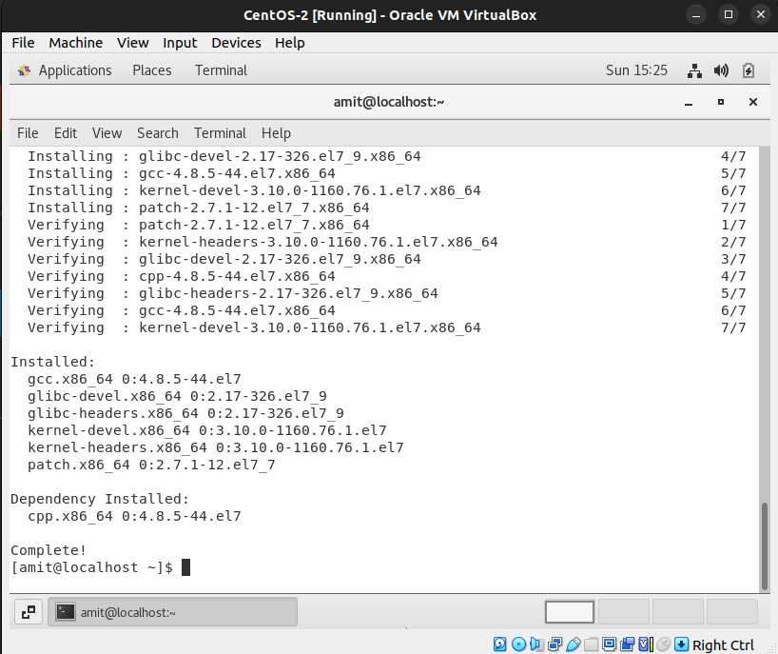
Here is the large screen picture of CentOS-
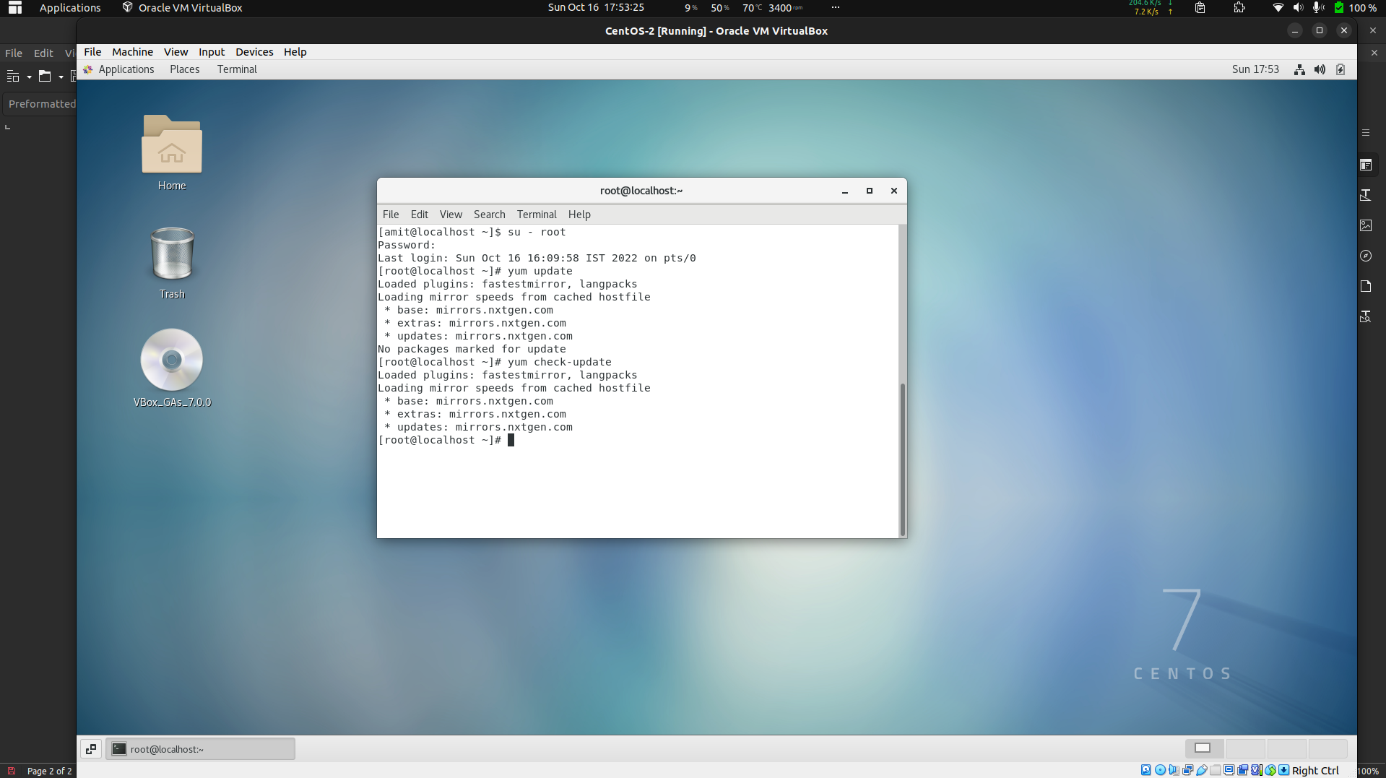
Here is the link that I follow: Make CentOS Full Screen

Assignemnt 2 :- Please update you CentOs machine

Method 1:
step 1: Go to root
=> su – root

step 2: Run update command
=> yum check-update/update

Method 2:
As I am able run ‘sudo’, I can dircetly run
=> sudo yum update

Assignments

Assignment 2: Password changing

Q: Login into your account and then change password?
  - Change your password into IneuR0n#42 and hit the Enter key

Ans: It successfully changed the login user password.

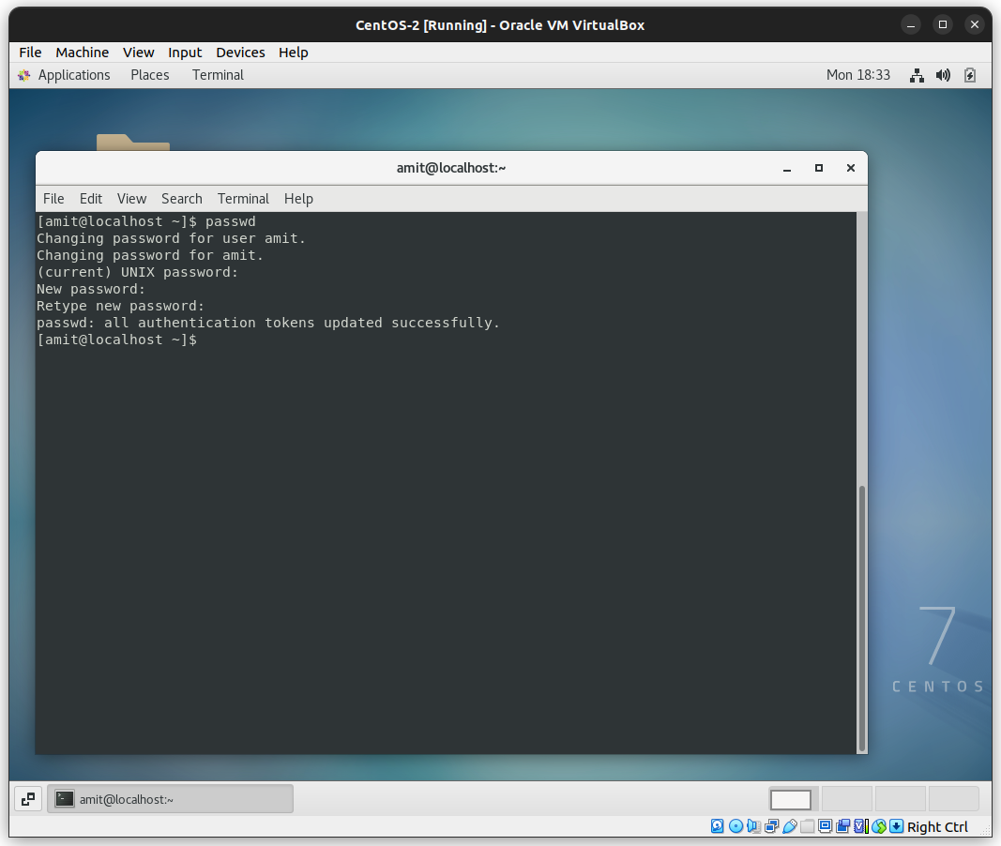
Q: Try again to change password but use like password 1234 or abcd

Ans: The password is shorter than 8 characters.
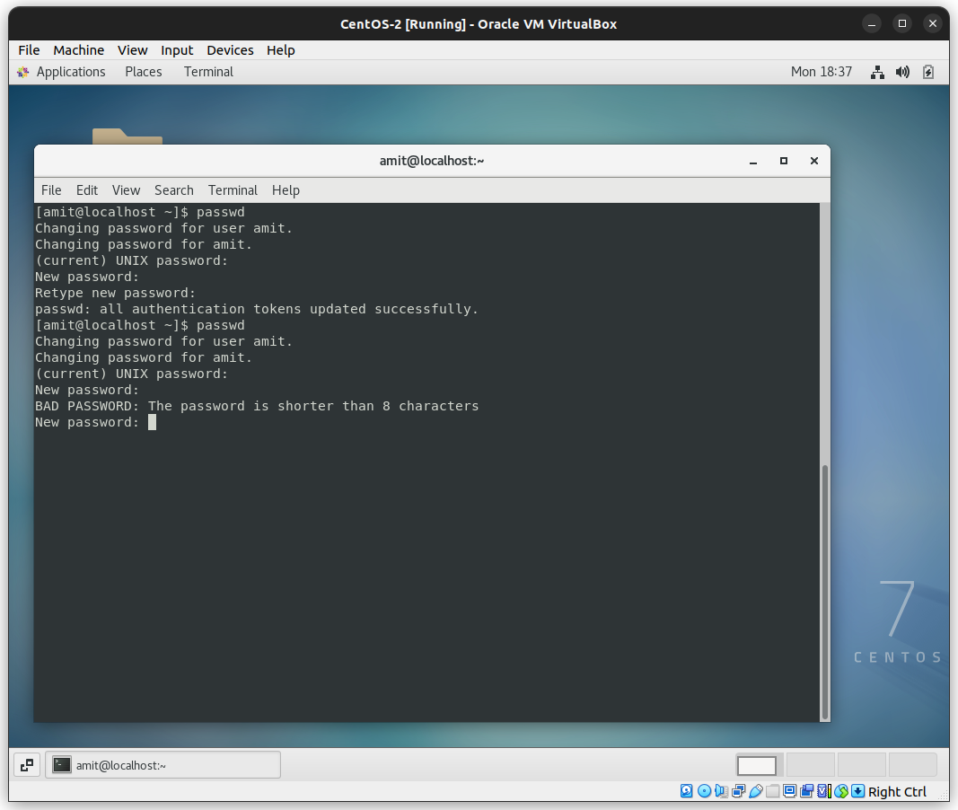
Q: Try again to change password but now don’t use any password just hit Enter key

Ans: Terminal prompts me that I didn’t pass any password.
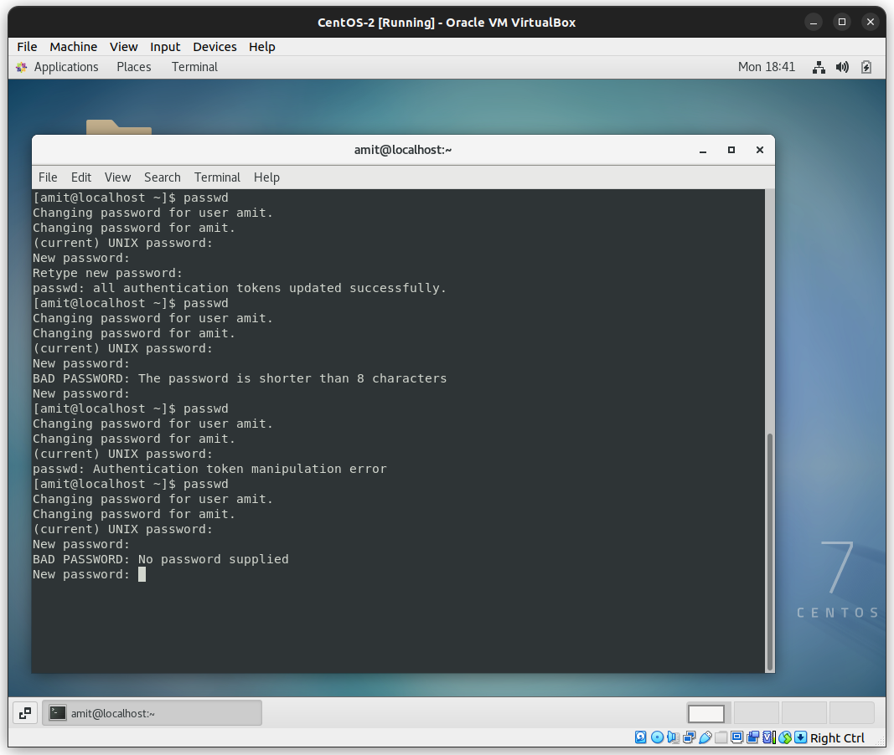

Assignmet 3: Working with Directories

Q: Enter the command cd / and then ls and then hit Enter key

Ans: It goes to root directory and ls shows whats in that dircetory.
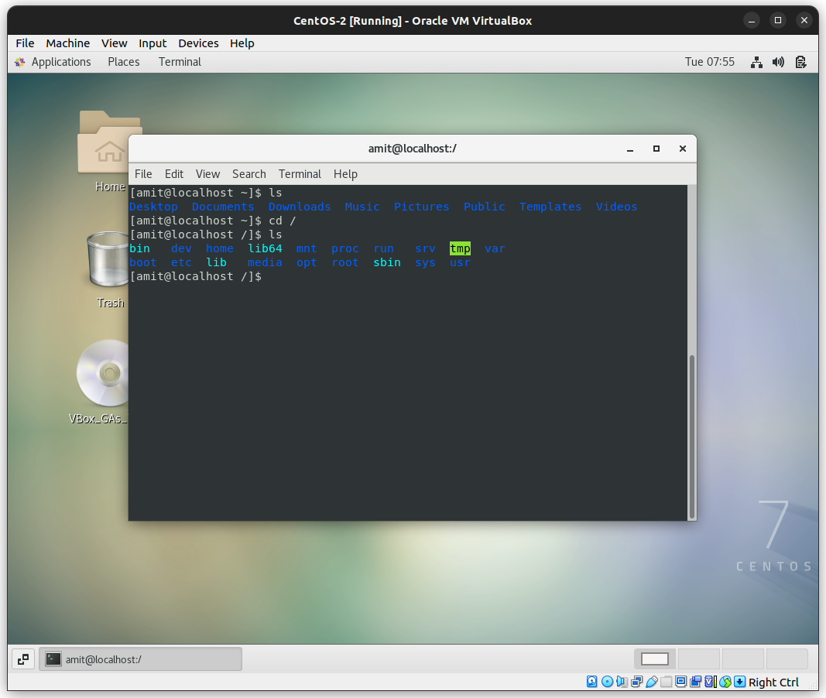
Q: Enter the command now cd /home and then hit Enter key

Ans: /home dircetory is where all the users personal home directory stays. When we create a new user it will create a personal home directory of that particular user with the username of that user.

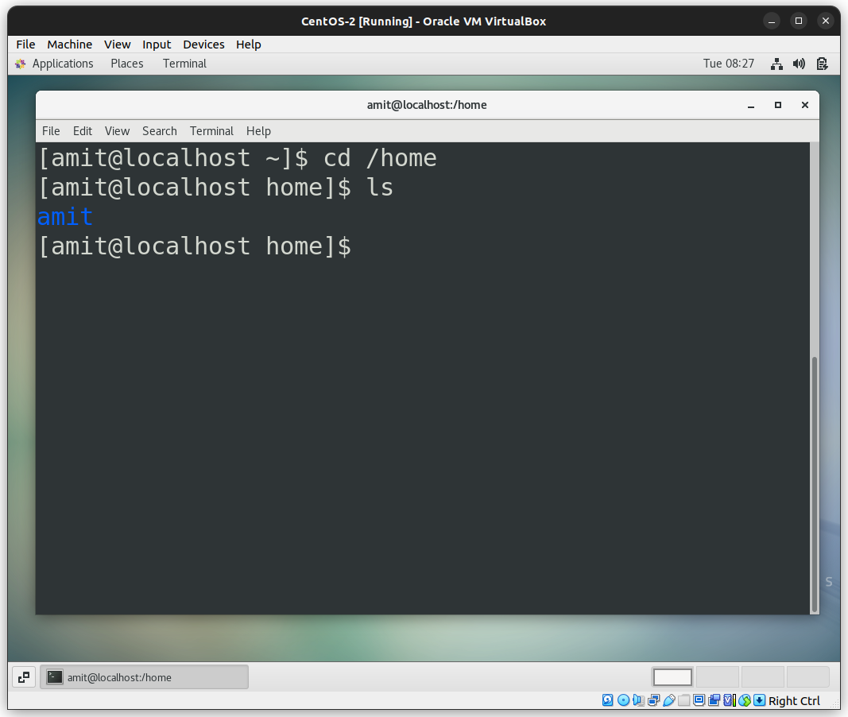

Q: Enter cd .. and hit Enter key

Ans: It goes to the ‘root’ directory.
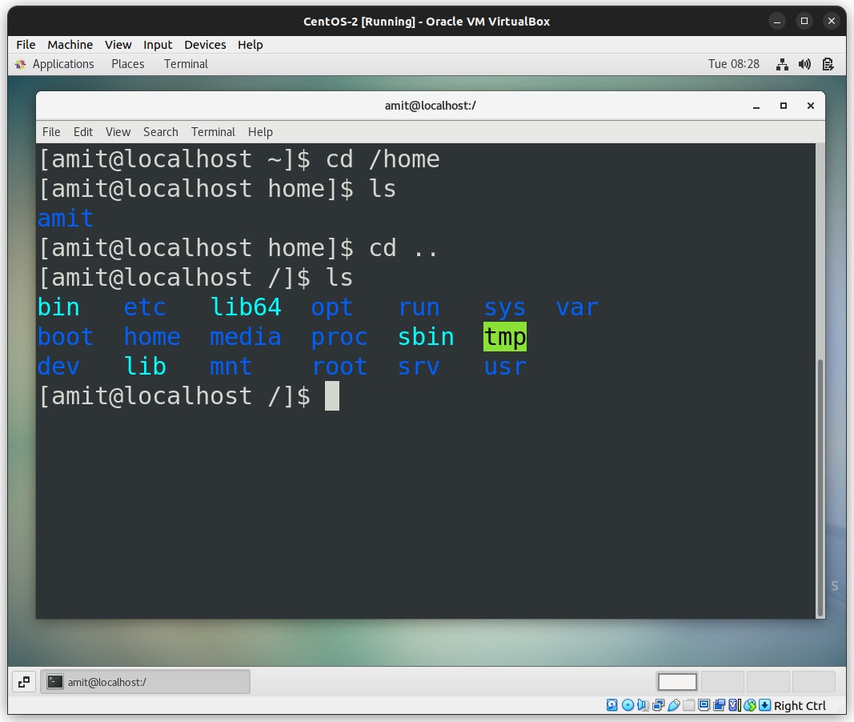
Q: Now enter cd /var/www/html and then type cd and hit Enter key

Ans: There is no such file or directory.
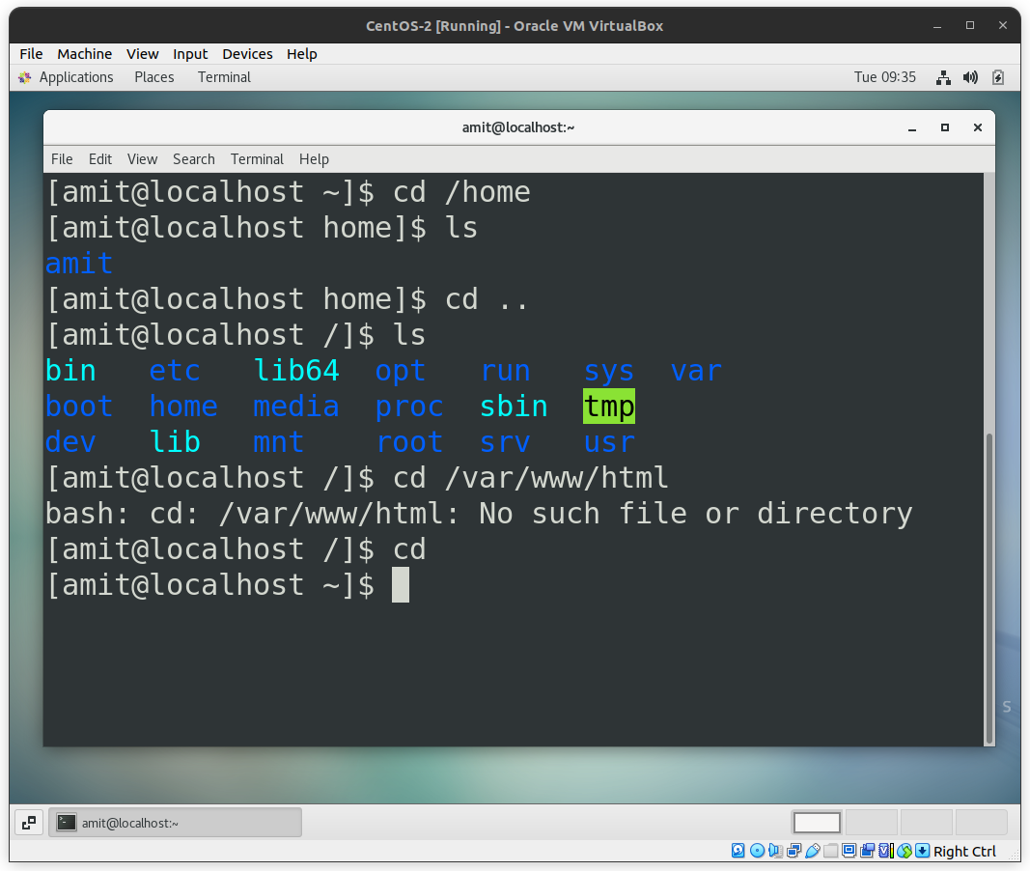

Q: Now type cd /root and then hit Enter key

Ans: As a normal user we can not access ‘root’ directory.
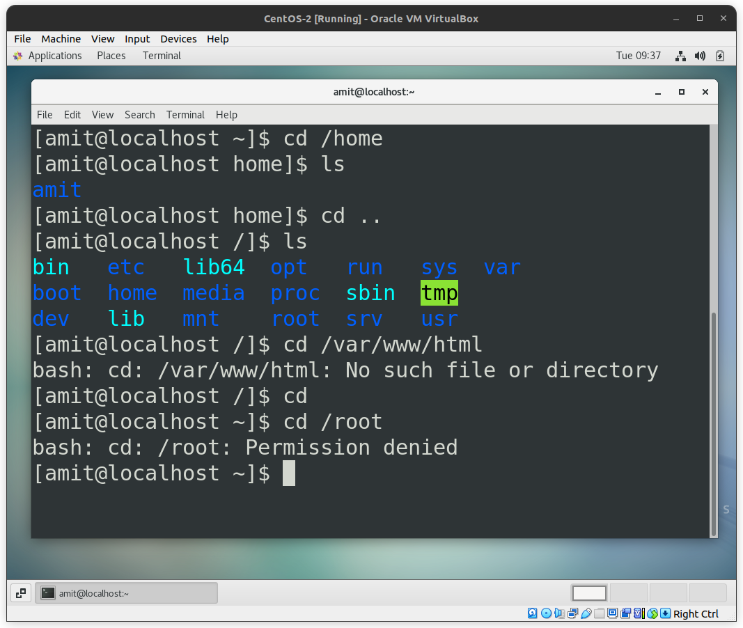

Assignment 4: Working with File Listing

Q: Go to cd /etc and type ls

Ans: /etc means "et cetera". It contains various configuration file.
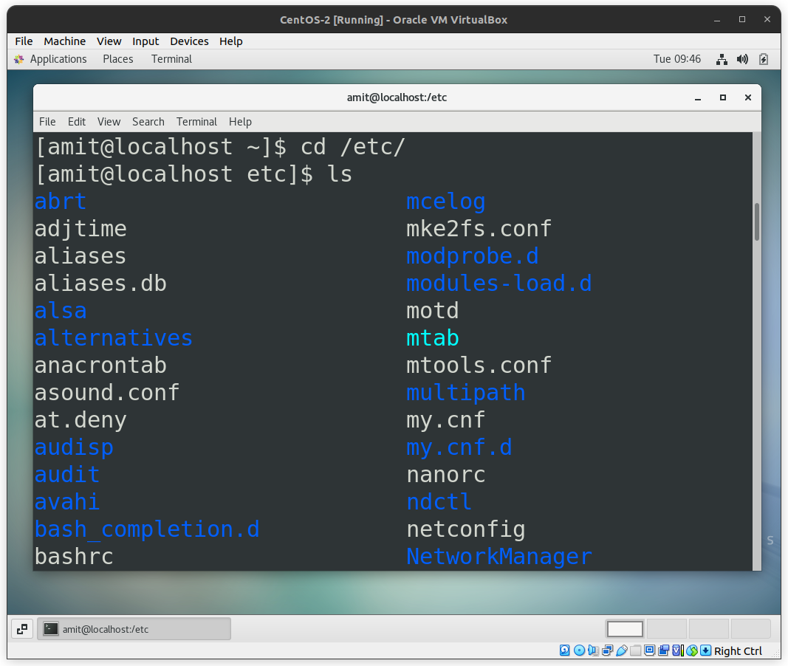
Q: Take screenshot and explain what different output you found compare to previous command you used?

Ans: The previous command is ‘cd /root’. It says that you don’t have permission to access that directory. You need to root permission to access ‘root’ directory.
As for ‘cd /etc’, it shows the contains of that directtory. You can access it as normal user.
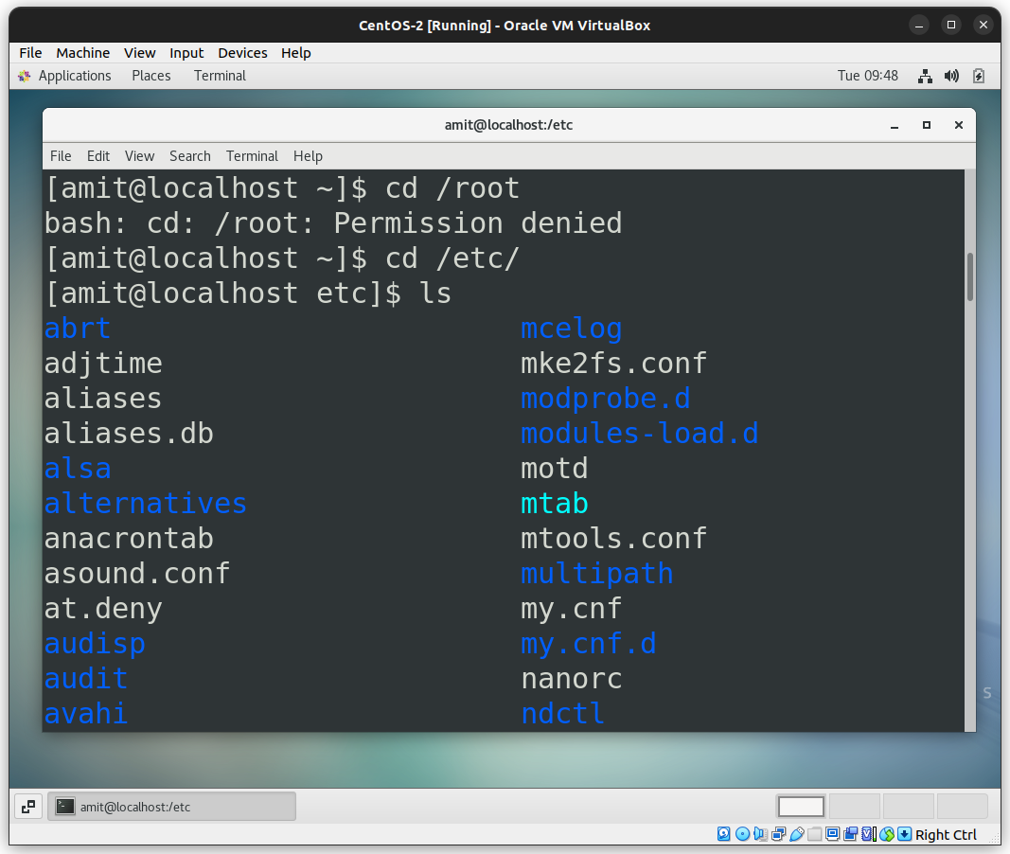
Q: Then type ls -al and hit Enter key

Ans: This command will show normal file as well as hidden files and directory with permission, size, date etc.
‘ls’ command by default list all the files except hidden files. ‘-a’ (--all - do not ignore entries starting with ‘.’) option will show normal files and directory as well as hidden file and directory also.
‘-l’ (long listing format) option will show the permissions of the files and directories as well as other attributes such as folder names, file and directory sizes, and modified date and time.
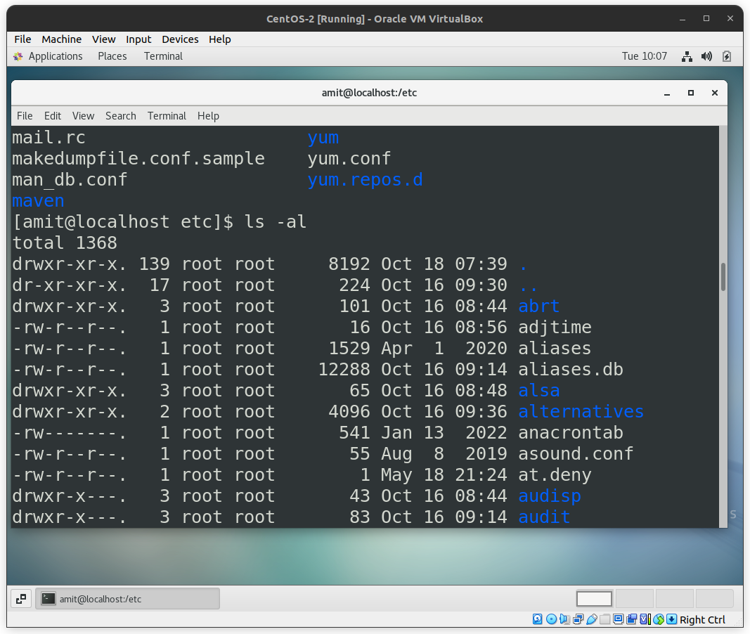
Q: Then use ls -i and hit Enter key

Ans: It stnads for –inode(index node). A inode is unqui identification number of a file. ‘ls -i’ will show the file with its inode number.
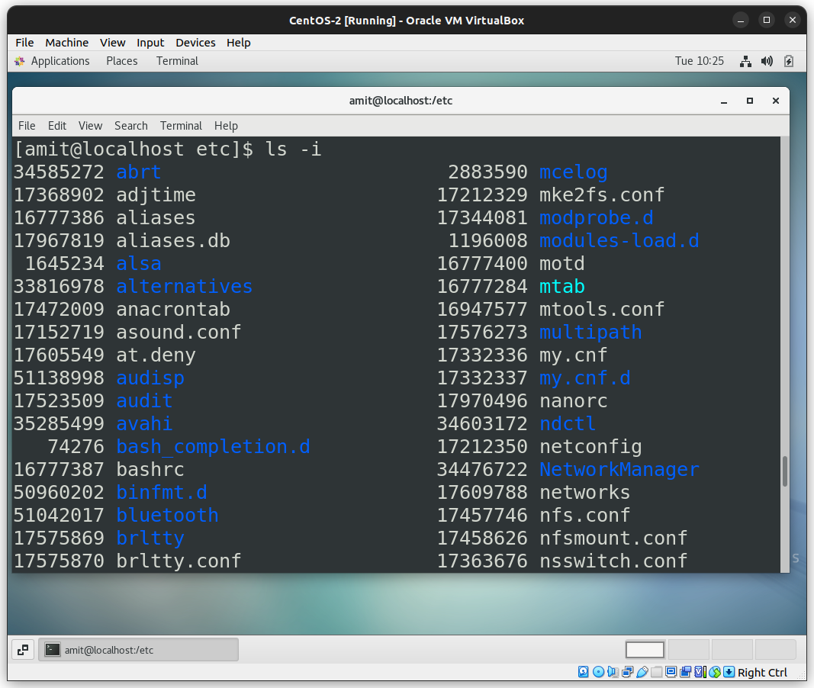
Q: Then use ls –-help and see other options about ls command

Ans: It shows all the avilable options of ls as well as its description.
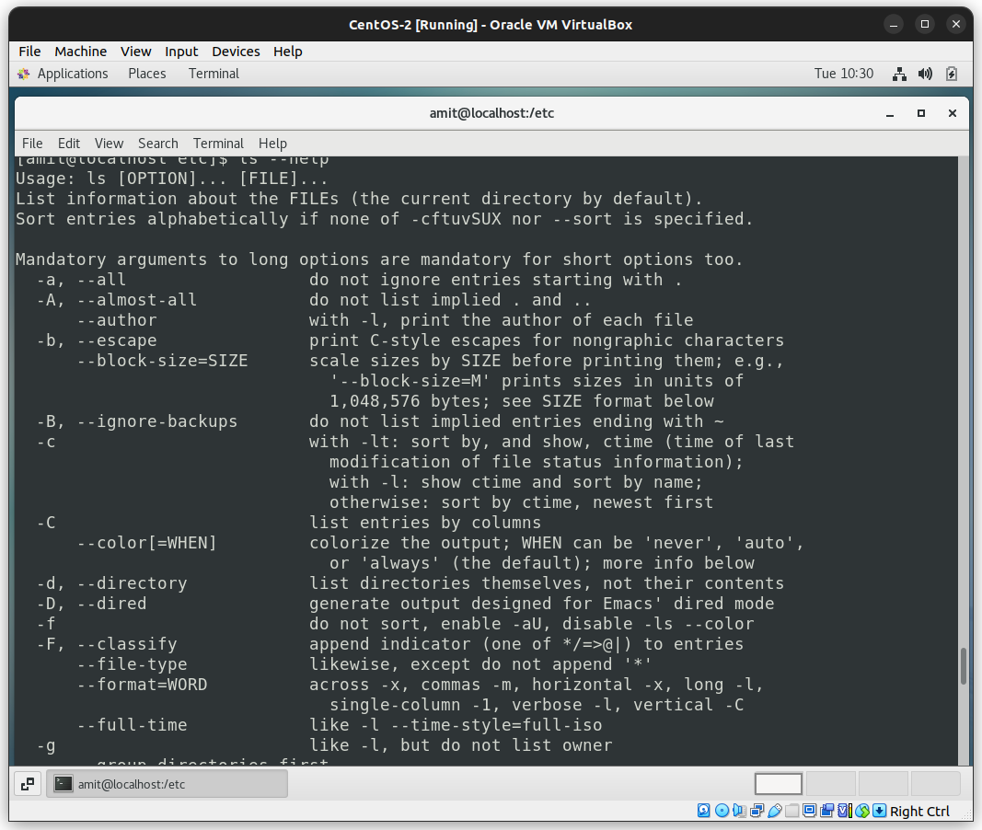
Some commands that I look into -
- ls -hl // it will show file size more human freindly
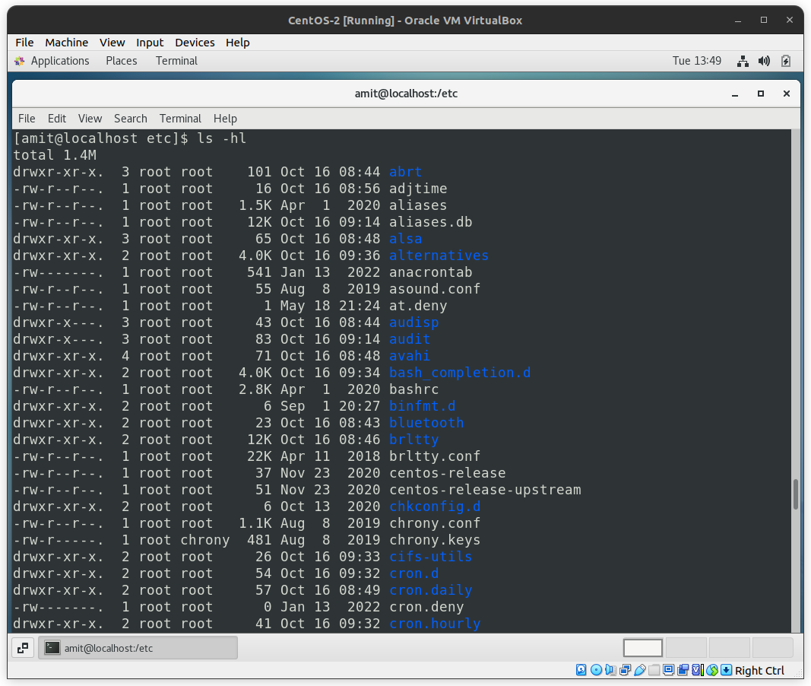
- ls -hlt // sort by time
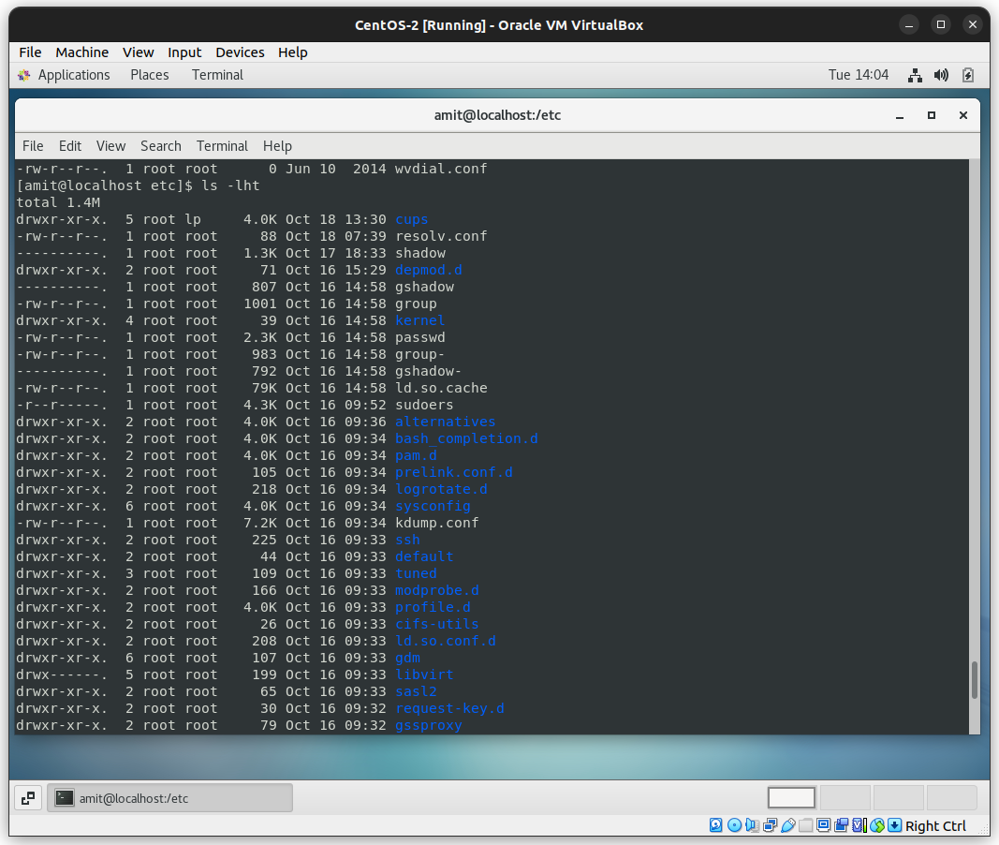

- ls -lR // It will show every directory and all directories with in it recursively.
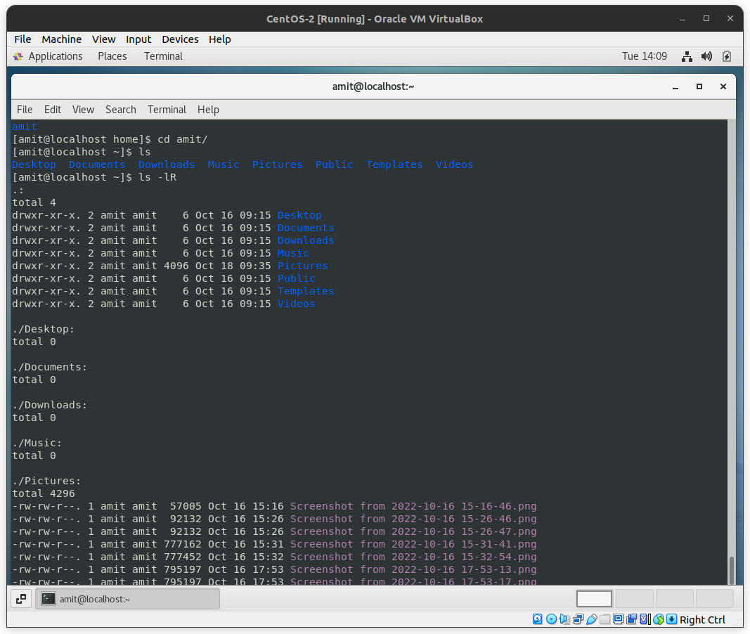
Assignment 5: Know where you are and where you working

Q: Check which location you working, type pwd and take screenshot

Ans: /home/amit
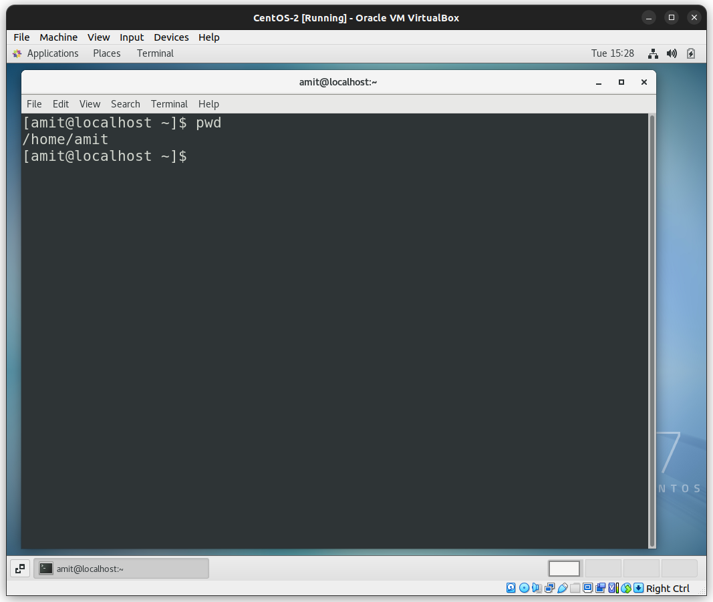
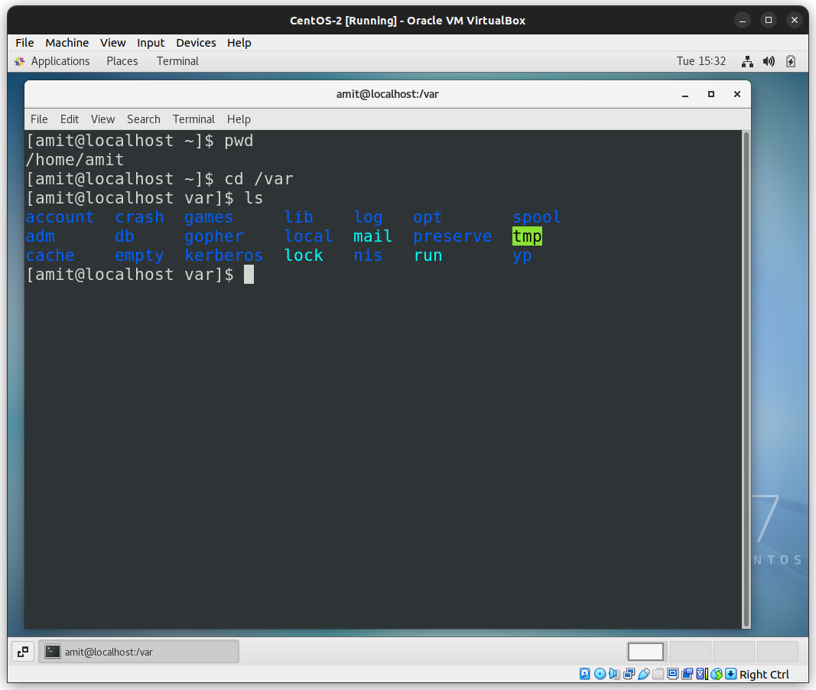
Q: Now use cd /var and hit Enter key
Q: Do explore other help options of each command to learn more other things we can do with these commands



