Science & Tech

**Quantum Computers: The Next Frontier in Computing**

Published on December 8, 2024

**The Next Frontier in Computing**

Quantum computing is an emerging field of cutting-edge computer science that takes advantage of the principles of quantum mechanics, such as superposition and entanglement, to perform calculations far beyond the capabilities of classical computers. These machines process information using qubits, which can simultaneously represent both 0 and 1, enabling them to solve complex problems more efficiently.

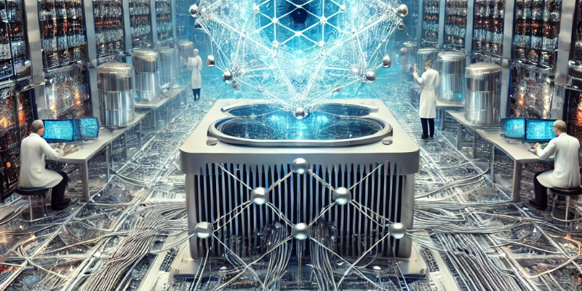An example of a quantum computer prototype. (Image: AI Genrated )

**Key milestones**

1950s-1980s: Theoretical foundations by Richard Feynman and David Deutsch.

1994: Shor's algorithm demonstrated the quantum advantage in cryptography.

2019: Google achieved "quantum supremacy."

An example of a quantum computer prototype. (Image Credit: IBM)

**Applications**

* **Optimization:**Improving logistics and financial modeling.
* **Cryptography:** Breaking encryption methods currently deemed secure.
* **Medicine:** Designing new drugs and understanding protein structures faster than ever.
* **Logistics:** Optimizing supply chains and reducing inefficiencies.
* **AI:**Enhancing machine learning algorithms.
* **Climate science:**Advancing simulations for climate research.

**Challenges**

Quantum computing faces obstacles such as qubit instability, error correction, scalability, and high cost.

**The Future**

Despite the challenges, advances in hardware, error correction, and accessibility through cloud platforms indicate that quantum computing will transform science, technology, and society in the coming decades.