RoundCraft | Agora-First Backend Architecture
Production blueprint for a configurable 2-5 member AI interview panel with native interruption, shared context, tools and evidence-linked assessment
CORE DECISION One Agora voice session per interview. The silent Panel Director arbitrates every completed candidate turn, so panelist 1 -> 3 -> 1 works naturally: one audible speaker, no linear handoff and no human reviewer.
STACK Next.js 16 + Agora RTC/RTM and Agent UI Kit | Agora Conversational AI with managed STT/TTS | Python 3.12, FastAPI and Agora Agents SDK | Supabase Auth/Postgres/pgvector/Storage | Vercel + Cloud Run
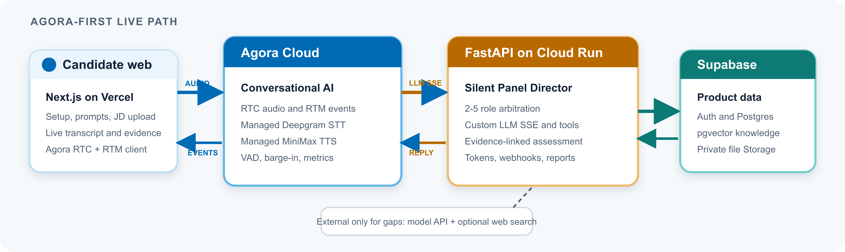
RUNTIME FLOW | DATA PLACEMENT | CONTROL, TOOLS & SAFETY
1 Optionally upload a JD; review editable panel and rubric recommendations.  2 Backend mints short RTC/RTM tokens and starts one Agora agent.  3 Speech/barge-in stays in Agora; managed STT yields the final turn.  4 Custom LLM callback scores all roles; Director selects exactly one.  5 Winner may use allowed tools; reply streams through Agora managed TTS.  6 RTM turns and webhook history reconcile; the assessor creates evidence-linked scores and drills. | DB Supabase Postgres: users, prompt versions, panel snapshots, sessions, turns, tool runs, evidence, scores and replay drills.  RAG pgvector: optional JD, resume, company/product context, case and rubric chunks.  LIVE Agora RTM carries transcript, speaker state, latency and errors; Postgres keeps durable panel memory and audit events.  FILE Private Supabase Storage: JD/resume uploads, reports and optional session artifacts. Recording is off by default.  KEY Transcript truth is keyed by Agora turn_id plus panelist_id; interrupted drafts remain visible but are never final score evidence. | TOOLS Typed and role-scoped: JD knowledge search, current web facts, safe calculator, evidence bookmark and replay drill.  PROMPT Built-ins are immutable: Select uses one, Edit forks a version and New creates a candidate-owned prompt.  SCORE No human escalation. Uncertainty becomes an adaptive probe, insufficient_evidence, or a replay drill.  SEC JWT + RLS, short-lived Agora tokens, server-only App Certificate, bearer-authenticated /llm, HMAC-SHA256 webhooks + noticeId dedupe.  OPS Vercel web + Cloud Run API; Agora state/latency/error events, signed URLs, retention controls and independent CI/CD.
OFFICIAL AGORA BASIS Managed mode | Custom LLM | Live transcripts | RTM state | Webhooks | Verified against current official documentation on 31 Aug 2026.

