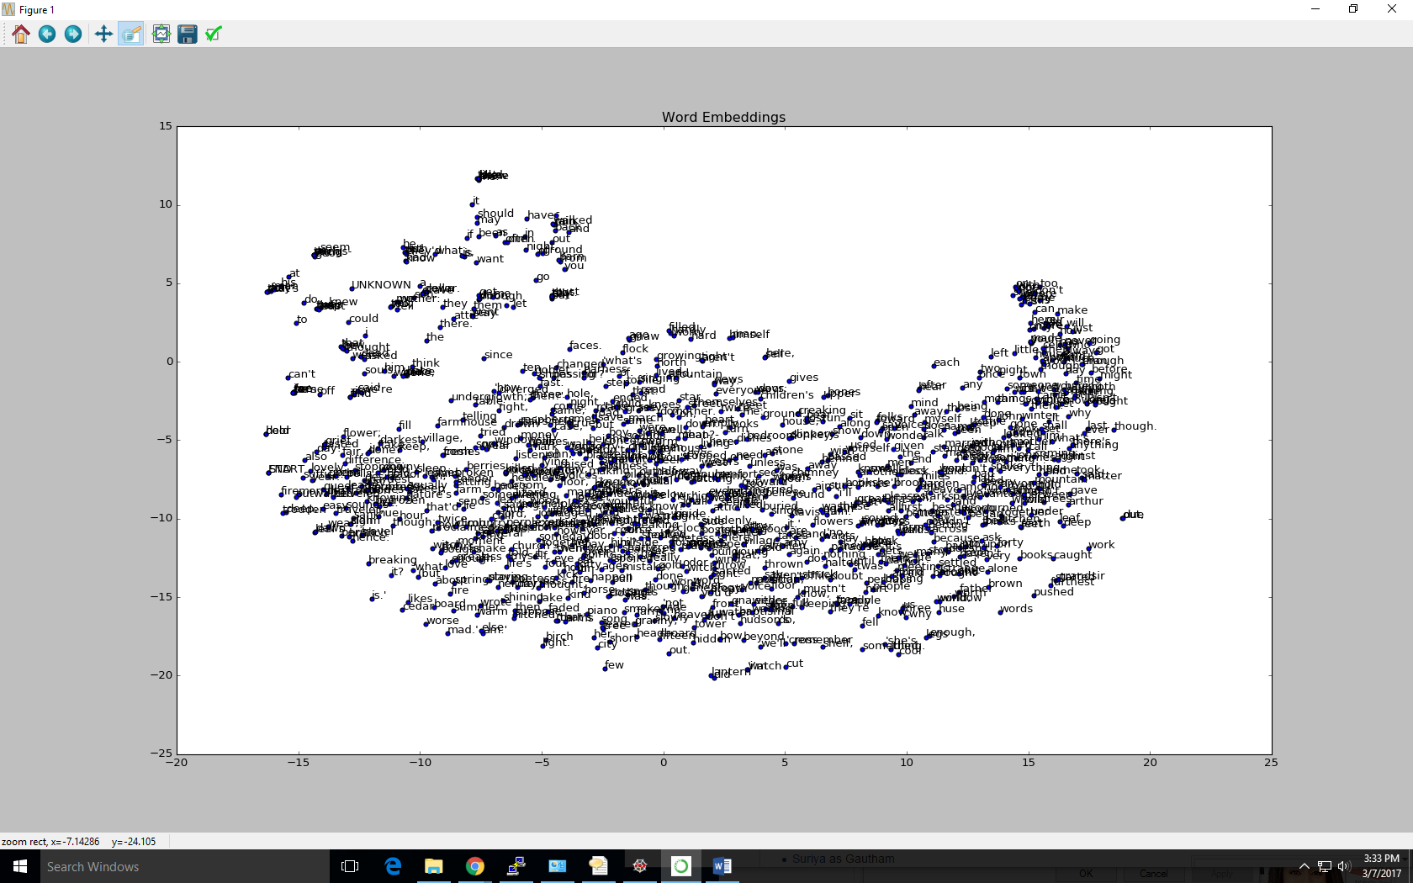

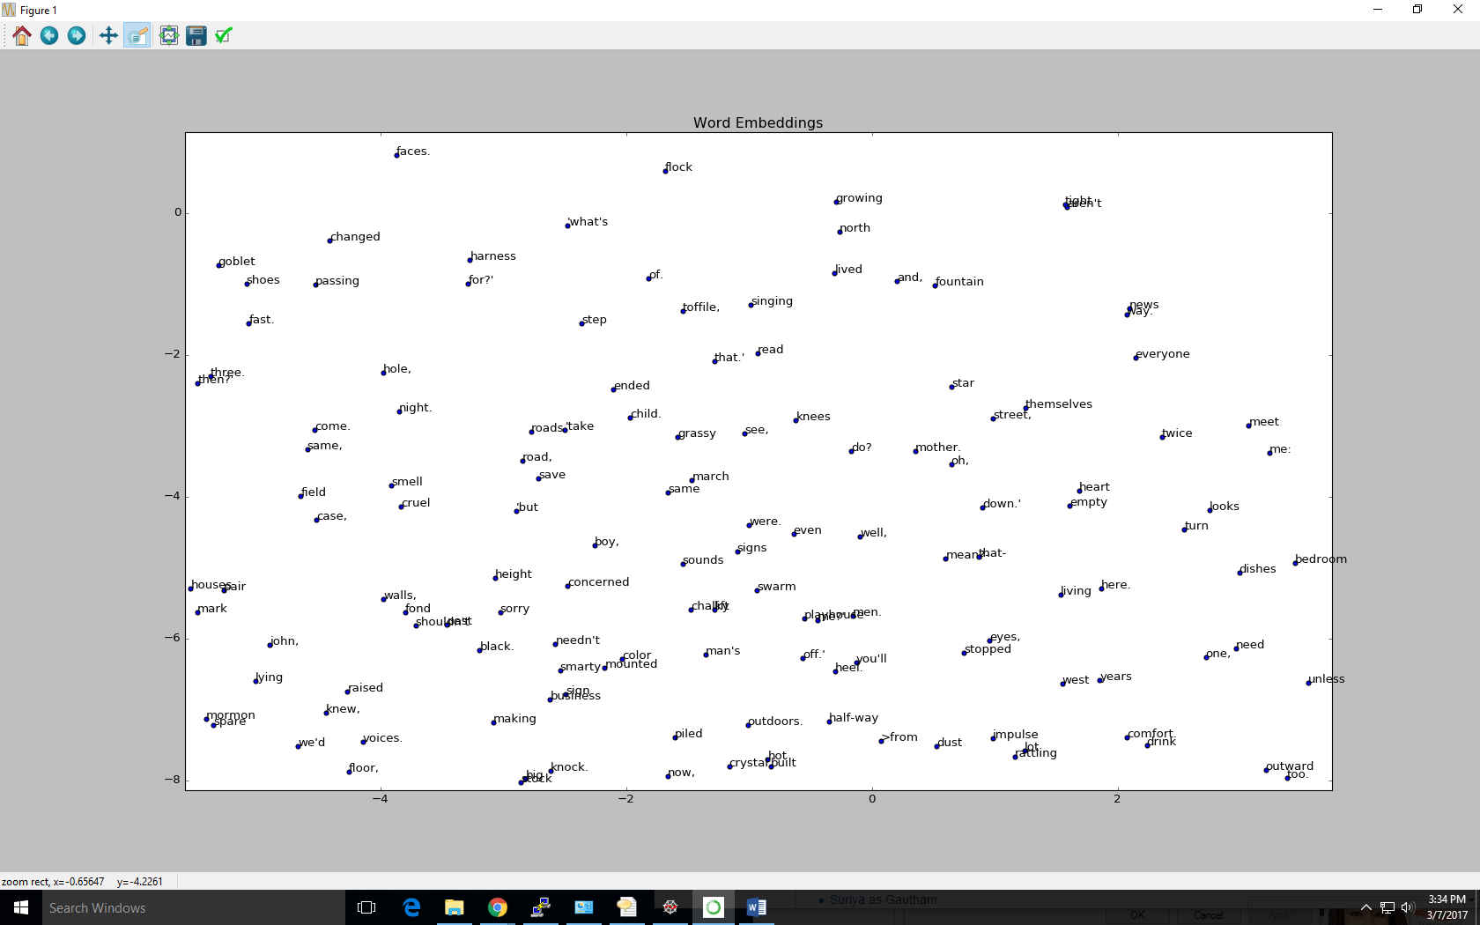

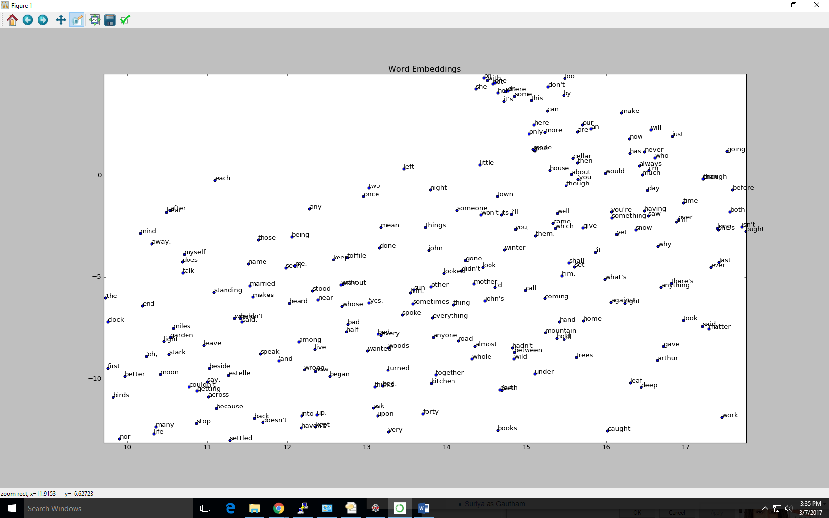

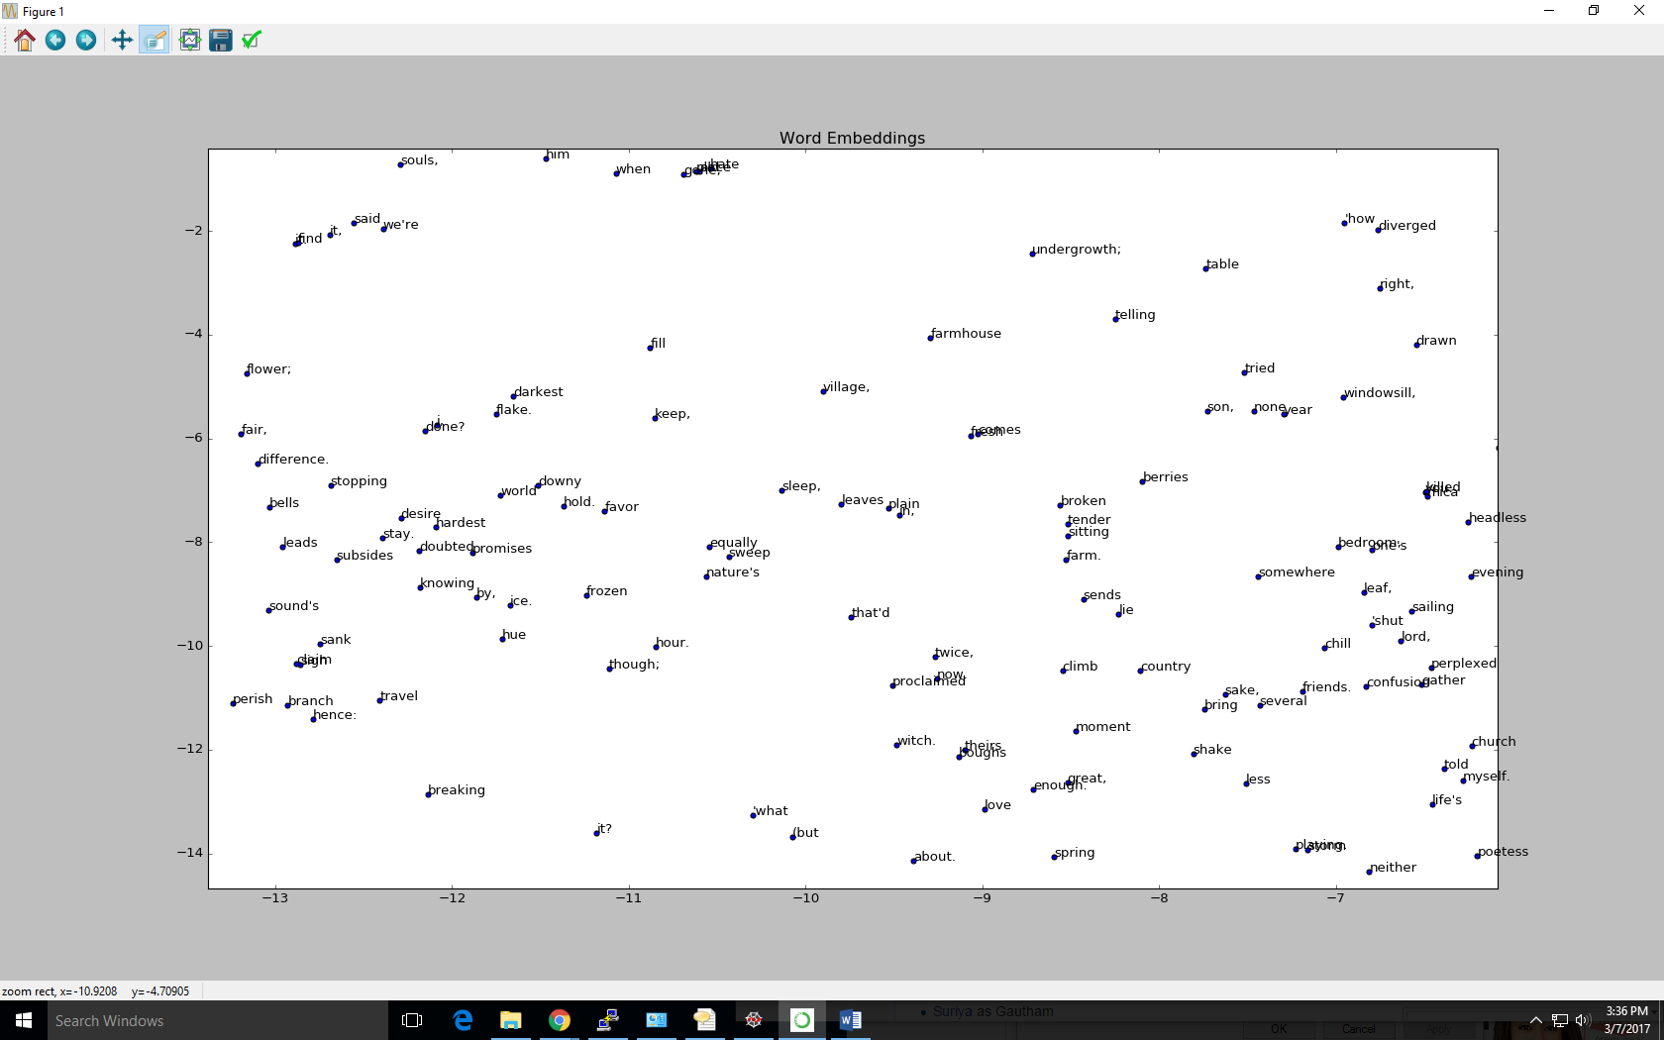

Poetry Generation

Vocabulary Size = 1000

and UNKNOWN

in UNKNOWN and UNKNOWN

from which UNKNOWN of UNKNOWN

she and came or UNKNOWN UNKNOWN

but UNKNOWN signs by a UNKNOWN UNKNOWN

'i can see the floor,

i can UNKNOWN together is UNKNOWN

or old UNKNOWN

i can UNKNOWN together is UNKNOWN

he's UNKNOWN and UNKNOWN

'yes, UNKNOWN and UNKNOWN

bless you, it's UNKNOWN

the UNKNOWN more up the UNKNOWN road,

to see that i'm the UNKNOWN had was UNKNOWN

UNKNOWN UNKNOWN

'no, i don't UNKNOWN it and be one of UNKNOWN the UNKNOWN UNKNOWN