**Department Of Information Technology**

**Master Of Computer Application**

**Problem Solving using C**

619402

PRACTICAL

Batch => MCA [2022-23]

Enrollment No. =>

Name => Amitesh Vashishth

Faculty => Prof. Madhuri

**Roll no** => **03**

**Problem Solving Using C (619401)**

**INDEX**

|  |  |  |  |  |
| --- | --- | --- | --- | --- |
| **Name:** | **Amitesh Vashishth** | **Enrollment No:** | |  |
| **SR NO.** | **TITLE** | **PAGE NO.** | **DATE** | **SIGN** |
|  | **Practical-1** |  | |  |
| 1. | Print “Hello World!”, “My name is <name>”, “<Address lines>”. | 1 | 7/10/21 |  |
| 2. | x1 = 2; x2 = 7;  Print “x1 = value, x2 = value”. | 2 | 7/10/21 |
| 3. | Write a program to take 5 integers and find and print the total and average of the 5 numbers. Repeat the same for floating point numbers instead of integers. | 3 | 7/10/21 |
| 4. | i) Initialize sum = 0; ii) repeat sum = sum + value; Write a program to find the sum of 1, 2, 3…., n. Print average (avg) also. | 4 | 8/10/21 |
| 5. | Write a program to accept n. Find sum of n values accepted 1 by 1. Also find average(avg). Print sum, avg.  Additionally, print the input values also. | 5 | 8/10/21 |
| 6. | Write a program to accept m and n input values to be stored in an array. Find sum and average(avg) of n values.  Print input values followed by sum, avg. | 6 | 8/10/21 |
| 7. | Write a program to declare string “GMCA” and print it. | 7 | 12/10/21 |
|  | **Practical-2** |  | |  |
| 8. | Write a program to accept as input: first name, middle name, surname; then print name, first as  a) first middle surname b) surname first middle. | 8 | 12/10/21 |  |
| 9. | Write a program to find string length. Is the string length same as number of characters in the string? | 9 | 12/10/21 |  |
| 10. | Write the program to find string length by using function for finding string length. Test this program to find lengths of first name, middle name and surname. | 10 | 12/10/21 |
| 11. | Write a program to print a given string in reverse order. | 11 | 12/10/21 |
|  | **Practical-3** |  | |  |

|  |  |  |  |  |
| --- | --- | --- | --- | --- |
| 12. | Write a program to take input n, and n values of temperature in ℉, Convert these into ℃ and print the values in a table with 1st column ℉ and 2nd column ℃. | 12 | 20/10/21 |  |
| 13. | Modify the previous program to convert temperature in ℃ into ℉. Write a function C2F() for this operation. | 14 | 20/10/21 |
|  | **Practical-4** |  |  | |
| 14. | Take two integer values from user as numerator(num1) and denominator(num2), find quotient(q) and remainder(r). | 16 | 22/10/21 |  |
| 15. | Input an array (a list) of n integers, find and print as a table whether numbers are even or odd. | 17 | 22/10/21 |
| 16. | Print all primes in the first n(n>1) integers. | 18 | 22/10/21 |
|  | **Practical-5** |  |  | |
| 17. | Given two integers m and n (m,n>= 0), develop an algorithm and write a program in c to find their greatest common divisor (GCD). |  | 26/10/21 |  |
| 18. | Write a program in c to rearrange the elements in an array so that they appear in reverse order. |  | 26/10/21 |
|  | **Practical-6** |  |  | |
| 19. | Write a program to calculate and display the value of the slope of the line connecting the two points whose coordinates are(3,7) and (8,12). Slope of a line between two points (x1,y1) and (x2,y2) is (y2-y1)/(x2-x1). Run the same program for the line connecting the points (2,10) and (12,6) and other pairs of points. |  |  |  |
| 20. | Write a program to calculate and display the co-ordinates of the midpoint of the line connecting the two points given in the previous exercise. The co-ordinates of the midpoint between two points having co-ordinates (x1,y1) and (x2,y2) are ( (x1+x2)/2 , (y1+y2)/2). |  |  |  |
| 21. | Write a program that calculates the distance between two points whose coordinates are (7,12) and (3,9). Distance between two points having coordinates (x1,y1) and (y1,y2) = sqrt([x1-x2]2 + [y1-y2]2). Also, run the program for the points (-12,-15) and (22,5) and a few other points. |  |  |  |
|  | **Practical-7** |  |  | |
| 22. | Given some integer x , develop an algorithm and write a program to compute the value of x^n where n is considerably larger than 1. This algorithm has time complexity O(n). |  |  |  |

|  |  |  |  |  |
| --- | --- | --- | --- | --- |
| 23. | Develop an improved algorithm having time complexity O(log2n). |  |  |  |
|  | **Practical-8** |  | | |
| 24. | Write a program to evaluate sin(x). |  | 25/11/21 |  |
| 25. | Write a program to determine & display the maximum height reached when the ball is thrown at 5 miles/hour at an angle of 60 degree.(Hint:Make sure to convert the initial velocity into the correct units.) |  | 25/11/21 |  |
| 26. | Write a program to calculate & print height of the ladder. Where ladder is kept at angle 𝜃 with the horizontal base and length of the ladder l. (A)L=20,θ=85° (B)L=25,θ=75°. |  | 26/11/21 |  |
| 27. | Write a program that calculates x & y co-ordinates of the point whose polar co-ordinates are (A)r=10,𝜃=30° (B)r=12.5,𝜃=67.8°. |  | 26/11/21 |  |
|  | **Practical-9** |  | | |
| 28. | Given an integer n>=1 , develop an algorithm and write a program to find the smallest exact divisor of n other than one. |  |  |  |
| 29. | Every integer can be expressed as a product prime numbers. Develop an algorithm and write a program to compute all the prime factors of a given integer n>0. |  |  |  |
|  | **Practical-10** |  | | |
| 30. | Write a program in c to find factorial of n. (n!) |  | 23/11/21 |  |
| 31. | Write a program in c to find first n terms of the Fibonacci sequence using an iterative algorithm. |  | 2311/21 |
|  | **Practical-11** |  | | |
| 32. | Write a C program to exchange values of two variable. |  | 30/11/21 |  |
| 33. | Implement the program in C for “exchanging the values of two variable” using function (which will require use of pointers for function arguments in c). |  | 30/11/21 |  |
| 34. | Write a C program to find sum of n values 𝑎𝑖,i=1 to n,using pointer instead of arrays. |  | 30/11/21 |  |
| 35. | Write a C program tocount number of words in a given text by representing text string as pointer. |  | 2/12/21 |  |
|  | **Practical-12** |  | | |
| 36. | Write a program to remove all duplicates from an ordered array and contract the array accordingly. |  | 2/12/21 |  |

|  |  |  |  |  |
| --- | --- | --- | --- | --- |
|  | **Practical-13** |  | | |
| 37. | Given a number >=20 develop an algorithm & write a program in c to compute square root of a given nonnegative number by divide-conquer method. |  | 3/12/21 |  |
| 38. | Write a c program using an improved algorithm to compute square root using Newton’s method and other methods. |  | 8/12/21 |  |
|  | **Practical-14** |  | | |
| 39. | write a c program to find maximum and minimum values in a given array of values. Also write the c program using pointers instead of array. |  |  |  |

**Program 1 : Print Hello World, Name and Address.**

**Input :**

// Print Hello World,Name and Name

#include<stdio.h>

#include<conio.h>

void main()

{

printf(“ Hello World!”); printf(“\n I am Harsh Prajapati”); printf(“\n Address : Nikol, Ahmedabad”);

getch();

}

**Output :**

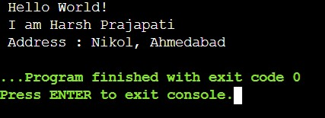

**Program 2 : X1 = 2, X2 = 7 Print both values.**

**Input :**

// Print Values

#include<stdio.h>

#include<conio.h>

void main()

{ int x1 = 2, x2 = 7;

printf("\n X1 = %d",x1); printf("\n X2 = %d",x2);

getch();

}

**Output :**

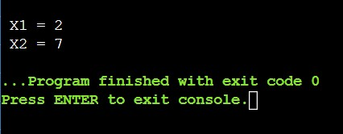

**Program 3 : Write a program to take 5 integer and find and print the total and average of the 5 numbers, repeat the same for floating point numbers instead of integers.**

**Input :**

//Print Sum and Average of Numbers

#include <stdio.h>

#include <conio.h>

int main()

{

//For Integer Sum and Average int a=10,b=20,c=30,d=40,e=50;

printf("\n Given Five Numbers : %d %d %d %d %d",a,b,c,d,e); int sum=a+b+c+d+e;

printf("\n\n Sum of Integer Value : %d",sum); int avg=sum/5;

printf("\n Average of Integer Value : %d \n",avg);

printf("\n-------------------------------------------------------------------\n");

//For Float Sum and Integer

float f=1.5,g=2.5,h=3.5,i=4.5,j=5.5,sumf,avgf; printf("\n Given Five Numbers : %f %f %f %f %f",f,g,h,i,j);

sumf= f+g+h+i+j;

printf("\n\n Sum of Float Value : %.2f \n",sumf); avgf=sumf/5;

printf(" Average of Float Value : %.2f",avgf);

return 0;

}

**Output :**

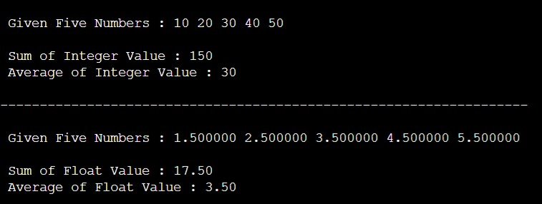

**Program 4 : Write a program to find the sum of 1, 2, 3, …, n. Print average also.**

**Input :**

// Print Sum and Average of N Number

#include <stdio.h>

int main()

{

int n,i,sum=0; float avg;

printf("\nEnter Any Number : "); scanf("%d",&n); for(i=1;i<=n;i++)

{

sum=sum+i;

} avg = sum/n; printf("\nSUM : %d\n",sum); printf("Average : %f",avg);

return 0;

}

**Output :**

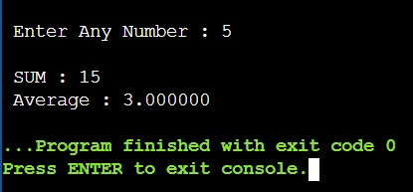

**Program 5: Write a program to accept n. Find sum of n values accepted one-by-one Also find average. Print sum, average additionally, print the input values also.**

**Input :**

//Print Sum and Average

#include <stdio.h> #include<conio.h>

void main()

{ int i,n;

float u,total=0,ave;

printf(" Enter Size of Value : "); scanf("%d",&n);

printf("-------------------------");

for(i=1;i<=n;i++)

{

printf("\n\n Enter Value : "); scanf("%f",&u); total += u; ave = total/i; printf("\n Total : %f",total);

printf("\n Average : %f",ave);

}

}

**Output :**

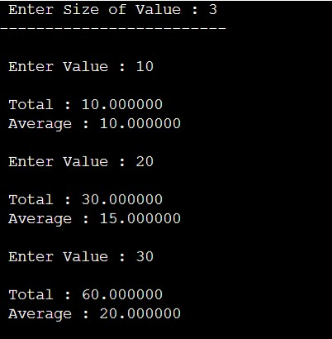

**Program 6: Write a program to accept n and n input values to be stored in an array. Find sum and average of n values. Print input values followed by sum, average.**

**Input :**

//Find Sum and Average Using Array

#include <stdio.h>

#include<conio.h>

void main()

{ int i,n;

float ar[100],total=0;

float ave;

printf(" Enter Size of Value : "); scanf("%d",&n); for(i=0;i<n;i++){ printf("\n Enter Value : "); scanf("%f",&ar[i]);

total += ar[i];

ave = total/n;

}

printf("\n------------------------------\n");

printf("\n Total : %f",total);

printf("\n Average : %f",ave);

}

**Output :**

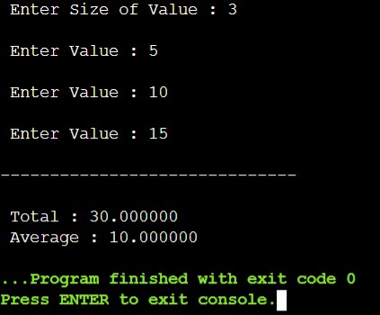

**Program 7: Write a program to declare string and print "Government MCA College”**

**Input :**

//Declare String Value and print.

#include <stdio.h>

#include <string.h>

void main()

{

char ch[] = "Government MCA Collage"; printf("\n\n Without for loop : %s",ch);

printf("\n____________________________________________\n");

int i; printf("\n Using for loop : ");

for(i=0;i<=strlen(ch);i++)

{

printf("%c",ch[i]);

}

}

**Output :**

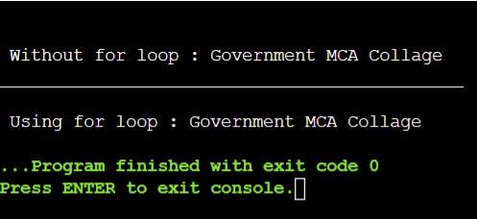

**Program 8: Write a program to accept as input first name, middle name and surname then print name, first as**

1. **FirstName MiddleName SurName.**
2. **SurName FirstName MiddleName**

**Input :**

//Print FirstName MiddleName LastName

#include <stdio.h>

#include <conio.h>

void main()

{

char fn[100],mn[100],srn[100]; printf("\n\n Enter Your First Name : "); scanf("%s",&fn);

printf("\n Enter Your Middle Name : "); scanf("%s",&mn);

printf("\n Enter Your Surname : "); scanf("%s",&srn);

printf("\n_____________________________________________________\n");

printf("\n Your Name is : %s %s %s",fn,mn,srn); printf("\n Your Name is : %s %s %s",srn,fn,mn);

getch();

}

**Output :**

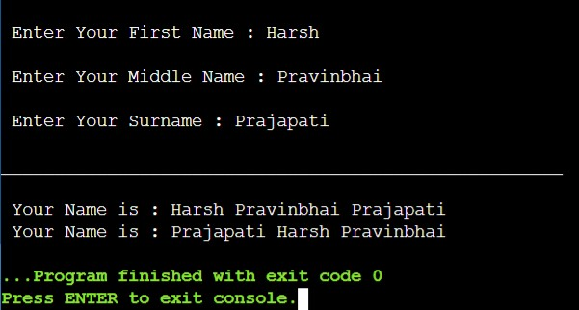

**Program 9: Write a program to find a string length. Is this string length same as no of characters in the string?**

**Input :**

//Find String Length and Print

#include <stdio.h>

#include <conio.h>

void main()

{

char str[] = "Government MCA College";

int count=0;

//Using String Function

int a = strlen(str); printf("\n\n %s",str);

printf("\n___________________________________________\n"); printf("\n String Length is Using Fuction : %d",a);

//Our Method

for(int i = 0;str[i] != NULL;i++)

{

count++;

}

printf("\n String Length Using Own Method : %d",count);

}

**Output :**

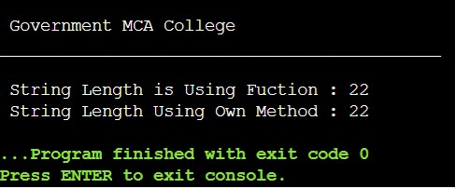

**Program 10: Write a program to find string length by using function for finding string length.**

**Test this program to find lengths of first, mid, and surname.**

**Input :**

//Print Length Of Your Name

#include <conio.h>

void main()

{

char fn[100],mn[100],srn[100]; printf(" Enter Your First Name : "); scanf("%s",&fn);

printf("\n Enter Your Middle Name : "); scanf("%s",&mn);

printf("\n Enter Your Surname : "); scanf("%s",&srn); printf("\n Your Name is : %s %s %s",fn,mn,srn); printf("\n\n Length Of First Name : %d",strlen(fn)); printf("\n Length Of Middle Name : %d",strlen(mn));

printf("\n Length Of Surname Name : %d",strlen(srn)); int total;

total = strlen(fn)+strlen(mn)+strlen(srn);

printf("\n_____________________________________\n"); printf("\n Total Length is : %d",total); getch();

}

Output :

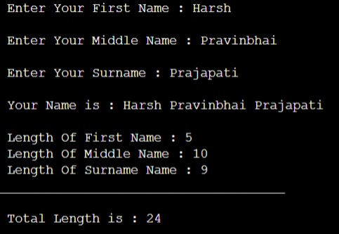

**Program 11 : Write a program to print a string in a reverse order.**

**Input :**

//Print String In Reverse Order

#include <stdio.h>

#include <string.h>

void main()

{

char ch[100];

int i,tmp;

printf("\n Enter Any String : ");

gets(ch);

tmp = strlen(ch);

printf("\n_________________________________________________________\n");

printf("\nGiven String In Reverse Order : ");

for(i=tmp-1;i>=0;i--)

{

printf("%c",ch[i]);

}

}

**Output :**

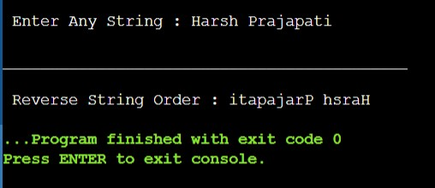

**Program 12: Write a program to take Input n, and n values of temperature in F, convert these into C and print the values in a table with 1st column containing F and 2nd column C**.

**Input :**

// Celsius to Fahrenheit Converter

#include <stdio.h> #include<conio.h>

void main()

{

float values[100],a; int choose,sizevalue;

printf("\n Choose F2C or C2F Press 1 or 2 : "); scanf("%d",&choose);

if(choose == 1)

{

printf("\n Enter the Number of Value : "); scanf("%d",&sizevalue);

for(int i = 0; i<sizevalue;i++)

{

printf("\n Enter Vaule of Fahrenheit : "); scanf("%f",&values[i]);

}

printf("--------------------------------------------------------"); printf("\n Fahrenheit value || Celsius Value\n-----------------------------------------------------"); for(int i = 0; i<values[i];i++)

{

a = values[i]-32; a = a*5; a = a/9; printf("\n Fahrenheit value : %f || Celsius is : %f ",values[i],a);

}

printf("\n--------------------------------------------------------");

}

if(choose == 2)

{

printf("\n Enter the Number of Value : "); scanf("%d",&sizevalue); for(int i = 0; i<sizevalue;i++)

{

printf("\n Enter Vaule of Celsius : "); scanf("%f",&values[i]);

}

printf("--------------------------------------------------------"); printf("\n Celsius value || Fahrenheit Value\n-----------------------------------------------------"); for(int i = 0; i<values[i];i++)

{

a = 32*5; a = 9*values[i]+a; a = a/5; printf("\n Celsius value : %f || Fahrenheit is : %f ",values[i],a);

}

printf("\n--------------------------------------------------------");

}

}

**Output :**

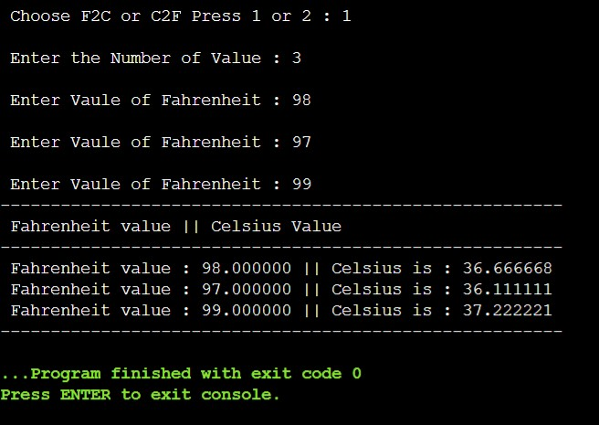

**Program 13: Modify the previous program to convert temperature in C into F. Write a function c2f () for this operation.**

// celsius to fahrenheit converter

#include <stdio.h> void main()

{

float values[100], a; int choose, sizevalue; printf("\n Choose F2C or C2F Press 1 or 2 : "); scanf("%d", &choose); c2f(choose); void c2f(int check)

{

if (check == 1)

{

printf("\n Enter the Number of Value : "); scanf("%d", &sizevalue); for (int i = 0; i < sizevalue; i++)

{

printf("\n Enter Vaule of Fahrenheit : "); scanf("%f", &values[i]);

}

printf("--------------------------------------------------------"); printf("\n Fahrenheit value || Celsius Value

\n--------------------------------------------------------"); for (int i = 0; i < values[i]; i++)

{

a = values[i] - 32; a = a * 5; a = a / 9; printf("\n Fahrenheit value : %f || Celsius is : %f ", values[i], a);

}

printf("\n--------------------------------------------------------");

}

if (choose == 2)

{

printf("\n Enter the Number of Value : "); scanf("%d", &sizevalue); for (int i = 0; i < sizevalue; i++)

{

printf("\n Enter Vaule of Celsius : "); scanf("%f", &values[i]);

}

printf("--------------------------------------------------------"); printf("\n Celsius value || Fahrenheit Value

\n--------------------------------------------------------"); for (int i = 0; i < values[i]; i++)

{ a = 32 * 5; a = 9 * values[i] + a; a = a / 5; printf("\n Celsius value : %f || Fahrenheit is : %f ", values[i], a);

}

printf("\n--------------------------------------------------------");

}

}

}

**Output :**

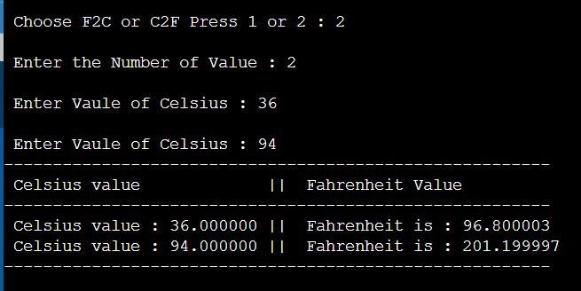

**Program 14: Take two integer values from user as Numerator (num1) and Denominator (num2), Find out Quotient (q) and Remainder (r). Repeat above program for floating point number.**

**Input :**

// Quotient And Remainder Finder

#include <stdio.h>

void main()

{ int n1,n2,q,r; printf("\n Enter First Number (Numerator) : "); scanf("%d",&n1); printf("\n Enter Second Number (Denominator) : "); scanf("%d",&n2);

q = n1/n2; //Computes Quotient r = n1%n2; //Computes Remainder

printf("\n Quotient : %d",q); printf("\n Remainder : %d",r);

}

**Output :**

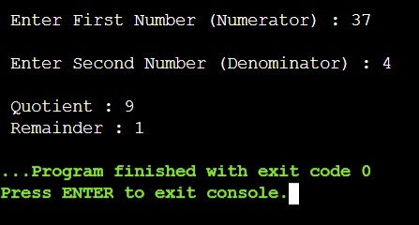

**Program 15: Input array (a list) of n integers, find and print as a table whether numbers are even or odd.**

// Check value even or odd using array

#include <stdio.h>

void main()

{

int a[100],n,i;

printf("\n How many numbers are you entered : "); scanf("%d",&n); for(i=1;i<=n;i++)

{

printf("\n Enter %d Elements : ",i);

scanf("%d",&a[i]);

}

printf("\n Even Numbers : "); for(i=1;i<=n;i++)

{ if(a[i]%2==0) {

printf("\n %d ",a[i]);

} }

printf("\n\n Odd Numbers : "); for(i=1;i<=n;i++)

{

|  |  |
| --- | --- |
|  | if(a[i]%2==1) |
|  | { |
|  | printf("\n %d ",a[i]); |
| }  } | } |

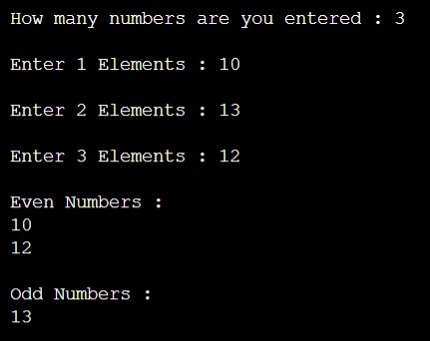

**Program 16: Print all primes in the first n (n>1) integers.**

**Input :**

//print prime number given range.

#include <stdio.h>

#include <conio.h>

void main(){ int n,c;

printf("\n Enter Value : "); scanf("%d",&n);

for (int i = 2; i <= n; i++) { c=0; for(int j=1;j<=i;j++)

{

if(i%j==0)

{

c++;

//printf("\n First loop : %d : Second loop : %d : value : %d",i,j,i%j);

}

else{

//printf("\n First loop : %d : Second loop : %d : value : %d",i,j,i%j);

}

}

if(c==2)

{

printf("\n Prime No : %d ",i);

}

//printf("\n");

}

}

**Output :**

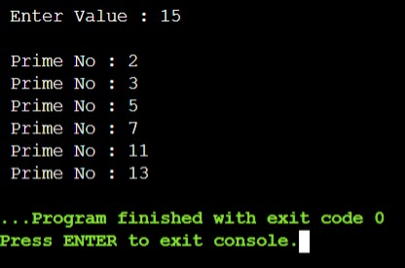

**Program 17: Given two integers m and n (m,n>= 0), develop an algorithm and write a program in c to find their greatest common divisor (GCD).**

**Input :**

//Find GCD

#include <stdio.h>

void main()

{

int m,n,gcd;

printf("\n Enter First Number : "); scanf("%d",&m);

printf("\n Enter Second Number : "); scanf("%d",&n);

for(int i=1;i<=m && i<=n;i++)

{

if(m%i==0 && n%i==0)

{

gcd=i;

}

}

printf("\n--------------------------------\n"); printf("Greatest Common Divisor Is : %d",gcd); printf("\n--------------------------------\n"); }

**Output :**

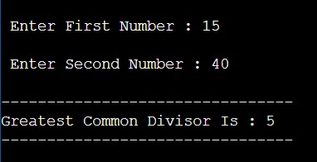

**Program 18: Write a program in c to rearrange the elements in an array so that they appear in reverse order.**

**Input :**

#include <stdio.h>

void main()

{

int a[100],n,i,last,first,tmp;

printf(" How many Elements are you added ? : "); scanf("%d",&n);

printf("\n Enter No Of Elements :\n");

for(i=0;i<n;i++)

{

scanf("%d",&a[i]);

}

printf("\n No Of Elements are : "); for(i=0;i<n;i++)

{

printf("%d\t",a[i]);

}

printf("\n\n-----------------------------------------------------------\n");

printf("\n Re-arrange Elements are : "); for (int i = n-1; i >= 0; i--)

{

printf("%d\t", a[i]);

}

}

**Output :**

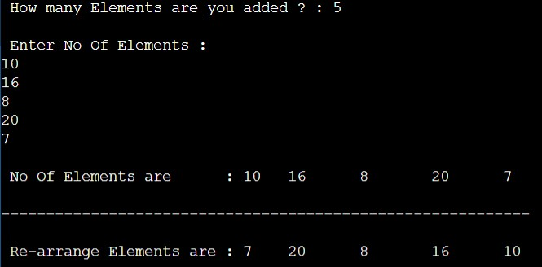

**Program 24: Write a program to evaluate sin(x).**

**Input :**

#include <stdio.h>

#include<math.h>

void main()

{

int n,i,sign=-1,fact=1; float x,ans;

printf("\n Enter a value of Degree : "); scanf("%f",&x);

printf(" Enter a value of N : ");

scanf("%d",&n);

x = x * 3.14 / 180;

ans = x;

printf("\n Degree Convert Into Radian : %.4f",ans);

for(i=3;i<=n;i+=2)

{

fact = fact * i * (i-1); ans = ans + sign * (pow(x,i) / fact);

sign = sign * -1;

}

printf("\n\n Value Of Sin(%.4f) : %.4f",x,ans);

}

**Output :**

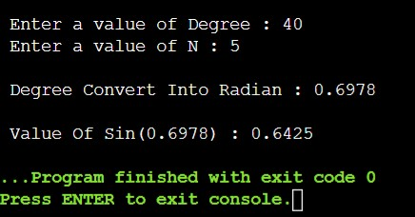

**Program 25: Write a program to determine & display the maximum height reached when the ball is thrown at 5 miles/hour at an angle of 60 degree. (Hint:Make sure to convert the initial velocity into the correct units.)**

**Input :**

#include <stdio.h>

#include <math.h>

void main()

{

float v,x,h,ans,feet,v2,sin2;

printf("\n Enter a Value of Velocity (Speed of Ball (MPH)) : "); scanf("%f",&v);

printf(" Enter a Value of Degree (Angle of Ball (Degree)) : "); scanf("%f",&x);

v = (v * 5280) / 3600; // covert Feet feet = v;

x = x * 3.14 / 180; // convert Degree

printf("\n ------------------------------------\n"); printf("\n Degree into radian : %.4f",x); printf("\n Converted into Feet/Sec : %.4f",feet);

v2 = feet * feet; sin2 = sin(x) * sin(x);

h = (0.5 * v2 * sin2) / 32.2;

printf("\n Height of the ball : %.4f",h);

}

**Output :**

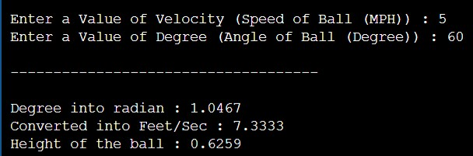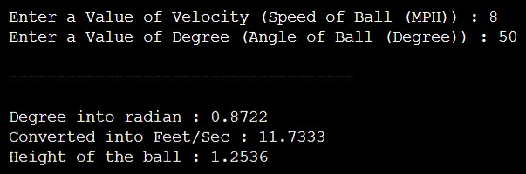

**Program 26: Write a program to calculate & print height of the ladder. Where ladder is kept at angle** 𝜽 **with the horizontal base and length of the ladder l.**

**(A)L=20,θ=85**° **(B)L=25,θ=75**°**.**

**Input :**

// find length of ladder

#include <stdio.h>

#include <math.h>

void main()

{ int l; float x,h;

printf("\n Enter a length of the ladder : "); scanf("%d",&l);

printf(" Enter a value in Degree : "); scanf("%f",&x);

x = x * 3.14 / 180;

printf("\n ------------------------------");

printf("\n Converted into radian : %.4f",x);

h = l * sin(x);

printf("\n ------------------------------"); printf("\n Height of the ladder : %.4f",h);

}

**Output :**

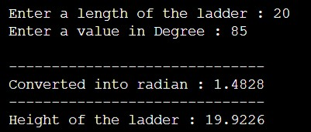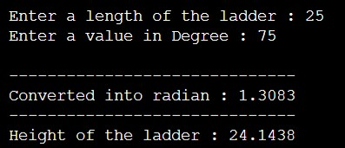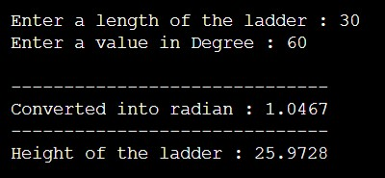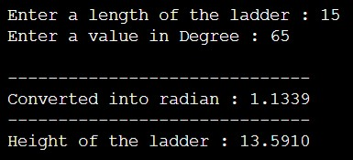

**Program 27: Write a program that calculates x & y co-ordinates of the point whose polar co-ordinates are (A)r=10,**𝜽**=30**° **(B)r=12.5,**𝜽**=67.8**°**.**

**Input :**

#include <stdio.h>

#include <math.h>

void main()

{

float r,a,x,y;

printf("\n Enter a value of radius : "); scanf("%f",&r);

printf(" Enter a value in Degree : "); scanf("%f",&a);

a = a * 3.14 / 180;

printf("\n-----------------------------\n");

printf("\n Converted into radian : %.4f",a);

1. = r * cos(a);
2. = r * sin(a);

printf("\n Coordinates Of X Is : %.4f",x); printf("\n Coordinates Of Y Is : %.4f",y);

}

**Output :**

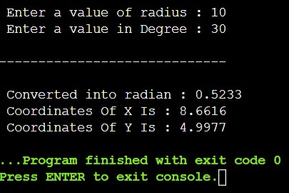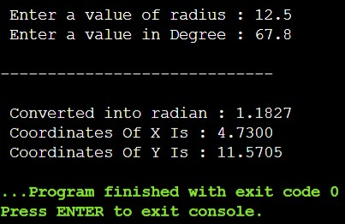

**Program 30: Write a program in c to find factorial of n. (n!)**

#include <stdio.h> int Factorial(int);

void main()

{

int n,i,fact=1,recur_fact; printf("\n Enter The Value Of N : "); scanf("%d",&n);

for(i=1;i<=n;i++)

{

fact = fact*i;

}

printf("\n----------------------------------\n"); printf("\n Factorial Using Iterative Method\n"); printf("\n Factorial Number Is : %d",fact);

printf("\n----------------------------------\n");

printf("\n Factorial Using Recursive Method\n");

recur_fact = Factorial(n);

printf("\n Factorial Number Is : %d",recur_fact);

}

int Factorial(int n)

{ if(n==0)

{

return 1;

}

else

{

return n*Factorial(n-1);

}

}

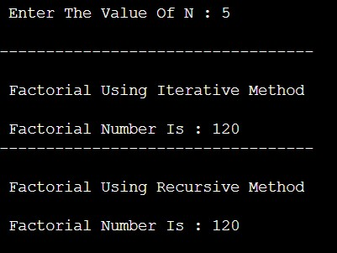

**Program 31: Write a program in c to find first n terms of the Fibonacci sequence using an iterative algorithm.**

#include <stdio.h> int Fibo(int);

void main()

{

int n,n1,n2,i,sum;

printf("\n Enter Any Number : "); scanf("%d",&n);

printf("-----------------------\n");

n1=0; n2=1; sum=0;

printf("\n Fibonacci Series Is Using Iterative Algorithm : %d %d ",n1,n2);

for(i=2;i<=n;i++)

{

sum=n1+n2; printf(" %d ",sum); n1=n2;

n2=sum;

}

printf("\n\n---------------------------------------------------------------------------------------\n"); printf("\n Fibonacci Series Is Using Recursive Algorithm : "); for(i=0;i<=n;i++)

{

printf(" %d ",Fibo(i));

}

}

int Fibo(int n)

{ if(n<=1) return n; else

return Fibo(n-1) + Fibo(n-2);

}

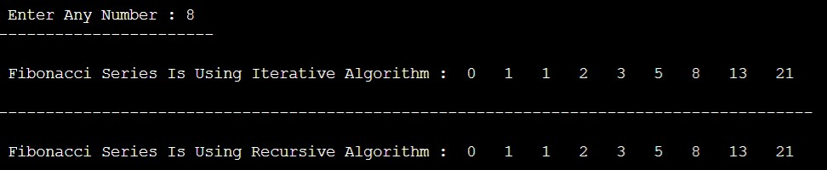

**Program 32: Write a C program to exchange values of two variable.**

#include<stdio.h> int main()

{

int a,b,x;

printf("Enter 1st Number : "); scanf("%d",&a); printf("Enter 2nd Number : "); scanf("%d",&b);

printf("\n1 : Using + And - Operator "); printf("\n2 : Using * And / Operator "); printf("\n3 : Using XOR Gate "); printf("\n------------------------");

printf("\nEnter Your Choice : "); scanf("%d",&x);

switch(x)

{

case 1: a=a+b; b=a-b; a=a-b;

printf("\n1st Number : %d",a);

printf("\n2nd Number : %d",b);

break; case 2: a=a*b; b=a/b; a=a/b;

printf("\n1st Number : %d",a); printf("\n2nd Number : %d",b);

break; case 3: a=a^b; b=a^b; a=a^b;

printf("\n1st Number : %d",a); printf("\n2nd Number : %d",b);

break; default:

printf("Enter Valid Value");

}

return 0;

}

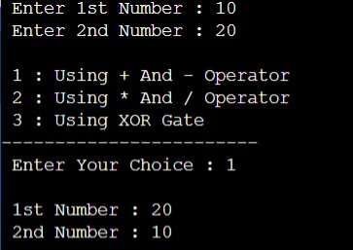

**Program 33: Implement the program in C for “exchanging the values of two variable” using function (which will require use of pointers for function arguments in c).**

**Input :**

#include <stdio.h>

int swap(int *a,int *b);

void main()

{

int x,y;

printf("\n Enter a Value of X : "); scanf("%d",&x);

printf(" Enter a Value of Y : ");

scanf("%d",&y);

swap(&x,&y);

printf("\n Value of X : %d",x); printf("\n Value of Y : %d",y);

}

int swap(int *a,int *b)

{

*a = *a + *b;

*b = *a - *b;

*a = *a - *b;

return *a,*b;

}

**Output :**

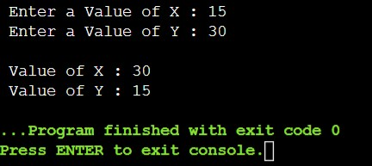

**Program 34: Write a C program to find sum of n values** 𝒂𝒊**,i=1 to n,using pointer instead of arrays.**

**Input :**

#include <stdio.h>

void main()

{

int i, n, sum = 0;

int *a;

printf("\n Enter the size oF Array : "); scanf("%d", &n);

printf("\n Enter Value : "); printf("\n______________\n");

for (i = 0; i < n; i++)

{

scanf(" %d", a + i);

}

for (i = 0; i < n; i++)

{

sum = sum + *(a + i);

}

printf("___________________________");

printf("\nAddition of Array = %d ", sum);

}

**Output :**

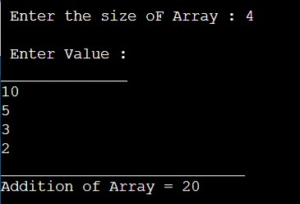

**Program 35: Write a C program tocount number of words in a given text by representing text string as pointer.**

**Input :**

#include <stdio.h>

#include <string.h>

void main()

{

char*s[200],*c; int count = 0, i;

printf("\nEnter the string: ");

gets(s);

c = s;

while(*c!='\0')

{

if (c[i] == ' ' && c[i+1] != ' ') i++; c++;

}

printf("Number of words in given string are: %d\n", i+1);

}

**Output :**

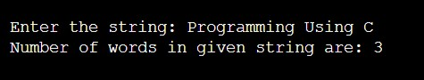

**Program 36: Write a program to remove all duplicates from an ordered array and contract the array accordingly.**

#include <stdio.h>

void main()

{

int arr[100],i,j,k,size;

printf(" How many number you want to Add in array : "); scanf("%d",&size); printf("\n Enter Value : \n"); for(i=0;i<size;i++)

{

scanf("%d",&arr[i]);

}

for(i=0;i<size;i++)

{

for(j=i+1;j<size;j++)

{

if(arr[i]==arr[j])

{

for(k=j;k<size-1;k++)

{

arr[k]=arr[k+1];

} size--; j--;

}

}

}

printf("\n---------------------------------------------------------------------\n");

printf("After Delete Duplicate Value : ");

for(i=0;i<size;i++)

{

printf(" %d\t",arr[i]);

}

}

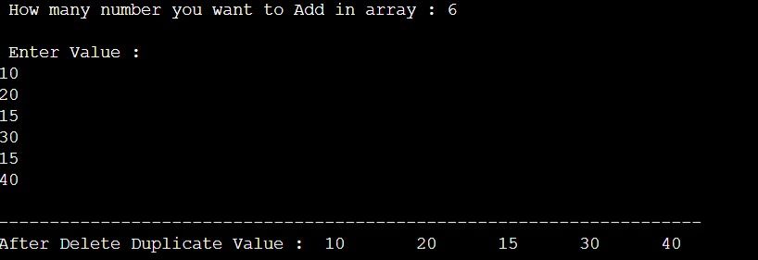

**Program 37: Given a number >=20 develop an algorithm & write a program in c to compute square root of a given non-negative number by divide-conquer method.**

**Input :**

#include<stdio.h>

void main()

{ int a;

printf("\n Enter value of A : ");

scanf("%d",&a); int s=1,l=a,mid=0; while(s<l)

{

mid=(s+l)/2;

if((mid*mid)==a)

{

break;

}

else if((mid*mid)<a)

{

s=mid+1;

} else{ l=mid;

}

}

printf("\n-------------------\n");

printf(" Root Value is : %d",mid);

}

**Output :**

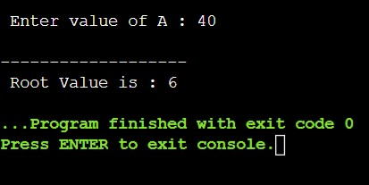

**Program 38: Write a c program using an improved algorithm to compute square root using Newton’s method and other methods.**

**Input :**

#include <stdio.h>

void main()

{

float n,x,f=0.0001,root=1,temp=2; printf(" Enter the value of n : "); scanf("%f",&n);

x=n;

while(f<(temp-root))

{

root=0.5*(x+(n/x)); temp=x;

x=root;

}

printf("\n------------------------------\n");

printf(" Root of given number : %.4f ",root);

}

**Output :**

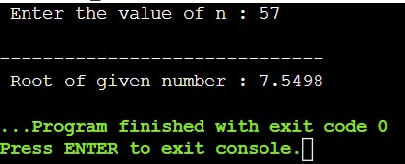

**Program 19: Write a program to calculate and display the value of the slope of the line connecting the two points whose coordinates are(3,7) and (8,12). Slope of a line between two points (x1,y1) and (x2,y2) is (y2-y1)/(x2-x1). Run the same program for the line connecting the points (2,10) and (12,6) and other pairs of points.**

#include<stdio.h> #include<conio.h> void main()

{ int x1, y1, x2, y2; float slope; printf(" Enter the value for 1st point(X1, Y1) : \n"); scanf("%d%d", &x1, &y1); printf("\n Enter the value of 2nd point(X2, Y2) : \n"); scanf("%d%d", &x2, &y2); slope = ((1.0)* (y2 - y1)) / (x2 - x1); printf("----------------------------------------"); printf("\n\n Slope = %.2f\n", slope);

}

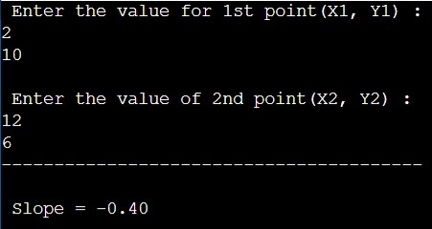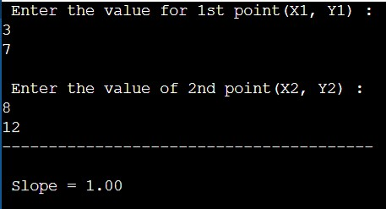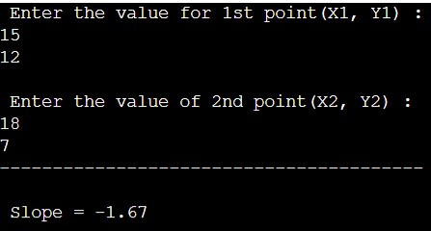

**Program 20: Write a program to calculate and display the coordinates of the midpoint of the line connecting the two points given in the previous exercise. The co-ordinates of the midpoint between two points having co-ordinates (x1,y1) and (x2,y2) are ( (x1+x2)/2 , (y1+y2)/2).**

#include<stdio.h>

void main()

{

int x1,x2,y1,y2,midx,midy; printf(" Enter X1 value : "); scanf("%d",&x1); printf(" Enter X2 value : "); scanf("%d",&x2); printf(" Enter Y1 value : "); scanf("%d",&y1); printf(" Enter Y2 value : ");

scanf("%d",&y2); midx=(x1+x2)/2;

midy=(y1+y2)/2;

printf("-----------------------\n"); printf(" Midpoint of X : %d",midx);

printf("\n Midpoint of Y : %d",midy);

}

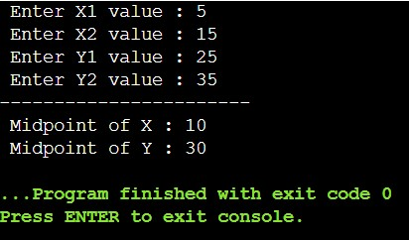

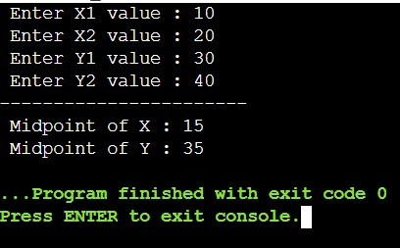

**Program 21: Write a program that calculates the distance between two points whose coordinates are (7,12) and (3,9). Distance between two points having coordinates (x1, y1) and (y1,y2) = sqrt([x1-x2]2 + [y1-y2]2). Also, run the program for the points (-12, -15) and (22,5) and a few other points.**

#include <stdio.h> #include <math.h> void main()

{

float x1, y1, x2, y2, distance;

printf(" X1 : "); scanf("%f", &x1); printf(" Y1 : "); scanf("%f", &y1); printf(" X2 : "); scanf("%f", &x2); printf(" Y2 : "); scanf("%f", &y2); distance = ((x1-x2)*(x1-x2))+((y1-y2)*(y1-y2));

printf("\n-----------------------------------------\n");

printf("Distance between the two points : %.4f", sqrt(distance)); printf("\n");

}

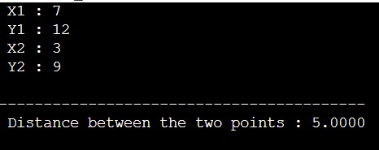

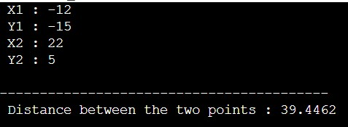

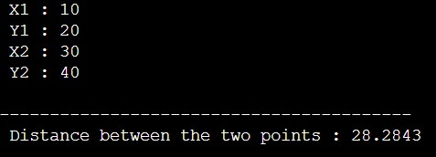

**Program 22: Given some integer x , develop an algorithm and write a program to compute the value of x^n where n is considerably larger than 1. This algorithm has time complexity O(n).**

#include<stdio.h>

int power(int x,int y)

{

if (y == 0) return 1; else if (y%2 == 0)

return power(x, y/2)*power(x, y/2); else

return x*power(x, y/2)*power(x, y/2);

}

void main()

{ int n1,n2;

printf(" Enter Base Value : "); scanf("%d",&n1);

printf(" Enter Exponent Value : "); scanf("%d",&n2);

printf("-------------------------\n");

printf(" x ^ y is : %d", power(n1, n2));

}

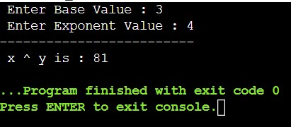

**Program 23: Develop an improved algorithm having time complexity O(log2n).**

#include<stdio.h>

int power(int x,int y)

{

int temp; if( y == 0)

return 1; temp = power(x, y/2); if (y%2 == 0) return temp*temp;

else return x*temp*temp;

}

void main()

{ int n1,n2;

printf(" Enter Base Value : "); scanf("%d",&n1);

printf(" Enter Exponent Value : "); scanf("%d",&n2);

printf("\n---------------------------\n");

printf(" x ^ y is : %d", power(n1, n2));

}

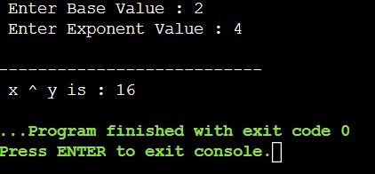

**Program 28: Given an integer n>=1 , develop an algorithm and write a program to find the smallest exact divisor of n other than one.**

#include<stdio.h>

#include<math.h>

void main()

{ int i,n;

printf(" Enter Number : "); scanf("%d",&n);

if(n>1)

{

for(i=2;i<=sqrt(n);++i)

{

if(n%i==0)

{

printf("\n Smallest Divisor of %d is %d",n,i); break; //if you not break then print all the divisor

}

}

}

else

{

printf("\n smallest divisor of %d = %d",n,n);

}

}

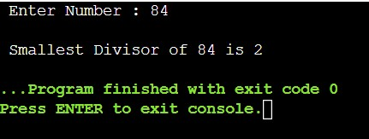

**Program 29: Every integer can be expressed as a product prime numbers. Develop an algorithm and write a program to compute all the prime factors of a given integer n>0.**

#include <stdio.h>

#include <math.h>

int main()

{

int num,i,j,prim; printf(" Enter a number : "); scanf("%d",&num); printf("\n Prime factors :\n "); printf("---------------------\n\n");

for(i=2;i<=num;i++)

{

if(num%i==0)

{

prim=1;

for(j=2;j<i/2;j++)

{

if(i%j==0);

{ prim=0; break;

}

}

if(prim==1)

{

printf("%d\t",i);

}

}

}

return 0;

}

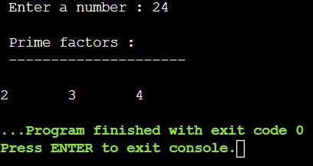

**Program 39: write a c program to find maximum and minimum values in a given array of values. Also write the c program using pointers instead of array.**

#include<stdio.h>

void main()

{

int array[50], *maximum, *minimum, size, i; printf(" Enter The Number Of Elements In Array : "); scanf("%d", &size);

printf("\n Enter Array Elements : \n\n"); for ( i = 0 ; i < size ; i++ )

{

scanf("%d", &array[i]);

}

maximum = array;

minimum = array;

for (i = 0; i < size; i++)

{

if (*(array+i) > *maximum)

{

*maximum = *(array+i);

}

}

printf("-------------------------------------");

printf("\n Maximum element in the array is %d\n", *maximum);

for (i = 0; i < size; i++)

{

if (*(array+i) < *minimum)

{

*minimum = *(array+i);

}

}

printf(" Minimum element in the array is %d\n", *minimum);

}

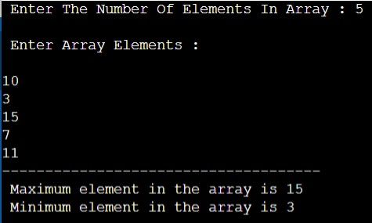

# EXTRA PROGRAM

**Program-40. Check whether the given Number is Armstrong Number or not.**

#include<stdio.h>

#include<conio.h>

void main()

{

int n,r,sum=0,temp; printf(" Enter Number : "); scanf("%d",&n); printf("------------------\n");

temp=n;

while(n>0)

{

r=n%10; sum=sum+(r*r*r);

n=n/10;

}

if(temp==sum)

printf(" Armstrong Number "); else

printf(" Not Armstrong Number");

}

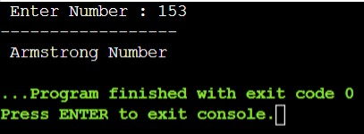

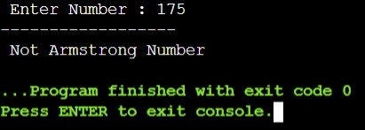

**41. Write a program to Calculate power of a number x^n.**

#include<stdio.h>

void main()

{

int x,n,i,ans=1; printf(" Enter Base Value : "); scanf("%d",&x);

printf(" Enter Exponent Value : "); scanf("%d",&n);

printf("------------------------\n");

for(i=1;i<=n;i++)

{

ans=ans*x;

}

printf(" x ^ n is : %d",ans);

}

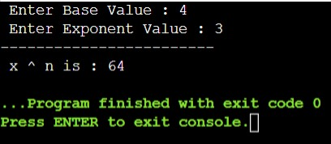

**42. Write a program to calculate LCM of two number.**

#include<stdio.h>

void main()

{

int n1, n2, i, gcd,lcm; printf(" Enter 1st Value : "); scanf("%d",&n1); printf(" Enter 2nd Value : "); scanf("%d",&n2);

printf("---------------------------\n");

for(i=1; i <= n1 && i <= n2; ++i)

{

if(n1%i==0 && n2%i==0)

{

gcd = i;

}

}

lcm=(n1*n2)/gcd;

printf(" LCM of %d And %d Is %d", n1, n2, lcm);

}

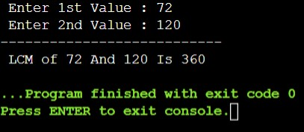

**43. Write a program to print the series 1 -3 5 -7 9 -11….**

#include<stdio.h>

void main()

{

int n,i=1,f=1,c=1; printf("Enter n numbers : "); scanf("%d",&n); printf("\n----------------------------\n"); for(c=1;c<=n;c++)

{

if(f%2==0)

{

printf(" %d ",-i);

} else

{

printf(" %d ",i);

} i+=2; f++;

}

}

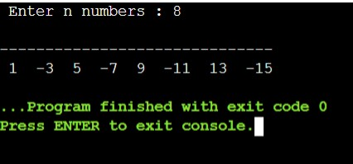

**44. Write a program to count number of digits in the given integer number also find sum of all digits.**

#include <stdio.h>

void main()

{

int n,sum=0,r; int count=0; printf(" Enter a number : "); scanf("%d",&n); while(n!=0)

{

r=n%10; n=n/10; count++; sum=sum+r;

}

printf("\n---------------------------------------------------"); printf("\n The number of digits in an integer is : %d",count); printf("\n---------------------------------------------------"); printf("\n Sum:%d",sum);

}

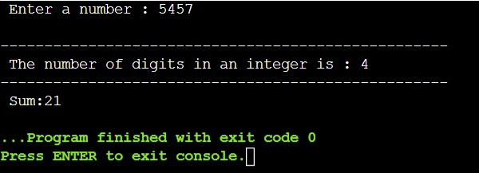

**45. Write a program to Convert to given integer Binary to Decimal.**

#include <stdio.h>

void main()

{

int num, b, d = 0, base = 1, rem; printf(" Enter Binary Value : "); scanf(" %d", &num);

printf("--------------------------\n\n"); b= num; while ( num > 0)

{

rem = num % 10; d = d + rem * base; num = num / 10; base = base * 2;

}

printf ( " The binary number is %d \t", b); printf("\n--------------------------");

printf (" \n The decimal number is %d \t", d);

}

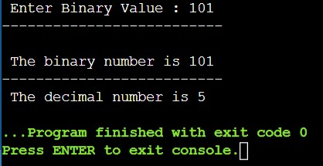

**46. Write a program to convert given integer Decimal to Binary.**

#include<stdio.h>

void main()

{ int a[10],n,i; printf(" Enter Decimal Number : "); scanf("%d",&n);

printf("---------------------------------"); for(i=0; n>0; i++)

{

a[i]=n%2; n=n/2;

}

printf("\n Binary of Given Number is = "); for(i=i-1; i>=0; i--)

{

printf("%d",a[i]);

}

}

