Q.1.Prompt for amount, interest rate and no. of years and calculate simple interest.
Ans:
<html>
<head>
<title>Demo</title>
</head>
<body>

<script>

var amount = prompt("Enter Amount", "How many $?");
var inrate= prompt("Enter Interest Rate", "Interest Rate?");
var years= prompt("Enter number of years", "For how long money is lent.,Enter number of years.");

var calc= amount*(1 + (inrate*years) );
var amount = prompt("Simple Interest is", calc);

</script>

</body>
</html>

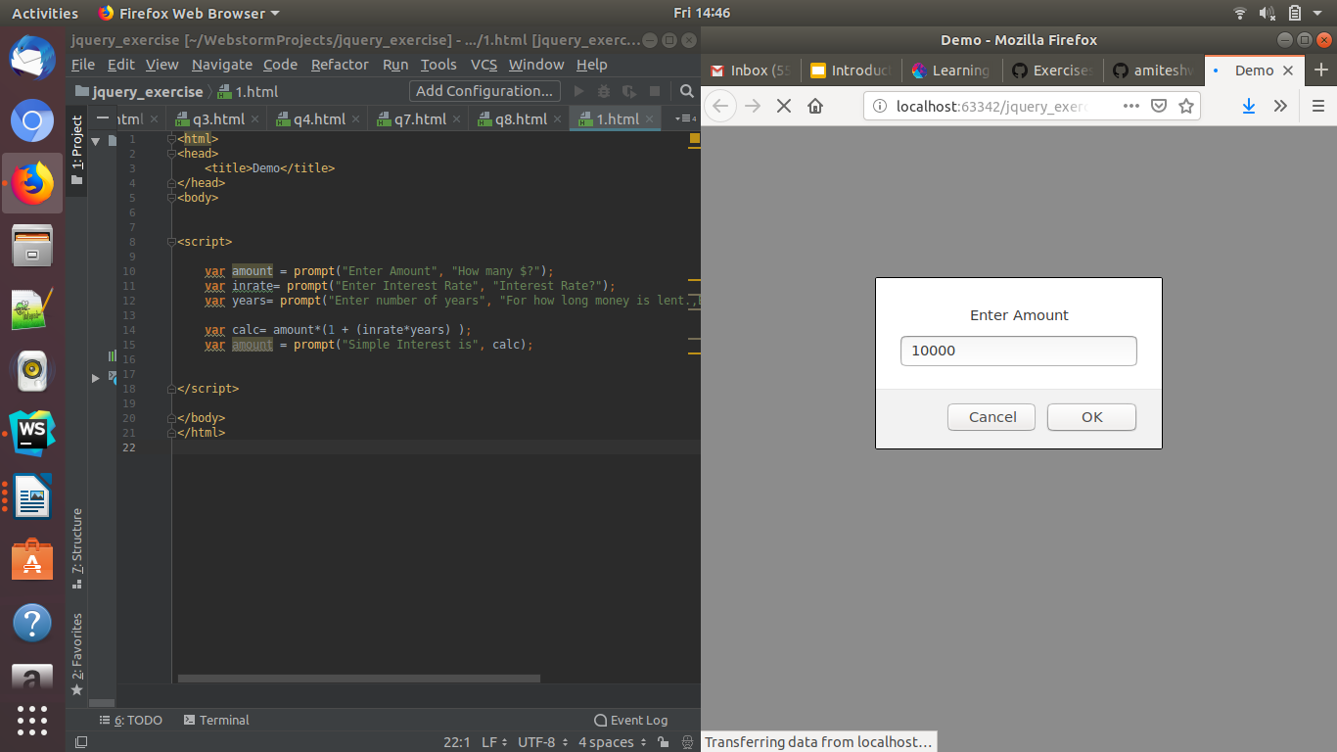

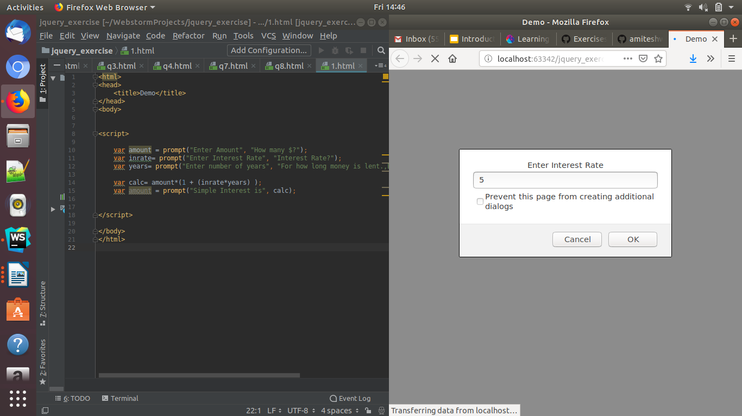

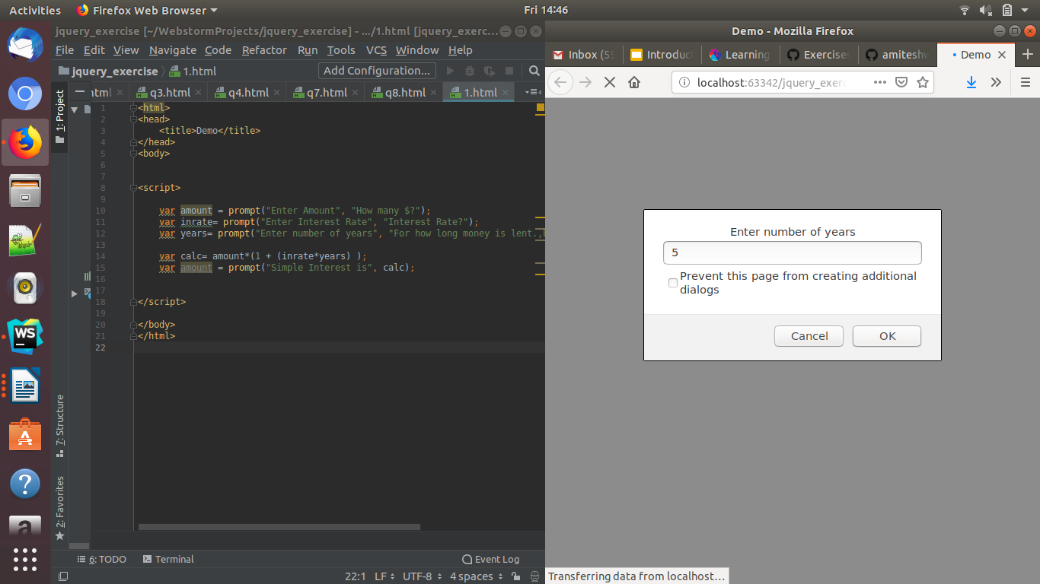

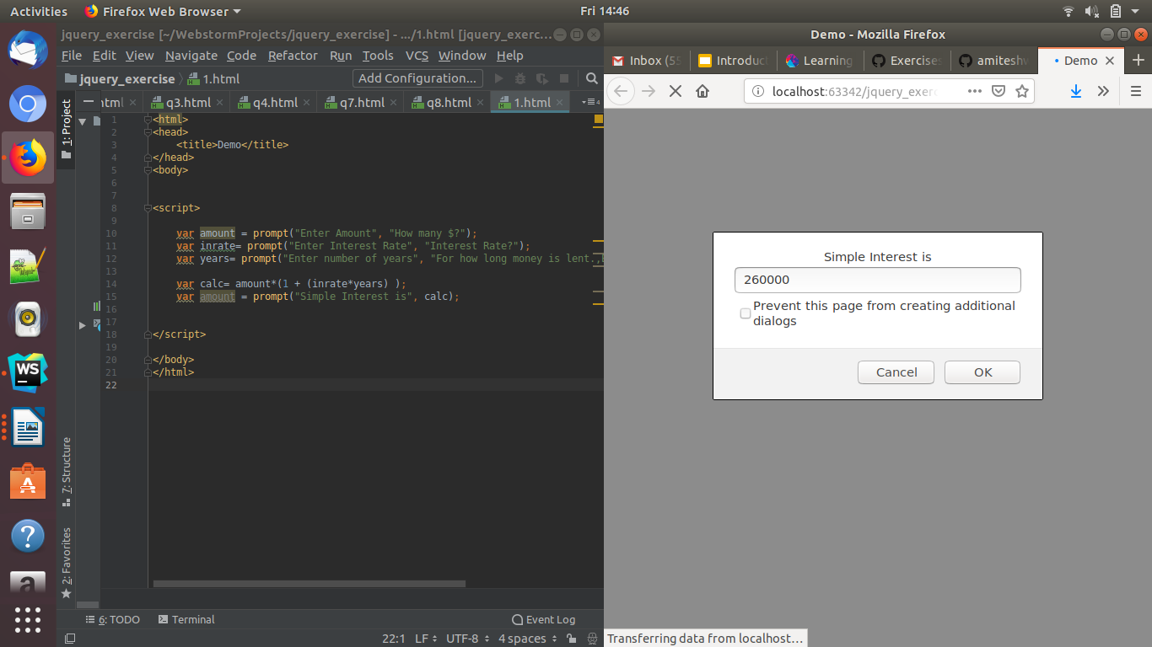

Q.2. is palindrome string.
Ans: <html>

<head>
<title> Palindrome or not </title>
</head>

<body>

<script>

var value = prompt("Enter the string");
console.log(value);
var output = value.split('').reverse().join('');
if (output==value)
{
alert("It's a palindrome");
}
else
{
alert("Not a Palindrome");
}
</script>

</body>
</html>

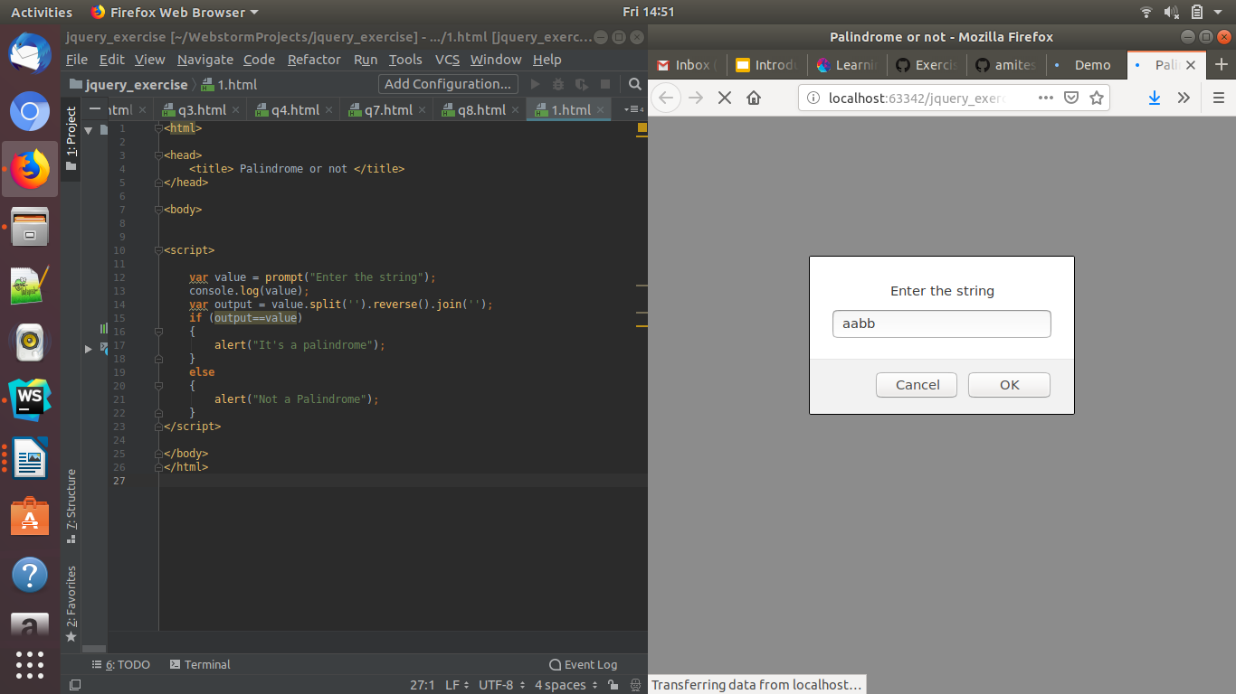
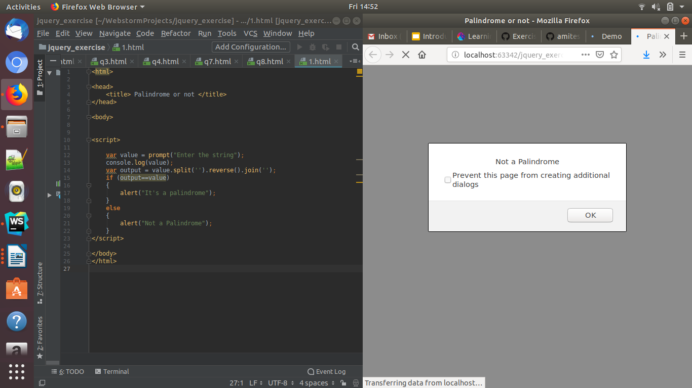

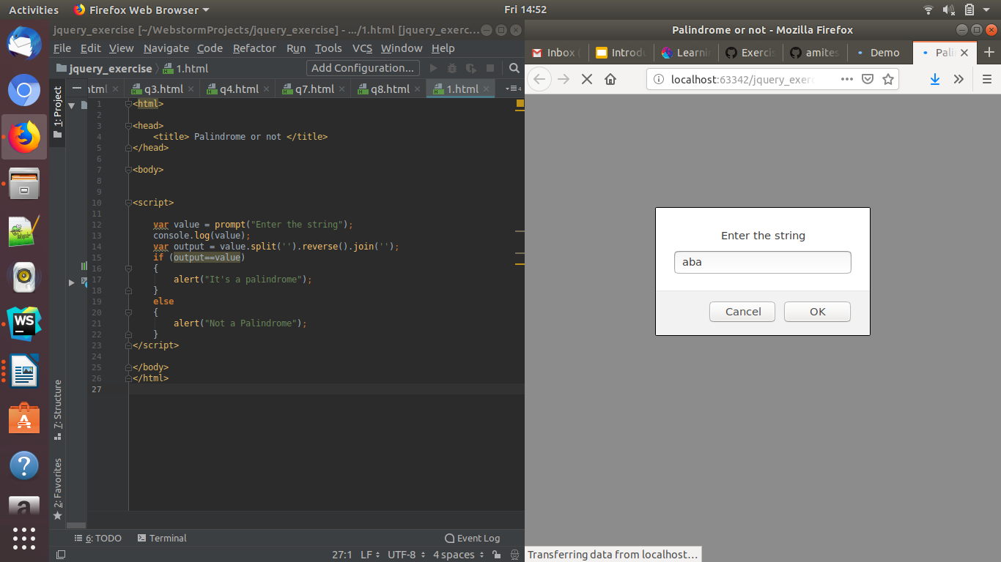
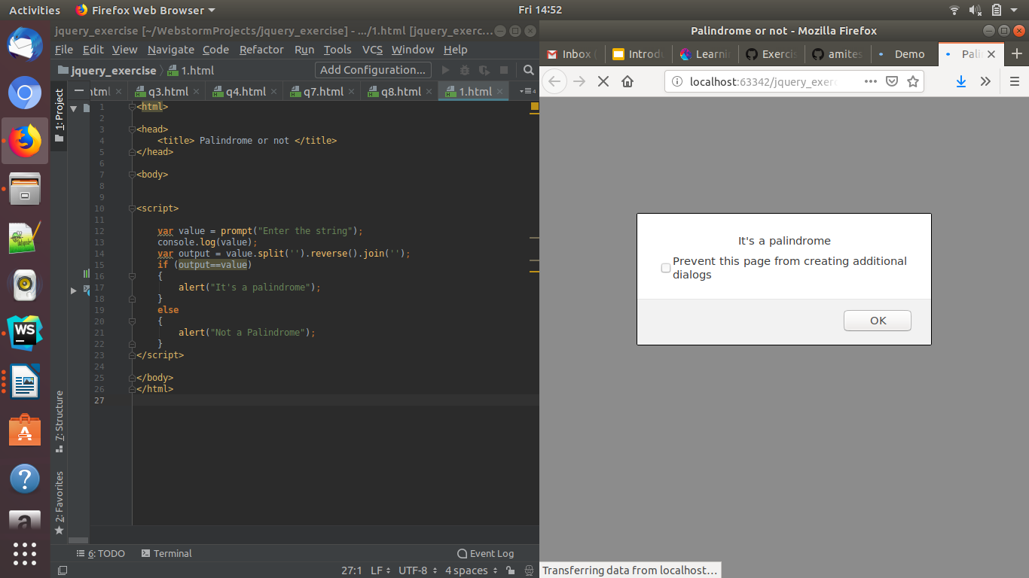

Q.3 Area of circle
Ans: <html>

<head>
<title> </title>
</head>

<body>

<script>

var radius = prompt("Enter the radius of the circle");
document.write("<P>The area of the circle is " + (radius * radius * Math.PI) + "</p>"); //var area=(3.14*radius*radius);

alert("The area is ",area);
</script>

</body>
</html>

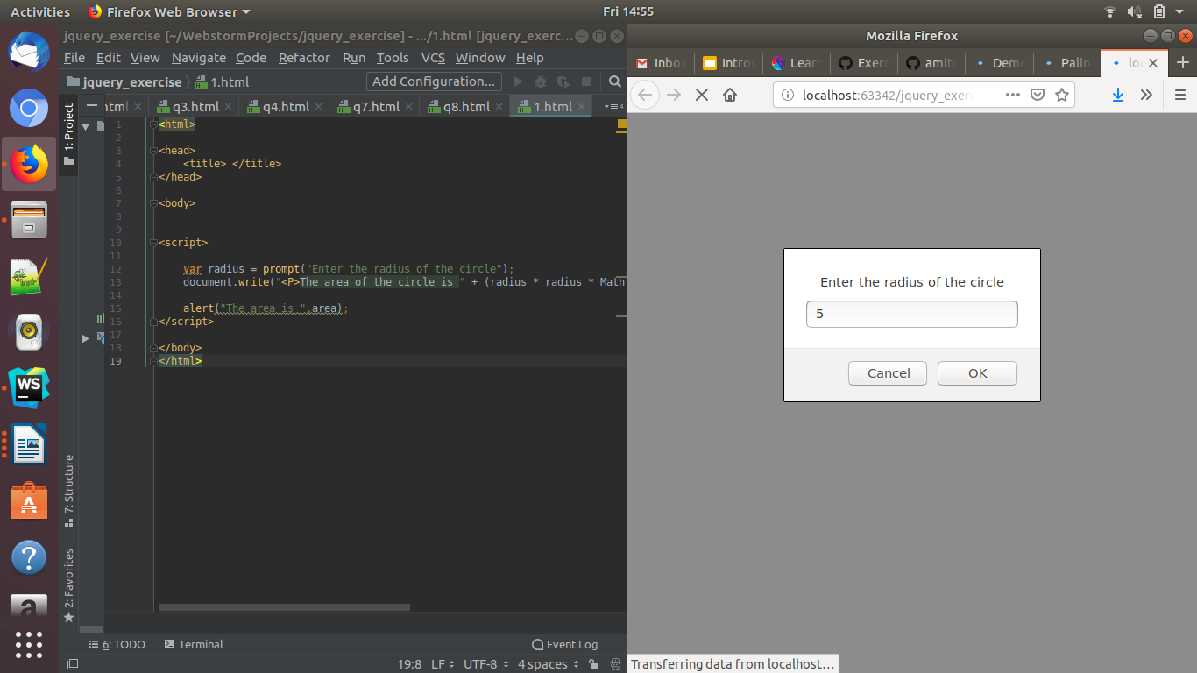

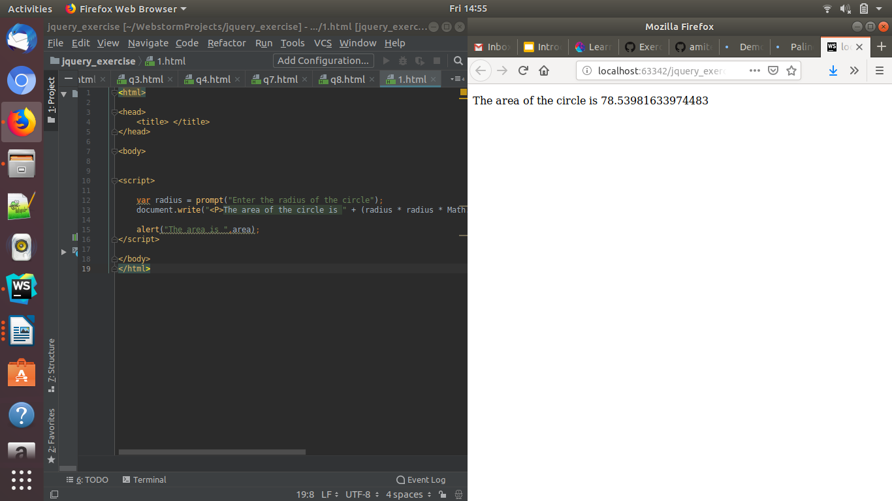

Q.4. Copy information of one object to another and log it to console.
Ans:
<html>
<body>
<script>

var obj = {};
obj.a = 5;
obj.b = 6;
obj.c = 10;
var objcpy = JSON.parse(JSON.stringify(obj));
console.log(obj);
console.log(objcpy);
</script>
</body>
</html>

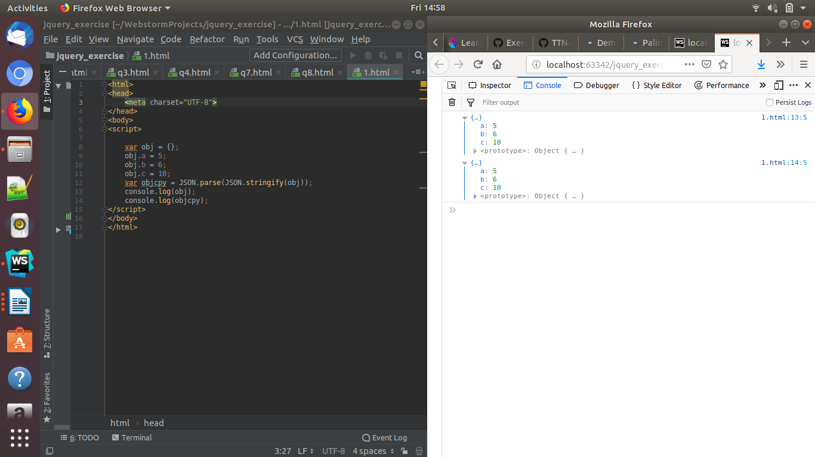

Q.5. Create a list of objects of Employee with info as follow :
  - Name, age, salary ,DOB

<html>
<head>
<title>Demo</title>
<meta charset="utf-8"/>
</head>
<body>

<script>
var arr= [
{ Name: 'A', age: 21, salary:25,DOB:'29/08/97' },
{ Name: 'B', age: 19, salary:4300,DOB:'23/08/97' },
{ Name: 'C', age: 18, salary:15055,DOB:'14/08/97' },
{ Name: 'D', age: 22, salary:20055,DOB:'14/09/97' }
];

  - filter all employees with salary greater than 5000

var arr1 = data.filter(d => d.salary > 5000);
console.log('arr1', arr1);

  - group employee on the basis of their age

Array.prototype.groupBy = function(prop) {
return this.reduce(function(groups, item) {
const val = item[prop]
groups[val] = groups[val] || []
groups[val].push(item)
return groups
}, {})
}
arr.groupBy(age);
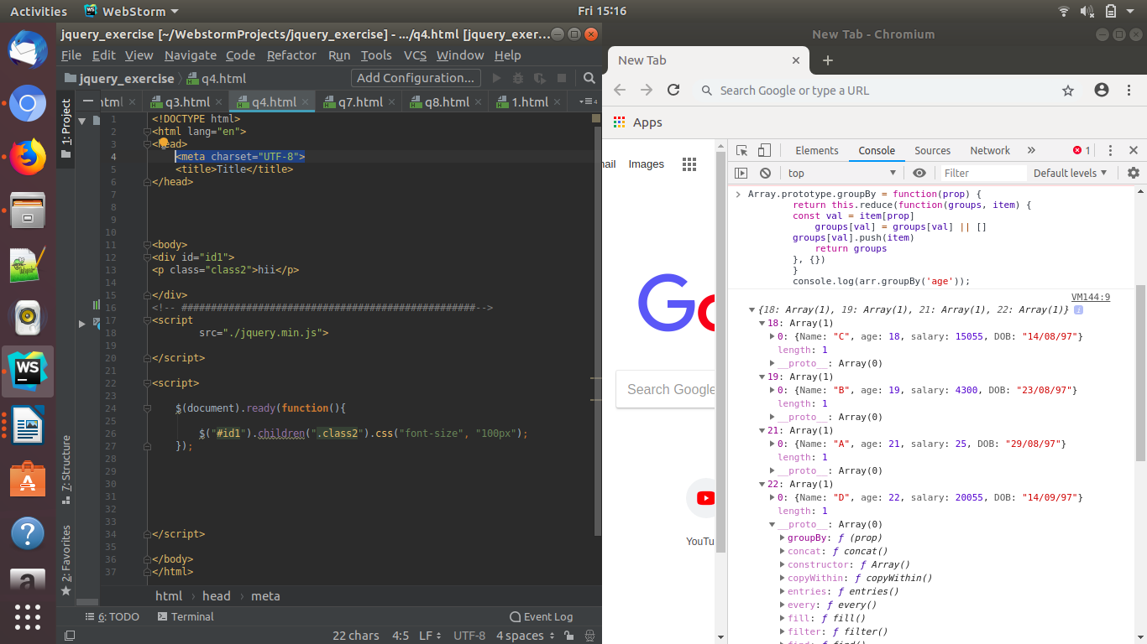

  - fetch employees with salary less than 1000 and age greater than 20. Then give them an increment 5 times their salary.
Ans:

