Q.1. Console "Hello Word" in document.ready function
Ans:
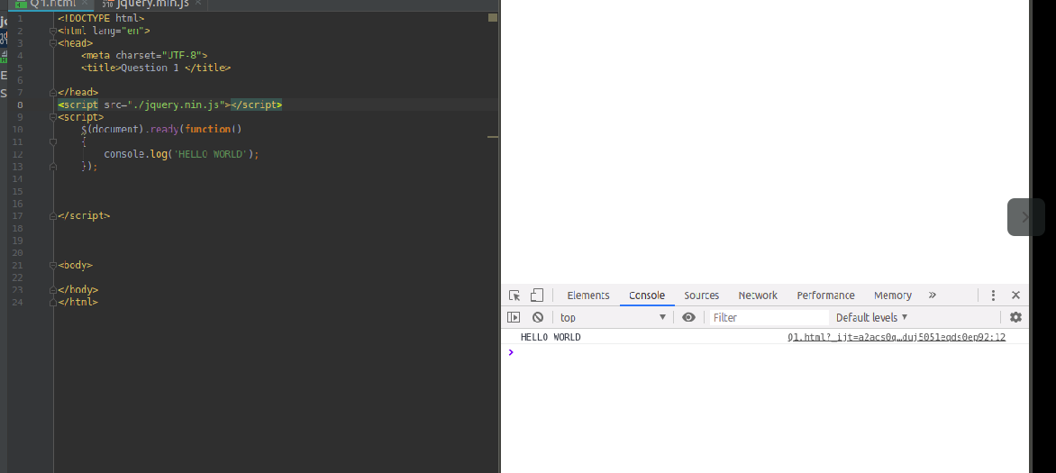

Q.2.Select a ID name "#test" and add class "load" when DOM is loaded.
Ans:

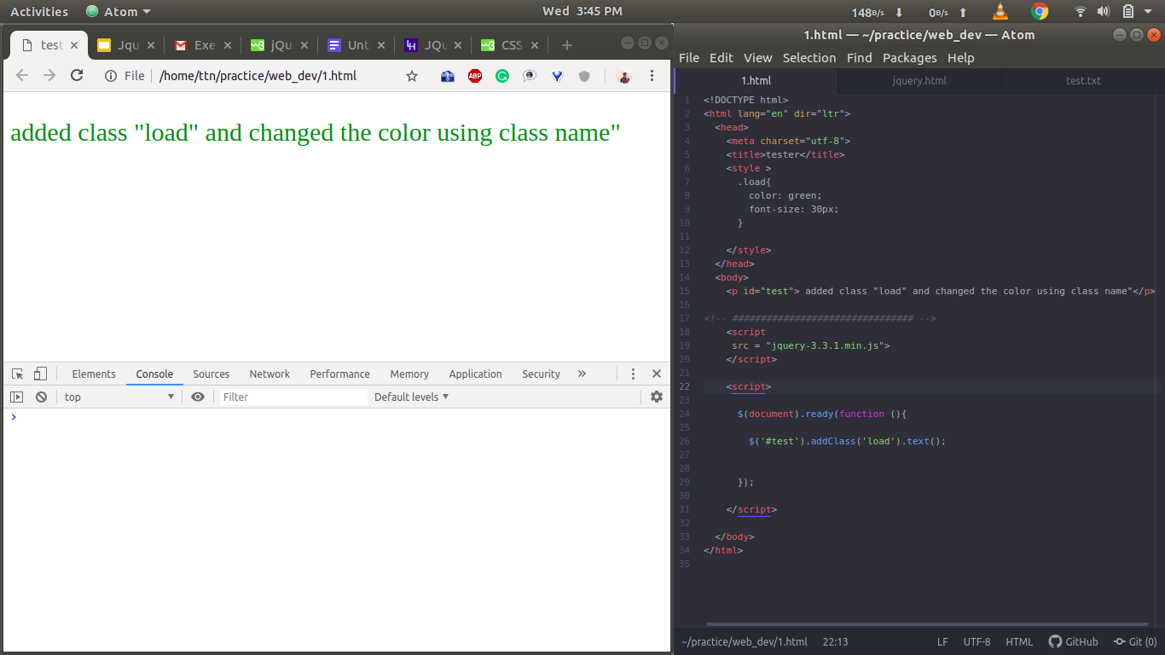

Q.3. Change the color of element which class name end with "-new"
Ans:
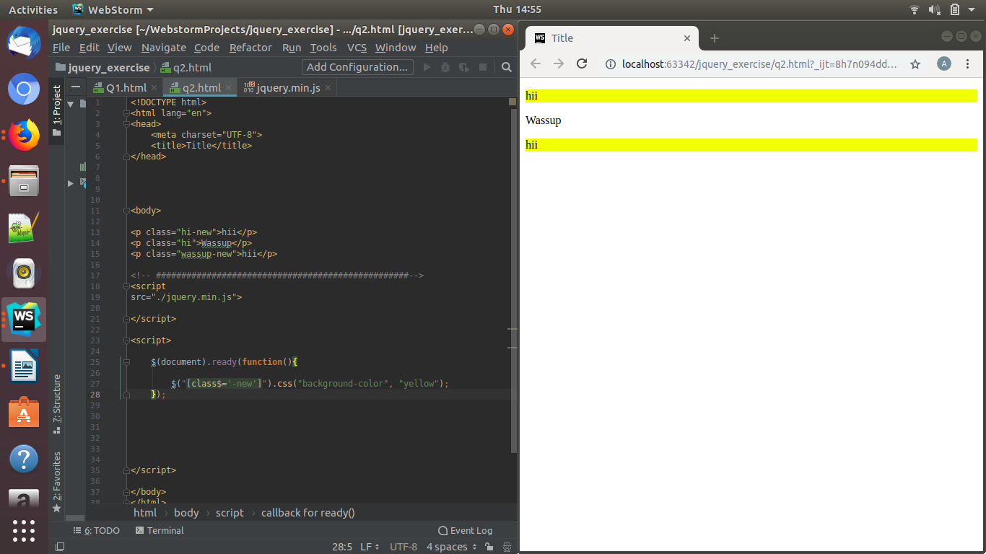

Q.4. Disable submit button using jquery attr method.
Ans:

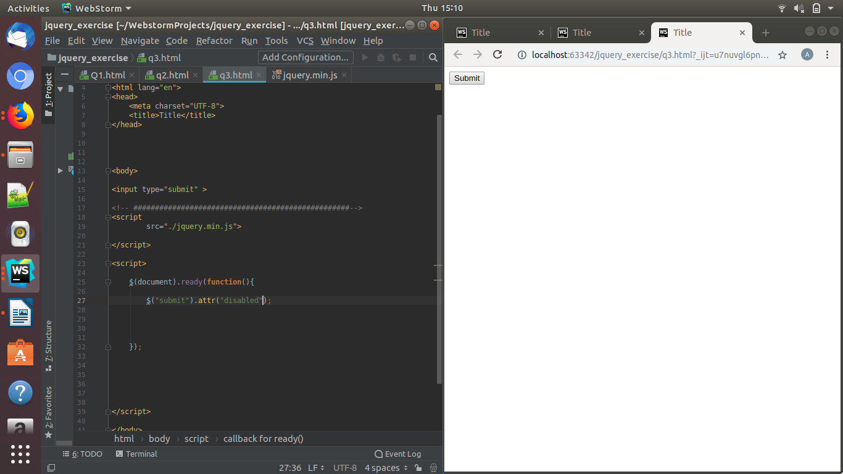

Q.5.Change the font size of ".target" which has parent element with id name "#main"
Ans:
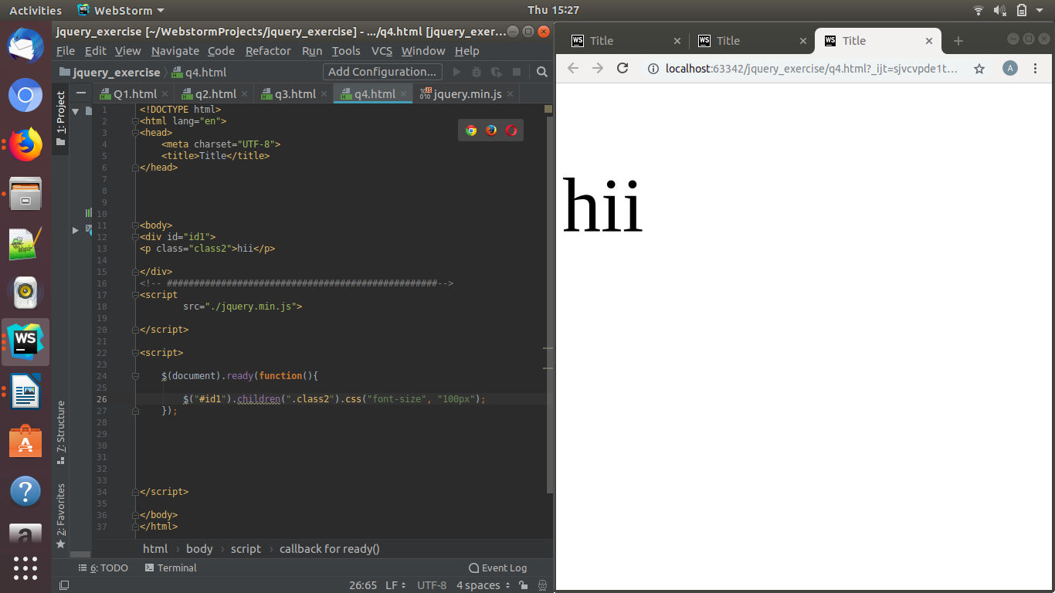

Q.6. After page load change the HTML of div element with "p" element
Ans:
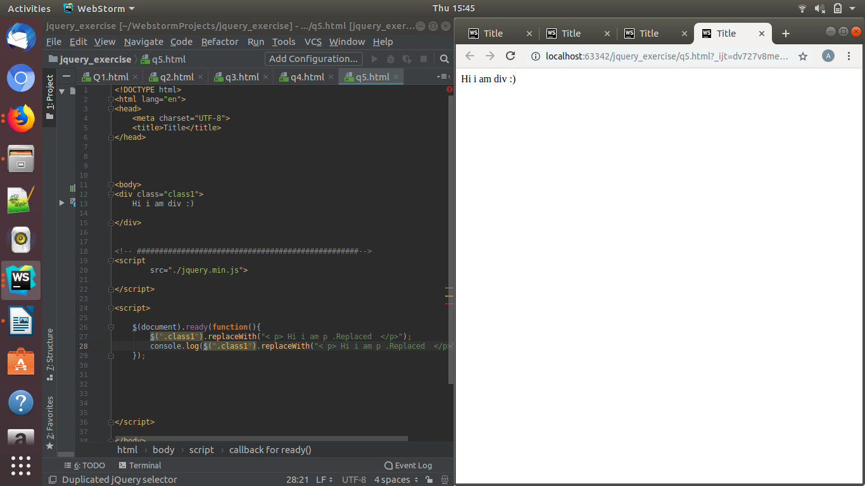

Q.7. Bind a click function to an "click" element and append next "click" next to it.
Ans:

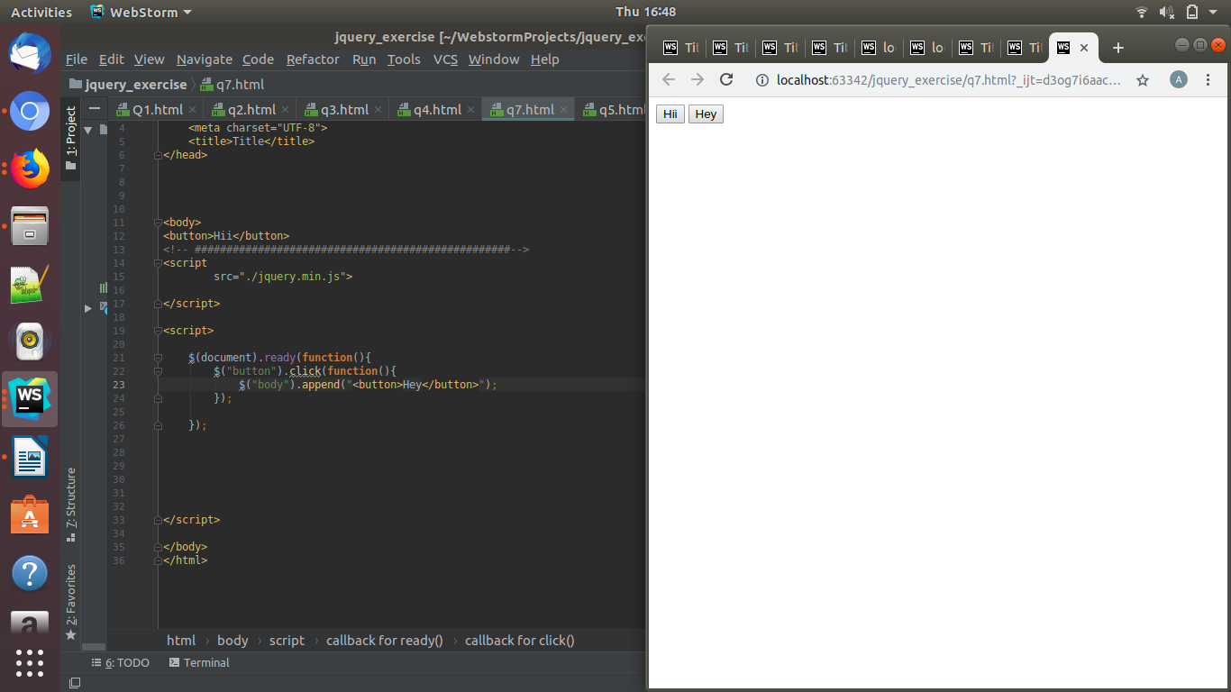

Q.8. Click event not working on element which added dynamicly or via script, make it work using .on method
Ans:
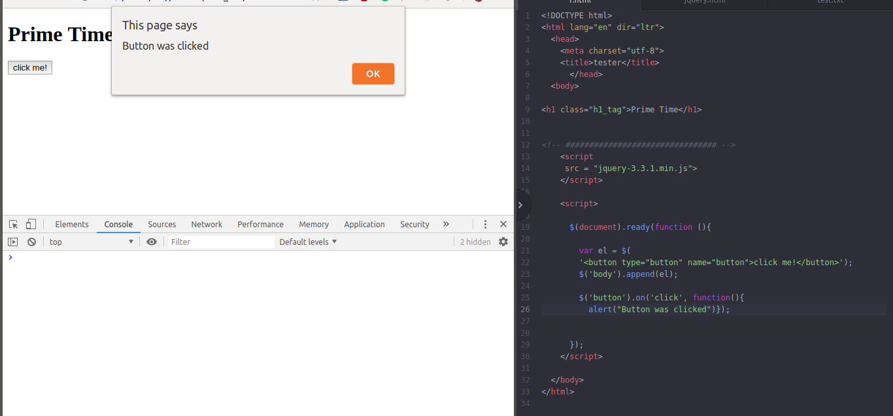

Q.9. Get dropdown selected value on onchanage event and append in div container

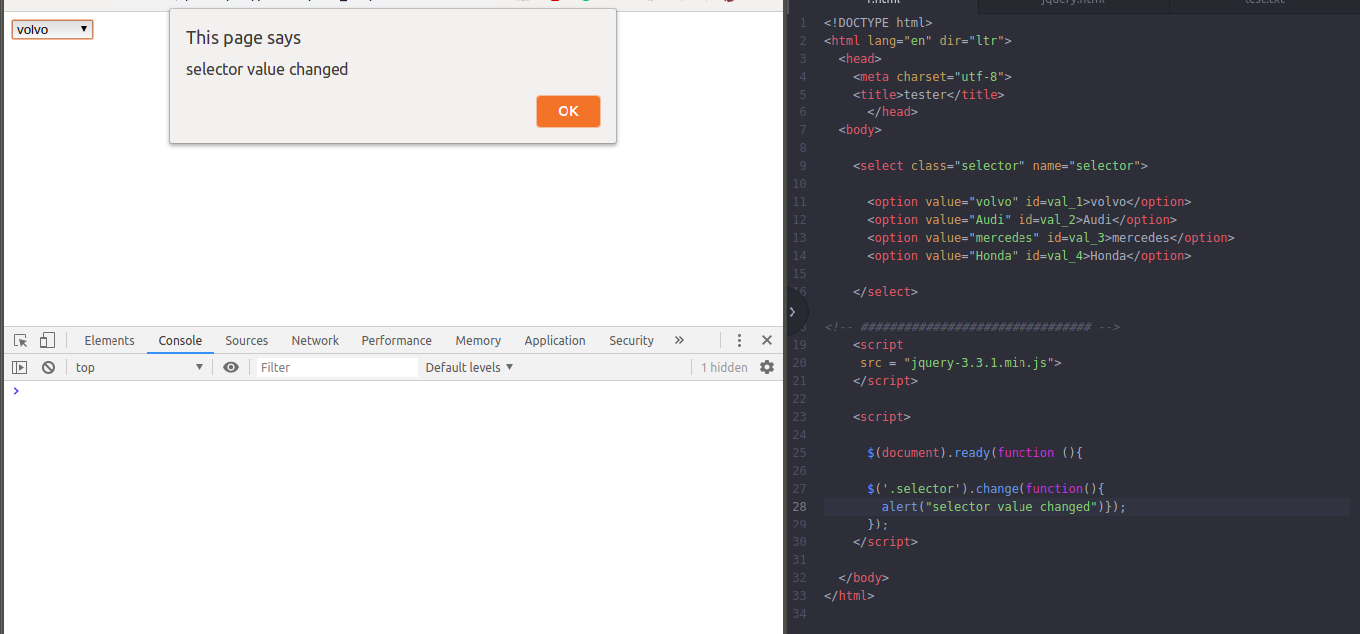

Q.10. Create a dropdown menu using hover method in jquery
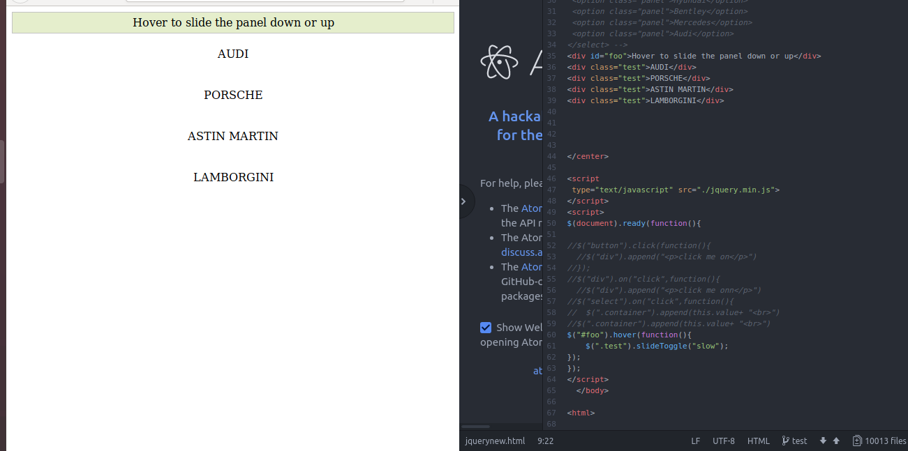
Q.11. On clicking on "google" tag. It is taking us to google home page. Stop it from happening.
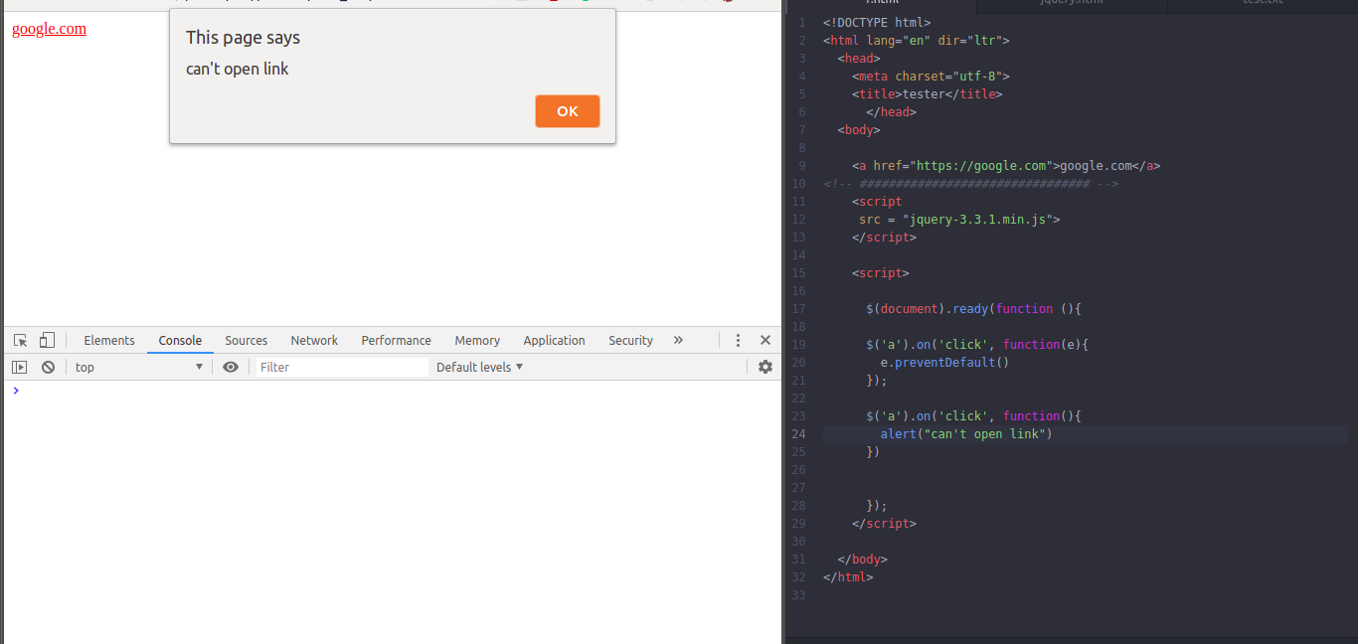

Q.12. We have bind a click funtion to parent div but we want stop it from performing when user clicks on its child li
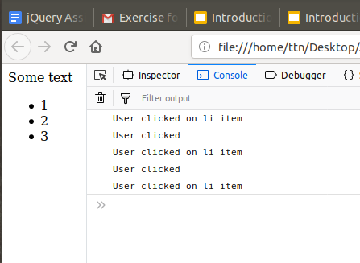

Q.13. Get the max height of elements using jquery each method
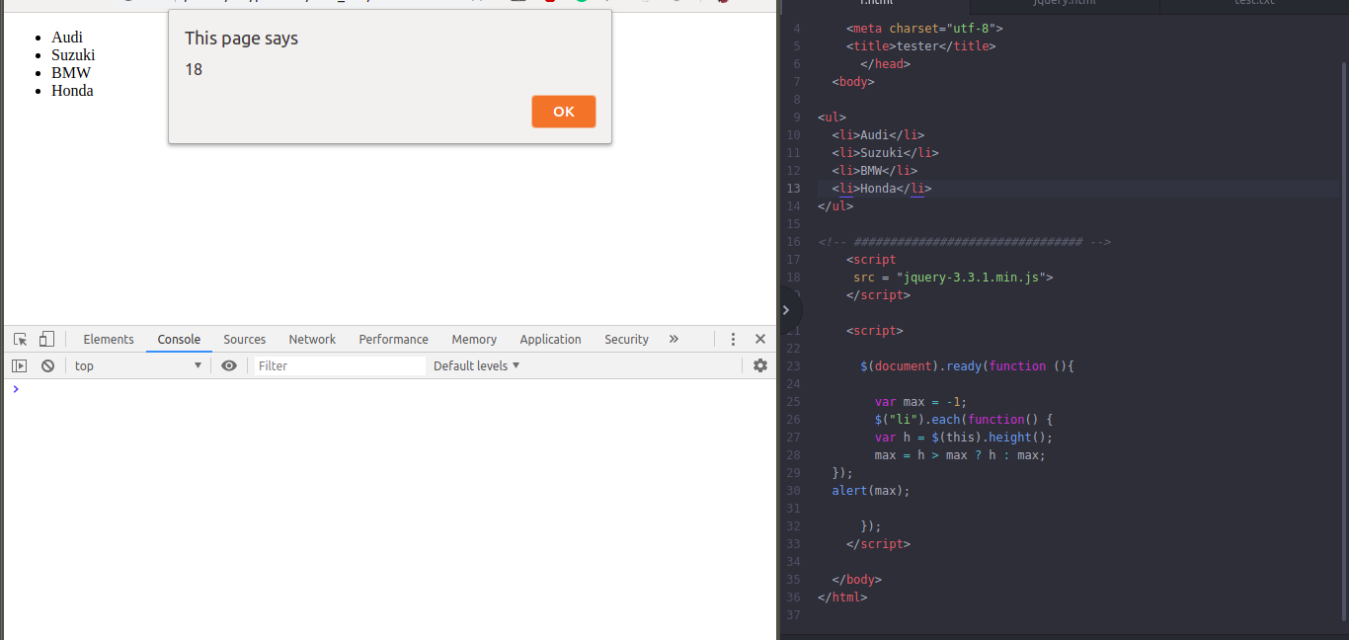
Q.14. Chagne color of every cell which has numberl larger than 10.
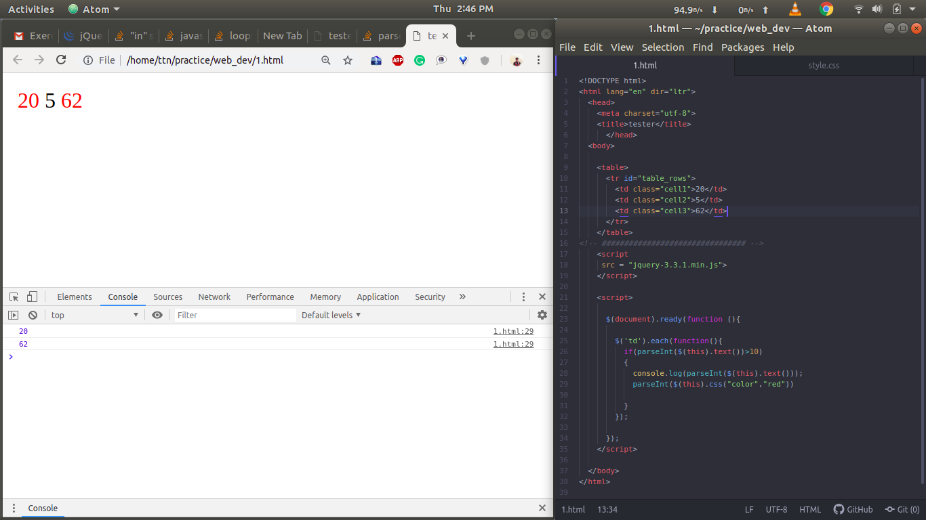

Q.15. Retrive the data from server using ajax get call
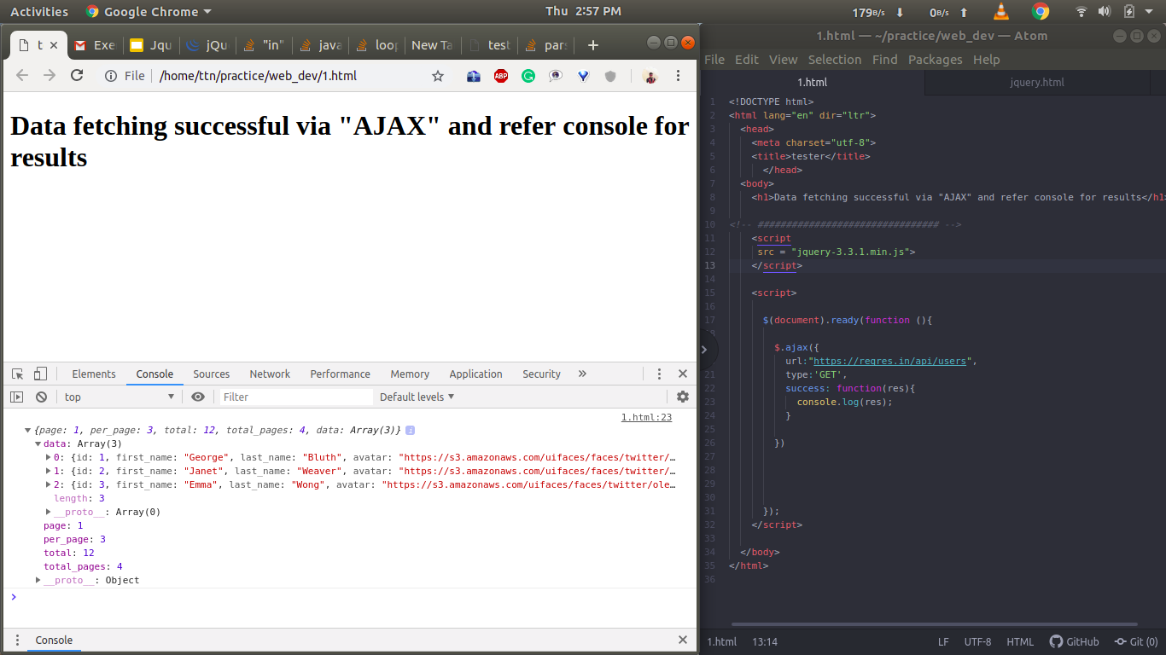
Q.16. Add cross button on row and bind click function which make a delete request to server, after success event remove the row fromdom