Write the following a functional interface and implement it using lambda:
- (1) First number is greater than second number or not Parameter (int ,int ) Return boolean
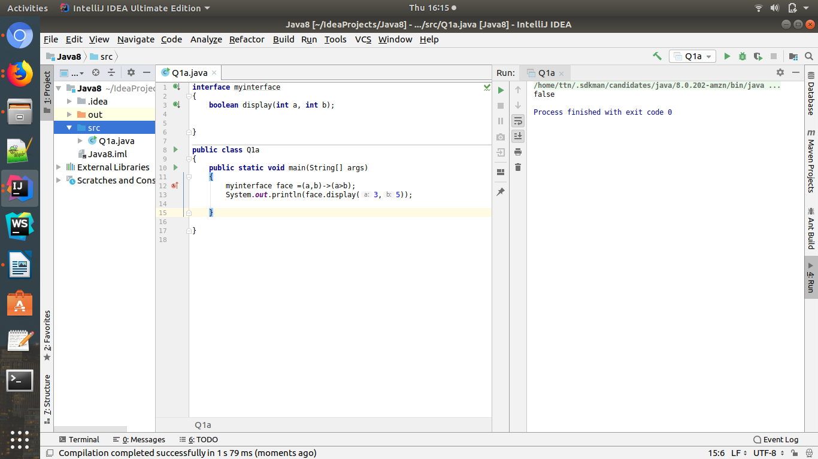
- (2) Increment the number by 1 and return incremented value Parameter (int) Return int
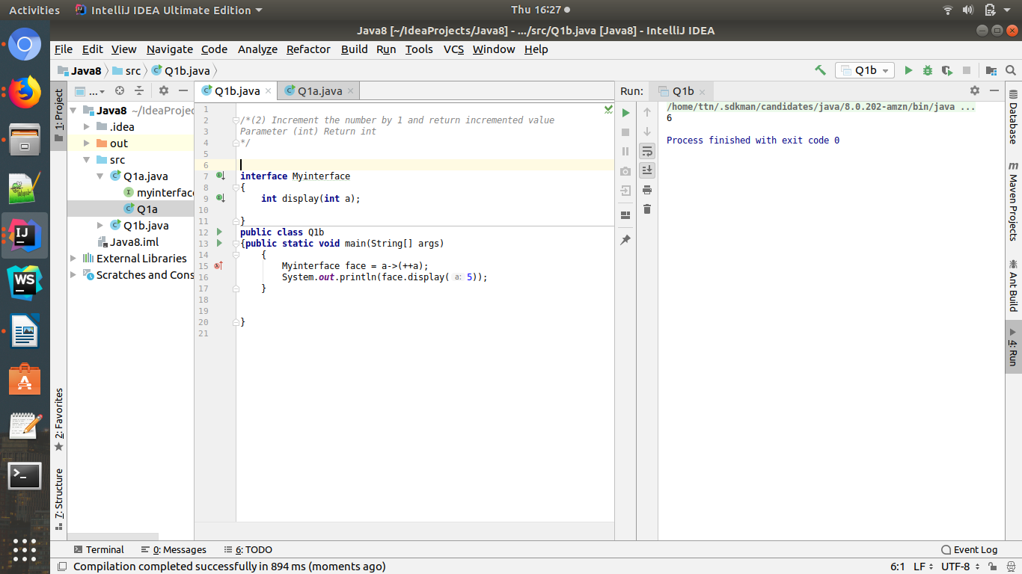

(3) Concatination of 2 string Parameter (String , String ) Return (String)

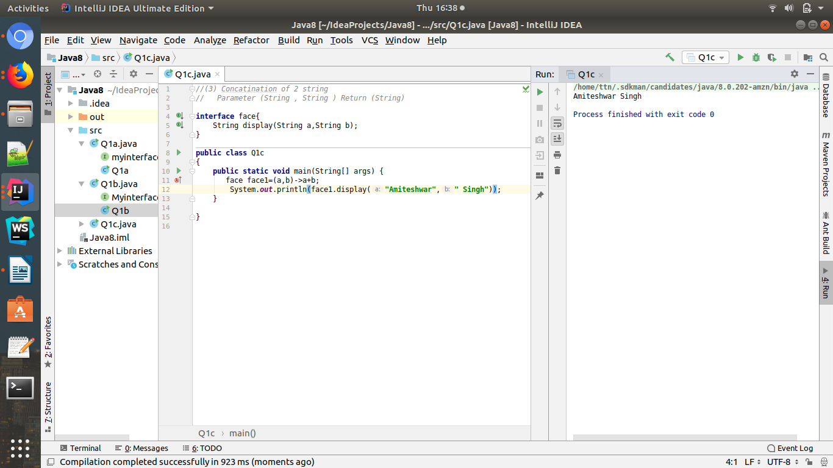

(4) Convert a string to uppercase and return . Parameter (String) Return (String)

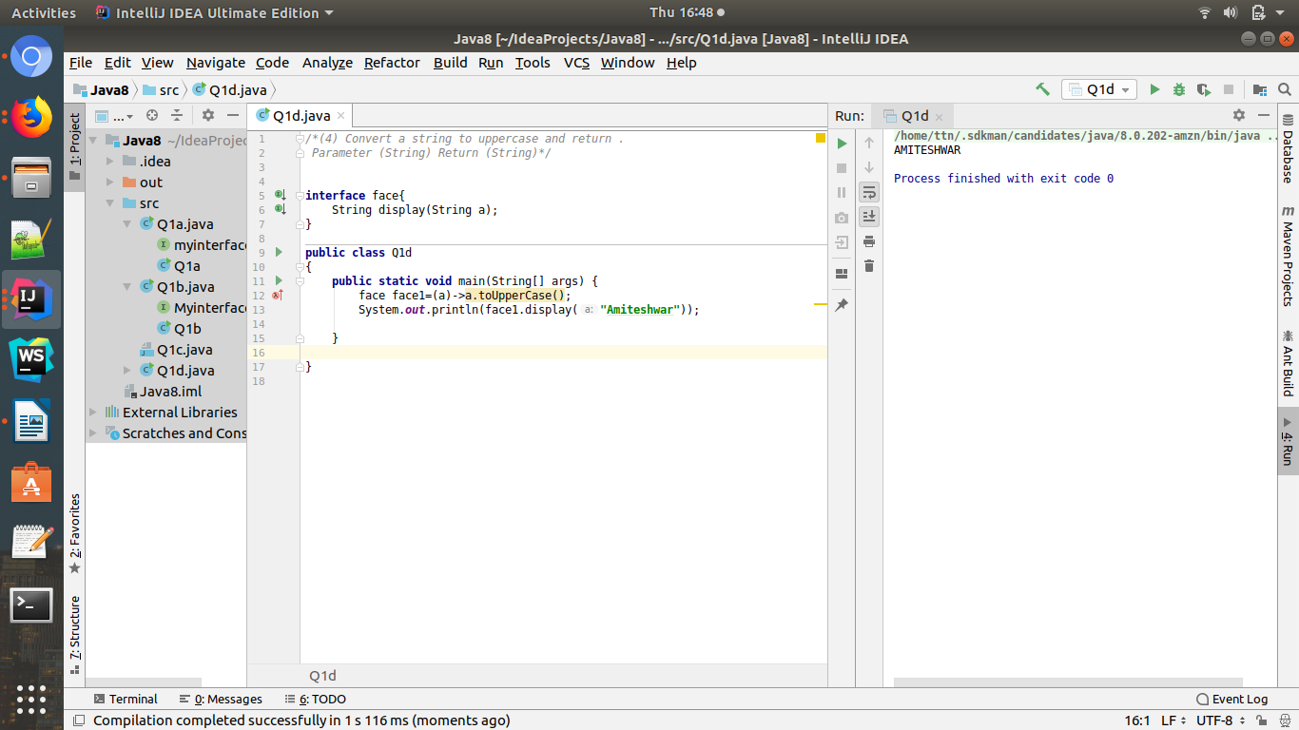

Q2) Create a functional interface whose method takes 2 integers and return one integer.

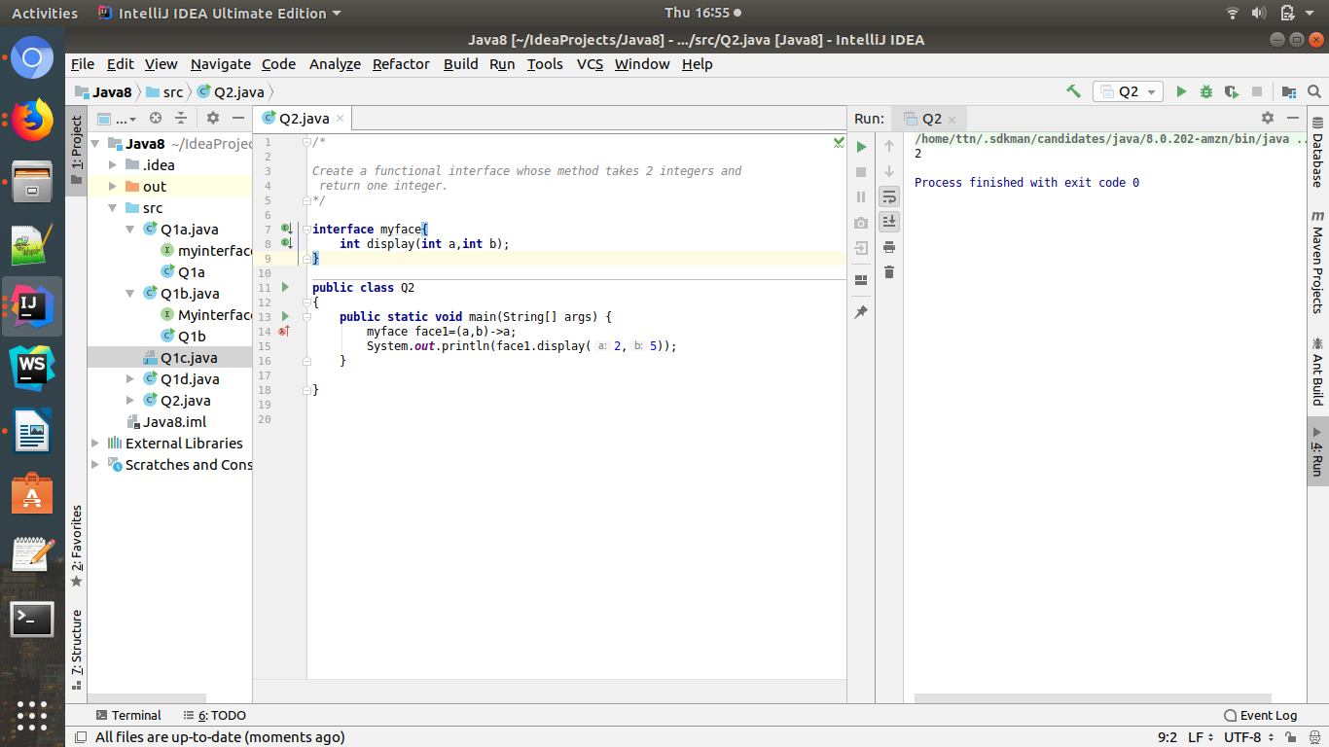

Q3 Using (instance) Method reference create and apply add and subtract method and using (Static) Method reference create and apply multiplication method for the functional interface created.
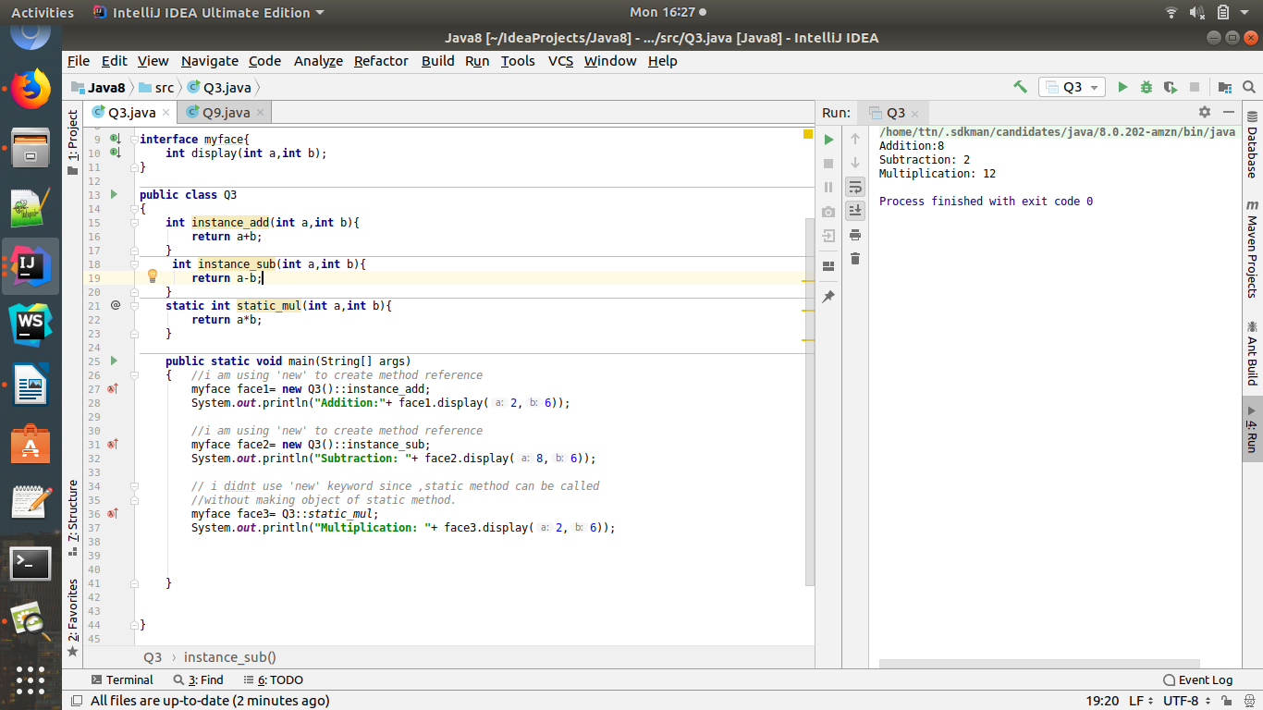

Q4 Create an Employee Class with instance variables (String) name, (Integer)age, (String)city and get the instance of the Class using constructor reference

Ans:
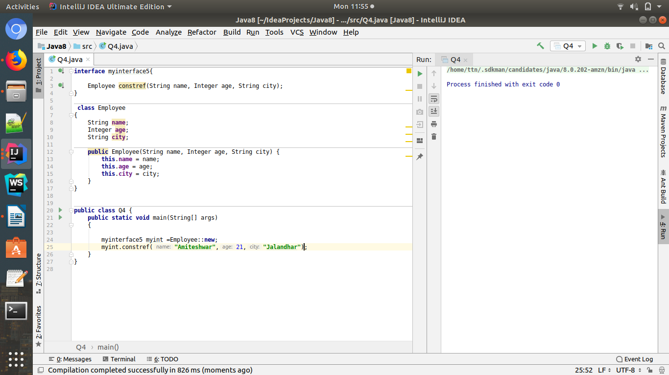

Q5.Implement following functional interfaces from java.util.function using lambdas:
- (1) Consumer
- (2) Supplier
- (3) Predicate
- (4) Function
Ans:

1)Consumer
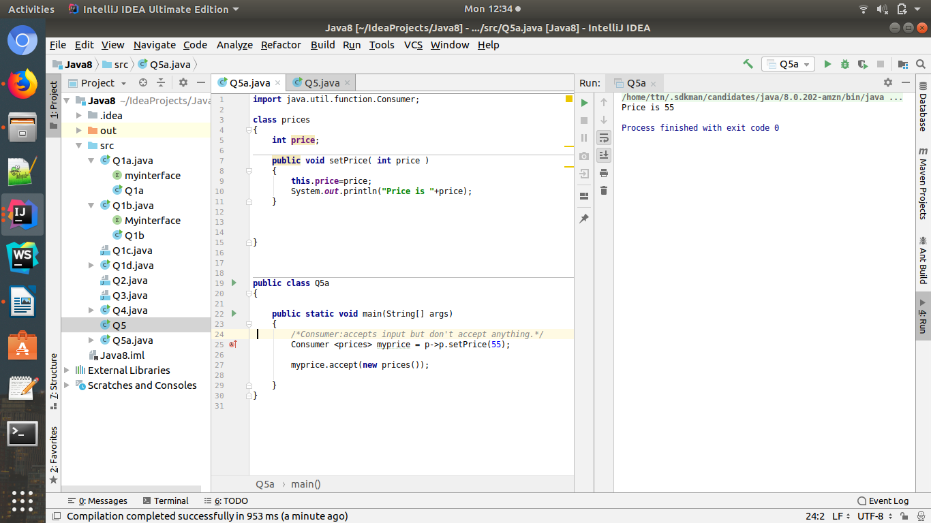
2)Supplier
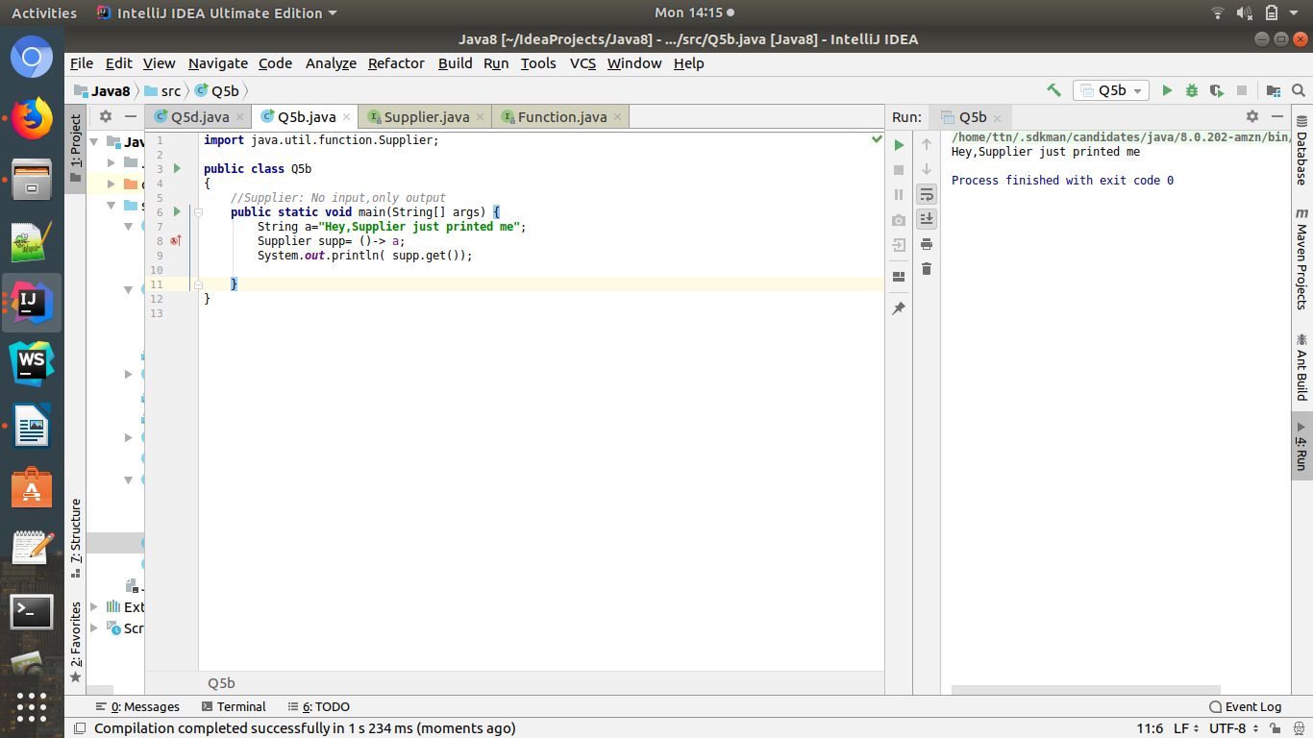

3)Predicate

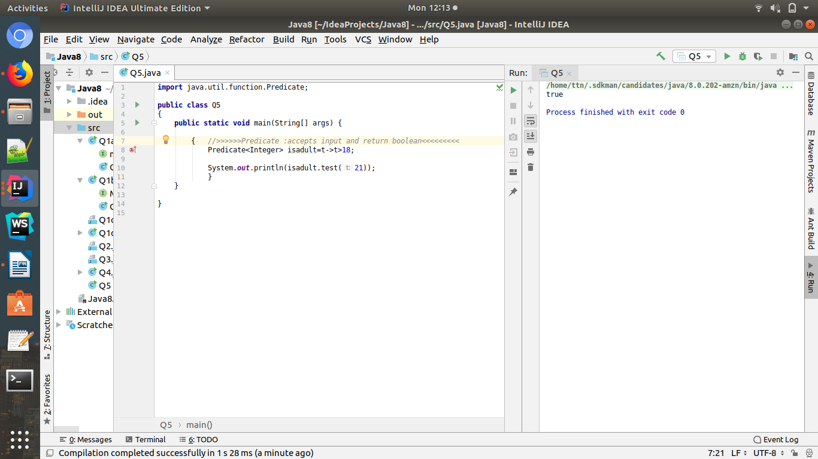

4)Function
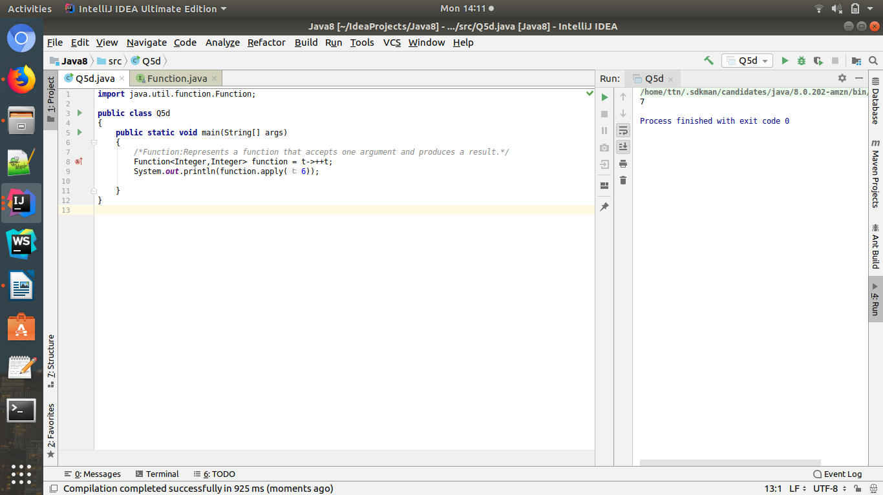

Q6.Create and access default and static method of an interface.
Ans:
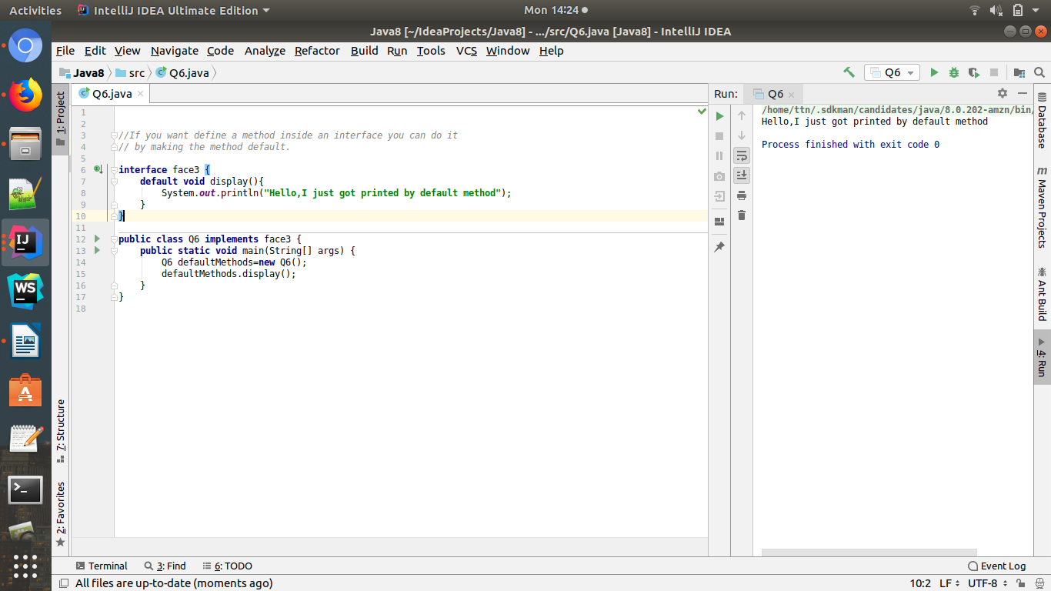
Default:

Static:
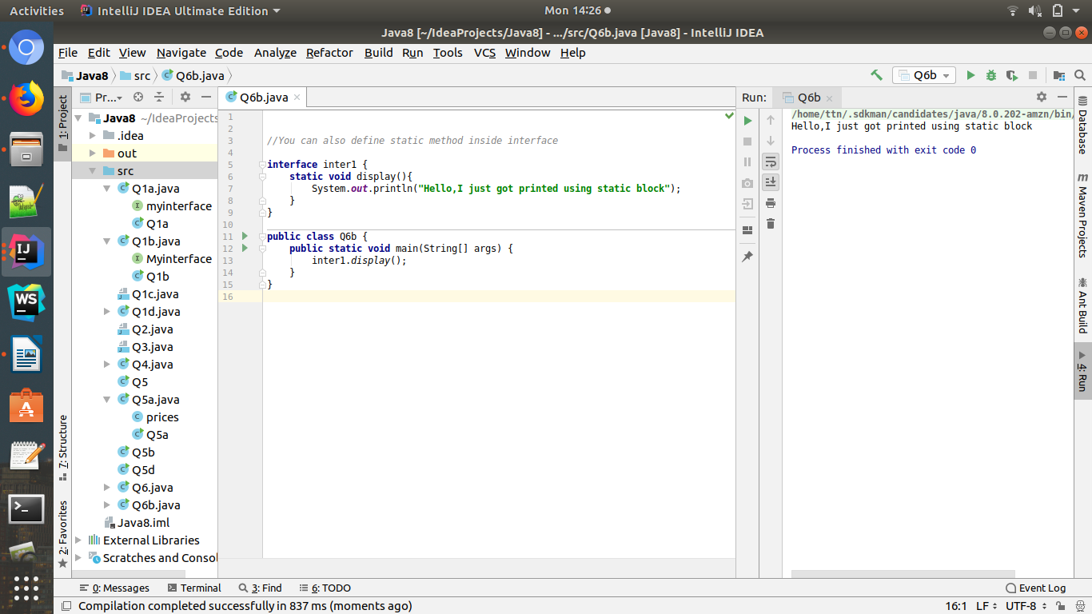

Q7. Override the default method of the interface.
Ans:
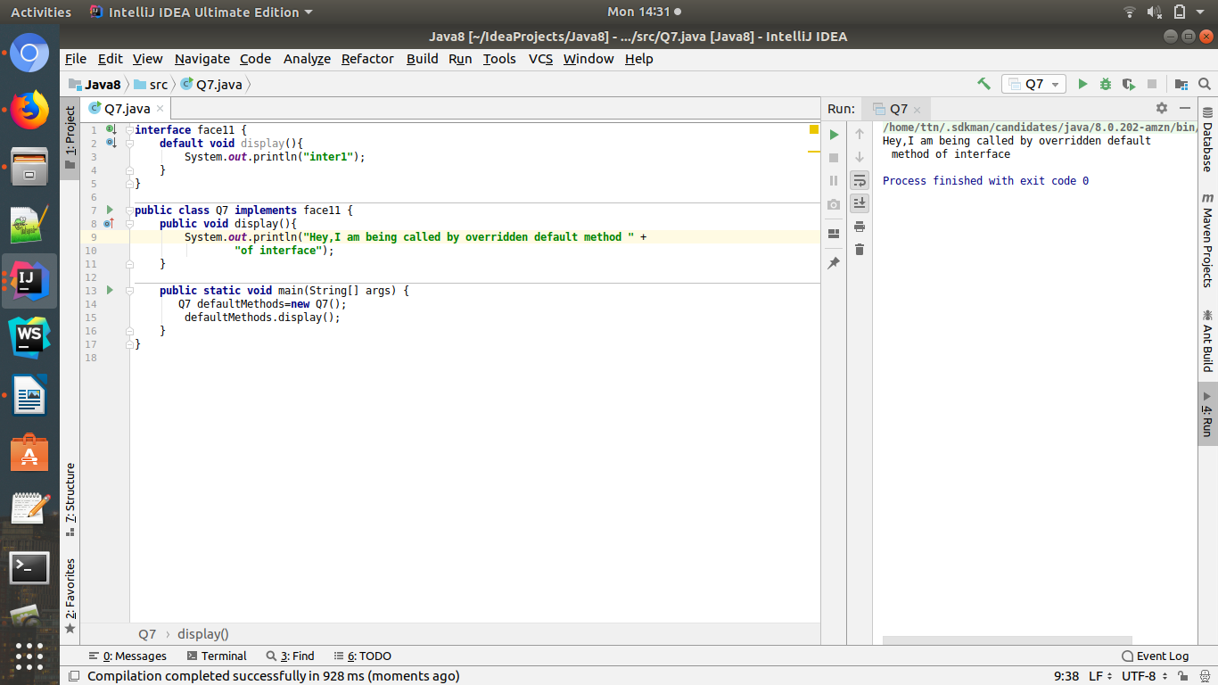

Q8. Implement multiple inheritance with default method inside interface.
Ans:
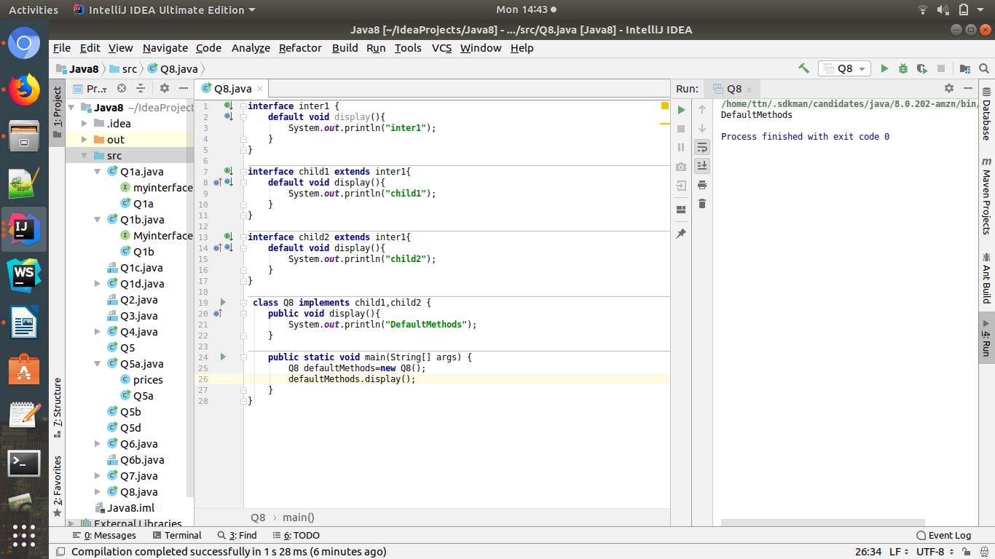

Q9.Collect all the even numbers from an integer list.
Ans:
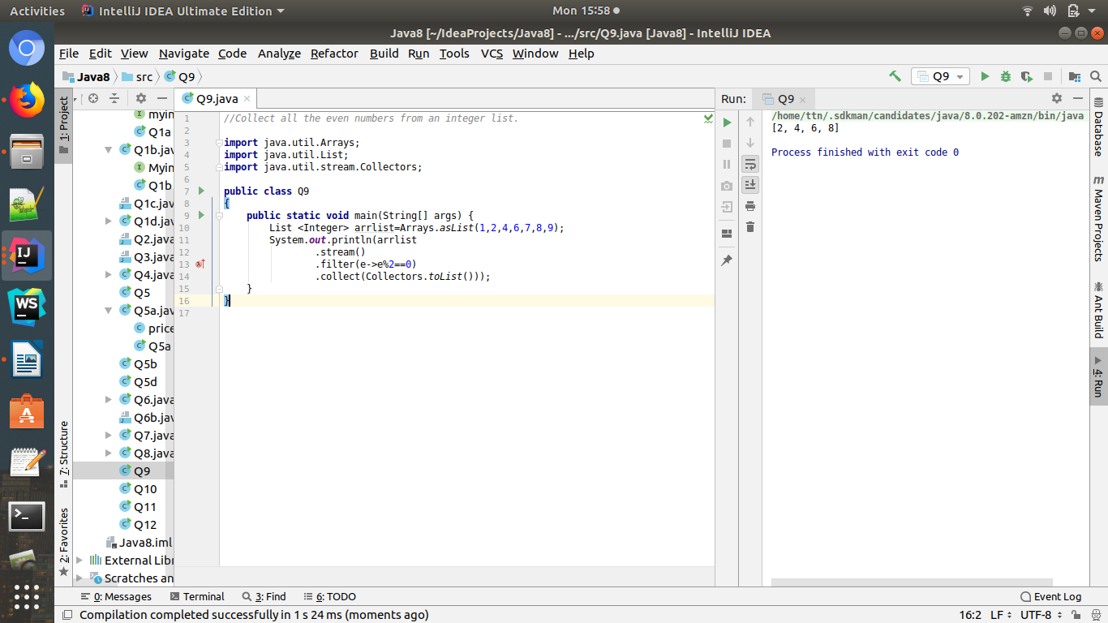

Q.10 Sum all the numbers greater than 5 in the integer list.

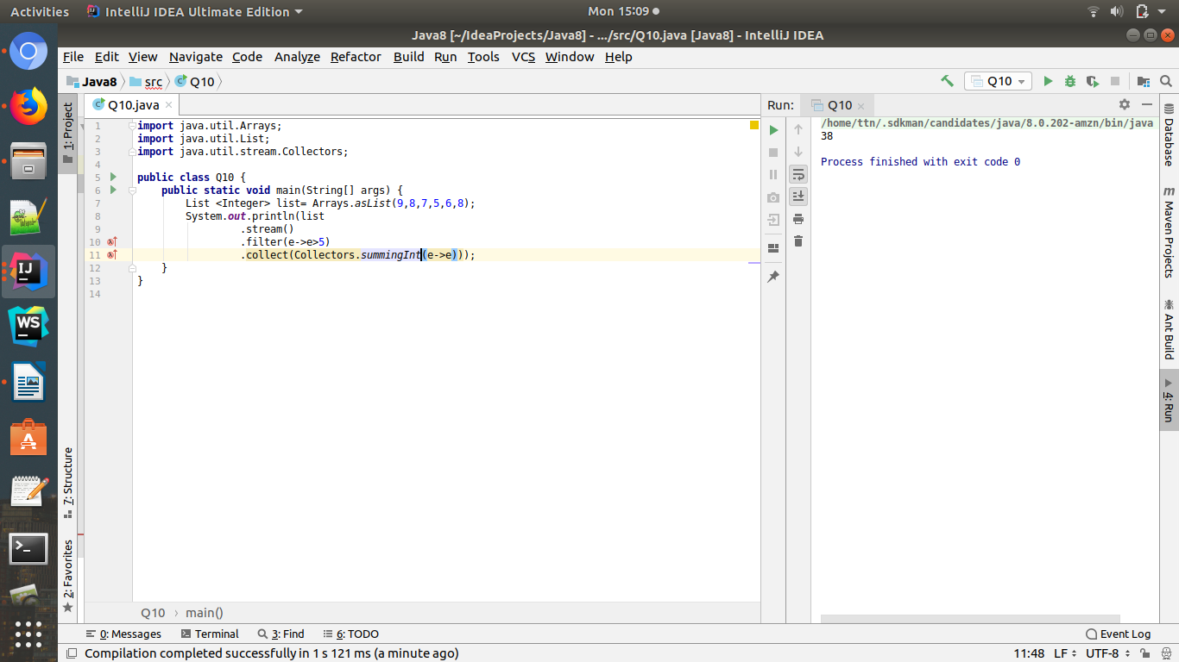
Q.11 Find average of the number inside integer list after doubling it.
Ans:
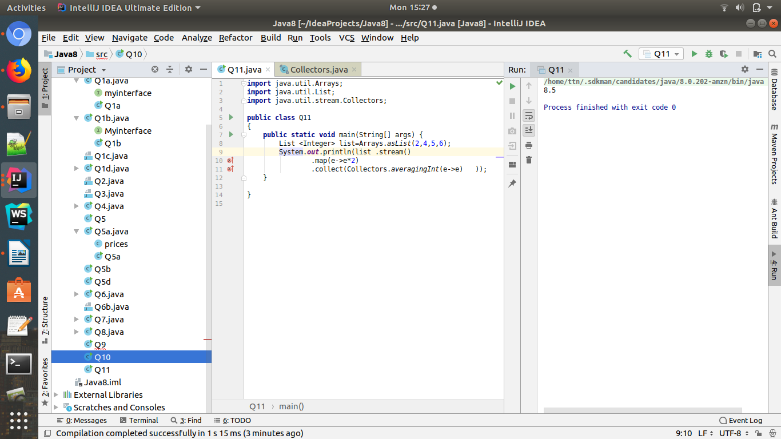

Q.12.Find the first even number in the integer list which is greater than 3.



