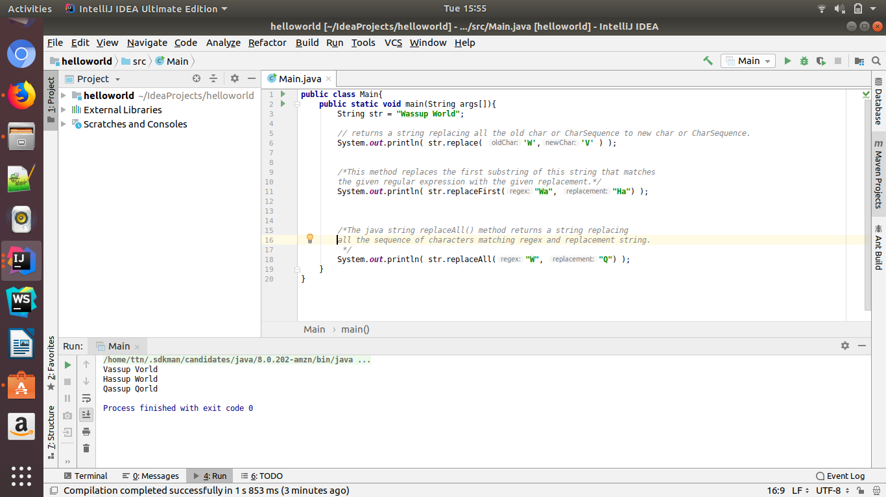
Q1. Write a program to replace a substring inside a string with other string ?

Q2. Write a program to find the number of occurrences of the duplicate words in a string and print them ?
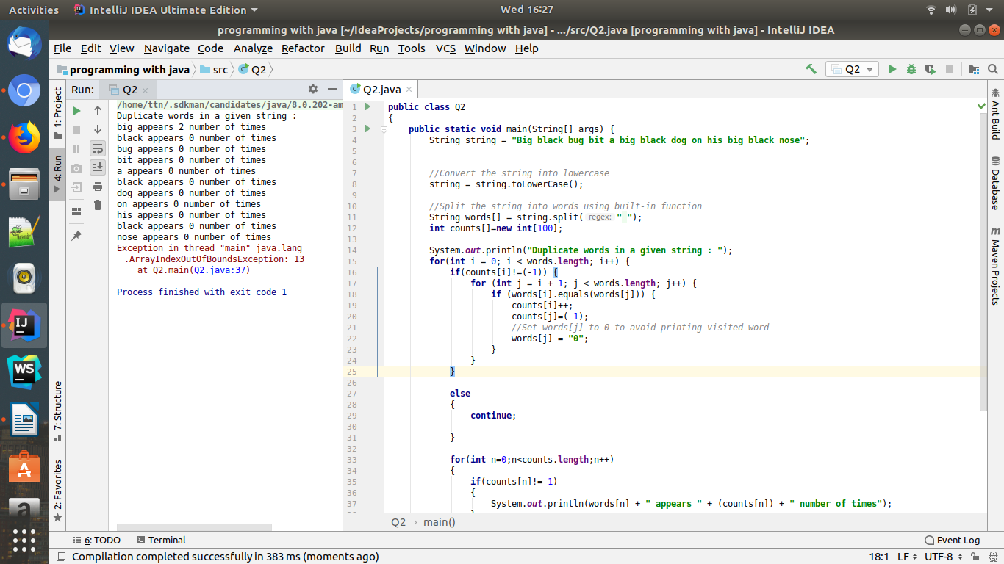

Q3. Write a program to find the number of occurrences of a character in a string without using loop?

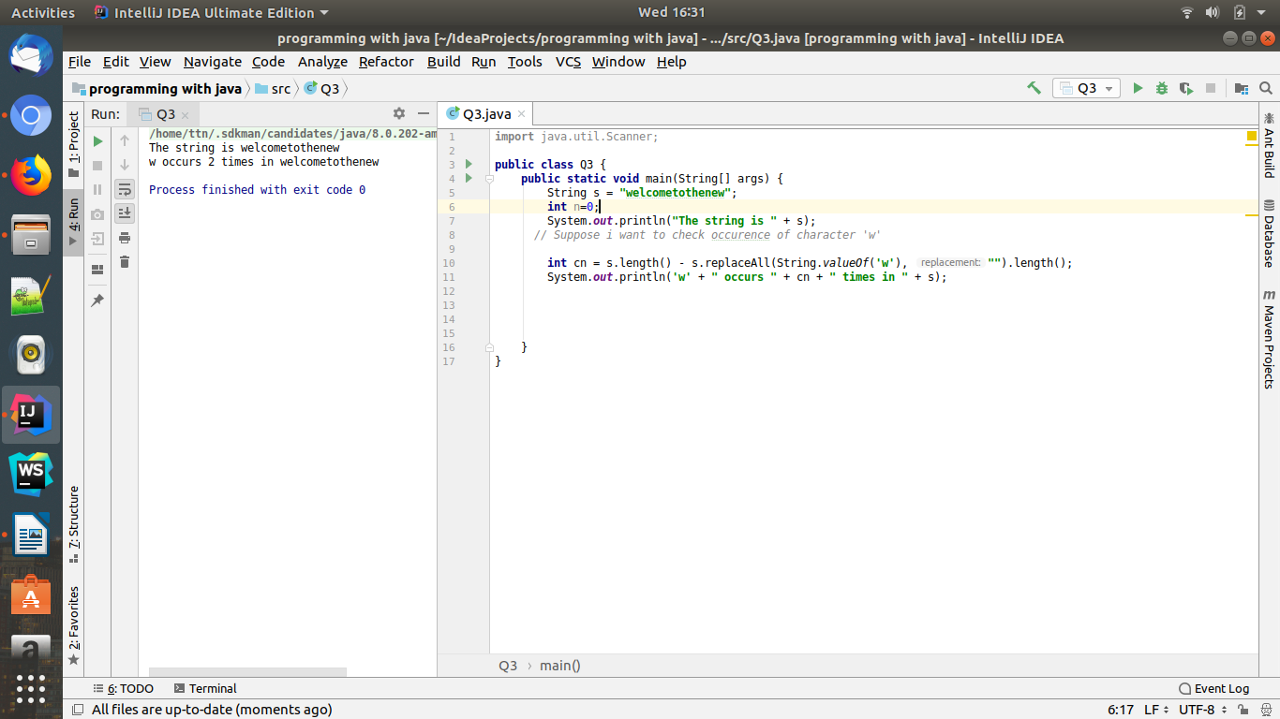
Q4. Calculate the number & Percentage Of Lowercase Letters,Uppercase Letters, Digits And Other Special Characters In A String
Ans:

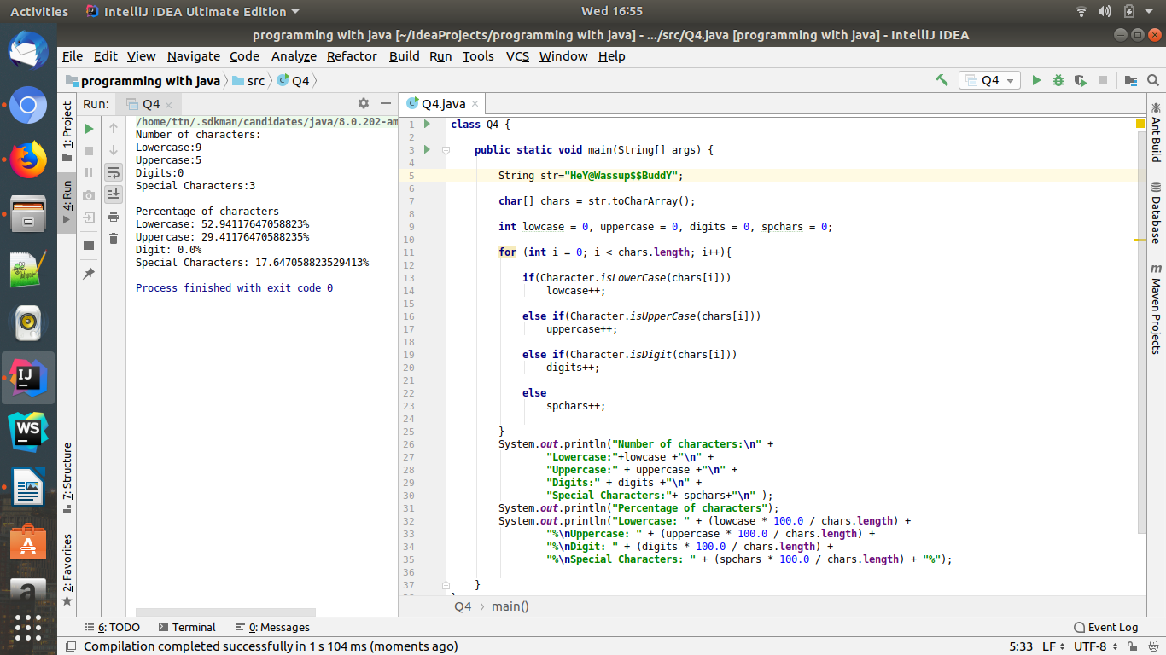

Q5. Find common elements between two arrays.
Ans:

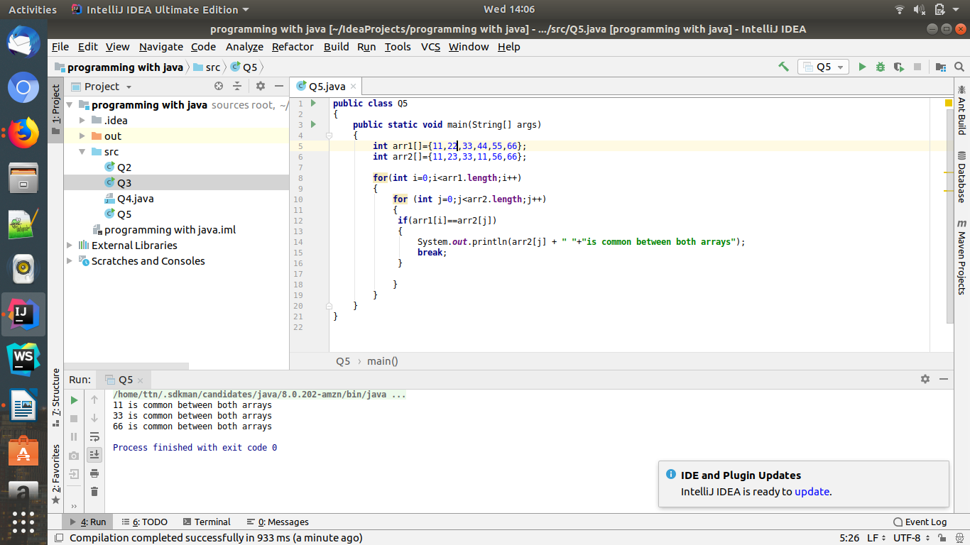

Q6. There is an array with every element repeated twice except one. Find that element.
Ans:

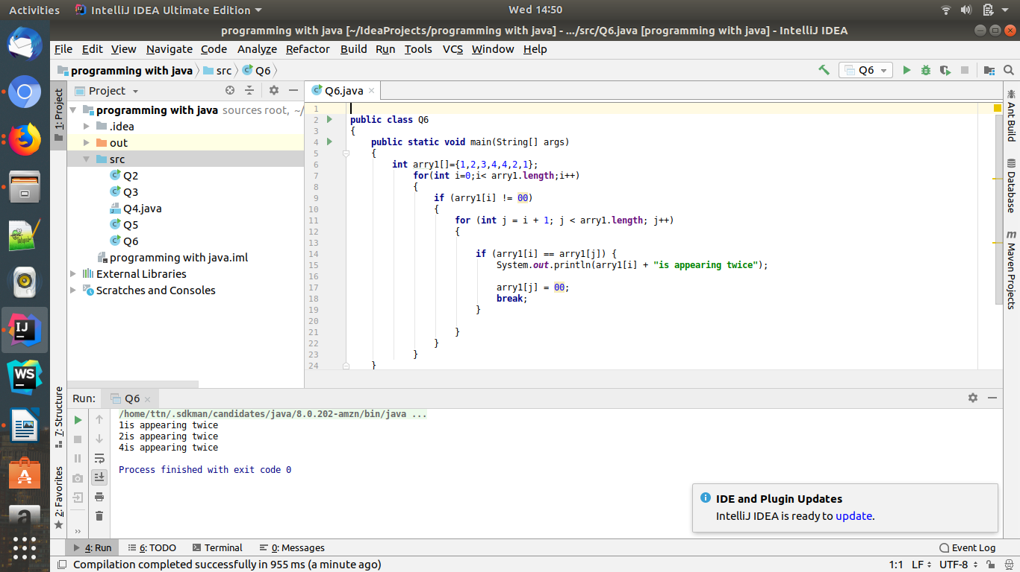

Q7. Write a program to print your Firstname,LastName & age using static block,static method & static variable respectively.
Ans:

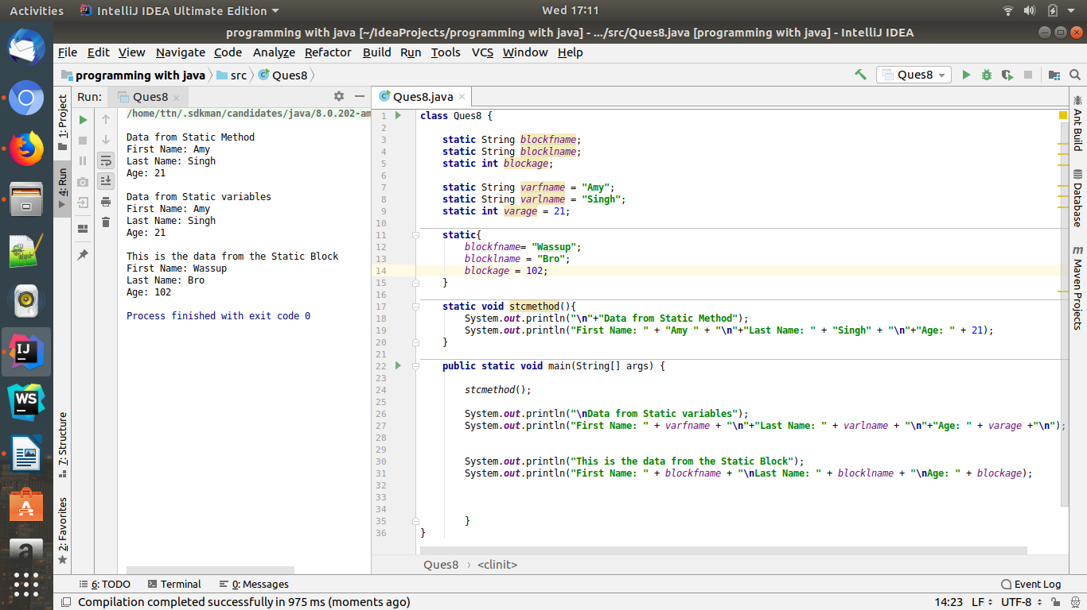

Q8. Write a program to reverse a string and remove character from index 4 to index 9 from the reversed string using String Buffer
Ans:
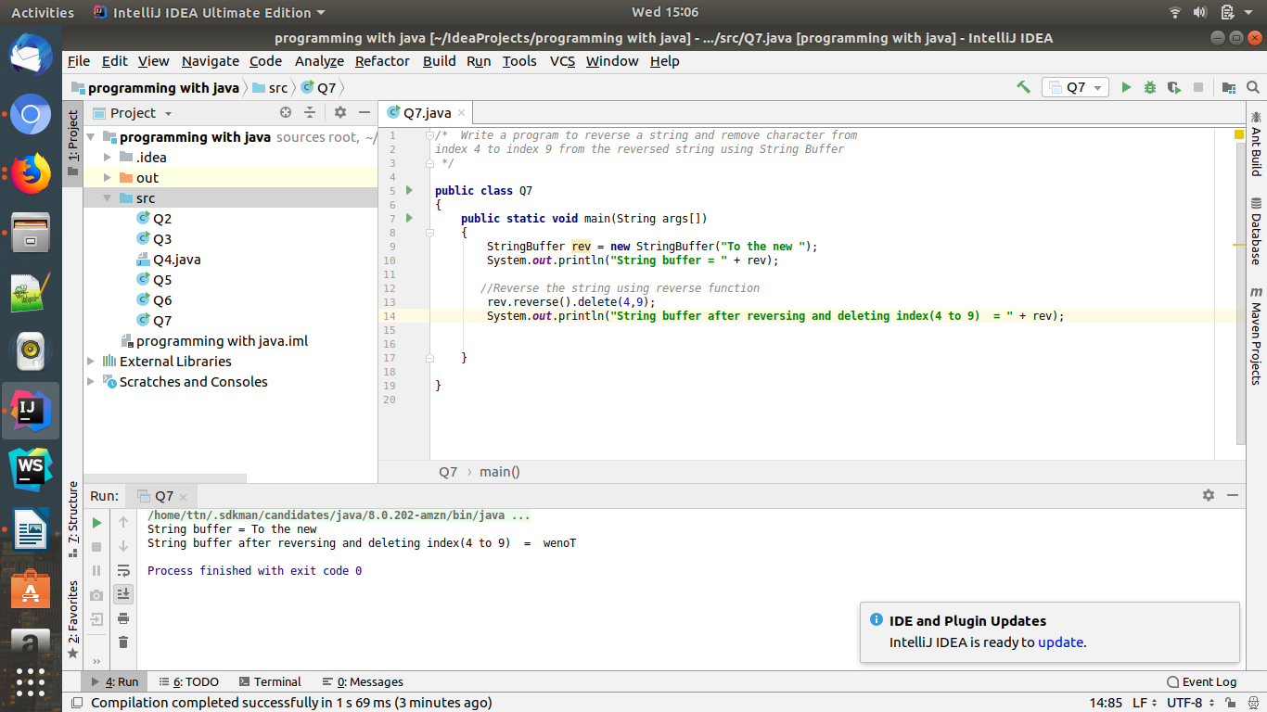

Q9.Write a program to display values of enums using a constructor & getPrice() method (Example display house & their prices)
Ans:

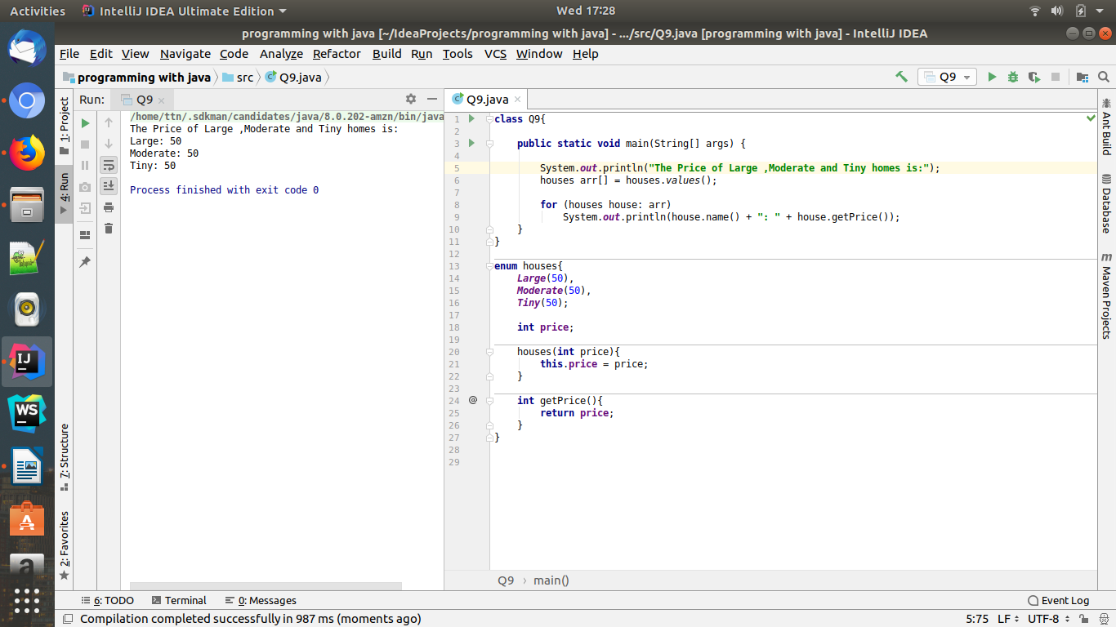

Q10.Write a single program for following operation using overloading
A) Adding 2 integer number
B) Adding 2 double
C) multiplying 2 float
D) multiplying 2 int
E) concate 2 string
F) Concate 3 String

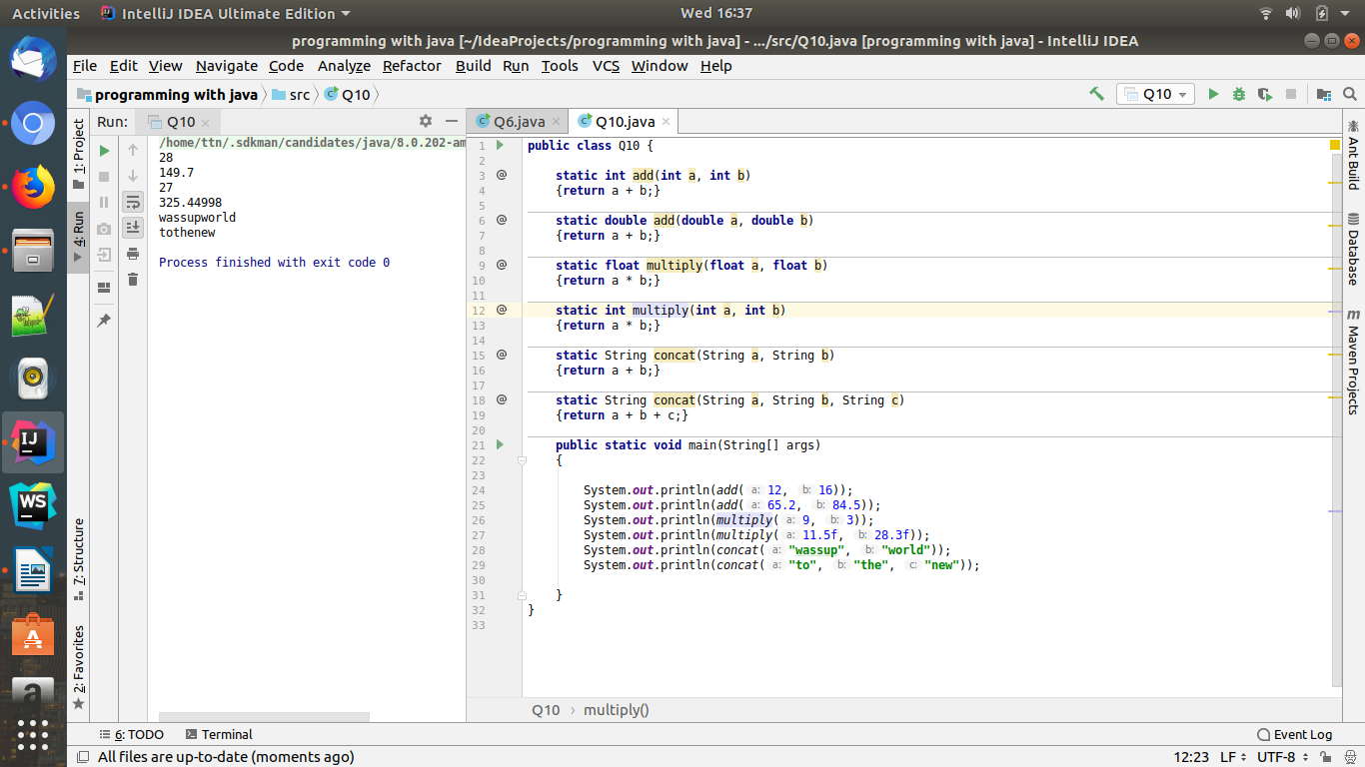
Ans:

Q11.Create 3 sub class of bank SBI,BOI,ICICI all 4 should have method called getDetails which provide there specific details like rateofinterest etc,print details of every banks.
Ans:

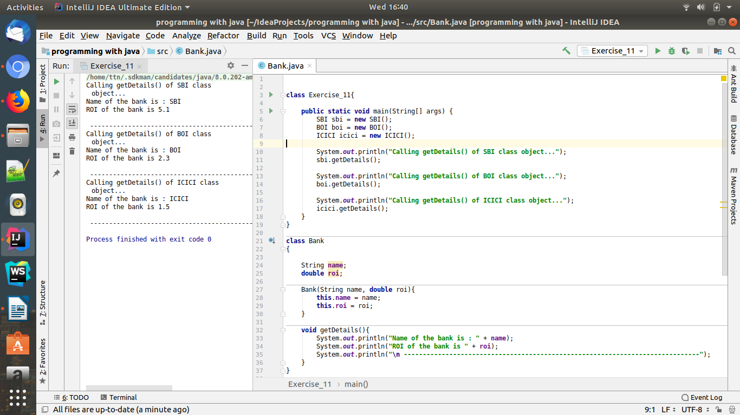
Since the code is not complete in the screenshot,below is the complete code for this program
Code:

class Exercise_11{
public static void main(String[] args) {
SBI sbi = new SBI();
BOI boi = new BOI();
ICICI icici = new ICICI();
System.out.println("Calling getDetails() of SBI class object...");
sbi.getDetails();
System.out.println("Calling getDetails() of BOI class object...");
boi.getDetails();
System.out.println("Calling getDetails() of ICICI class object...");
icici.getDetails();
}
}
class Bank
{
String name;
double roi;
Bank(String name, double roi){
this.name = name;
this.roi = roi;
}
void getDetails(){
System.out.println("Name of the bank is : " + name);
System.out.println("ROI of the bank is " + roi);
System.out.println("\n ------------------------------------------------------------------------------");
}
}
class SBI extends Bank{
SBI(){
super("SBI", 5.1);
}
}
class BOI extends Bank{
BOI(){
super("BOI", 2.3);
}
}
class ICICI extends Bank{
ICICI(){
super("ICICI", 1.5);
}
}

