Q.1. Write Java code to define List . Insert 5 floating point numbers in List, and using an iterator, find the sum of the numbers in List.
Ans:

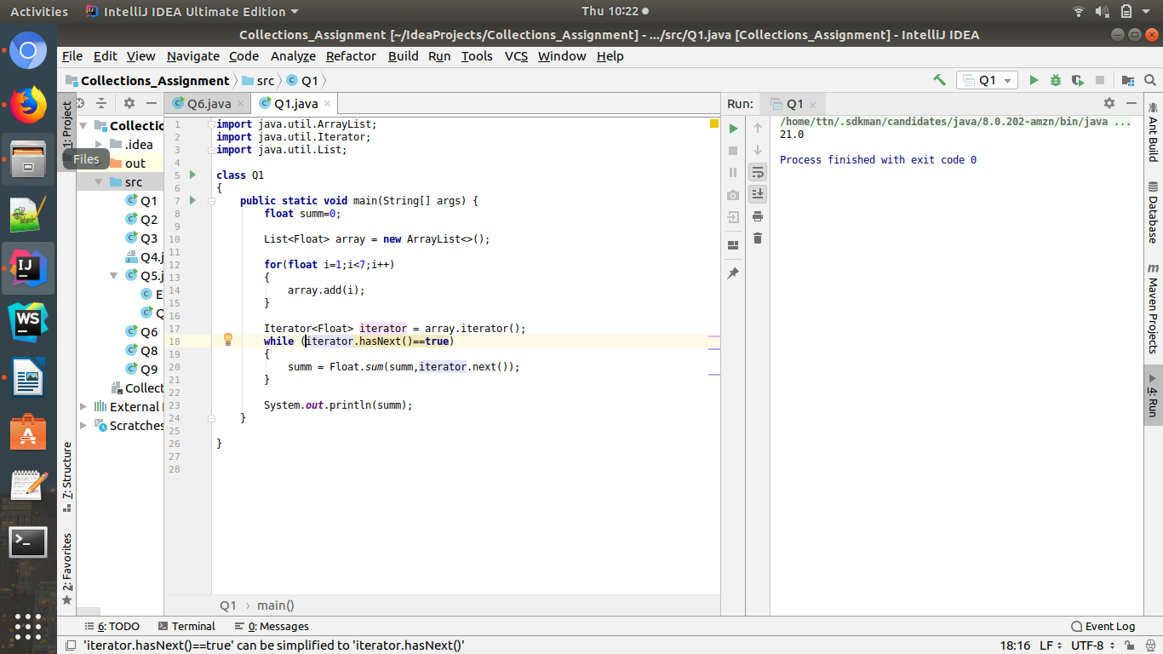

Q.2. Write a method that takes a string and returns the number of unique characters in the string.
Ans:
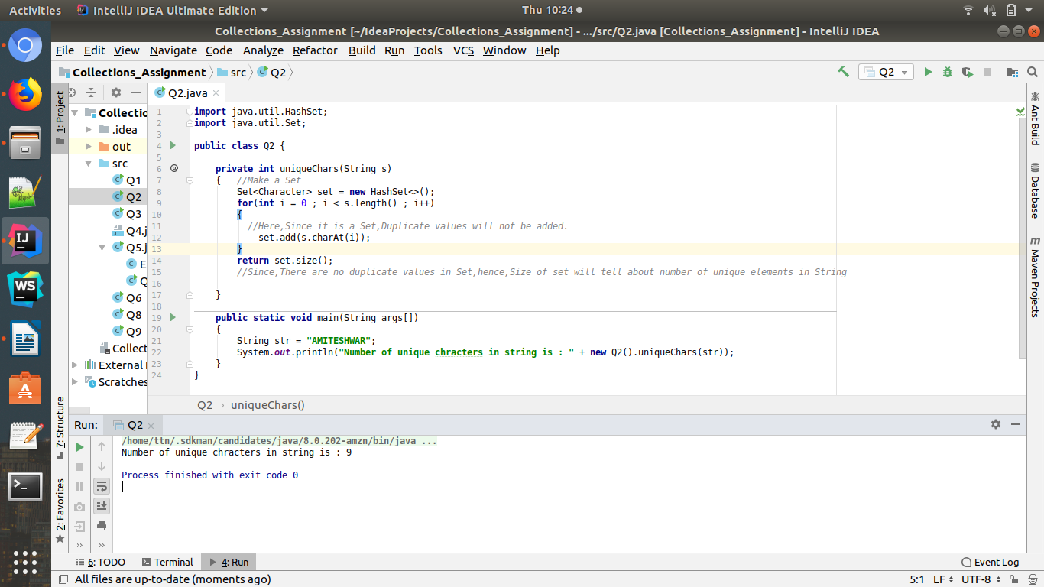

Q3.Write a method that takes a string and print the number of occurrence of each character characters in the string.
Ans:
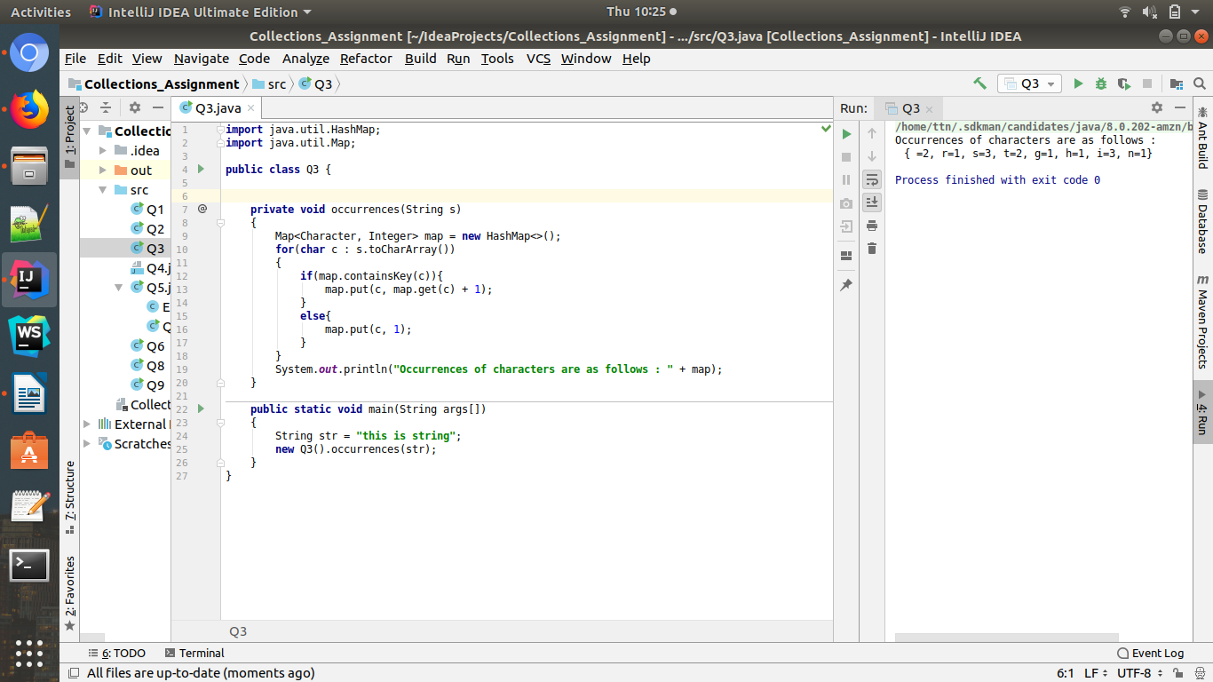

Q4.Write a program to sort Employee objects based on highest salary using Comparator. Employee class{ Double Age; Double Salary; String Name
Ans:
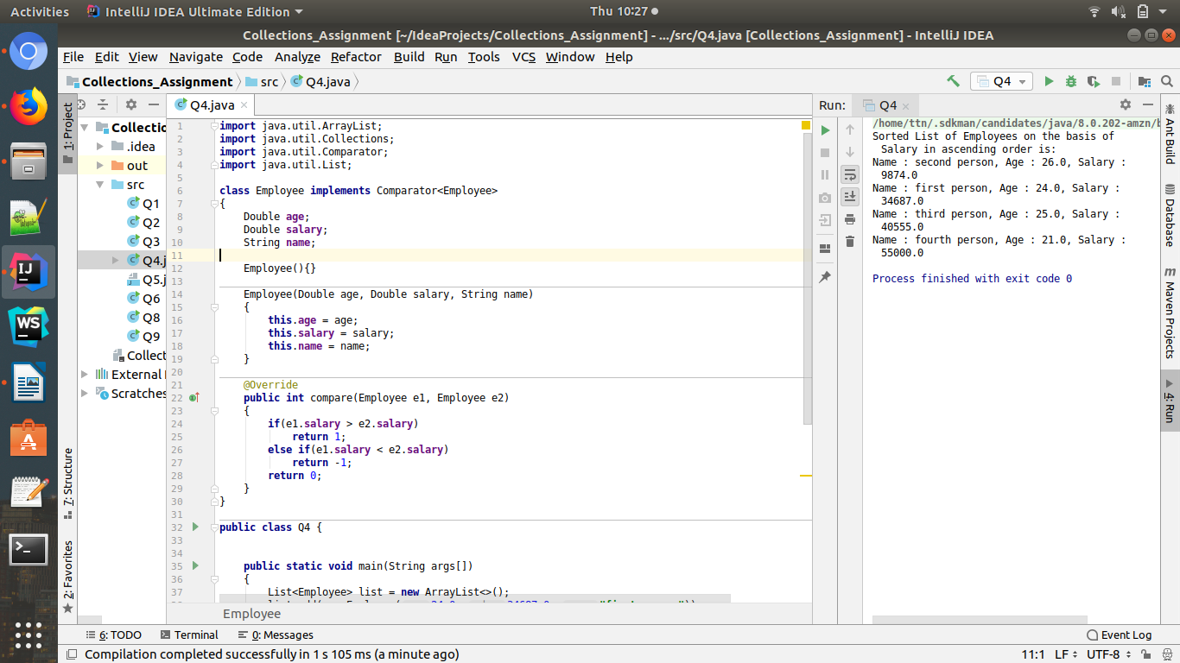

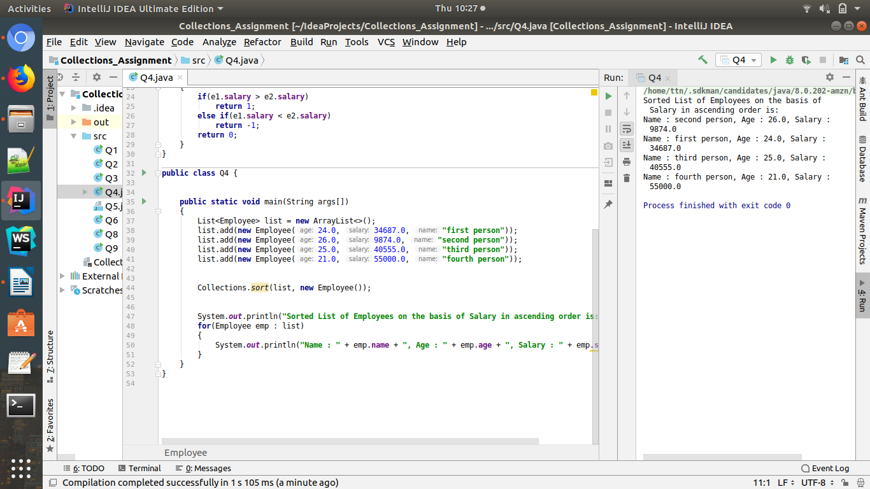
Code:

import java.util.ArrayList;
import java.util.Collections;
import java.util.Comparator;
import java.util.List;
class Employee implements Comparator<Employee>
{
Double age;
Double salary;
String name;
Employee(){}
Employee(Double age, Double salary, String name)
{
this.age = age;
this.salary = salary;
this.name = name;
}
@Override
public int compare(Employee e1, Employee e2)
{
if(e1.salary > e2.salary)
return 1;
else if(e1.salary < e2.salary)
return -1;
return 0;
}
}
public class Q4 {
public static void main(String args[])
{
List<Employee> list = new ArrayList<>();
list.add(new Employee(24.0, 34687.0, "first person"));
list.add(new Employee(26.0, 9874.0, "second person"));
list.add(new Employee(25.0, 40555.0, "third person"));
list.add(new Employee(21.0, 55000.0, "fourth person"));
Collections.sort(list, new Employee());
System.out.println("Sorted List of Employees on the basis of Salary in ascending order is: ");
for(Employee emp : list)
{
System.out.println("Name : " + emp.name + ", Age : " + emp.age + ", Salary : " + emp.salary);
}
}
}

Q.5. Write a program to sort the Student objects based on Score , if the score are same then sort on First Name . Class Student{ String Name; Double Score; Double Age
Ans:
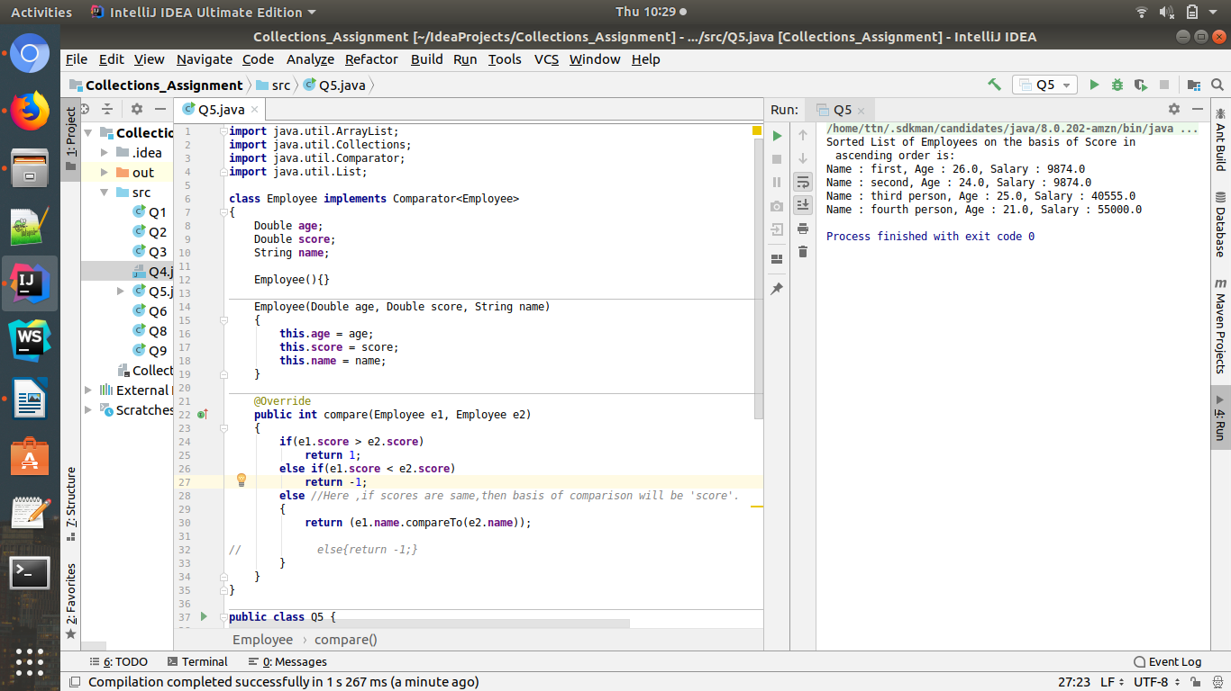
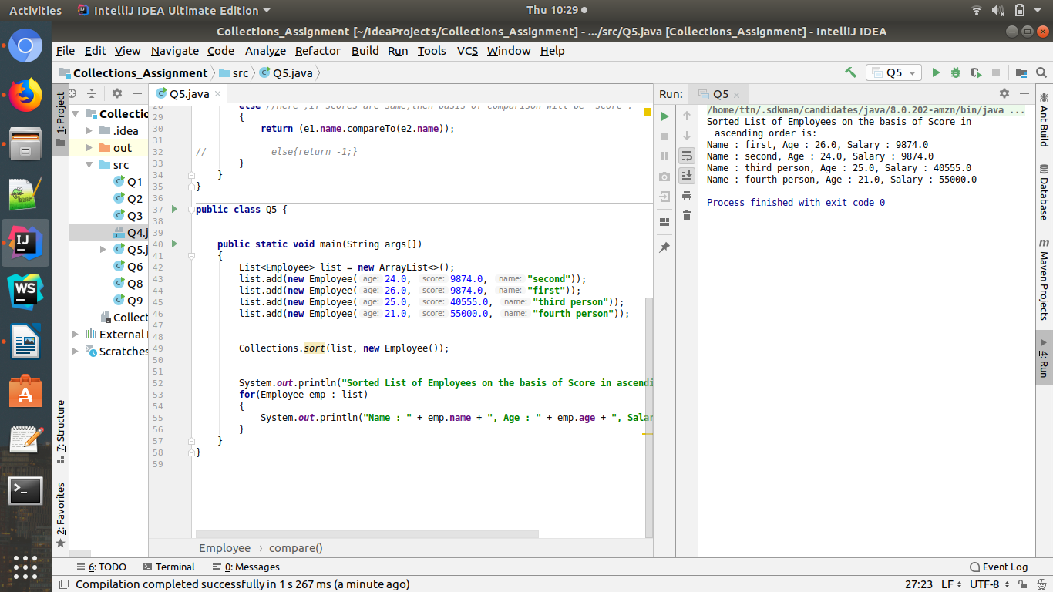

import java.util.ArrayList;
import java.util.Collections;
import java.util.Comparator;
import java.util.List;
class Employee implements Comparator<Employee>
{
Double age;
Double score;
String name;
Employee(){}
Employee(Double age, Double score, String name)
{
this.age = age;
this.score = score;
this.name = name;
}
@Override
public int compare(Employee e1, Employee e2)
{
if(e1.score > e2.score)
return 1;
else if(e1.score < e2.score)
return -1;
else //Here ,if scores are same,then basis of comparison will be 'score'.
{
return (e1.name.compareTo(e2.name));
// else{return -1;}
}
}
}
public class Q5 {
public static void main(String args[])
{
List<Employee> list = new ArrayList<>();
list.add(new Employee(24.0, 9874.0, "second"));
list.add(new Employee(26.0, 9874.0, "first"));
list.add(new Employee(25.0, 40555.0, "third person"));
list.add(new Employee(21.0, 55000.0, "fourth person"));
Collections.sort(list, new Employee());
System.out.println("Sorted List of Employees on the basis of Score in ascending order is: ");
for(Employee emp : list)
{
System.out.println("Name : " + emp.name + ", Age : " + emp.age + ", Salary : " + emp.score);
}
}
}

Q6.Print the elements of an array in the decreasing frequency if 2 numbers have same frequency then print the one which came first.

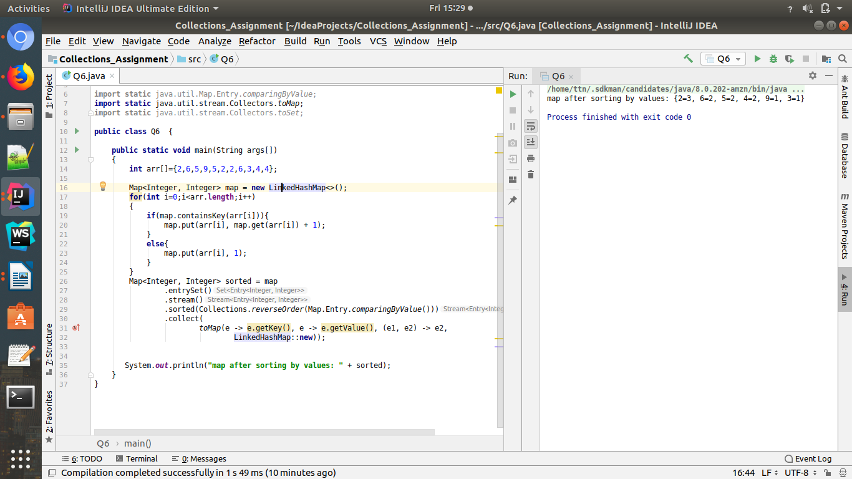

Q7) Design a Data Structure SpecialStack that supports all the stack operations like push(), pop(), isEmpty(), isFull() and an additional operation getMin() which should return minimum element from the SpecialStack. (Expected complexity O(1))
Ans:
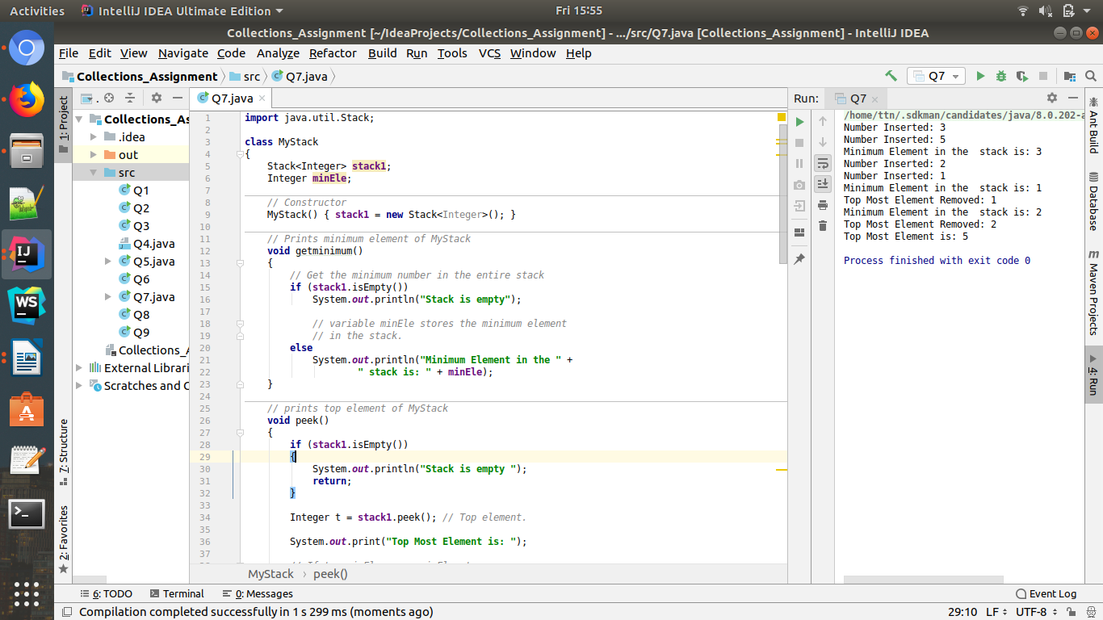
Whole code isn’t in screenshot,Below is the full code

import java.util.Stack;
class MyStack
{
Stack<Integer> stack1;
Integer minEle;
// Constructor
MyStack() { stack1 = new Stack<Integer>(); }
// Prints minimum element of MyStack
void getminimum()
{
// Get the minimum number in the entire stack
if (stack1.isEmpty())
System.out.println("Stack is empty");
// variable minEle stores the minimum element
// in the stack.
else
System.out.println("Minimum Element in the " +
" stack is: " + minEle);
}
// prints top element of MyStack
void peek()
{
if (stack1.isEmpty())
{
System.out.println("Stack is empty ");
return;
}
Integer t = stack1.peek(); // Top element.
System.out.print("Top Most Element is: ");
// If t < minEle means minEle stores
// value of t.
if (t < minEle)
System.out.println(minEle);
else
System.out.println(t);
}
// Removes the top element from MyStack
void pop()
{
if (stack1.isEmpty())
{
System.out.println("Stack is empty");
return;
}
System.out.print("Top Most Element Removed: ");
Integer t = stack1.pop();
// Minimum will change as the minimum element
// of the stack is being removed.
if (t < minEle)
{
System.out.println(minEle);
minEle = 2*minEle - t;
}
else
System.out.println(t);
}
// Insert new number into MyStack
void push(Integer x)
{
if (stack1.isEmpty())
{
minEle = x;
stack1.push(x);
System.out.println("Number Inserted: " + x);
return;
}
// If new number is less than original minEle
if (x < minEle)
{
stack1.push(2*x - minEle);
minEle = x;
}
else
stack1.push(x);
System.out.println("Number Inserted: " + x);
}
};
// Driver Code
public class Q7
{
public static void main(String[] args)
{
MyStack s = new MyStack();
s.push(3);
s.push(5);
s.getminimum();
s.push(2);
s.push(1);
s.getminimum();
s.pop();
s.getminimum();
s.pop();
s.peek();
}
}

Q8 ) Write a program to format date as example "21-March-2016"
Ans:
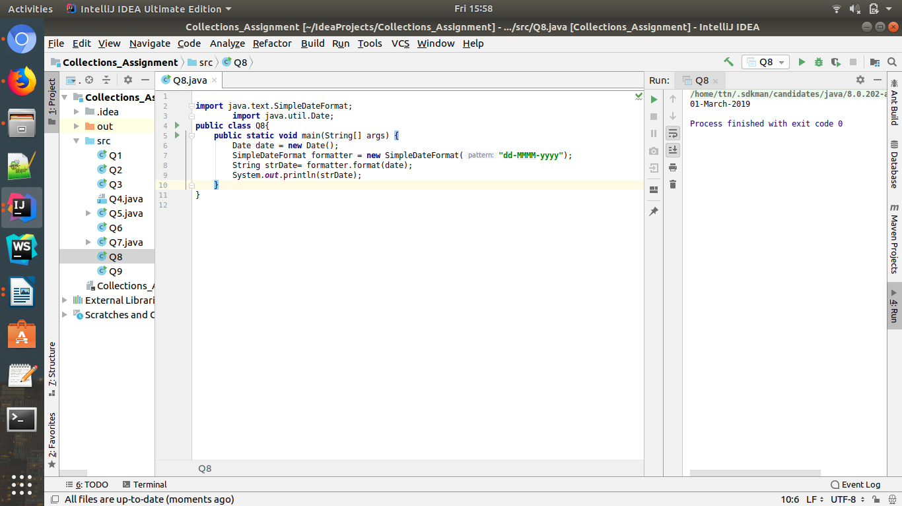

Q9)Write a program to display times in different country format.
Ans:
