1. Create Java classes having suitable attributes for Library management system.Use OOPs concepts in your design.Also try to use interfaces and abstract classes.
Ans:

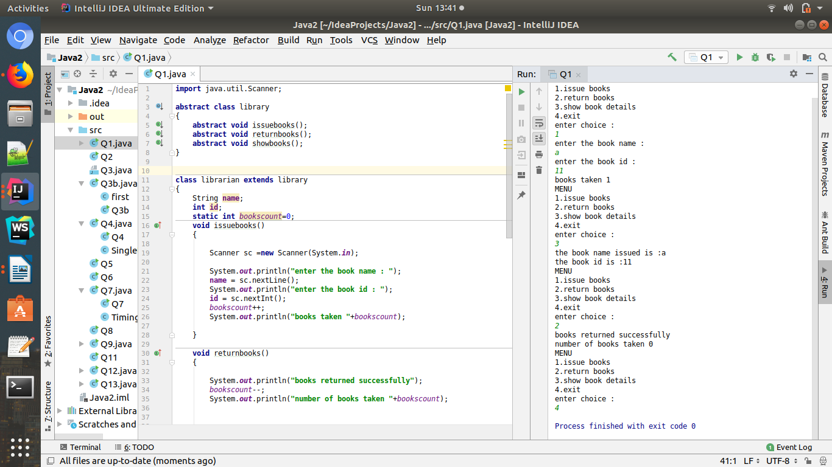

Code:
import java.util.Scanner;
abstract class library
{
abstract void issuebooks();
abstract void returnbooks();
abstract void showbooks();
}
class librarian extends library
{
String name;
int id;
static int bookscount=0;
void issuebooks()
{
Scanner sc =new Scanner(System.in);
System.out.println("enter the book name : ");
name = sc.nextLine();
System.out.println("enter the book id : ");
id = sc.nextInt();
bookscount++;
System.out.println("books taken "+bookscount);
}
void returnbooks()
{
System.out.println("books returned successfully");
bookscount--;
System.out.println("number of books taken "+bookscount);
}
void showbooks()
{
System.out.println("the book name issued is :"+name);
System.out.println("the book id is :"+id);
}
}
class Q1
{
public static void main(String args[])
{
library lib=new librarian();
do {
System.out.println("MENU");
System.out.println("1.issue books");
System.out.println("2.return books");
System.out.println("3.show book details");
System.out.println("4.exit");
System.out.println("enter choice :");
Scanner sc = new Scanner(System.in);
int choice = sc.nextInt();
if (choice == 1)
lib.issuebooks();
else if (choice == 2)
lib.returnbooks();
else if(choice == 3)
lib.showbooks();
else
System.exit(0);
}while(true);
}
}

Q.2. WAP to sorting string without using string Methods?.
Ans:
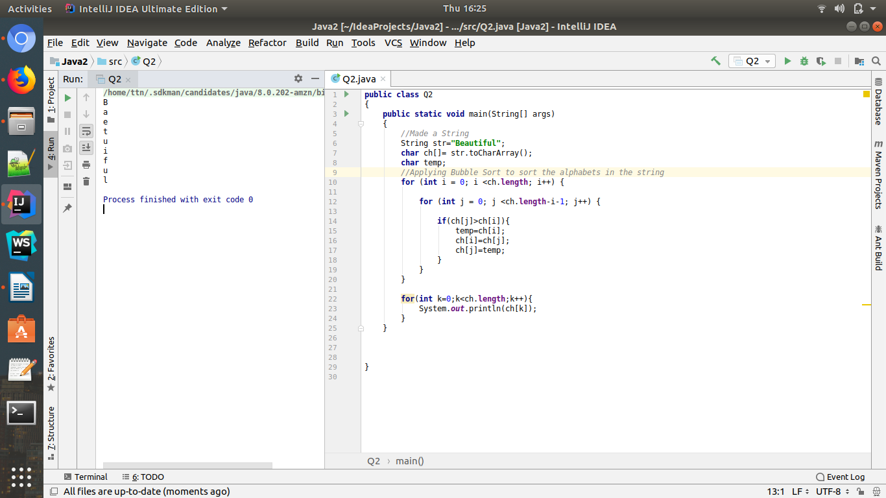

Q.3. WAP to produce NoClassDefFoundError and ClassNotFoundException exception.
Ans:
ClassNotFoundException:
ClassNotFoundException is a runtime exception that is thrown when an application tries to load a class at runtime using the Class.forName() or loadClass() or findSystemClass() methods ,and the class with specified name are not found in the classpath.

Here,in the code ,i have used Class.forName();

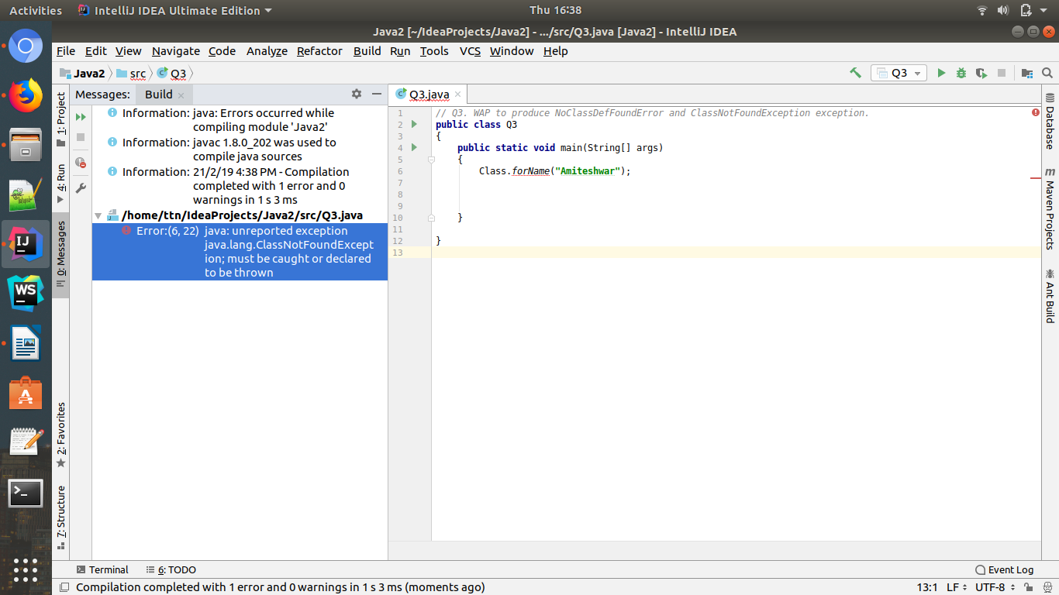

NoClassDefFoundError is an error that is thrown when the Java Runtime System tries to load the definition of a class, and that class definition is no longer available.

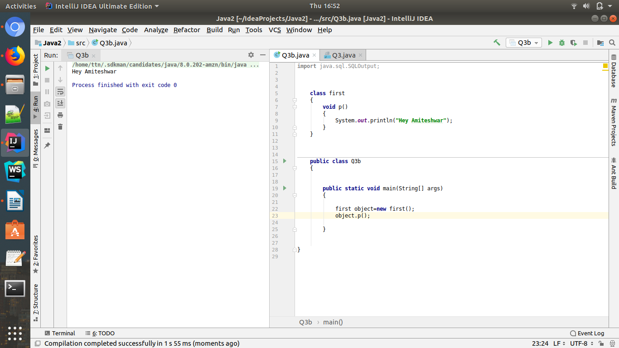
The code will compile properly:

When i will remove the class that i have called inside main function,here,Class first,then the NoclassDefError is generated.

Below is the screenshot:

Firstly,i went to folder containing first.class

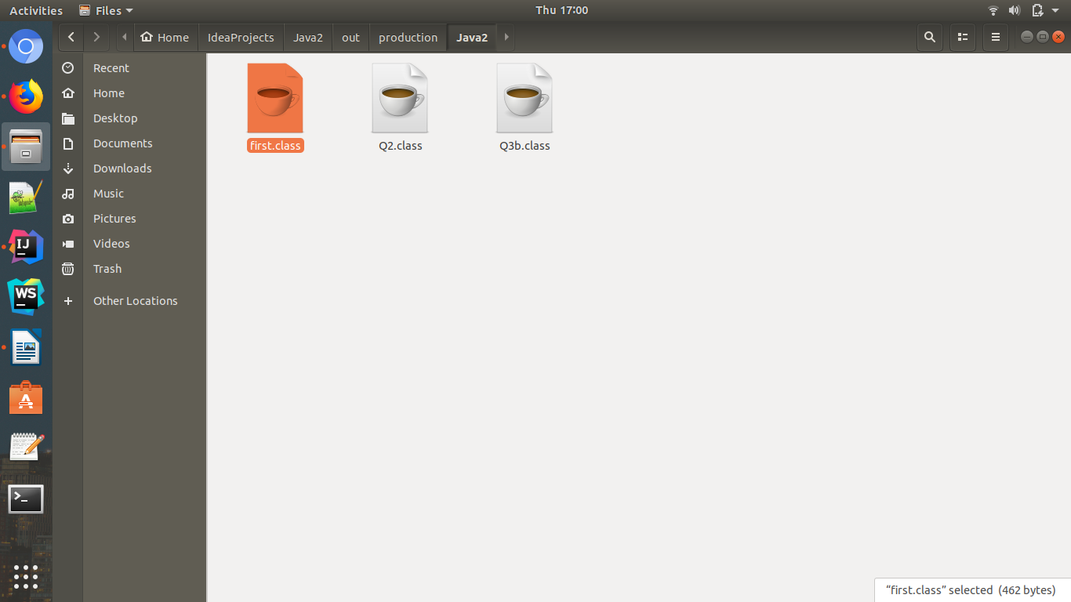

Delete the first.class
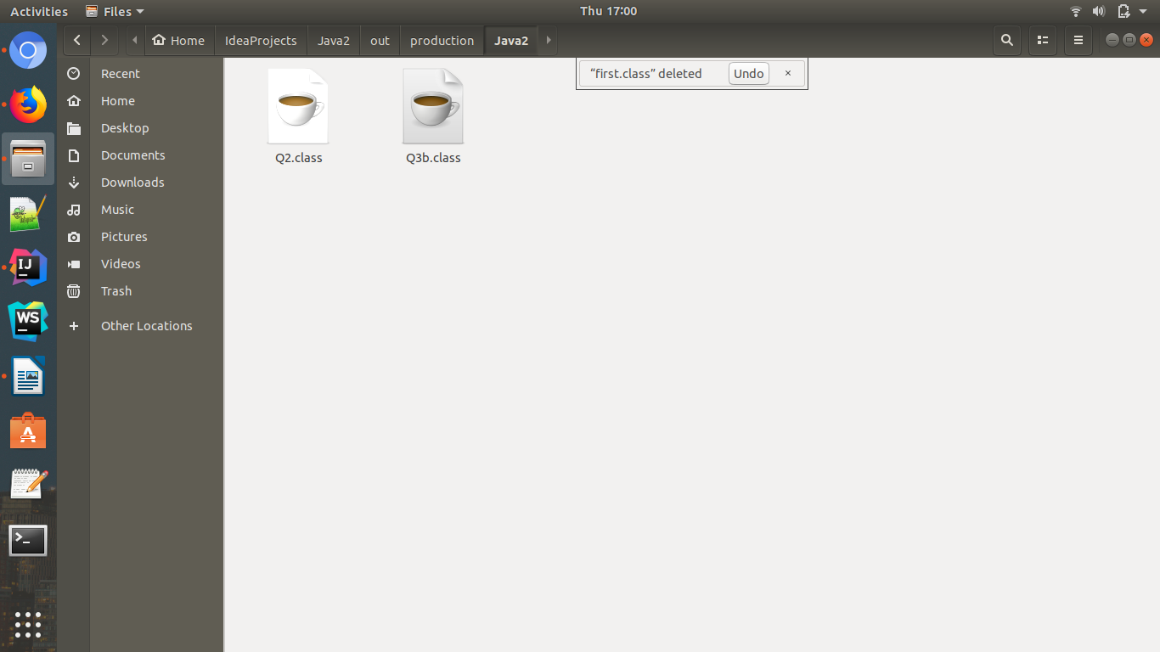

NoClassDefError is generated.

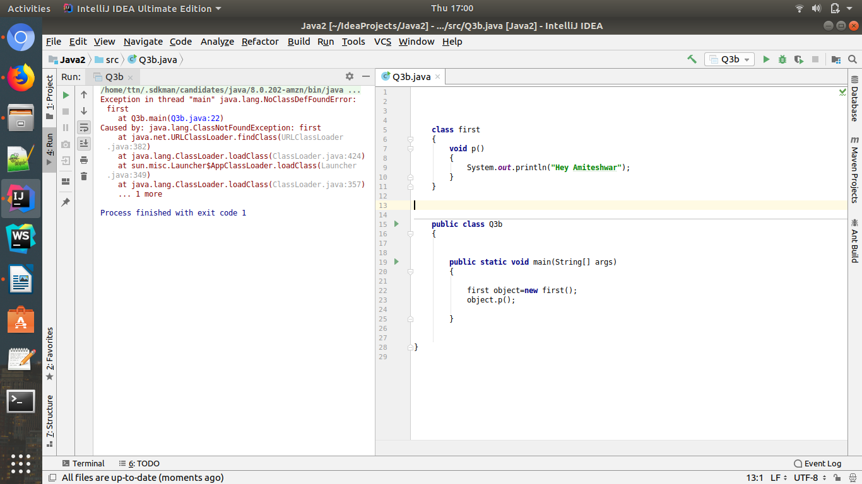

Q4 WAP to create singleton class.
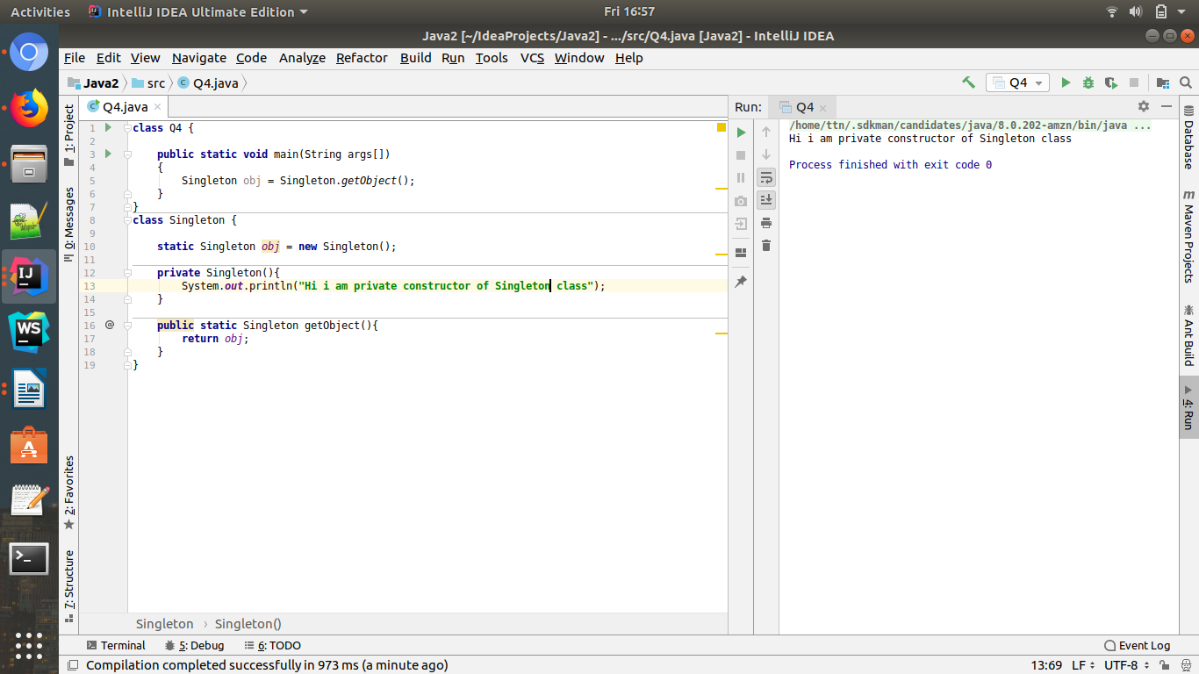

5. WAP to show object cloning in java using cloneable and copy constructor both.
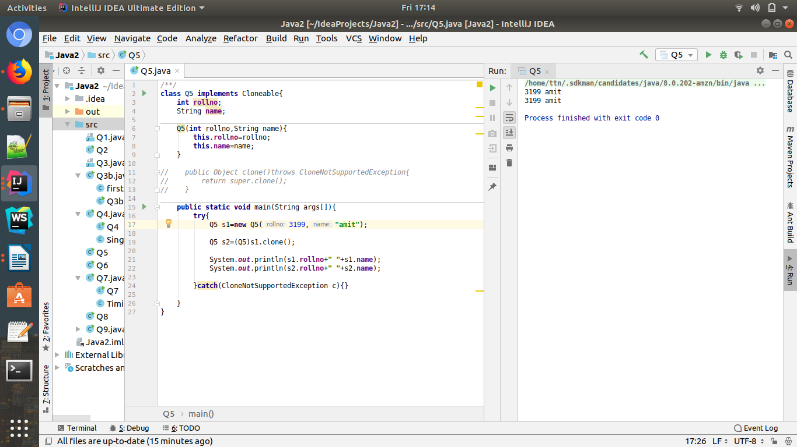
Ans:

Q.6. WAP showing try, multi-catch and finally blocks.

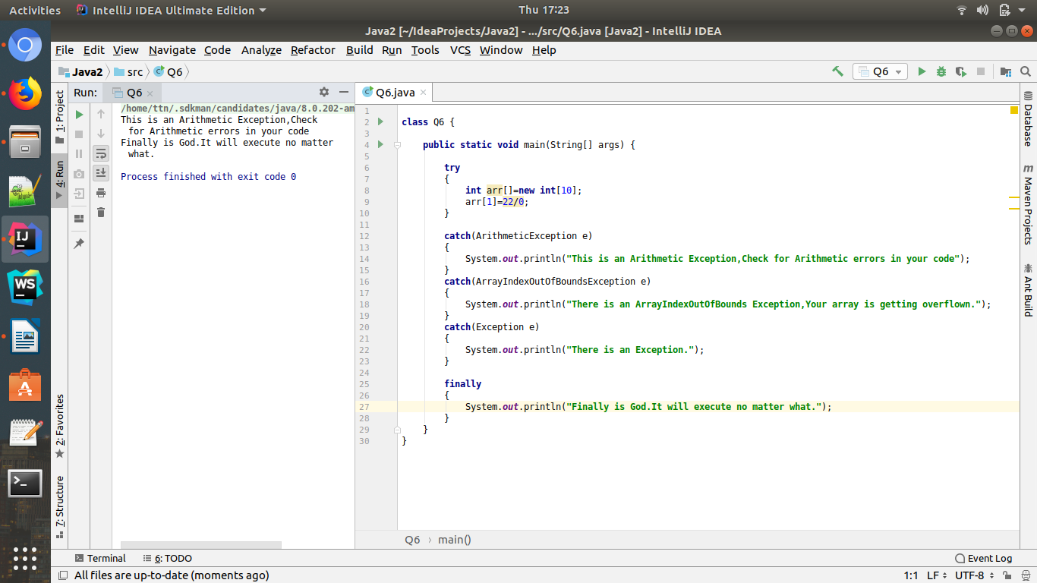

Q.7. WAP to convert seconds into days, hours, minutes and seconds.
Ans:
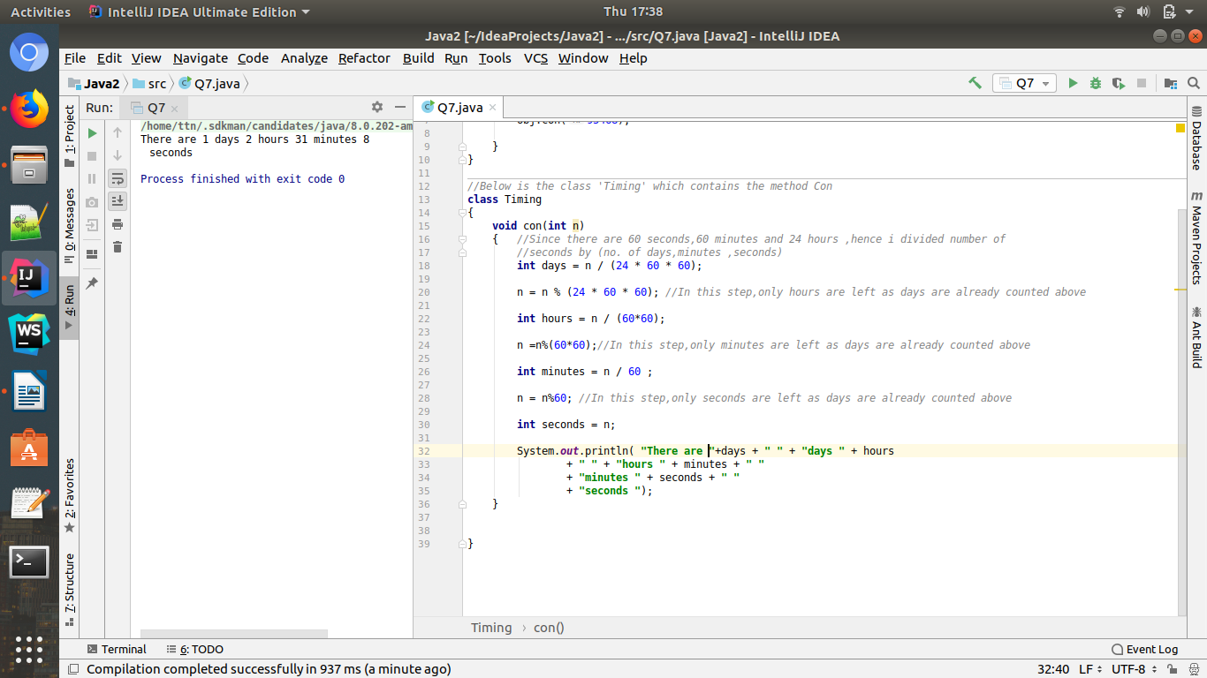

Q.8. WAP to read words from the keyboard until the word done is entered. For each word except done, report whether its first character is equal to its last character. For the required loop, use a
a)while statement
b)do-while statement
Ans:
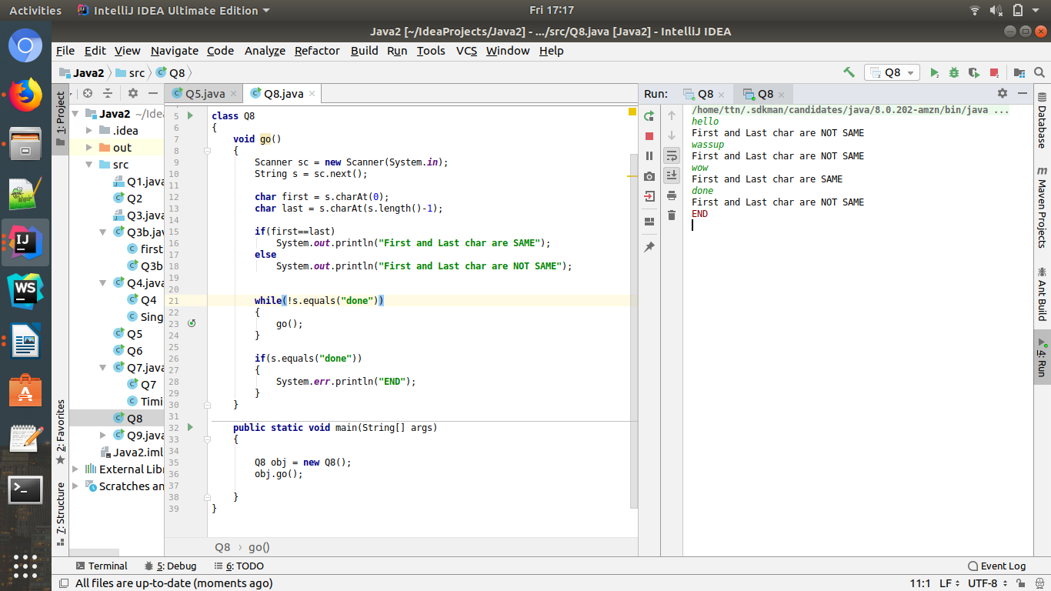
b)do while loop
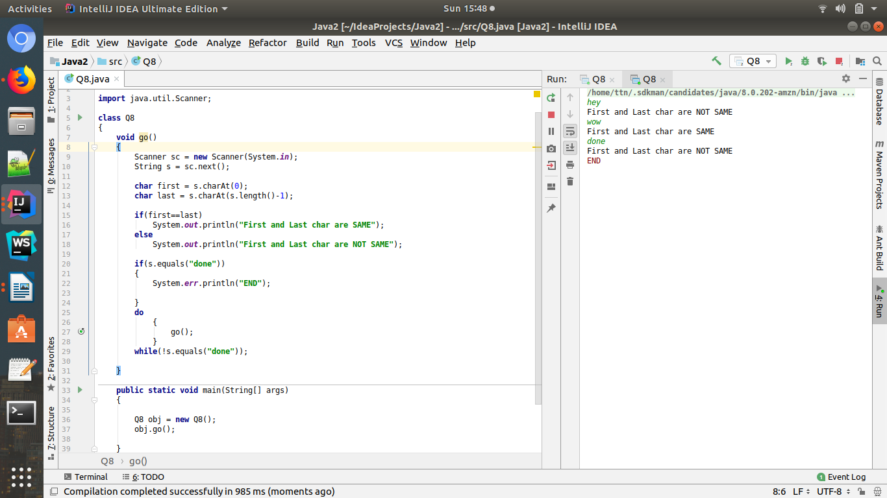

Q9) Design classes having attributes for furniture where there are wooden chairs and tables, metal chairs and tables. There are stress and fire tests for each products.

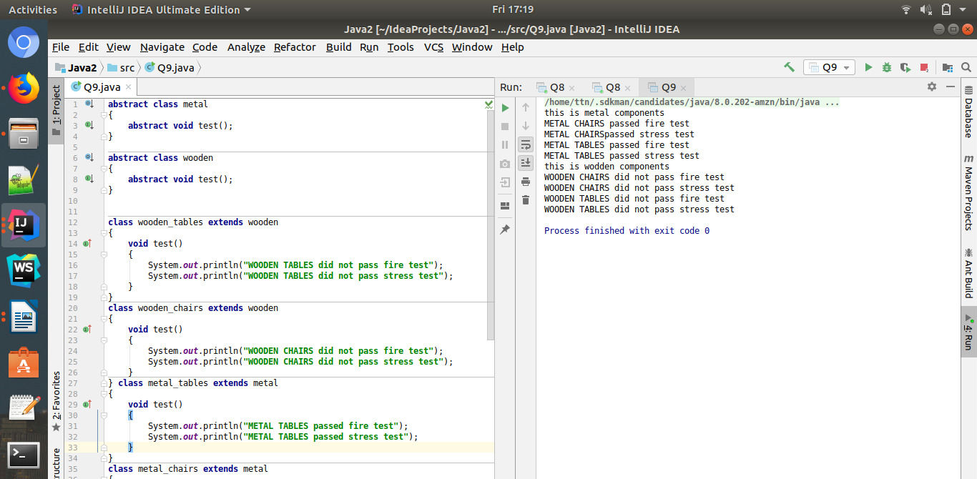
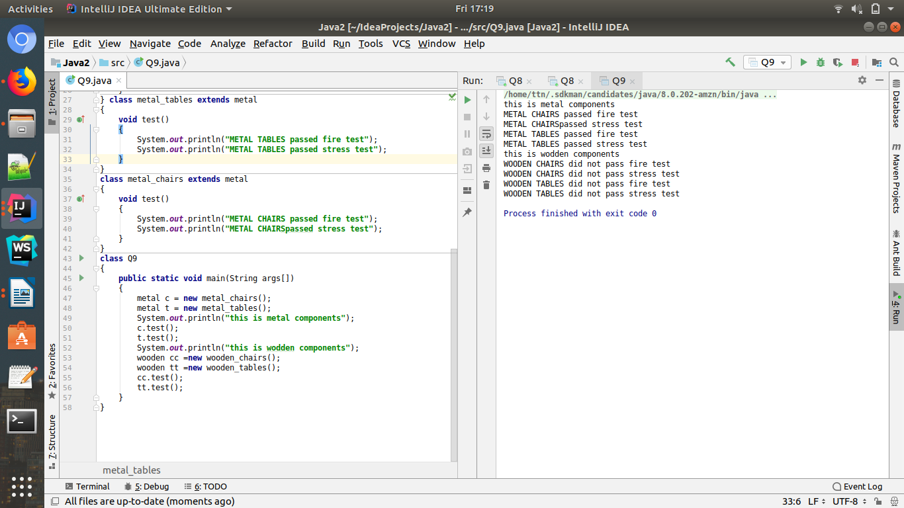

Code:

package com.multithreading.demo;
import java.util.concurrent.ExecutorService;
import java.util.concurrent.Executors;
public class Q3{
public static void main(String[] args) {
ExecutorService executorService = Executors.newSingleThreadExecutor();
executorService.submit(new Runnable()
{
@Override
public void run() {
System.out.println("Thread 1");
}
});
executorService.submit(new Runnable()
{
@Override
public void run() {
System.out.println("Thread 2");
}
});
executorService.submit(new Runnable() {
@Override
public void run() {
try {
Thread.sleep(3000L);
} catch (Exception e) {
// e.printStackTrace();
}
System.out.println("Thread 3");
}
});
executorService.shutdown();
}
}

Q.10. Design classes having attributes and method(only skeleton) for a coffee shop. There are three different actors in our scenario and i have listed the different actions they do also below

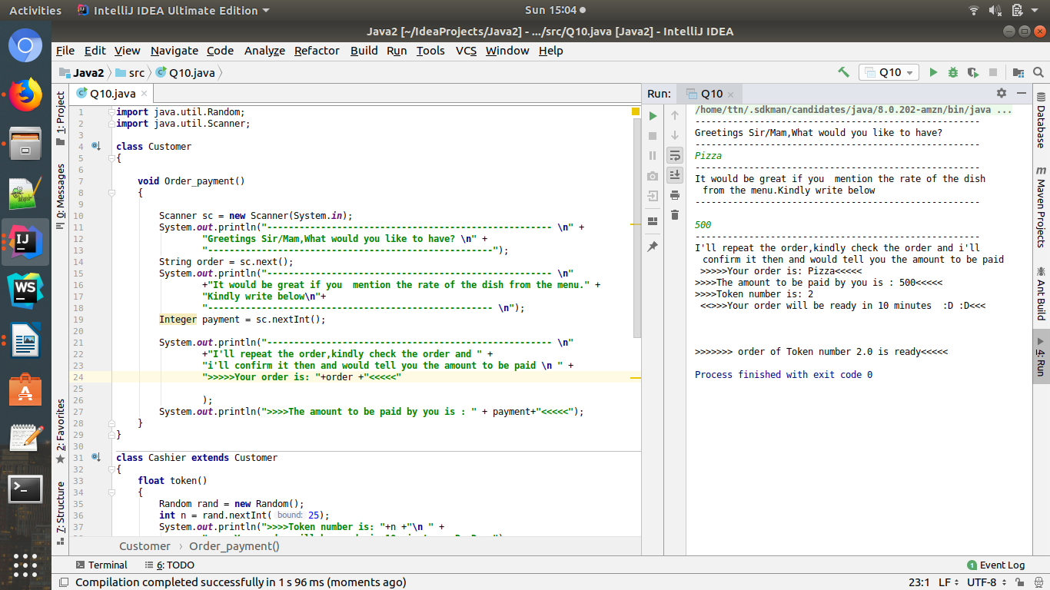
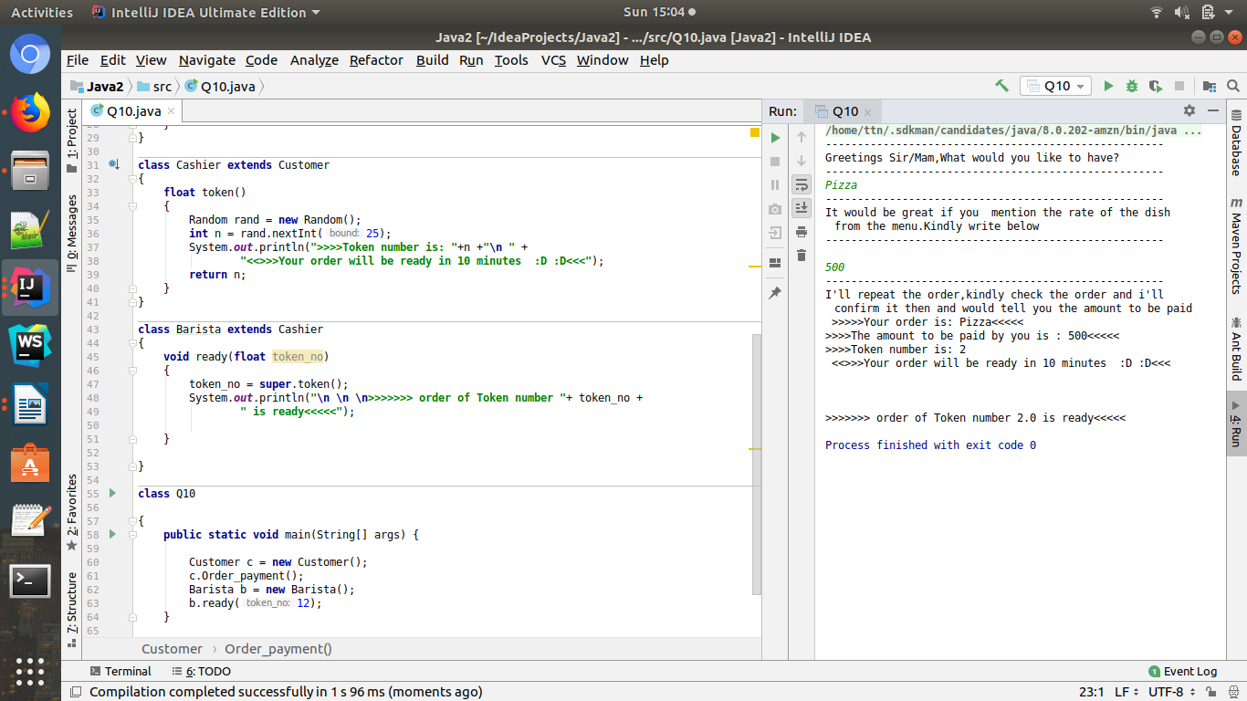

11. Convert the following code so that it uses nested while statements instead of for statements:
int s = 0;
int t = 1;
for (int i = 0; i < 10; i++)
{
s = s + i;
for (int j = i; j > 0; j−−)
{
t = t * (j - i);
}
s = s * t;
System.out.println("T is " + t);
}
System.out.println("S is " + s);

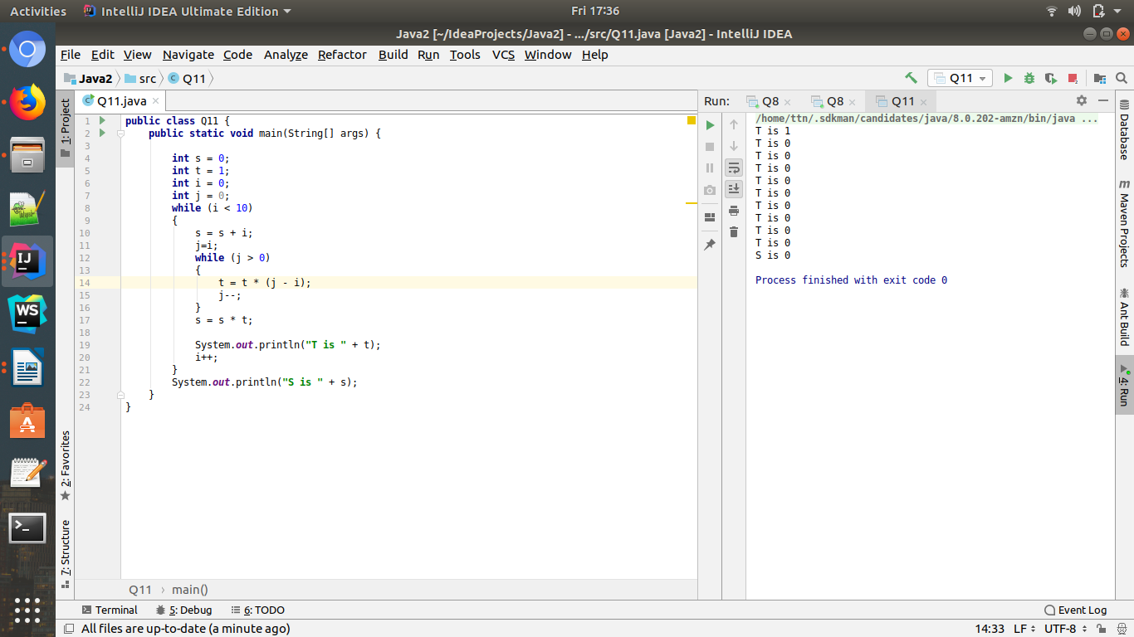

Q.12What will be the output on new Child(); ?

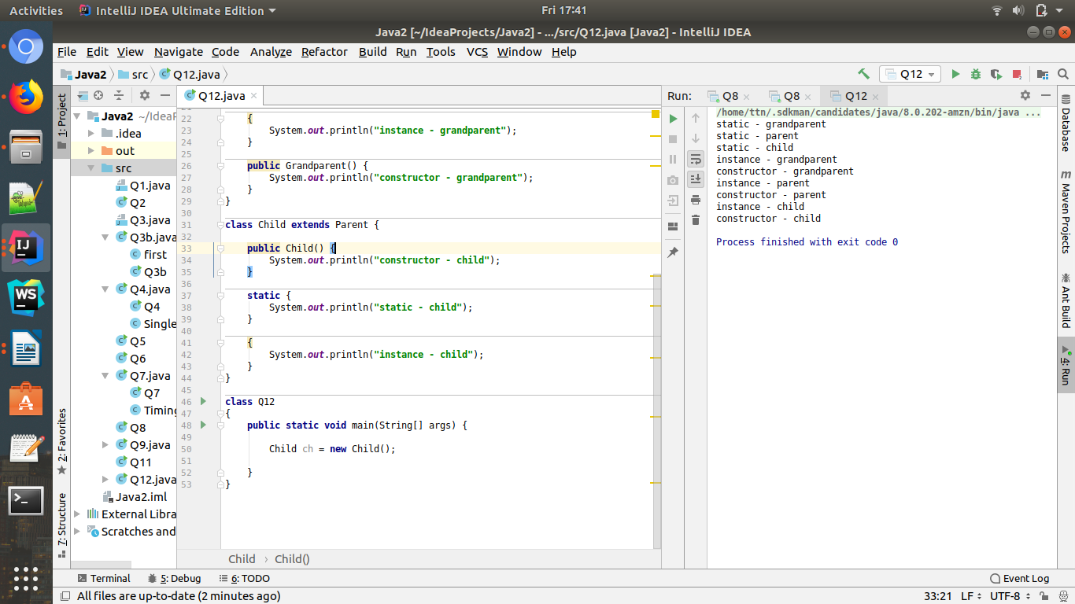
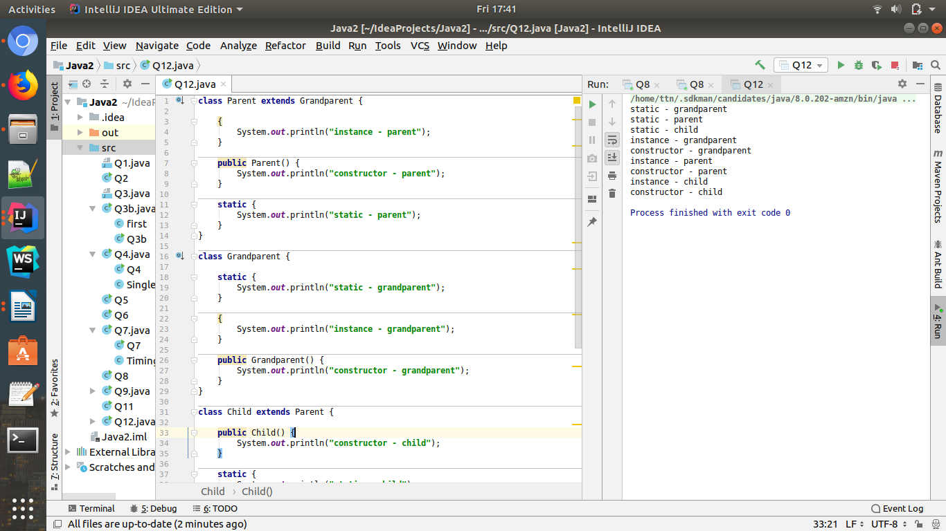

Q13. Create a custom exception that do not have any stack trace.
Ans:

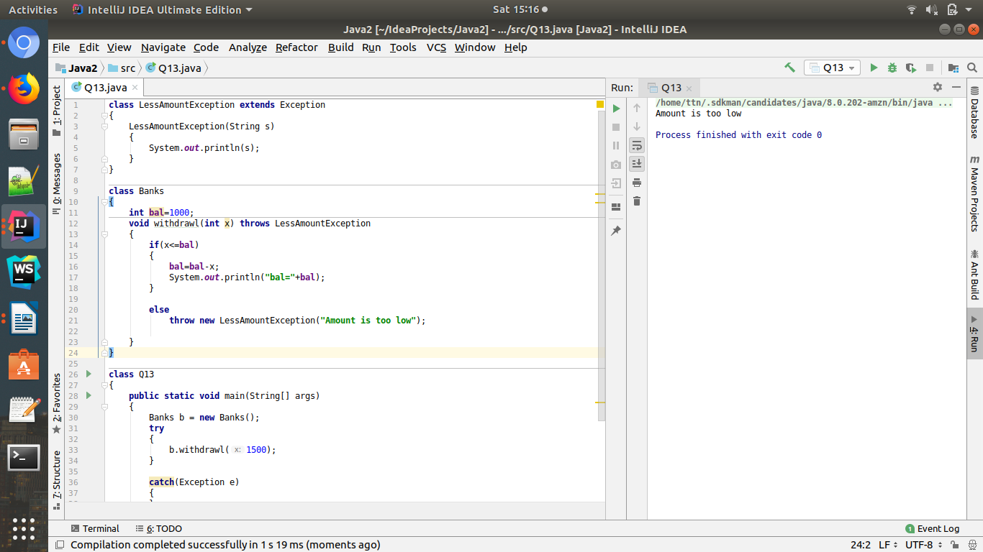
See balance (int bal) is 1000.And b.withdrawl(1500) wants to withdraw 1500 and since 1500>1000,
Exception will be thrown that that the balance.i.e. Amount is too low.


