1)Create and Run a Thread using Runnable Interface and Thread class.

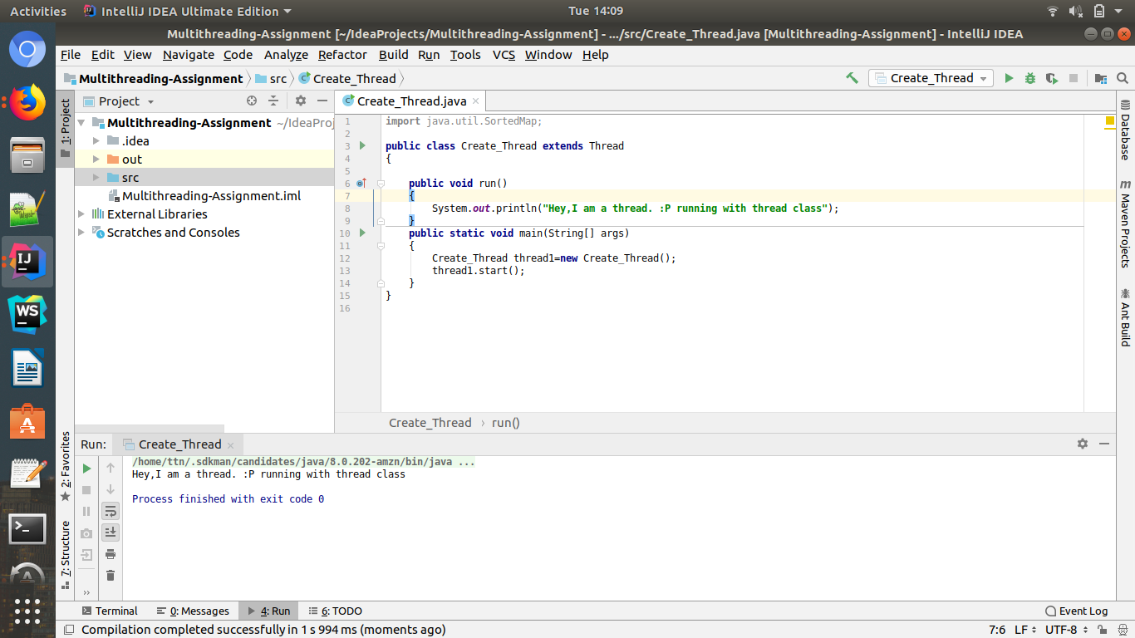

2)Use sleep and join methods with thread.

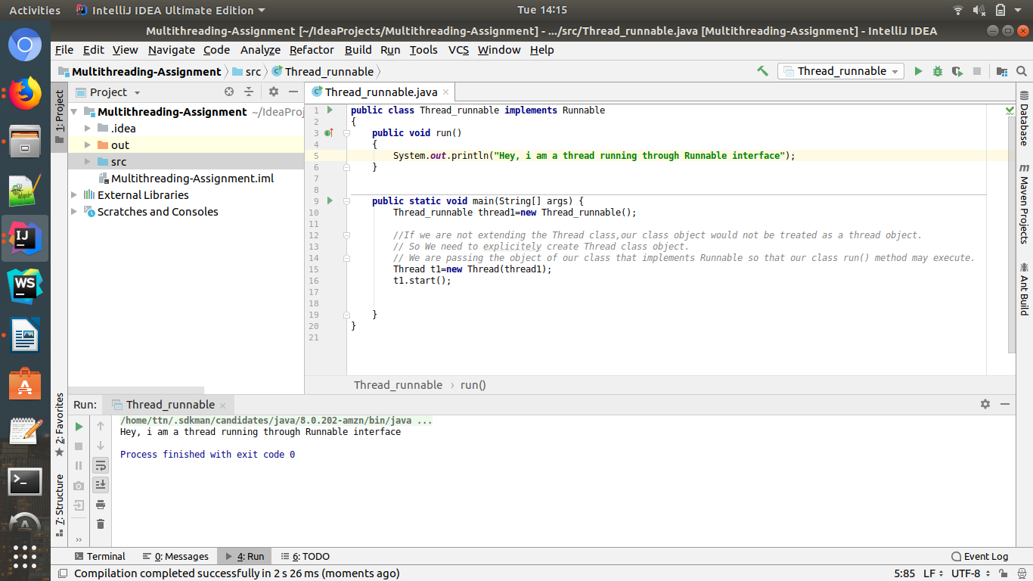

3)Use a singleThreadExecutor to submit multiple threads.

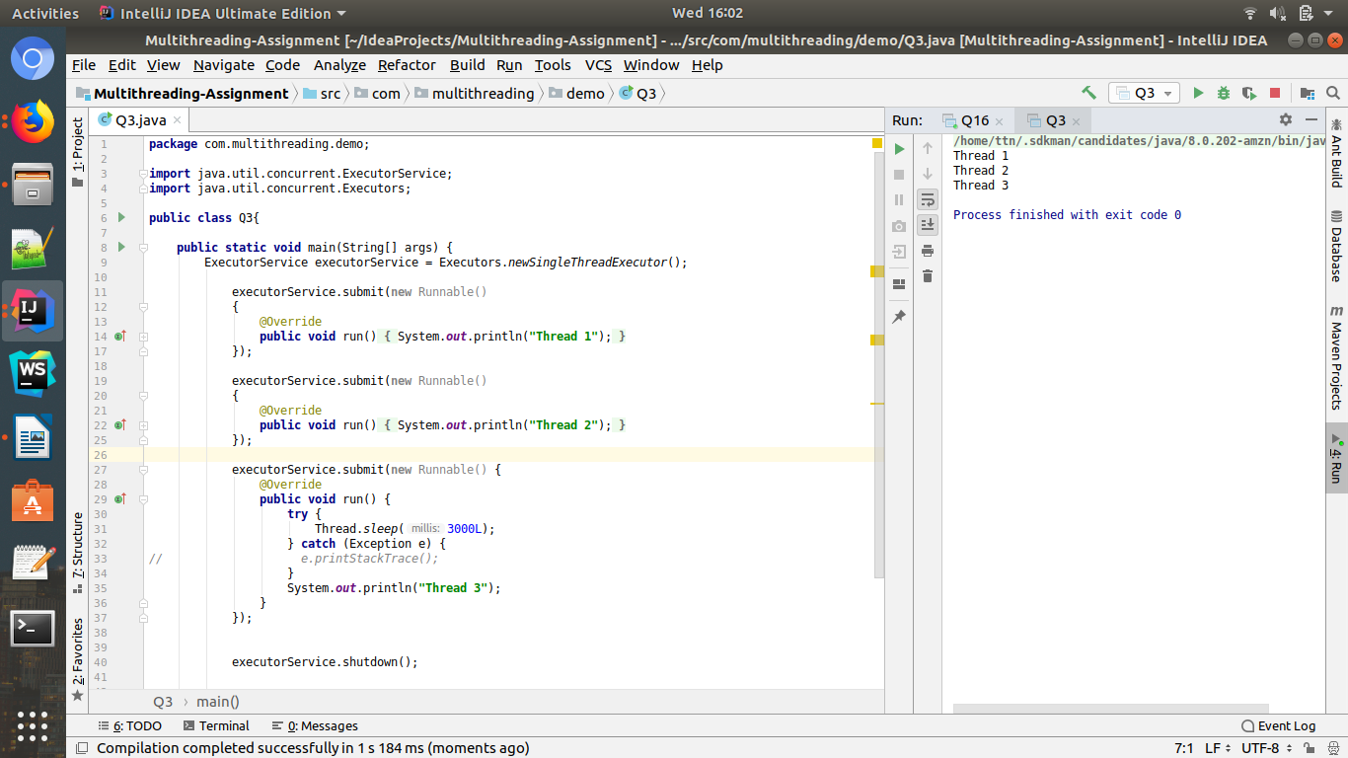

4)Try shutdown() and shutdownNow() and observe the difference.
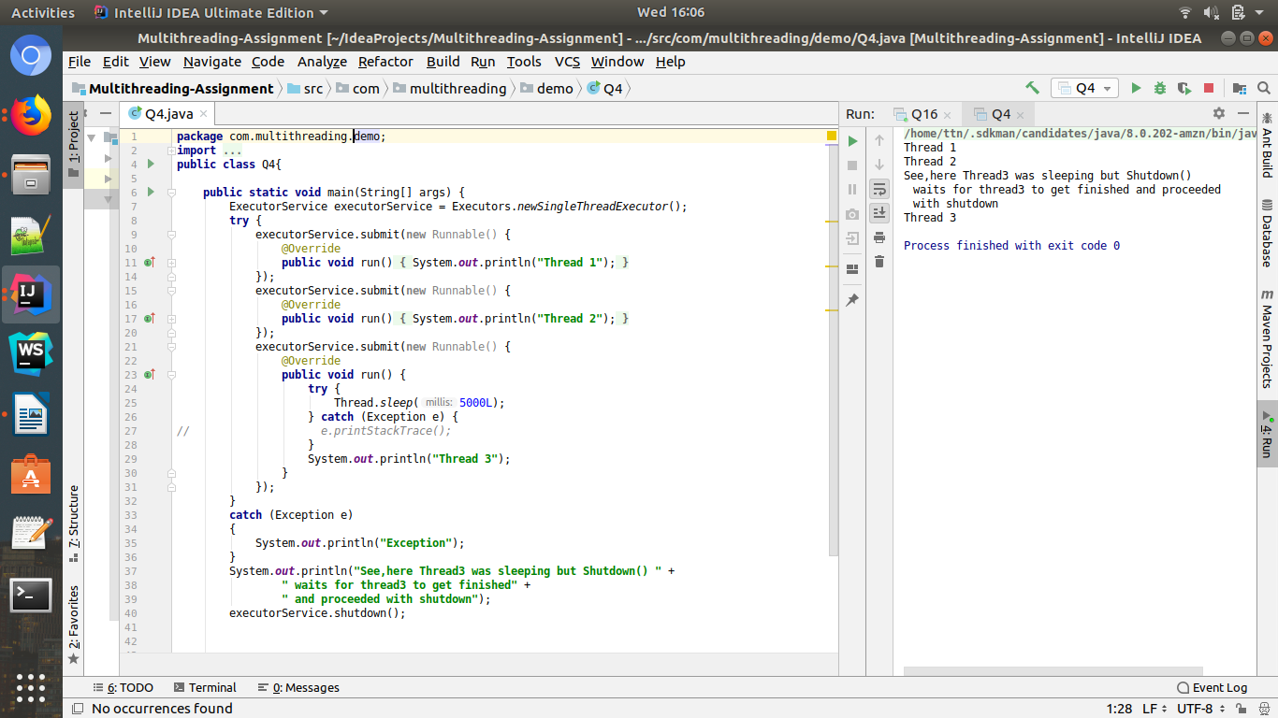

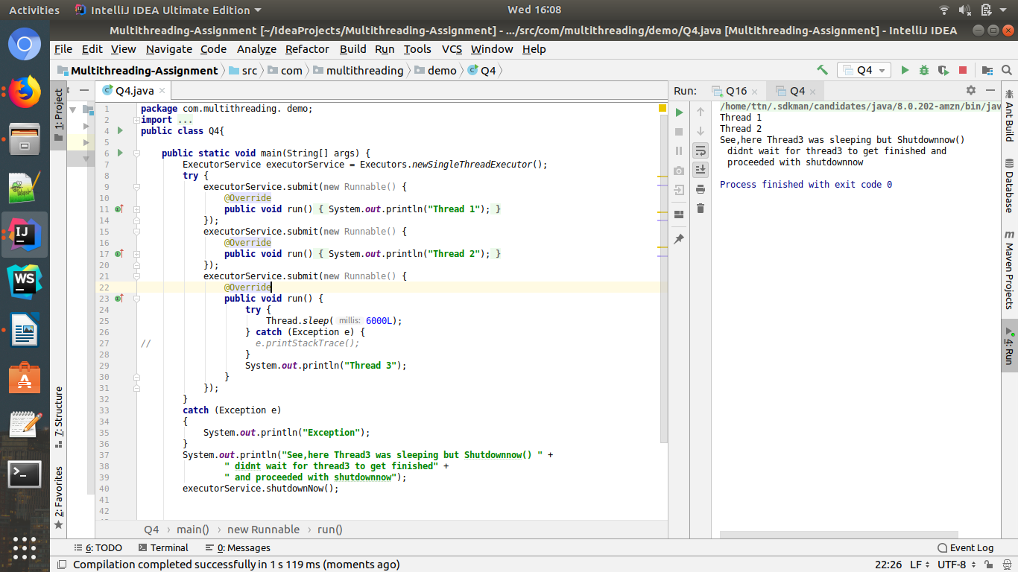

5)Use isShutDown() and isTerminate() with ExecutorService.
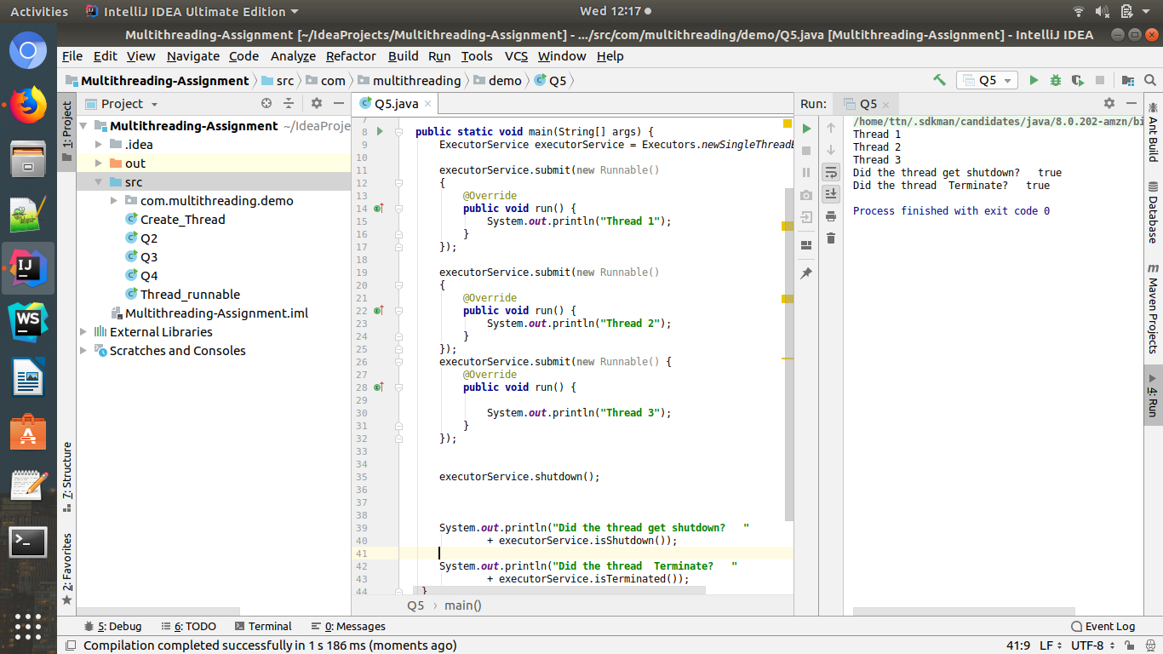

6)Return a Future from ExecutorService by using callable and use get(), isDone(), isCancelled() with the Future object to know the status of task submitted.

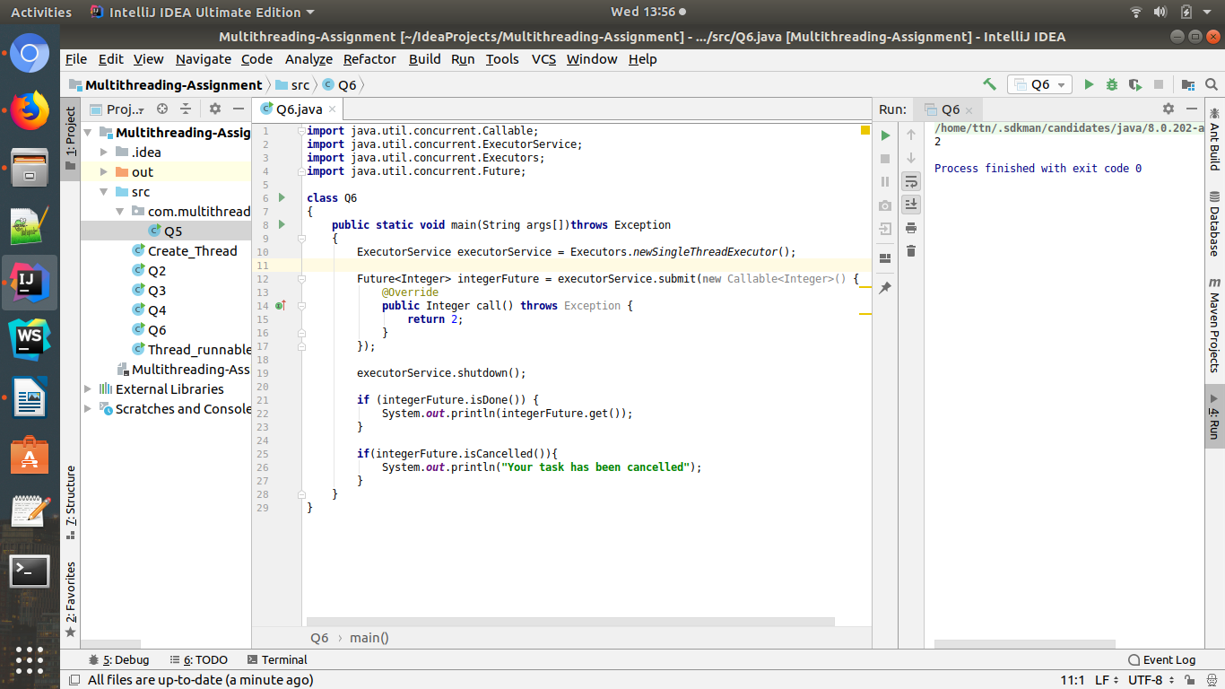

7)Submit List of tasks to ExecutorService and wait for the completion of all the tasks.
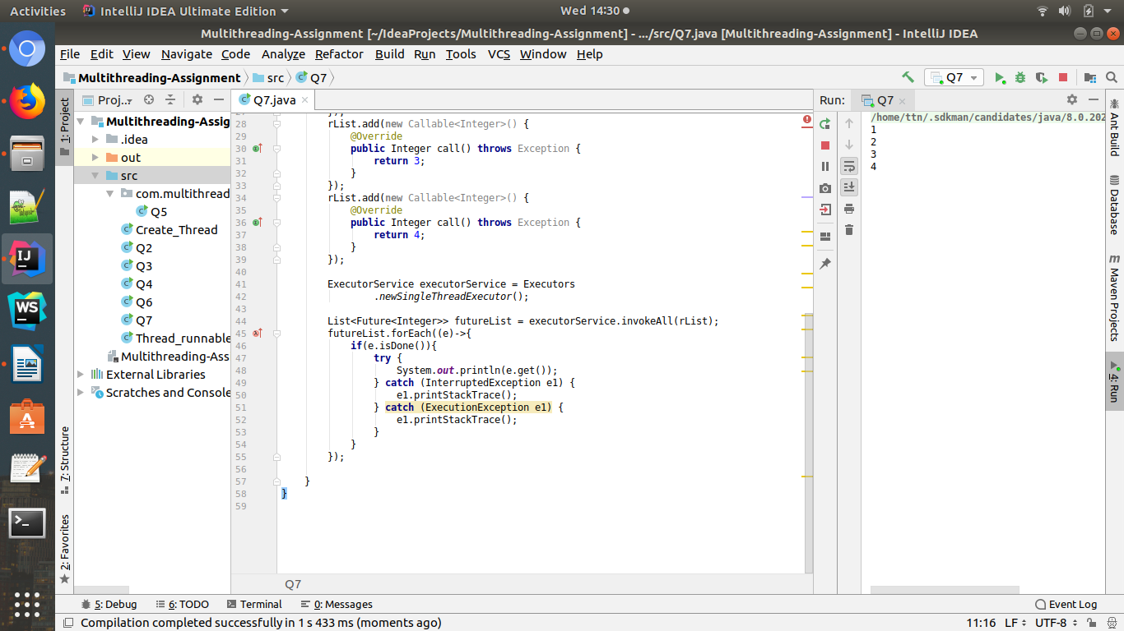
Full Code:
package com.multithreading.demo;
import java.util.ArrayList;
import java.util.List;
import java.util.concurrent.Callable;
import java.util.concurrent.ExecutionException;
import java.util.concurrent.ExecutorService;
import java.util.concurrent.Executors;
import java.util.concurrent.Future;
public class Q7 {
public static void main(String[] args) throws InterruptedException {
List<Callable<Integer>> rList = new ArrayList<>();
rList.add(new Callable<Integer>() {
@Override
public Integer call() throws Exception {
return 1;
}
});
rList.add(new Callable<Integer>() {
@Override
public Integer call() throws Exception {
return 2;
}
});
rList.add(new Callable<Integer>() {
@Override
public Integer call() throws Exception {
return 3;
}
});
rList.add(new Callable<Integer>() {
@Override
public Integer call() throws Exception {
return 4;
}
});
ExecutorService executorService = Executors
.newSingleThreadExecutor();
List<Future<Integer>> futureList = executorService.invokeAll(rList);
futureList.forEach((e)->{
if(e.isDone()){
try {
System.out.println(e.get());
} catch (InterruptedException e1) {
e1.printStackTrace();
} catch (ExecutionException e1) {
e1.printStackTrace();
}
}
});
}
}

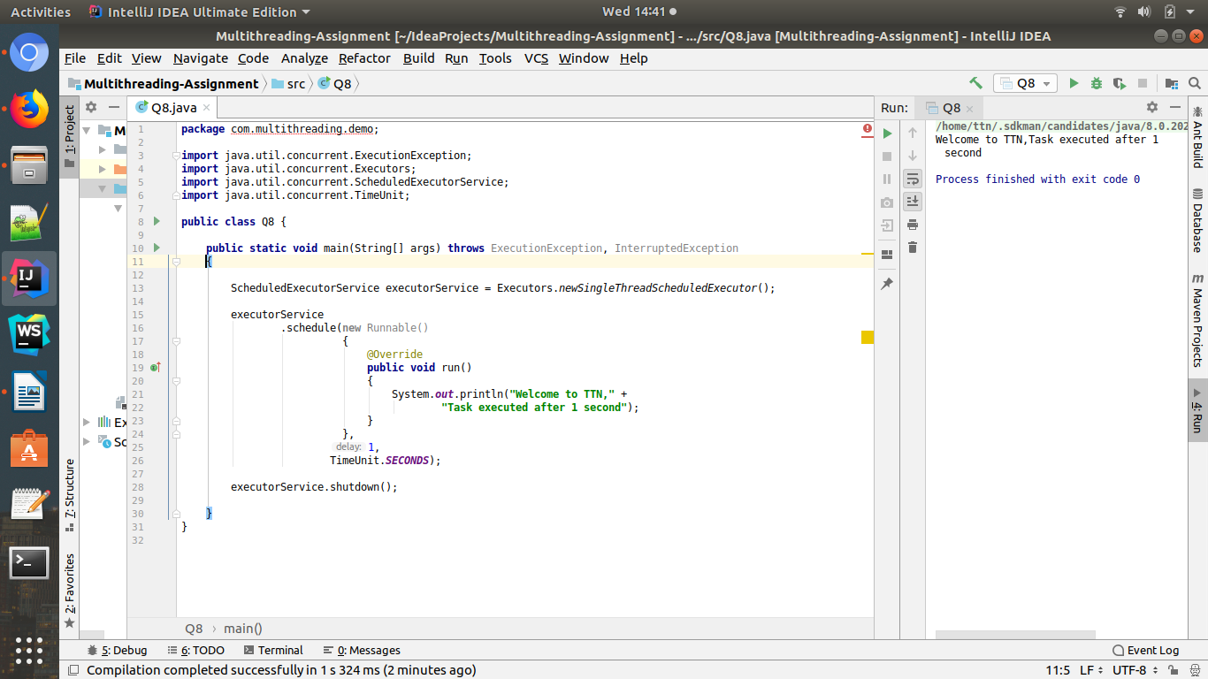
8)Schedule task using schedule(), scheduleAtFixedRate() and scheduleAtFixedDelay()

9) Increase concurrency with Thread pools using newCachedThreadPool() and newFixedThreadPool().
Ans:

newCachedThreadPool:

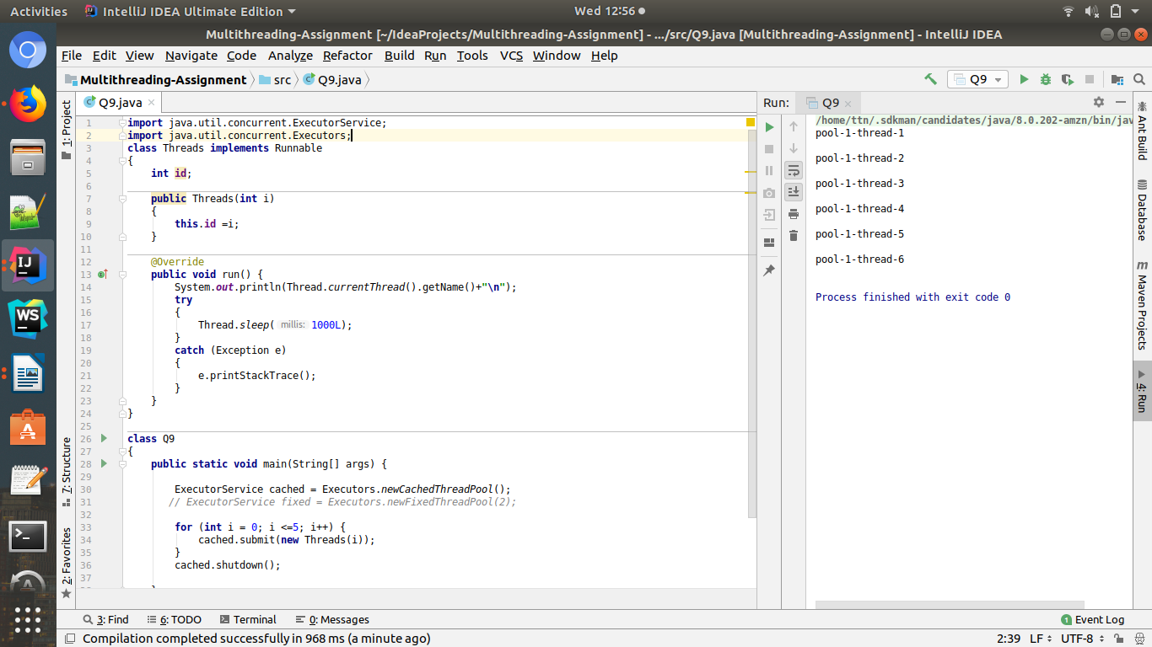
newFixedThreadPool:

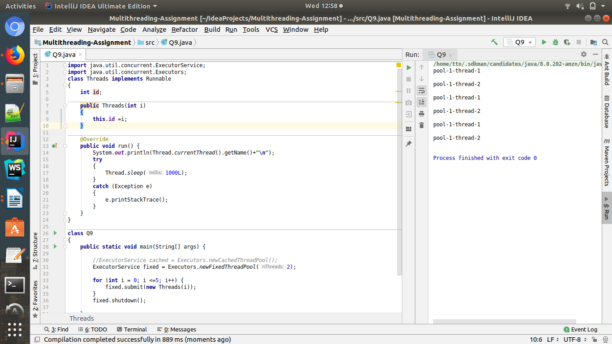
Here,as specified ,only two threads are used.

Q.10. Use Synchronize method to enable synchronization between multiple threads trying to access method at same time.
Ans:

>Synchronization in java is the capability to control the access of multiple threads to any shared resource.
>Java Synchronization is better option where we want to allow only one thread to access the shared resource.

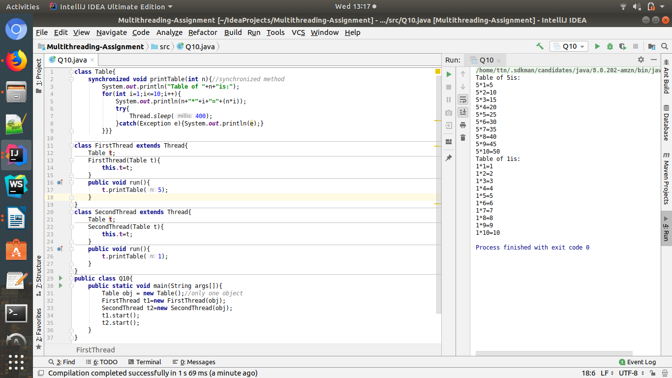

Q.11 Use Synchronize block to enable synchronization between multiple threads trying to access method at same time.
Ans:
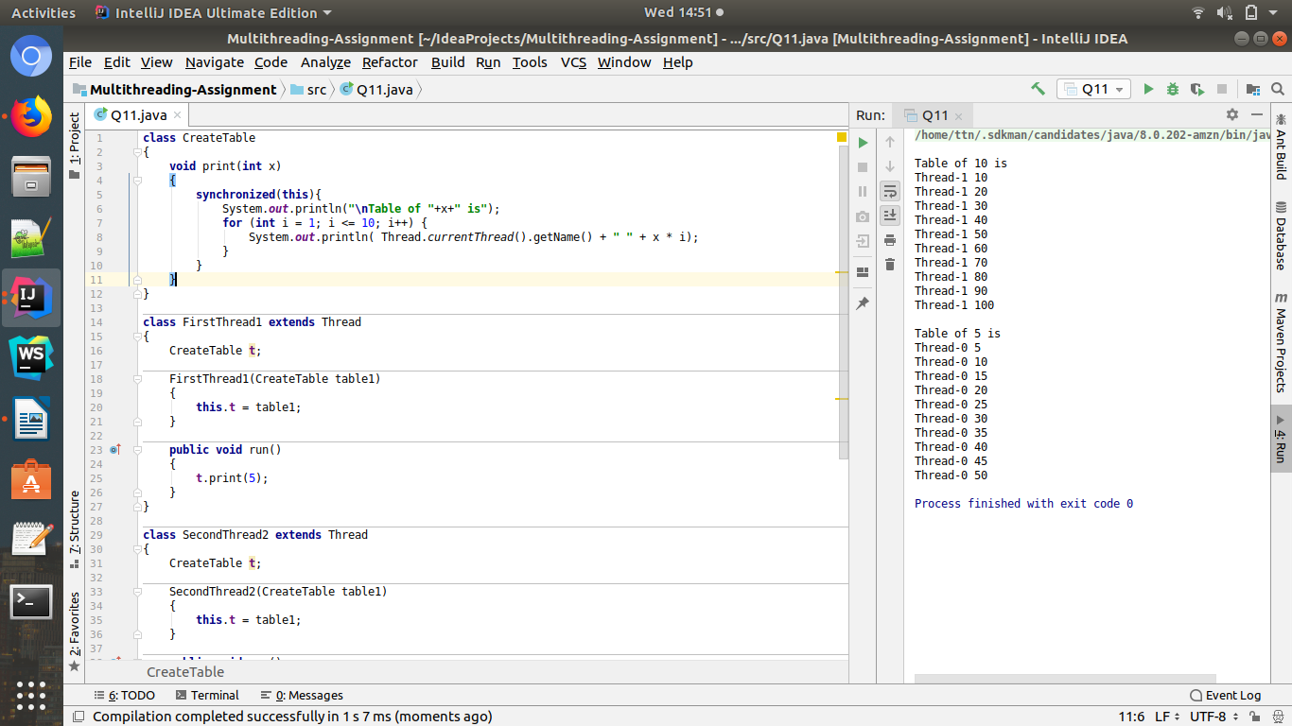

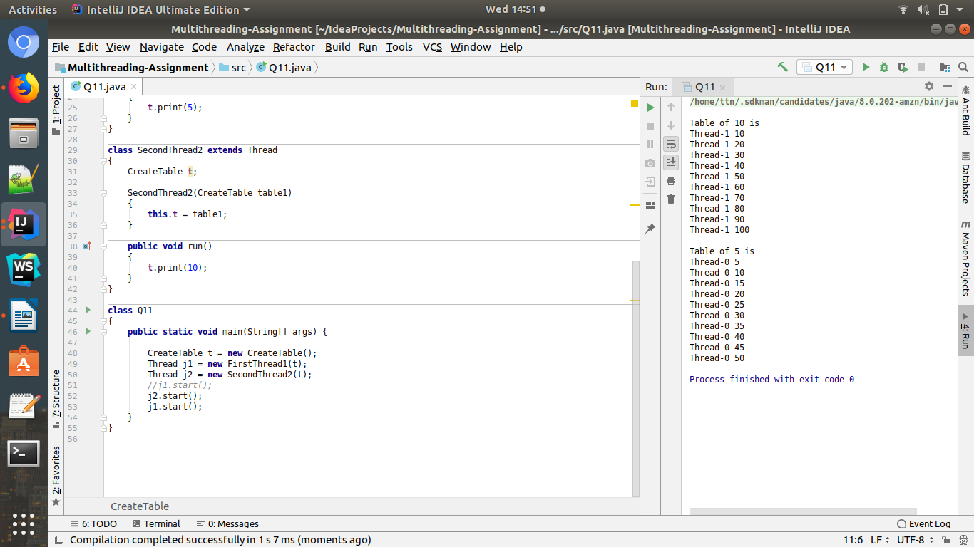

Q.12.Use Atomic Classes instead of Synchronize method and blocks.
Ans:
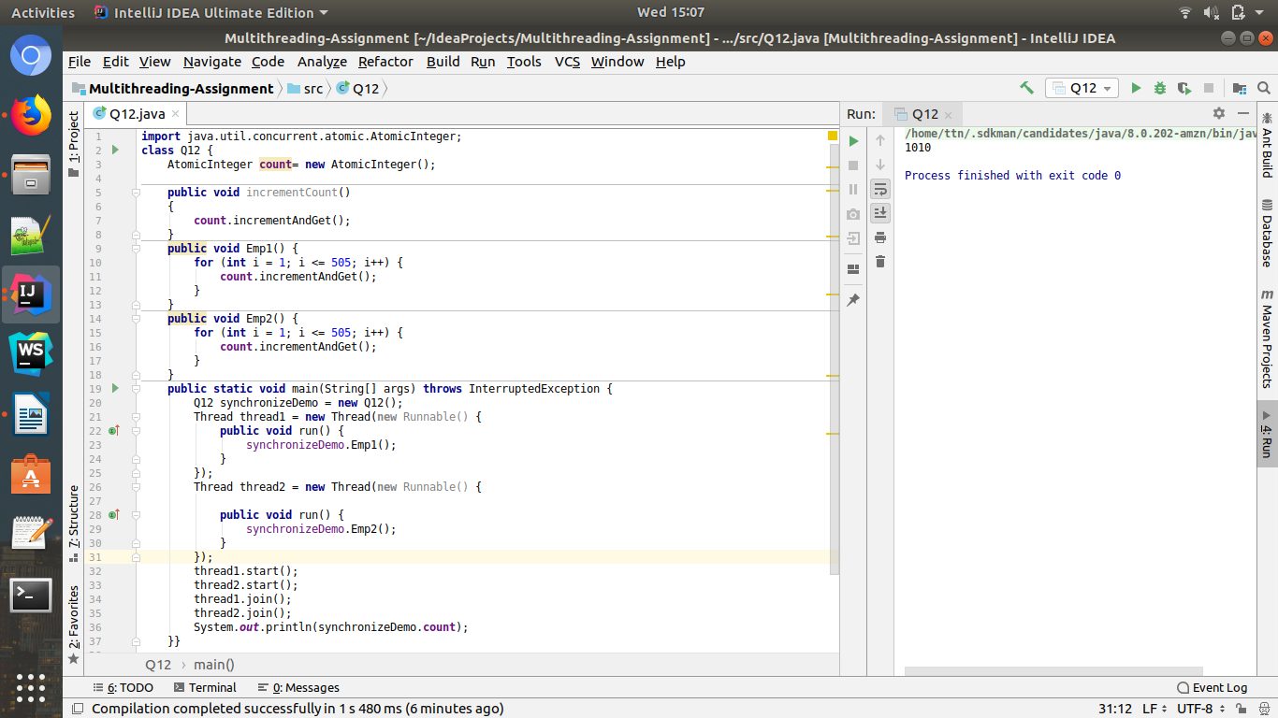

Q.13 Coordinate 2 threads using wait() and notify().
Ans:
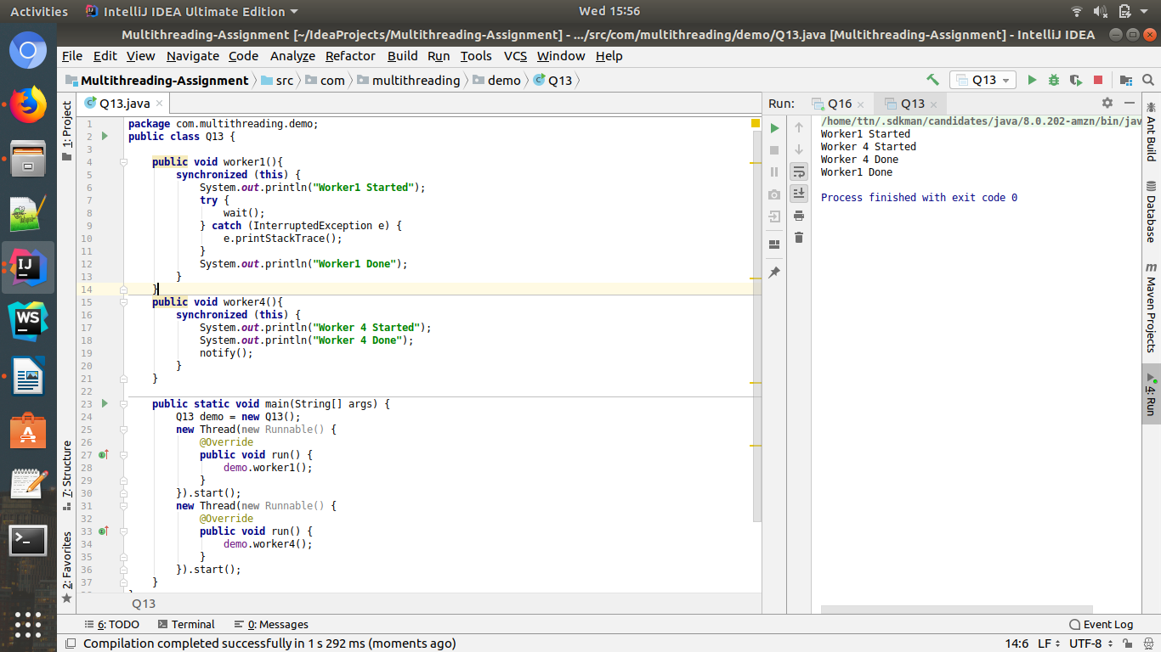

Q14.Coordinate mulitple threads using wait() and notifyAll()

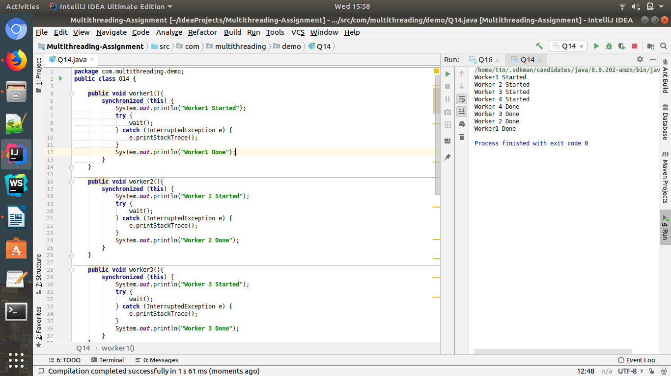

Code:

package com.multithreading.demo;
public class Q14 {
public void worker1(){
synchronized (this) {
System.out.println("Worker1 Started");
try {
wait();
} catch (InterruptedException e) {
e.printStackTrace();
}
System.out.println("Worker1 Done");
}
}
public void worker2(){
synchronized (this) {
System.out.println("Worker 2 Started");
try {
wait();
} catch (InterruptedException e) {
e.printStackTrace();
}
System.out.println("Worker 2 Done");
}
}
public void worker3(){
synchronized (this) {
System.out.println("Worker 3 Started");
try {
wait();
} catch (InterruptedException e) {
e.printStackTrace();
}
System.out.println("Worker 3 Done");
}
}
public void worker4(){
synchronized (this) {
System.out.println("Worker 4 Started");
System.out.println("Worker 4 Done");
notifyAll();
}
}
public static void main(String[] args) {
Q14 demo = new Q14();
new Thread(new Runnable() {
@Override
public void run() {
demo.worker1();
}
}).start();
new Thread(new Runnable() {
@Override
public void run() {
demo.worker2();
}
}).start();
new Thread(new Runnable() {
@Override
public void run() {
demo.worker3();
}
}).start();
new Thread(new Runnable() {
@Override
public void run() {
demo.worker4();
}
}).start();
}
}

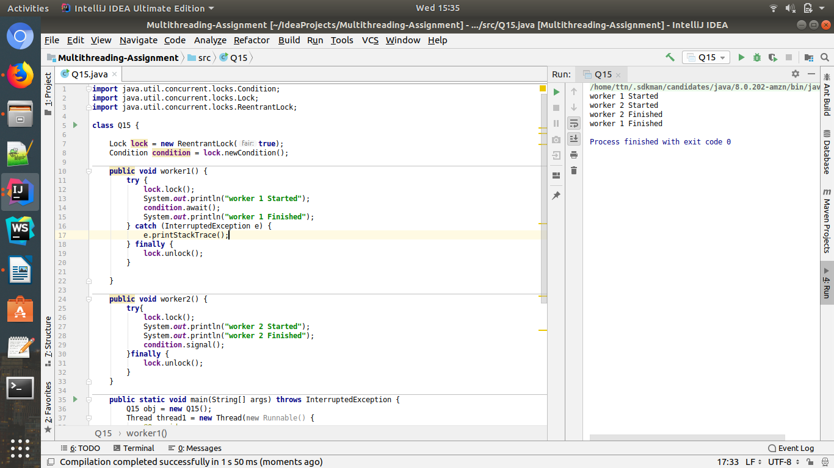
Q15. Use Reentract lock for coordinating 2 threads with signal(), signalAll() and wait().

Code:

import java.util.concurrent.locks.Condition;
import java.util.concurrent.locks.Lock;
import java.util.concurrent.locks.ReentrantLock;
class Q15 {
Lock lock = new ReentrantLock(true);
Condition condition = lock.newCondition();
public void worker1() {
try {
lock.lock();
System.out.println("worker 1 Started");
condition.await();
System.out.println("worker 1 Finished");
} catch (InterruptedException e) {
e.printStackTrace();
} finally {
lock.unlock();
}
}
public void worker2() {
try{
lock.lock();
System.out.println("worker 2 Started");
System.out.println("worker 2 Finished");
condition.signal();
}finally {
lock.unlock();
}
}
public static void main(String[] args) throws InterruptedException {
Q15 obj = new Q15();
Thread thread1 = new Thread(new Runnable() {
@Override
public void run() {
obj.worker1();
}
});
Thread thread2 = new Thread(new Runnable() {
@Override
public void run() {
obj.worker2();
}
});
thread1.start();
thread2.start();
thread1.join();
thread2.join();
}
}

Q.16. Create a deadlock and Resolve it using tryLock().
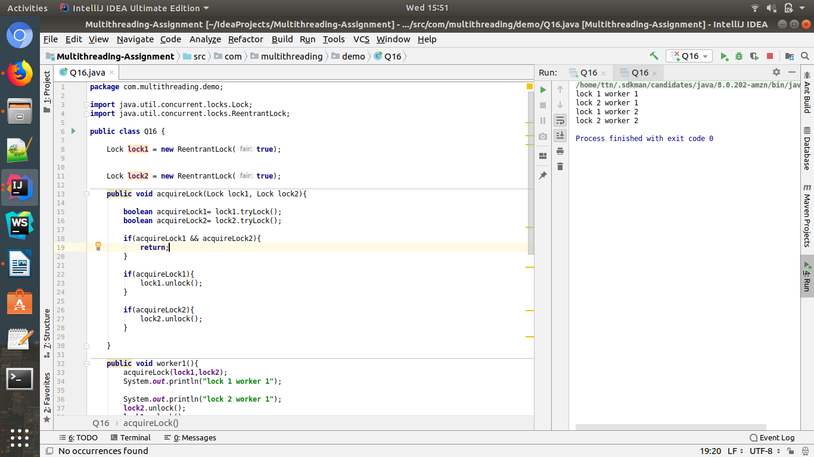
Ans

Full Code on next page.

Code:
package com.multithreading.demo;
import java.util.concurrent.locks.Lock;
import java.util.concurrent.locks.ReentrantLock;
public class Q16 {
Lock lock1 = new ReentrantLock(true);
Lock lock2 = new ReentrantLock(true);
public void acquireLock(Lock lock1, Lock lock2){
boolean acquireLock1= lock1.tryLock();
boolean acquireLock2= lock2.tryLock();
if(acquireLock1 && acquireLock2){
return;
}
if(acquireLock1){
lock1.unlock();
}
if(acquireLock2){
lock2.unlock();
}
}
public void worker1(){
acquireLock(lock1,lock2);
System.out.println("lock 1 worker 1");
System.out.println("lock 2 worker 1");
lock2.unlock();
lock1.unlock();
}
public void worker2(){
acquireLock(lock2,lock1);
System.out.println("lock 1 worker 2");
System.out.println("lock 2 worker 2");
lock1.unlock();
lock2.unlock();
}
public static void main(String[] args) throws InterruptedException {
Q16 demo = new Q16();
Thread thread1 = new Thread(new Runnable() {
@Override
public void run() {
demo.worker1();
}
});
Thread thread2 = new Thread(new Runnable() {
@Override
public void run() {
demo.worker2();
}
});
thread1.start();
thread2.start();
thread1.join();
thread2.join();
}
}

