- Select a location on your machine where kafka would be executed. For eg. C:\Work
- Download https://packages.confluent.io/archive/6.2/confluent-6.2.0.zip in this location & unzip it to get folder confluent-6.2.0
- Inside folder confluent-6.2.0 create folder “data” & then inside “data” 4 folders -: zk,kfk1,kfk2,kfk3
- Type env in windows run to open environment variables window
- Click on Path & then edit button
- 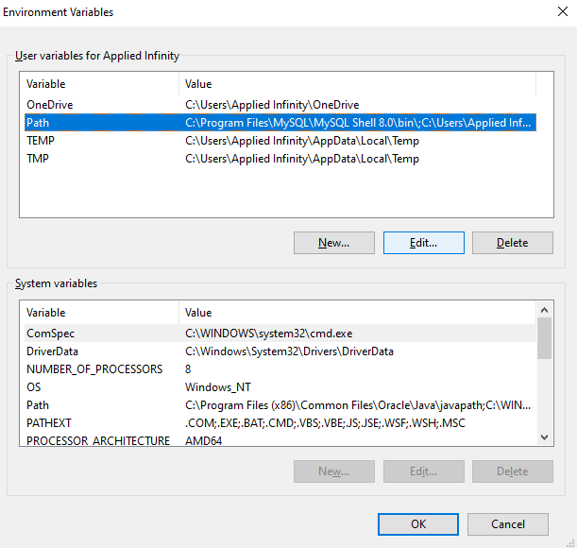

- Click on New after Edit button click and enter the path according to your location
- 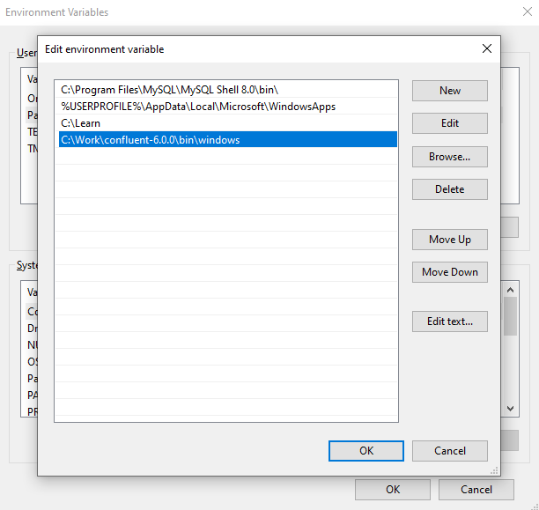

- Type network in windows run to open network status window & click on properties

- 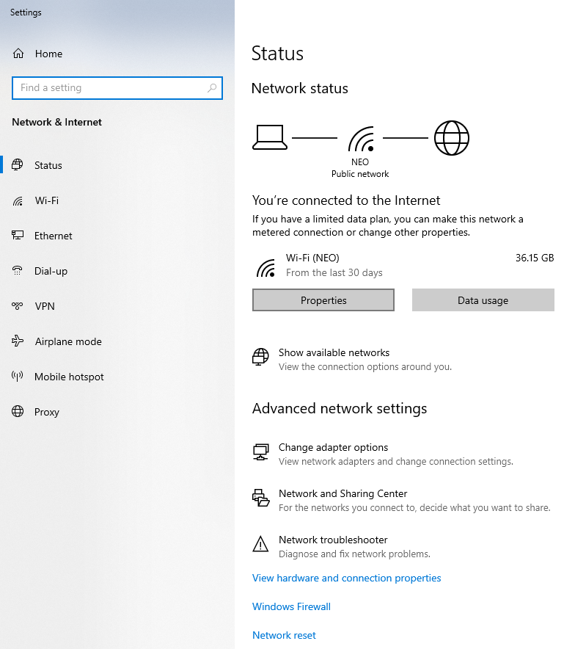

- In properties section note down ip4 address

- 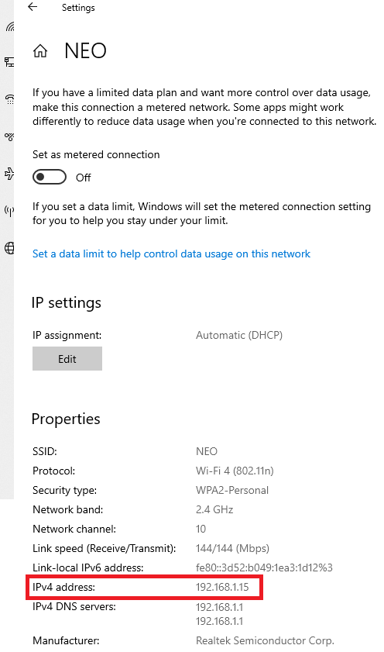

- Go to folder confluent-6.2.0 and inside folder bin-> windows open kafka-run-class.bat file in NOTEPAD / Notepad++
- Press enter on line no 45 where you will see this written -:
  - rem Classpath addition for kafka-core dependencies
- add the following below it & save the file
if exist %BASE_DIR%\share\java\kafka\* (
call:concat %BASE_DIR%\share\java\kafka\*
)
- open https://bit.ly/contactrkk-training in browser & from inside KFK folder download
  - server1.properties
  - server2.properties
  - server3.properties
  - zookeeper.properties

- open zookeeper.properties and on line 16 change path according to your location
- open server1.properties, server2.properties, server3.properties & replace all occurrences of 192.168.1.15 with your IP address.
- On line no 60 in all three files above set path according to your location
- Go to folder confluent-6.2.0 and inside folder etc-> kafka copy/replace all above 4 files.
- Open up multiple command prompts
- 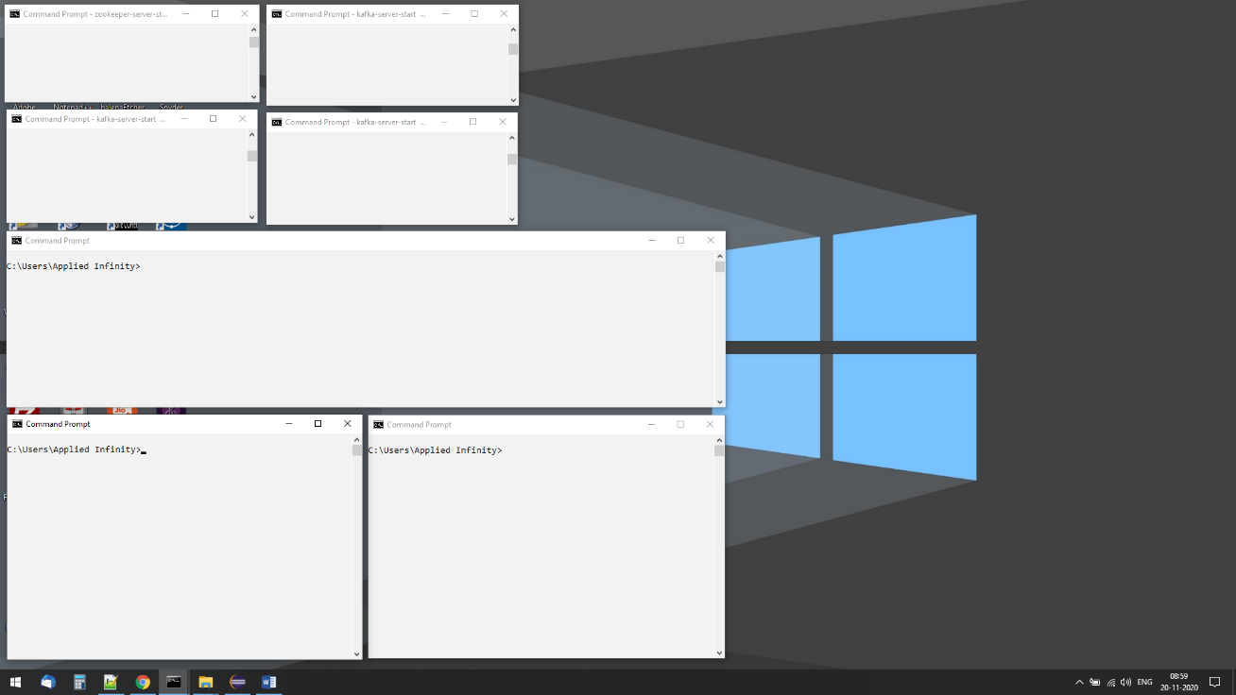
- On terminal 1 run following command with path according to your location
  - zookeeper-server-start C:\Work\confluent-6.2.0\etc\kafka\zookeeper.properties
- On terminal 2 run following command with path according to your location
  - kafka-server-start C:\Work\confluent-6.2.0\etc\kafka\server1.properties
- On terminal 3 run following command with path according to your location
  - kafka-server-start C:\Work\confluent-6.2.0\etc\kafka\server2.properties
- On terminal 4 run following command with path according to your location
- kafka-server-start C:\Work\confluent-6.2.0\etc\kafka\server3.properties
- 3 NODE KAFKA CLUSTER IS UP & RUNNING !!!

