**How to run the BasicPromotionEngine solution:**

1. Download the CodingTestAssignment.zip file from the Git repository and unzip the folder.

2. Open the **BasicPromotionEngine.sln** file from **CodingTestAssignment\BasicPromotionEngine** extracted file in Visual Studio.

3. Build the solution and run the application

Now enter the scenarios provided in

**Scenario A**:  
1 * A 50  
1 * B 30  
1 * C 20  
======  
Total 100

**Output:**

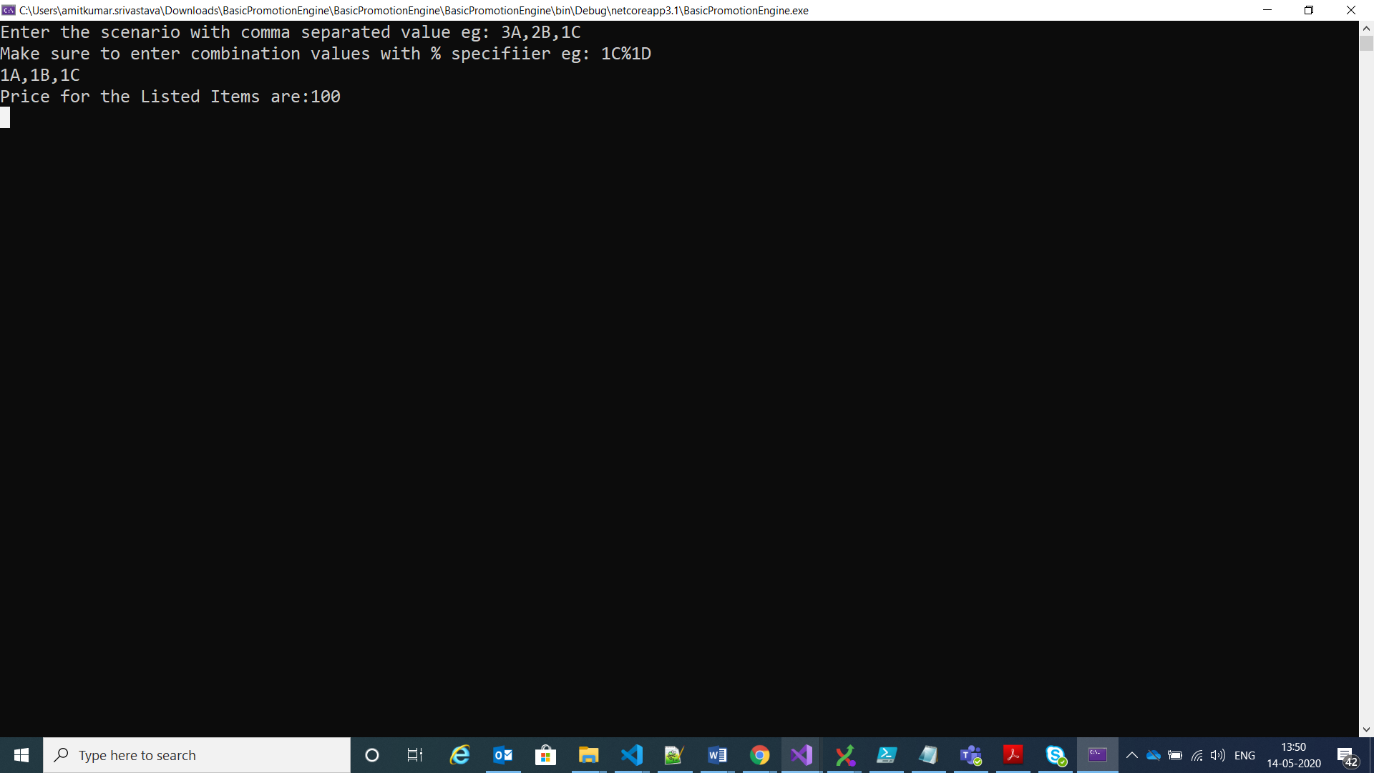

**ScenarioB:**

Scenario B  
5 * A 130 + 2*50  
5 * B 45 + 45 + 30  
1 * C 20  
======  
Total 370

**Output:**

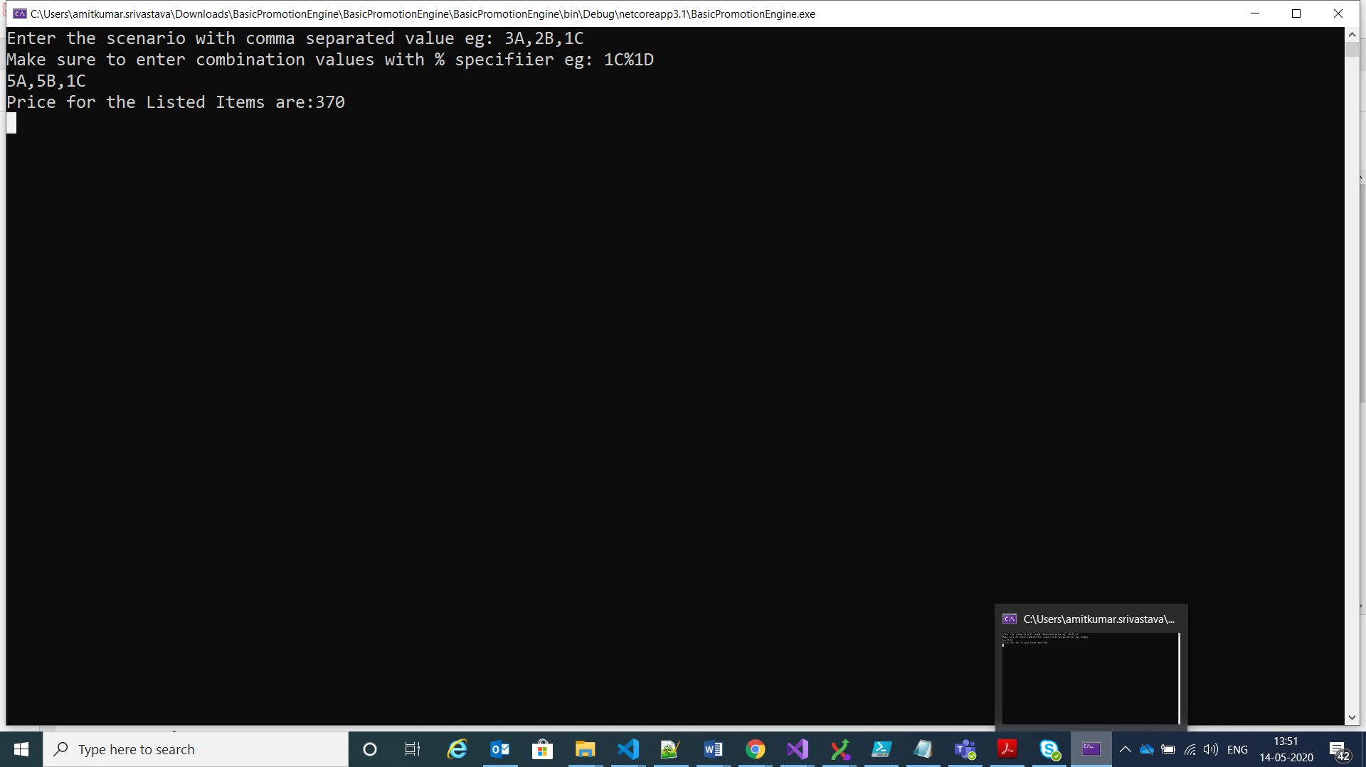

**Scenario C:**

Scenario C  
3 * A 130  
5 * B 45 + 45 + 1 * 30  
1 * C -  
1 * D 30  
======  
Total 280

