1. Checking whether /user/acadgild directory exist or not.

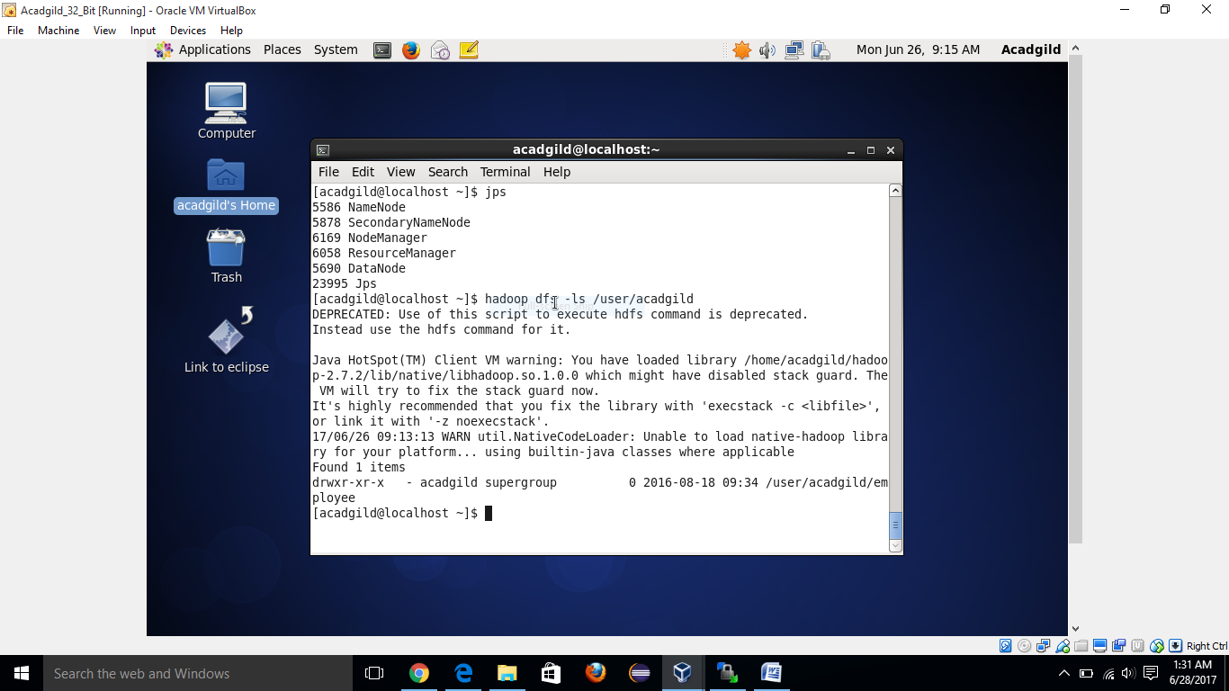

1. Creating /user/acadgild/hadoop

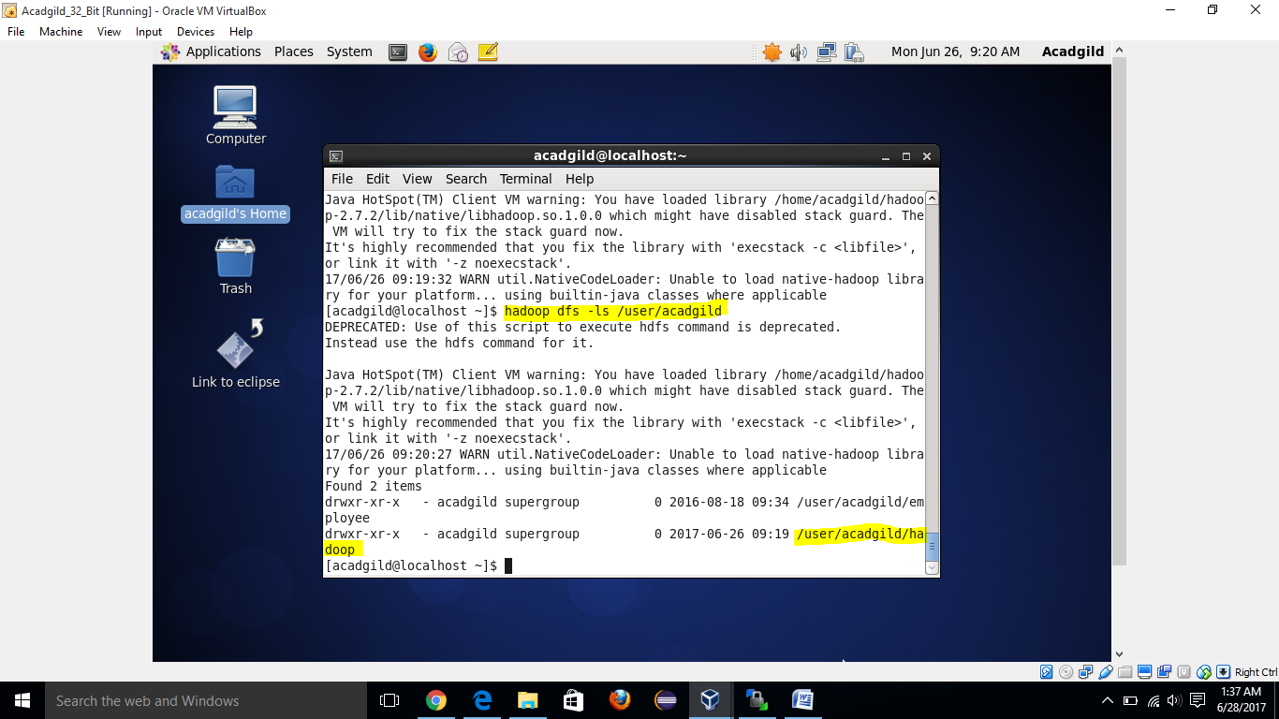

1. Creating a file word-count.txt under directory /user/acadgild/hadoop

