**--Creating a HBase table 'customer' with one column family 'details'.**

Create ‘customer’, ‘details’

**-- shell script that loads the content of the file customers.dat in the HBase table.**

Hbase org.apache.hadoop.hbase.mapreduce.ImportTsv –Dimporttsv.separator=,-Dimportts.columns=

HBASE_ROW_KEY, details:name, details:country, details:exp customer /user/acadgild/hbase/customers.dat

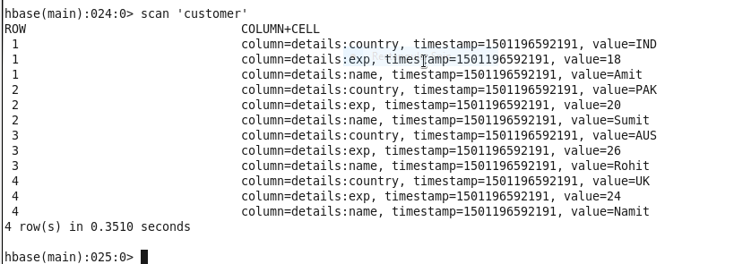

**1. Create a customer_hive table on the top of 'customer' table created in the last session.**

Calculate the maximum and minimum age of customer from the table.

hbase org.apache.hadoop.hbase.mapreduce.ImportTsv -Dimporttsv.separator=, -Dimporttsv.columns=HBASE_ROW_KEY, details:name,details:country, details:exp customer /user/acadgild/hbase/customers.dat

create external table customer_hbase(eid int,name string,country string,age int)

STORED BY 'org.apache.hadoop.hive.hbase.HBaseStorageHandler'

with serdeproperties ("hbase.columns.mapping"=":key,details:name,details:country,details:exp")

tblproperties("hbase.table.name"="customer");

**Calculate the maximum and minimum age of customer from the table.**

SELECT MAX(age), MIN(age) FROM customer_hbase

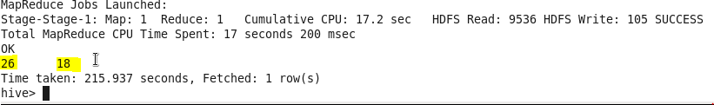

**2. Access the customer hbase table from pig and compute the maximum and minimum age among all the customers along with their corresponding name and id.**

data = LOAD 'hbase://customer' USING org.apache.pig.backend.hadoop.hbase.HBaseStorage('details:*', '-loadKey true') as (id:CHARARRAY, details:MAP[]);

grp = GROUP data BY ALL;

grp_max = FOREACH grp GENERATE data.id, data.name, MAX(data.age), MIN(data.age);