1. Contents of the table **company** created in MySQL.

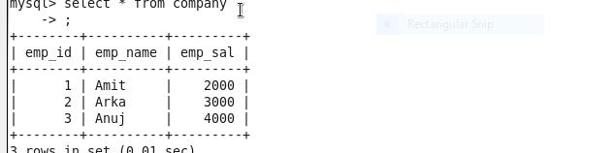

1. Data that has to be updated and inserted

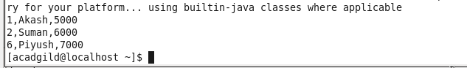

1. After performing UPSERT
2. 