1. Creating table acadgild in MySQL

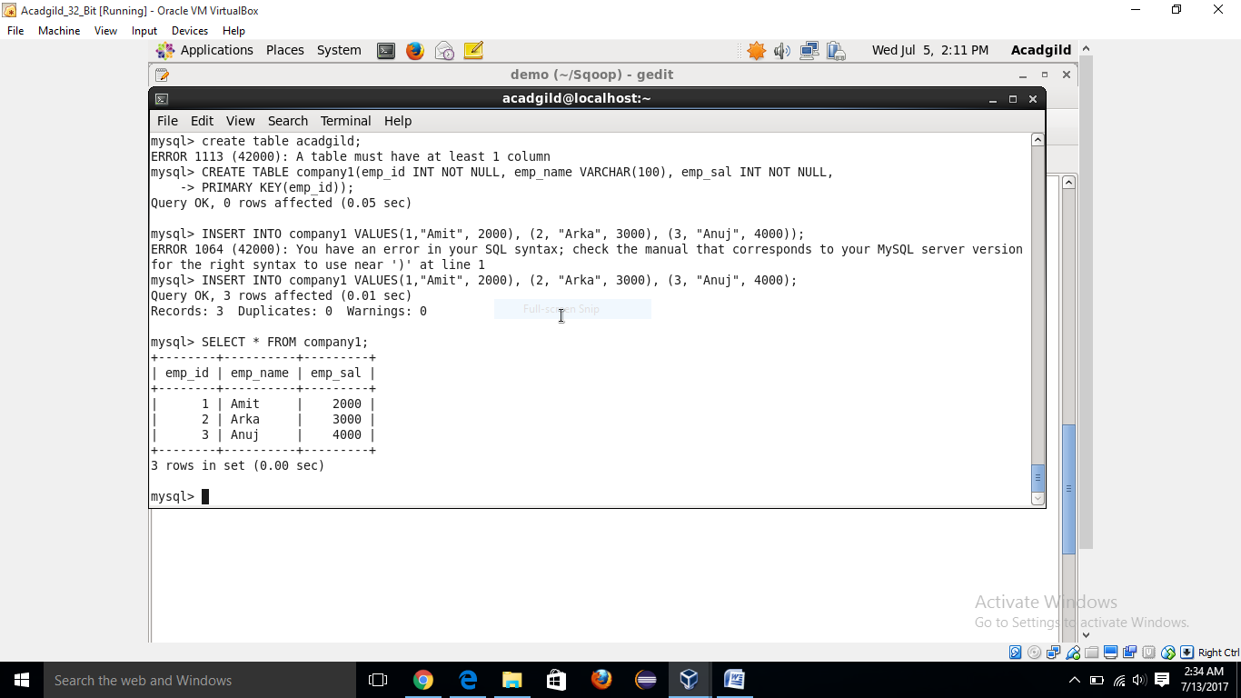

1. Using sqoop to import data into HDFS

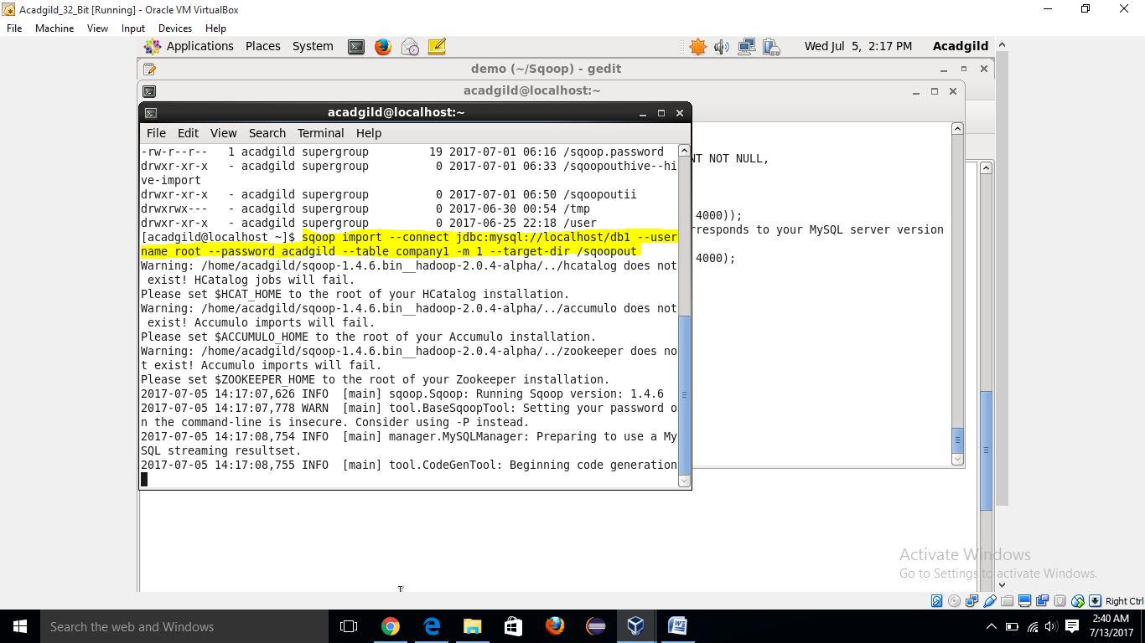

1. Inserting few more records into table

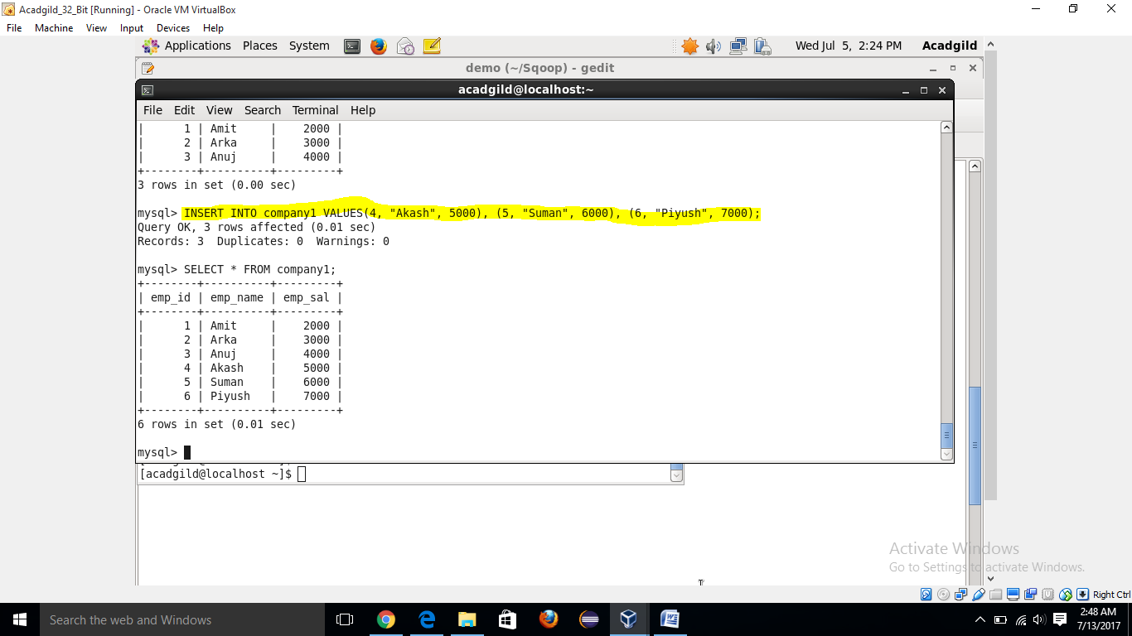

1. Incremental import

**Sqoop import –connect jdbc :mysql://localhost/db1 --username root --password acadgild --table company1 --target-dir /sqoopout/ --incremental append --check-column emp_id --last-value 3**

