1. Creating an HBase table named 'clicks' with a column family 'hits' such that it should be able to store last 5 values of qualifiers inside 'hits' column family.

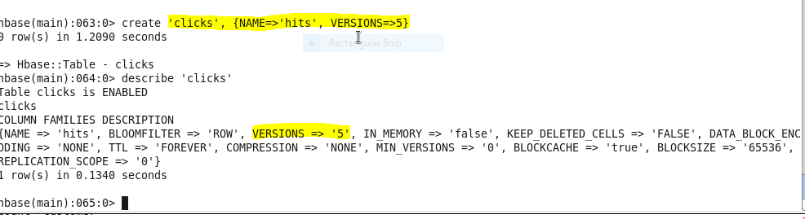

1. Add few records in the table and update some of them. Use IP Address as row-key. Scan the table to view if all the previous versions are getting displayed.

