Two distinct methods for synthesizing a signal from its short-time Fourier transform have previously been proposed. We called these methods the filter-bank summation (FBS) method and the over-lap add (OLA) method .

In the ***weighted overlap add* (WOLA)** method, we apply a *second window* after the inverse [DFT](https://ccrma.stanford.edu/~jos/mdft/) and prior to the final overlap-add to create the output [signal](http://ccrma.stanford.edu/~jos/filters/Definition_Signal.html). Such a window can be called a synthesis window, postwindow, or simply output window.''

**VMD**

It is an entirely non-recursive variational mode decomposition model, where the modes are extracted concurrently. The model looks for an ensemble of modes and their respective center frequencies, such that the modes collectively reproduce the input signal, while each being smooth after demodulation into baseband. In Fourier domain, this corresponds to a narrow-band prior. We show important relations to Wiener filter denoising. Indeed, the proposed method is a generalization of the classic Wiener filter into multiple, adaptive bands. Our model provides a solution to the decomposition problem that is theoretically well founded and still easy to understand. The variational model is efficiently optimized using an alternating direction method of multipliers approach. Preliminary results show attractive performance with respect to existing mode decomposition models. In particular, our proposed model is much more robust to sampling and noise. Finally, we show promising practical decomposition results on a series of artificial and real data.[1][**https://ieeexplore.ieee.org/document/6655981**](https://ieeexplore.ieee.org/document/6655981)

The goal of VMD is to decompose a real valued input signal *f* into a discrete number of sub-signals (modes),*uk*, that have specific sparsity properties while reproducing the input. Here,the sparsity prior of each mode is chosen to be its bandwidth in spectral domain. In other words, we assume each mode *k* to be mostly compact around a center pulsation *ωk*, which is to be determined along with the decomposition .

Real-world signals are usually viewed as a voltage changing over time. This is referred to as the time domain. Fourier’s theorem states that any waveform in the time domain can be represented by the weighted sum of sines and cosines. The Fourier transform deconstructs a time domain representation of a signal into the frequency domain representation. The frequency domain shows the voltages present at varying frequencies. It is a different way to look at the same signal.

A digitizer samples a waveform and transforms it into discrete values. Because of this transformation, the Fourier transform will not work on this data. Instead, the discrete Fourier transform (DFT) is used, which produces as its result the frequency domain components in discrete values, or bins. The fast Fourier (FFT) is an optimized implementation of a DFT that takes less computation to perform but essentially just deconstructs a signal. The frequency domain is great at showing if a clean signal in the time domain actually contains cross talk, noise, or jitter.

Windowing Although performing an FFT on a signal can provide great insight, it is important to know the limitations of the FFT and how to improve the signal clarity using windowing.

**What Is Windowing**

When you use the FFT to measure the frequency component of a signal, you are basing the

analysis on a finite set of data. The actual FFT transform assumes that it is a finite data set, a

continuous spectrum that is one period of a periodic signal. For the FFT, both the time domain

and the frequency domain are circular topologies, so the two endpoints of the time waveform

are interpreted as though they were connected together. When the measured signal is periodic

and an integer number of periods fill the acquisition time interval, the FFT turns out fine as it

matches this assumption.

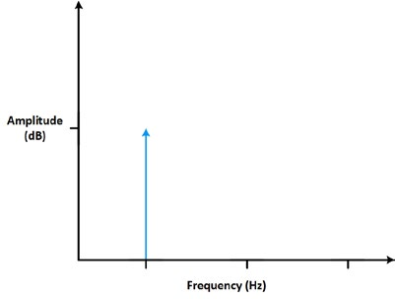

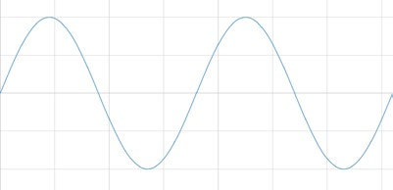

(A)

(B)

Figure : Measuring an integer number of periods (A) gives an ideal FFT (B).

However, many times, the measured signal isn’t an integer number of periods. Therefore, the

finiteness of the measured signal may result in a truncated waveform with different

characteristics from the original continuous-time signal, and the finiteness can introduce sharp

transition changes into the measured signal. The sharp transitions are discontinuities.

When the number of periods in the acquisition is not an integer, the endpoints are

discontinuous. These artificial discontinuities show up in the FFT as high-frequency

components not present in the original signal. These frequencies can be much higher than the

Nyquist frequency and are aliased between 0 and half of your sampling rate. The spectrum you

get by using a FFT, therefore, is not the actual spectrum of the original signal, but a smeared

version. It appears as if energy at one frequency leaks into other frequencies. This

phenomenon is known as spectral leakage, which causes the fine spectral lines to spread into

wider signals.

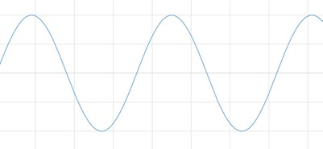

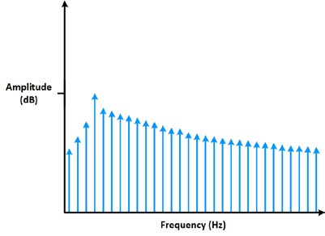

Figure : Measuring a noninteger number of periods (A) adds spectral leakage to the FFT (B).

You can minimize the effects of performing an FFT over a noninteger number of cycles by using

a technique called windowing. Windowing reduces the amplitude of the discontinuities at the

boundaries of each finite sequence acquired by the digitizer. Windowing consists of multiplying

the time record by a finite-length window with an amplitude that varies smoothly and gradually

toward zero at the edges. This makes the endpoints of the waveform meet and, therefore,

results in a continuous waveform without sharp transitions. This technique is also referred to as

applying a window.

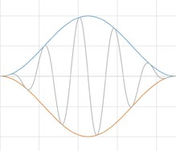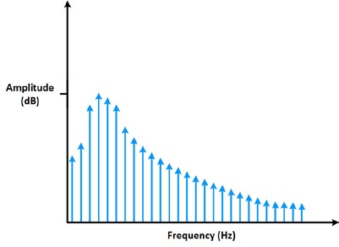

Figure: Applying a window minimizes the effect of spectral leakage.

**Windowing Functions**

There are several different types of window functions that you can apply depending on the

signal. To understand how a given window affects the frequency spectrum, you need to

understand more about the frequency characteristics of windows.

An actual plot of a window shows that the frequency characteristic of a window is a continuous

spectrum with a main lobe and several side lobes. The main lobe is centered at each frequency

component of the time-domain signal, and the side lobes approach zero. The height of the side

lobes indicates the affect the windowing function has on frequencies around main lobes. The side

lobe response of a strong sinusoidal signal can overpower the main lobe response of a nearby

weak sinusoidal signal. Typically, lower side lobes reduce leakage in the measured FFT but

increase the bandwidth of the major lobe. The side lobe roll-off rate is the asymptotic decay rate

of the side lobe peaks. By increasing the side lobe roll-off rate, you can reduce spectral leakage.

Selecting a window function is not a simple task. Each window function has its own

characteristics and suitability for different applications. To choose a window function, you must

estimate the frequency content of the signal.

* If the signal contains strong interfering frequency components distant from the frequency

of interest, choose a smoothing window with a high side lobe roll-off rate.

* If the signal contains strong interfering signals near the frequency of interest, choose a

window function with a low maximum side lobe level.

* If the frequency of interest contains two or more signals very near to each other, spectral

resolution is important. In this case, it is best to choose a smoothing window with a very

narrow main lobe.

* If the amplitude accuracy of a single frequency component is more important than the

exact location of the component in a given frequency bin, choose a window with a wide

main lobe.

* If the signal spectrum is rather flat or broadband in frequency content, use the uniform

window, or no window.

* In general, the Hanning (Hann) window is satisfactory in 95 percent of cases. It has good

frequency resolution and reduced spectral leakage. If you do not know the nature of the signal but you want to apply a smoothing window, start with the Hann window.

Even if you use no window, the signal is convolved with a rectangular-shaped window of

uniform height, by the nature of taking a snapshot in time of the input signal and working

with a discrete signal. This convolution has a sine function characteristic spectrum. For this

reason, no window is often called the uniform or rectangular window because there is still

a windowing effect.

The **Hamming and Hann window** functions both have a sinusoidal shape. Both windows

result in a wide peak but low side lobes. However, the Hann window touches zero at both

ends eliminating all discontinuity. The Hamming window doesn’t quite reach zero and thus

still has a slight discontinuity in the signal. Because of this difference, the Hamming window

does a better job of cancelling the nearest side lobe but a poorer job of canceling any others.

These window functions are useful for noise measurements where better frequency

resolution than some of the other windows is wanted but moderate side lobes do not

present a problem.

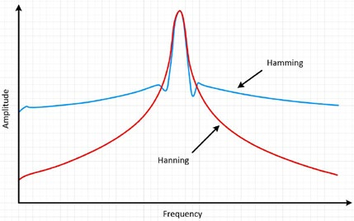

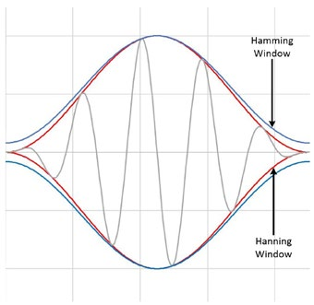

Figure : and Hann windowing result in a wide peak but nice low side lobes

The Blackman-Harris window is similar to Hamming and Hann windows. The resulting spectrum

has a wide peak, but good side lobe compression. There are two main types of this window. The

4-term Blackman-Harris is a good general-purpose window, having side lobe rejection in the high

90s dB and a moderately wide main lobe. The 7-term Blackman-Harris window function has all

the dynamic range you should ever need, but it comes with a wide main lobe.

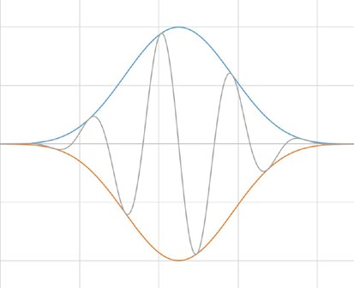

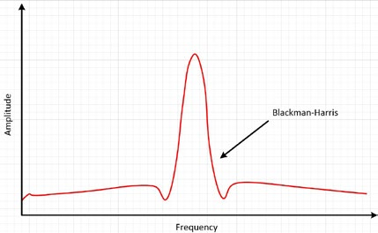

Figure : The Blackman-Harris results in a wide peak, but good side lobe compression.

A Kaiser-Bessel window strikes a balance among the various conflicting goals of amplitude accuracy, side lobe distance, and side lobe height. It compares roughly to the Blackman-

Harris window functions, but for the same main lobe width, the near side lobes tend to be

higher, but the further out side lobes are lower. Choosing this window often reveals signals

close to the noise floor. The flat top window is sinusoidal as well, but it actually crosses the zero line. This causes a much broader peak in the frequency domain, which is closer to the true amplitude of the signal than with other windows. These are just a few of the possible window functions. There is no universal approach for selecting a window function. However, the table below can help you in your initial choice. Always compare the performance of different window functions to find the best one for the application.

In order to assess the bandwidth of a mode, we propose the following scheme: 1) for each mode *uk*, compute the associated analytic signal by means of the Hilbert transform in order to obtain a unilateralfrequency spectrum. 2) for each mode, shift the mode’s frequency spectrum to “baseband”, by mixing with an exponential tuned to the respective estimated center frequency. 3) The bandwidth is now estimated through the H1 Gaussian smoothness of the demodulated signal, i.e. the squared L2-norm of the gradient. The resulting constrained variational problem is the following:

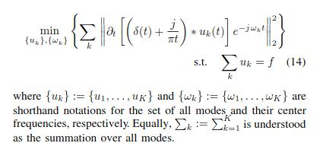

The reconstruction constraint can be addressed in different ways. Here, we suggest making use of both a quadratic penalty term and Lagrangian multipliers, in order to render the problem unconstrained. The quadratic penalty is a classic way to encourage reconstruction ﬁdelity, typically in the presence of additive i.i.d. Gaussian noise. The weight of the penalty term is derived from such a Bayesian prior to be inversely proportional to the noise level in the data. Conversely, in a noisefree setting, the weight needs to be inﬁnitely big in order to enforce strict data ﬁdelity, rendering the system ill- conditioned in the process. On the other hand, Lagrangian multipliers are a common way of enforcing constraints strictly. The combination of the two terms thus beneﬁts both from the nice convergence properties of the quadratic penalty at ﬁnite weight, and the strict enforcement of the constraint by the Lagrangian multiplier. Therefore, we introduce the augmented Lagrangian multiplier as follows :

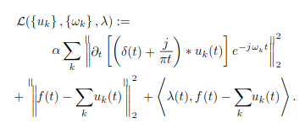

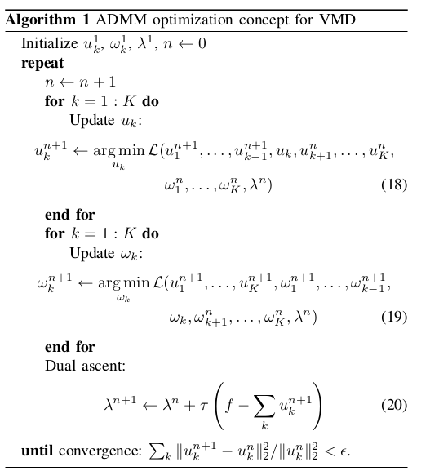

*(Code Snippet from VMD.m script* for the above algorithm)

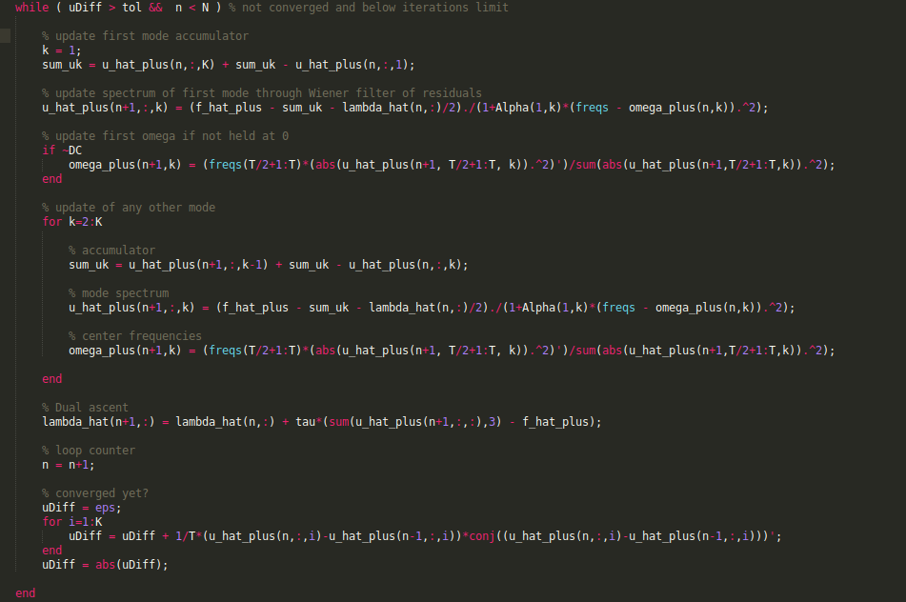

The solution to the original minimization problem (14) is now found as the saddle point of the augmented Lagrangian *L* in a sequence of iterative sub-optimizations called alternate direction method of multipliers (ADMM) [34]–[36], see algorithm1. In the next paragraphs, we will then detail how the respectivesub-problems can be solved.

**Minimization w.r.t. *uk :***

To update the modes *uk* , we first rewrite the subproblem (16) as the following equivalent minimization problem:

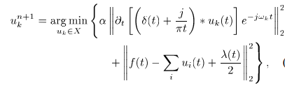

*where for simplicity we omit .n and .n+1 for the fixed directions and , respectively, but each is implicitly understood as the most recent available update. Now, making use of the Parseval/Plancherel Fourier isometry under the norm, this problem can be solved in spectral domain:*

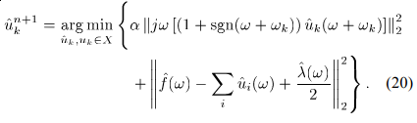

*We now perform a change of variables $ω←ω−ω_{k}$ in the first term:*

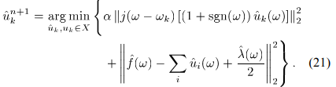

*Exploiting the Hermitian symmetry of the real signals in the reconstruction fidelity term, we can write both terms as halfspace integrals over the non-negative frequencies:*

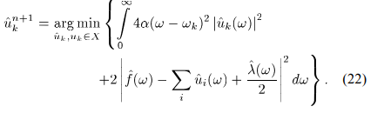

*The solution of this quadratic optimization problem is readily found by letting the first variation vanish for the positive frequencies:*

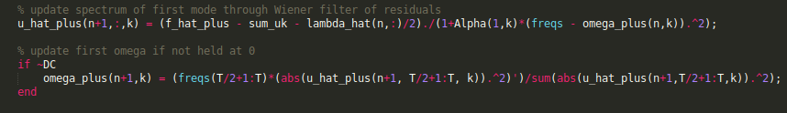

*(Code Snippet from VMD.m script )*

*which is clearly identified as a Wiener filtering of the current residual, with signal prior $1/{{\left(ω−ω_{k}\right)}^{2}}$. The full spectrum of the real mode is then simply obtained by Hermitian symmetric completion. Conversely, the mode in time domain is obtained as the real part of the inverse Fourier transform of this filtered analytic signal.*

***Minimization w.r.t. $ω_{k}$* :**

The center frequencies $ω_{k}$ do not appear in the reconstruction fidelity term, but only in the bandwidth prior. The relevant problem thus reads:

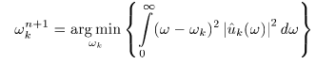As before, the optimization can take place in Fourier domain, and we end up optimizing:

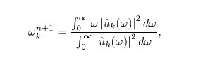This quadratic problem is easily solved as:

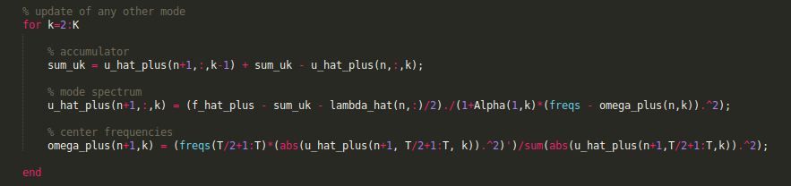

(Code snippet from VMD.m script for minimization w.r.t. omegas)

which puts the new $ω_{k}$ at the center of gravity of the corresponding mode’s power spectrum. This mean carrier frequency is the frequency of a least squares linear regression to the instantaneous phase observed in the mode. Plugging the solutions of the sub-optimizations into the ADMM algorithm 1, and directly optimizing in Fourier domain where appropriate, we get the complete algorithm for variational mode decomposition, summarized in algorithm.

**Improved Variational Mode Decomposition :**

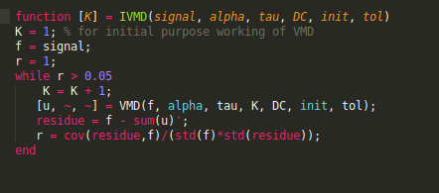To overcome the unadaptable quadratic penalty problem, an improved VMD model via correlation coefficient and new update formulas are proposed to decompose ECG signals. To improve the denoising precision, this algorithm is combined with the interval threshold algorithm. First, the correlation coefficient is calculated, to determine quadratic penalty, in order to extract the first IMF made up of baseline drift. Then, the new update formulas derived from the variance that describes the noise level are used, to perform decomposition on the rest signal. Finally, the Interval thresholding algorithm is performed on each IMF.

(Code snippet from IVMD.m script to optimize K, number of modes)

(code snippet from DyVMD.m for preprocessing for IVMD Algorithm)

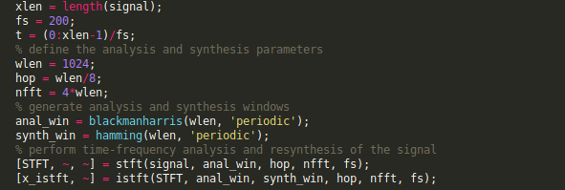

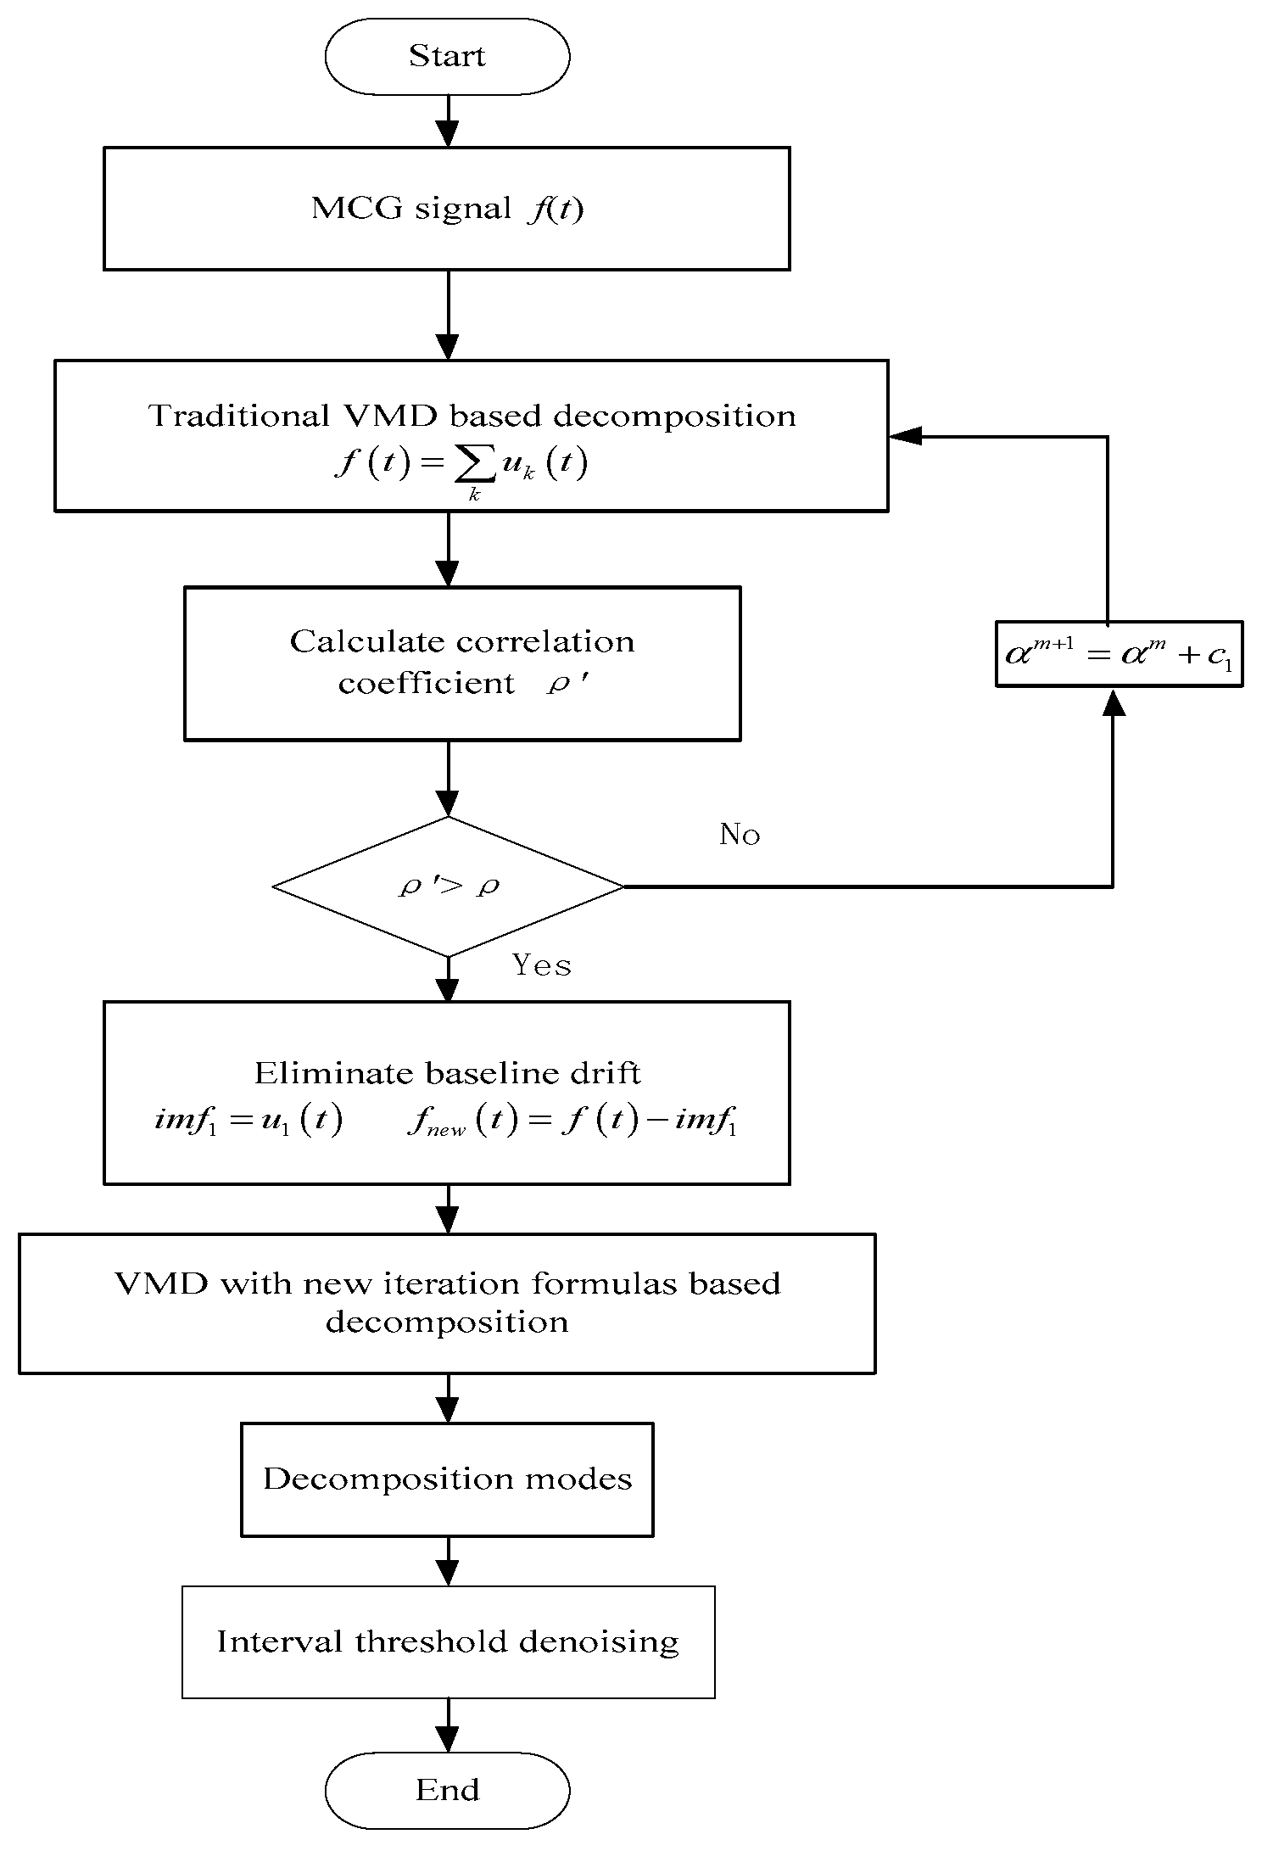

ECG

<https://www.mdpi.com/2073-8994/10/7/269/htm>