personalCFO — Marketing landing page spec
Phase 1 go-to-market page · v1.0 · June 2026

1. Purpose of this document
This spec defines the content, structure, and visual direction for personalCFO's public marketing homepage — the page a prospective user lands on before they've uploaded anything. It is written for whoever designs and builds the page, and assumes the product context already established in the Phase 1 PRD and the personal finance competitive analysis in this project.
This is not a pixel-perfect design file. It specifies what every section must say and why, the visuals each section needs, and the tone constraints the copy has to stay inside. Visual treatment (exact layout, type scale, imagery) is left to design, with the two reference diagrams below as a starting point.

2. Audience & positioning

Who lands on this page
The same person the product is built for: a financially literate professional, roughly 30–55, with multiple income streams (salary plus equity, rental, freelance, or gig income) and accounts spread across three to six institutions. They are privacy-conscious — reluctant to hand bank credentials to an aggregator — and have likely already tried a budgeting app, a spreadsheet, or pasting statements into ChatGPT, and outgrown all three.

Positioning statement
“personalCFO is the financial analyst that only tells you what your real transactions say — without asking for your bank password.”

What this page must not do
- Gamify the experience — no streaks, no badges, no confetti.
- Lecture the visitor about their spending habits before they've even signed up.
- Oversell AI as magic — the differentiator is what the system does, not that it uses AI.
- Make a claim the product can't back up today (see §7, copy guardrails).

3. Page goals & success criteria
- Primary goal: convert a visitor into an upload (or waitlist signup) within one scroll session.
- Secondary goal: pre-empt the “isn't this just ChatGPT” objection before it causes a bounce.
- Tertiary goal: build enough trust on security and privacy that uploading real statements feels safe.
Success criteria (qualitative, pre-launch): a visitor unfamiliar with the product should be able to, after one read-through, explain in a single sentence why this isn't “just ChatGPT.” If the page can't produce that sentence in someone's head, the comparison section in §5.4 needs to be sharper before anything else changes.

4. Information architecture
Sections appear in this order, top to bottom:
- Nav
- Hero
- Problem statement
- Why not just use ChatGPT (comparison)
- How it works (4-step workflow)
- Feature showcase
- Insight Feed showcase
- Security & privacy
- Final CTA
- Footer

5. Section-by-section spec

5.1 Navigation
Wordmark left. Links: Features, How it works, Security — anchor-scrolling to the matching section, no dropdowns. One CTA button on the right (“Join the waitlist” pre-launch, “Upload a statement” once live). Sticky on scroll.

5.2 Hero
- Headline: “The financial analyst who never makes up a number.”
- Subhead: “Upload your statements and get a structured ledger of your real finances — plus a chatbot that only ever says what your data actually shows.”
- Primary CTA: “Upload your first statement.”
- Secondary CTA: “See how it works” (anchors to §5.5).
- Trust microcopy under the CTAs: “No bank credentials required · Encrypted at rest.”
Visual: one mock chat exchange, shown as a small card, with a specific and traceable answer — not a vague one. Example:
You asked: “How much did I spend on dining last month?”
personalCFO: “$1,240 — up 38% from your 3-month average of $897, driven by 5 charges over $100.”
This single example carries more positioning weight than any adjective on the page: it demonstrates specificity and traceability in one glance, which is the entire argument of §5.4.

5.3 Problem statement
- Headline: “You have the data. You don't have the picture.”
Body: Most financially active people have four to six accounts across different institutions, producing dozens of statements a year that nobody actually reads. Existing finance apps force a choice: hand bank credentials to an aggregator and hope the connection holds, or do it yourself in a spreadsheet. Neither gets you an answer the moment you actually have a question.

5.4 Why not just use ChatGPT
- Headline: “Why not just paste your statements into ChatGPT?”
Intro line: “You can — and you'll get an answer. The question is whether you can trust it, and whether it's still there next month.”
Full point-by-point comparison, to ship as a table or matched card grid:
Dimension | ChatGPT | personalCFO
Memory | Each conversation starts from zero; statements get re-pasted next month. | Every import adds to one permanent, structured ledger that gets smarter over time.
Accuracy | Reads numbers off a PDF and reasons in prose; estimates and rounding aren't traceable. | Every dollar in every answer comes from a tool call against the real transaction database — never generated, never estimated.
Parsing | One format, one institution, one shot; mixed PDF layouts and sign conventions trip up a general model. | Purpose-built parsers per institution, with automatic sign-convention detection and duplicate removal across files.
Proactivity | Only answers what you think to ask. | A 10-signal Insight Feed flags cashflow risk, subscription creep, duplicate charges, and spending spikes automatically.
Income intelligence | Treats every deposit the same. | Classifies salary, freelance, rental, interest, and gig income, and asks you to confirm what it's unsure about.
Privacy | Statements become part of a general-purpose chat history. | Purpose-built for financial data: encrypted at rest, account numbers masked, never used to train a model, never sold.
Auditability | A paragraph of prose with no way to check its work. | Every insight links back to the specific transactions behind it, with a confidence score attached.

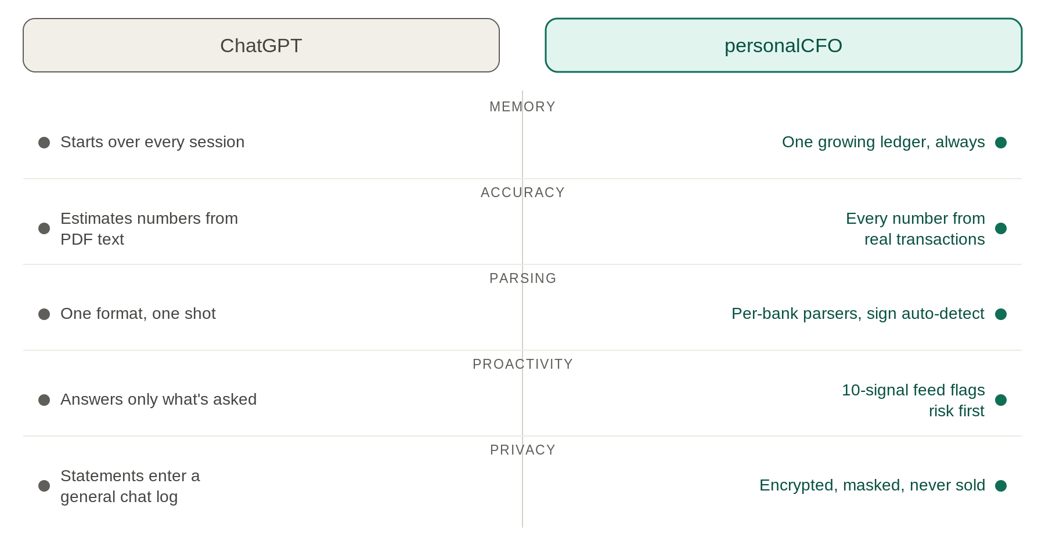
Figure 1. Visual summary of the strongest five differentiators — use as the at-a-glance graphic, with the full table available on click-through or scroll.
Closing line (set as a pull quote): “ChatGPT is a brilliant generalist. personalCFO is the one place that already knows your transactions — and only ever tells you what they actually say.”

5.5 How it works
- Headline: “From statement to answer in four steps.”
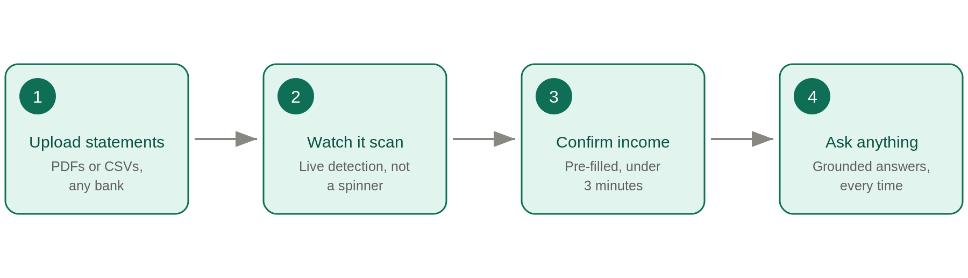
Figure 2. The four-step import-to-answer workflow.
- 1. Upload statements — drag in PDFs or CSVs from any of your accounts (Chase, Amex, Bank of America, Citi, Capital One, Wells Fargo, and more). Multiple files, multiple institutions, one import.
- 2. Watch it scan — a live scan shows the system finding income, large expenses, and transfers in real time. Not a spinner: a window into the reasoning.
- 3. Confirm your income — a quick, pre-filled review of salary, freelance, rental, and gig income. Usually under three minutes. Accept what's right, correct what's not.
- 4. Ask anything — chat with your real financial history, and watch the Insight Feed surface what's worth knowing without being asked.

5.6 Feature showcase
Six-item grid, each a short title plus a one-line description:
- Multi-institution import — Chase, Amex, Bank of America, Citi, Capital One, Wells Fargo, and more, in PDF or CSV, in one batch.
- Smart income classification — salary, freelance, rental, interest, gig: auto-detected, and easy to correct in under three minutes.
- Grounded, hallucination-free chat — every figure traces back to a real transaction. If the data doesn't exist to answer a question, the system says so.
- Proactive Insight Feed — ten detectors surface what's worth knowing before you think to ask.
- No bank credentials, ever — you upload statements you already have. Nothing is linked, nothing is stored beyond what's needed.
- Built for multi-income earners — most finance apps assume one paycheck. personalCFO doesn't.

5.7 Insight Feed showcase
- Headline: “Always watching, never nagging.”
Subhead: a one-line reminder that this is an analyst's flag, not a behavioral lecture — consistent with the no-gamification design principle in §2.
Three example insight cards (illustrative placeholder copy — see note below):
- Subscription creep (medium confidence): “You've added 3 new subscriptions this quarter — $47/month more than January.”
- Duplicate charge (high confidence): “$89.99 to Adobe appears on two statements, three days apart. Likely a duplicate.”
- Cashflow risk (medium confidence): “At your current pace, you're on track to run about $340 short before your next paycheck.”
Note: the three cards above are illustrative only. Final wording, severity labels, and confidence thresholds must be pulled directly from the Insight Feed spec (specs/Insight Feed.md) at build time — do not ship these exact strings without checking them against the live detector logic.

5.8 Security & privacy
- Headline: “Built like it knows it's handling your money.”
- No bank credentials requested, ever.
- Transaction data encrypted at rest.
- Account numbers masked to the last 4 digits.
- No ads, no data selling, no hidden commissions.
Every claim in this section must stay literally true to S1–S5 in the Phase 1 functional spec. Do not let marketing copy promise more security than the shipped system actually provides.

5.9 Final CTA
- Headline: “Find out what your statements have been saying all along.”
- CTA: “Upload your first statement — free.”
- Reassurance line: “No bank login required. Takes about 3 minutes.”

5.10 Footer
Wordmark, repeated nav links, legal links (Privacy, Terms), contact, copyright line. No social icons unless the accounts actually exist and are maintained.

6. Visual & tone direction
The product's own design principle applies directly to this page: it must feel like a knowledgeable analyst, not a budgeting nag. No gamification, no confetti, no streaks, no behavioral lectures — the same restraint the in-app experience uses should show up in how the marketing page looks and talks.
- Flat, clean layout with generous whitespace; avoid gradients and decorative effects.
- One accent color, used sparingly — for CTAs and to mark the personalCFO side of any comparison. Don't let color do the persuading; let the specificity of the copy do it.
- Avoid stock-photo finance imagery — no piggy banks, no people pointing at laptops smiling. Every visual on the page should be a mockup of the actual product.
- Every example shown (chat answers, insight cards) should use specific, plausible numbers — never a placeholder like “$X.” Specificity is itself part of the trust argument this page is making.

7. Copy guardrails

Avoid
- “AI-powered” as a headline claim — per the competitive analysis, AI is table stakes across this category, not a differentiator. Lead with what the system does, not what it's built with.
- Superlatives (“the best,” “revolutionary,” “game-changing”).
- Any promise the product can't keep today — Phase 1 explicitly excludes financial advice and automated money movement, so the page must not imply either.

Prefer
- Concrete mechanisms over adjectives — “every number traces to a transaction” beats “powerful AI insights.”
- Specific numbers over vague claims, even in illustrative copy.

8. Open questions before this ships
- Waitlist vs. live upload as the primary CTA — depends on Phase 1 launch readiness.
- Legal review needed on “never sold” and “no hidden commissions” claims before publishing.
- Real product screenshots should replace the illustrative mockups in this spec once F4 (chat) and F5 (live import experience) are stable.
- Pricing and monetization messaging is intentionally omitted — revenue model isn't finalized yet, per the competitive analysis (§6.5).

