AWS Academy Cloud Architecting 3 – Capstone Project

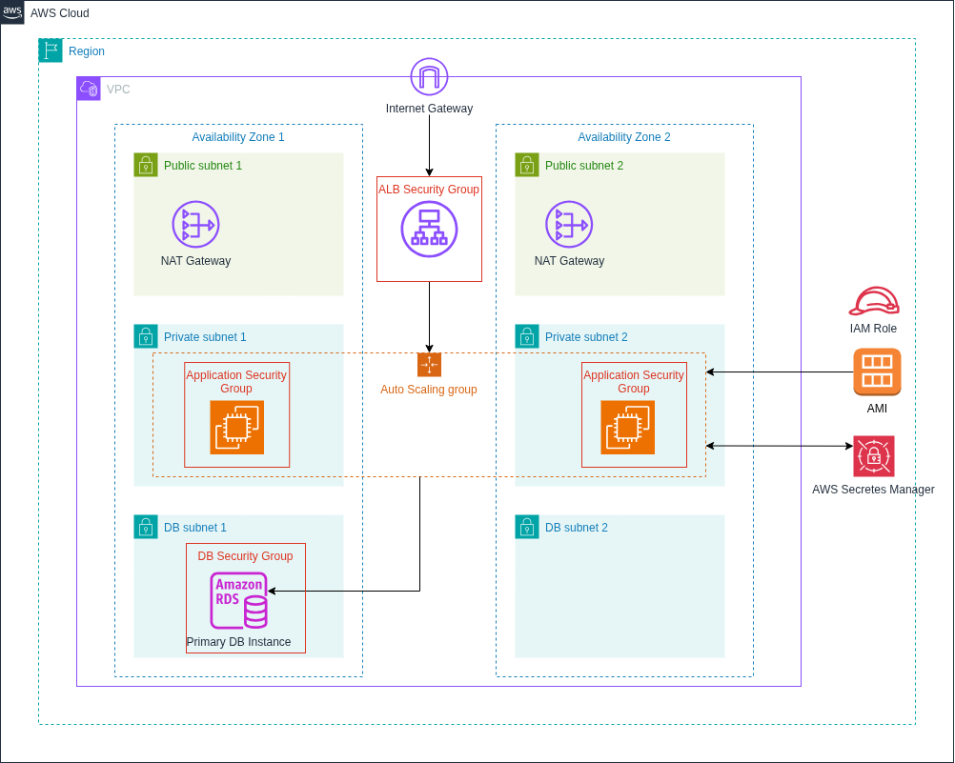
Figure 1: Deploying Highly available web application with the load distributed across multiple web servers and Availability Zones.

Overview
This project is about deploying highly availavle PHP application with the load distributed across multiple web servers and Availability Zones in AWS. This documentaion focuses on the following sections:
- Creating an Amazon RDS database instance.
- Using AWS Secretes Manager.
- Creating an Application Load Balancer.
- Creating the application server in an Auto Scaling Group.
- Importing data into an RDS MySQL database.

VPC Resource Map
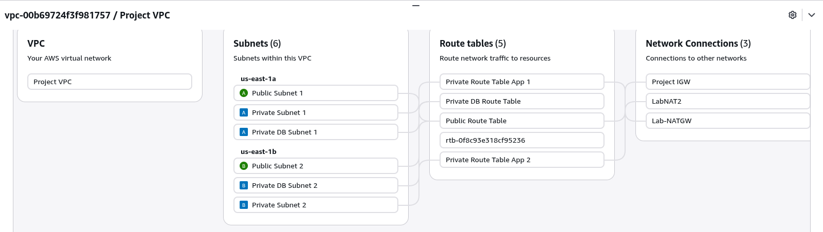
This VPC is created according to the solution architecture diagram shown above. It spans two Availability Zones (AZs), each containing three subnets — a public subnet, a private subnet, and a database subnet. Resources in the public subnets have direct access to the internet through an Internet Gateway (IGW). Resources in the private subnets can access the internet indirectly via NAT Gateways deployed in the corresponding public subnets of each Availability Zone.

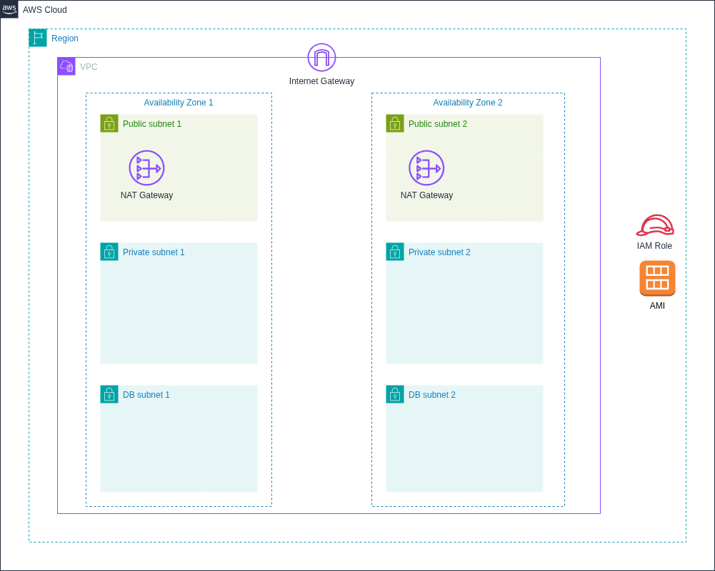
Figure 2: VPC Layout

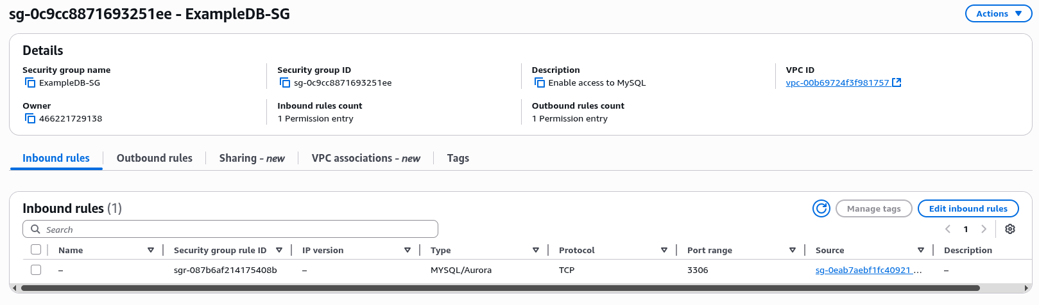
Security Groups
The security group for the database (ExampleDB-SG) is configured to allow inbound TCP connections on port 3306 only from the security group of the web server instances (Inventory-App-SG). This ensures that only the application servers within the VPC can access the database, providing a secure communication channel between the web and database tiers.
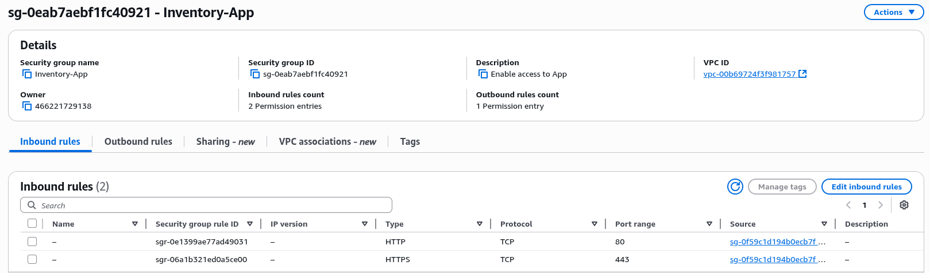

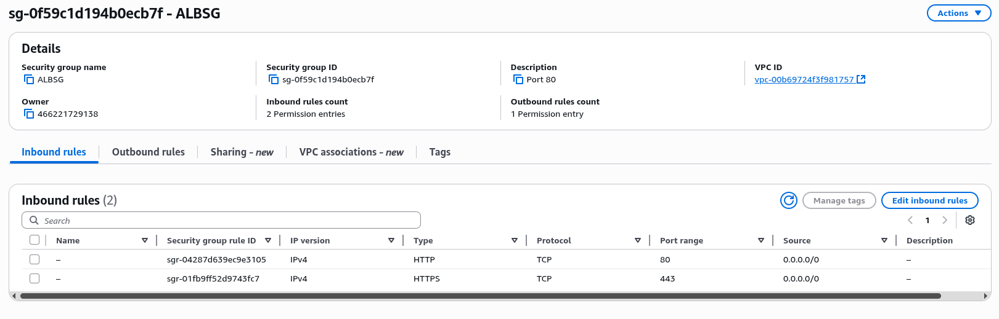
The security group for the application servers (Inventory-App-SG) allows inbound connections on ports 80 (HTTP) and 443 (HTTPS) only from the security group of the Application Load Balancer (ALB-SG). This ensures that all web traffic to the application servers passes securely through the load balancer, preventing direct external access.
The security group for the Application Load Balancer (ALB-SG) allows inbound traffic on ports 80 (HTTP) and 443 (HTTPS) from the internet. This configuration enables public users to access the web application through the load balancer while maintaining controlled and secure entry points to the system.

Creating an Amazon RDS MySQL database

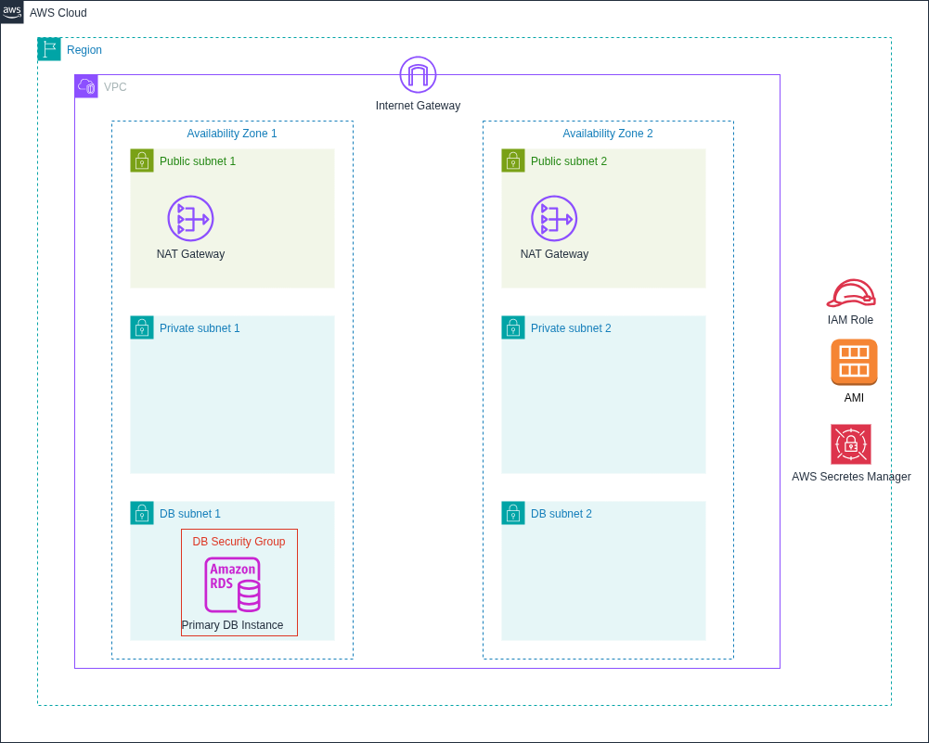
Figrue 3: Creating RDS MySQL DB Instance
RDS MySQL database is hosted in a single Availability Zone within a private subnet. In a production environment, enabling Multi-AZ deployment provides resilience and high availability by automatically replicating the database to a standby instance in another Availability Zone. The security group for the database is configured to allow inbound TCP connections on port 3306 only from the security group of the web server instances, ensuring that only the web servers can access the database.

Step By Step Guide
Note: All the other options not shown in this guide are set to default.
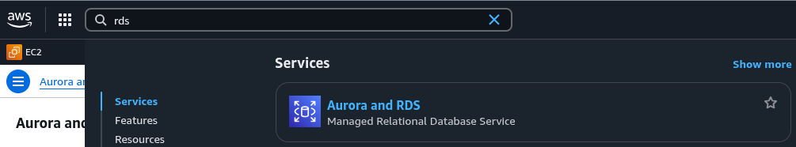
1. Search fo RDS and click to open Aurora and RDS.
2. Proceed with Create a database.
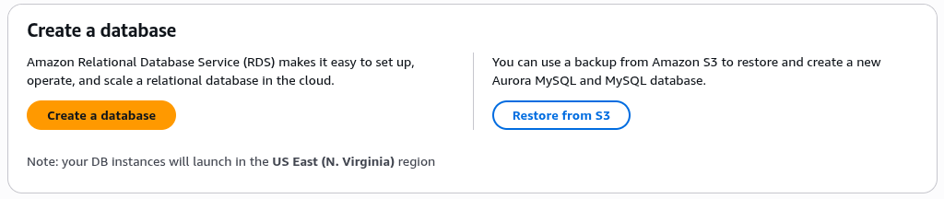

3. In database creation method section, select Standard create.
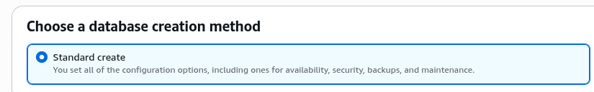
4. Select the database engine. MySQL is selected in this tutorial.
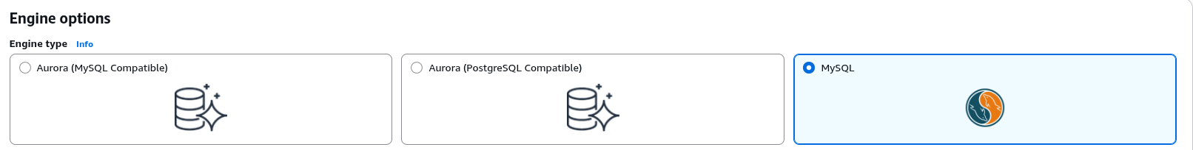

5. Select Dev/Test template, since we are in development/test environment.
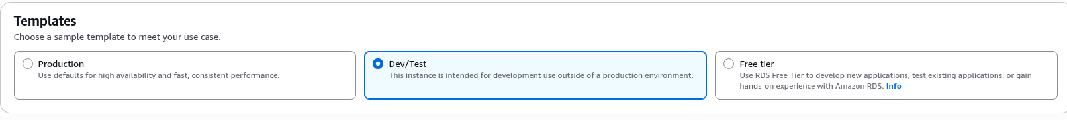
6. Select Single-AZ Instance deployment since we are not in the production environment.
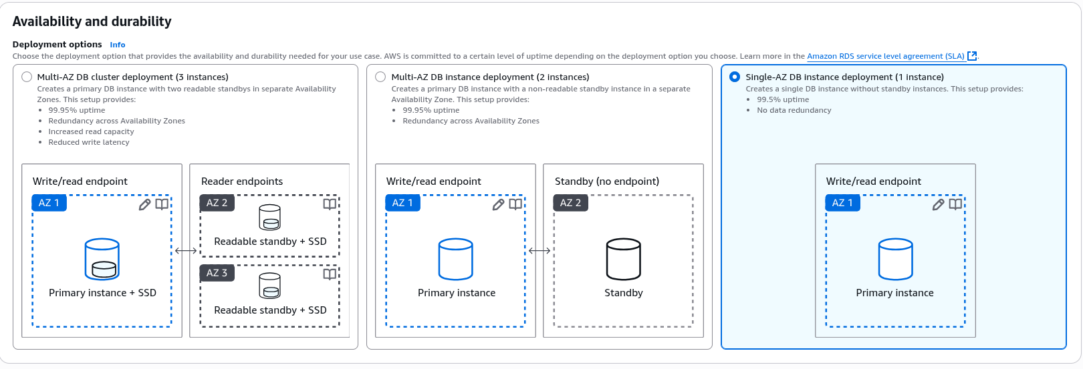
7. Give a DB instance identifier.
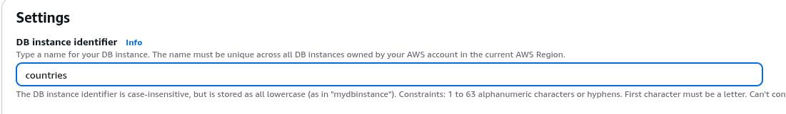
8. Set Master username as admin.
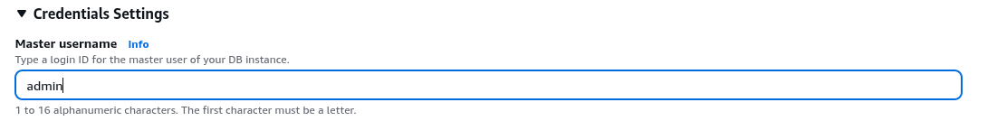
9. In Credentials management section select Managed in AWS Secrets Manager and select encryption key as default. Using Secrets Manager to store Database credentials is most secure option.
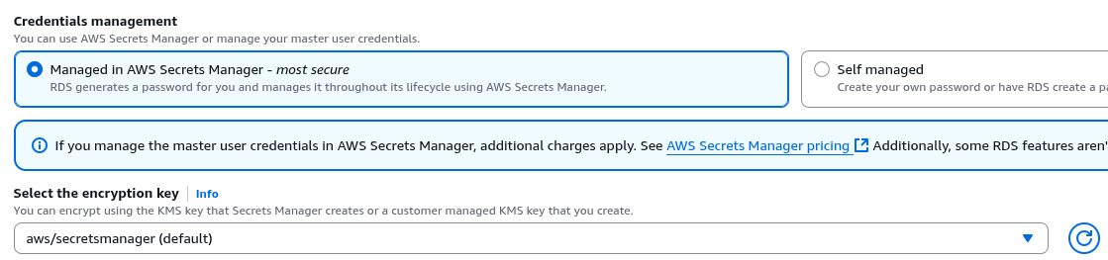
10. For Instance configuration, select DB instance and instance class as required. This tutorial uses Brustable classes and db.t3.micro instance.
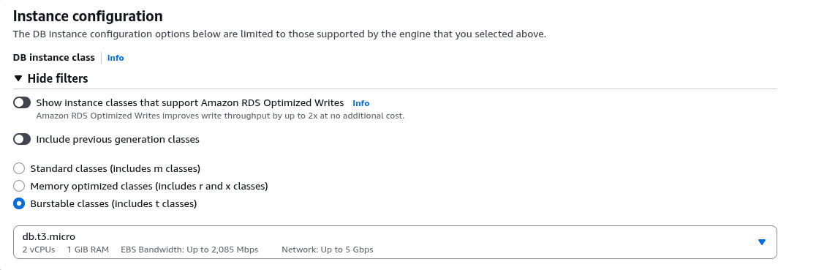
11. Select approprite storage type and size. Here General Purpose SSD (gp2) is selected for type and 20 GiB for size.
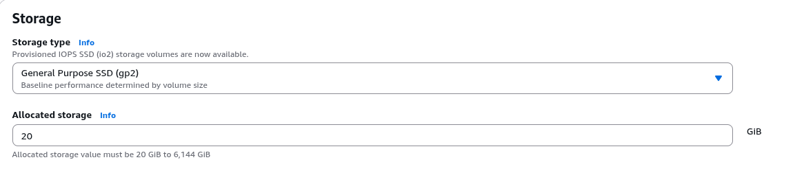
12. Select the VPC. For this tutorial Project VPC is created with resources as presented above in the resource map.
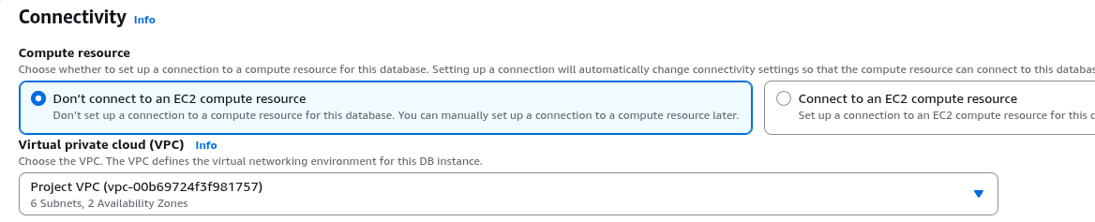
13. Select the subnet group. Subnet group has two private subnets created for the database instance.
14. Select no in Public access section.
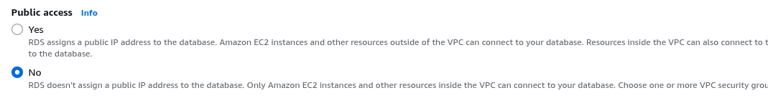
15. Select the existing security group. The security group for the database (ExampleDB-SG) is configured to allow inbound TCP connections on port 3306 only from the security group of the web server instances (Inventory-App-SG).
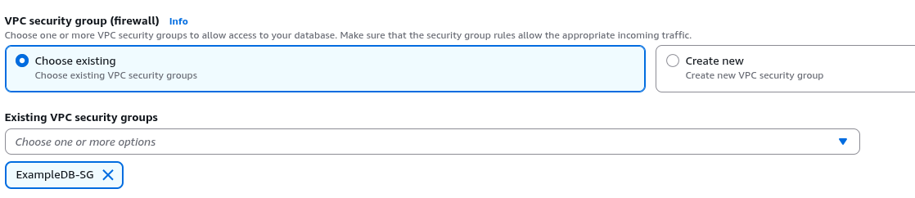
16. Select the Availability Zone.
17. Proceed with Password authentication.
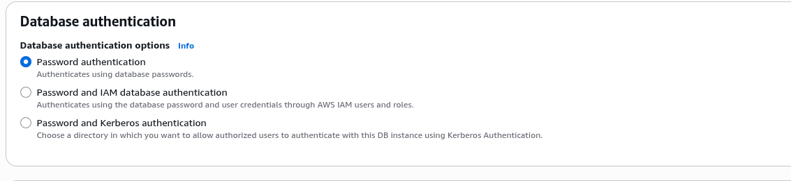
18. Since this is not production environment disable Enhanced Monitoring.
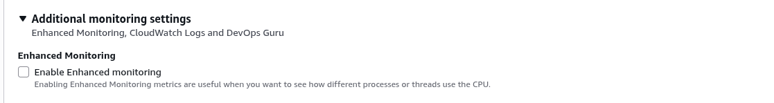

19. Proceed with Create database.


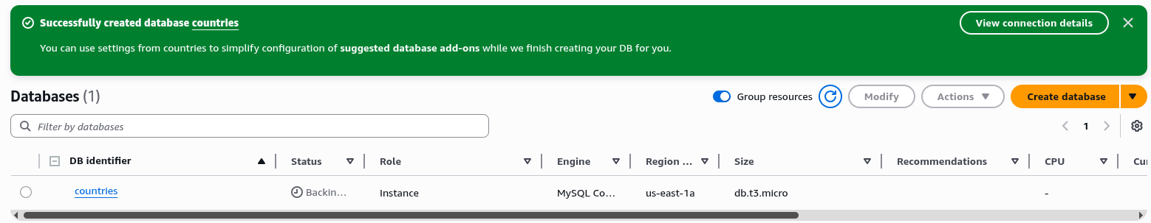
Congratulations ! RDS instance is created successfully.

Creating an Applicattion Load Balancer

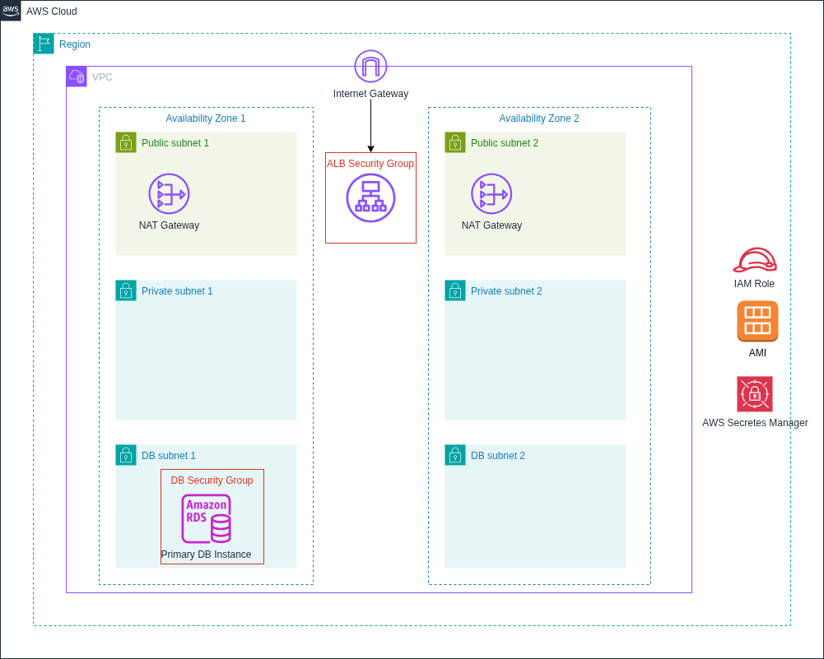
Figure 4: Creating Application Load Balancer

Application Load Balancer is launched in two public subnets. The load balancer’s DNS name is used to access the web application. The security group for the Application Load Balancer allows inbound traffic on ports 80 (HTTP) and 443 (HTTPS) from the internet.

Step By Step Guide
Note: All the other options not shown in this documentation are set to default.
1. Search for load balancer and open Load Balancers with EC2 feature.
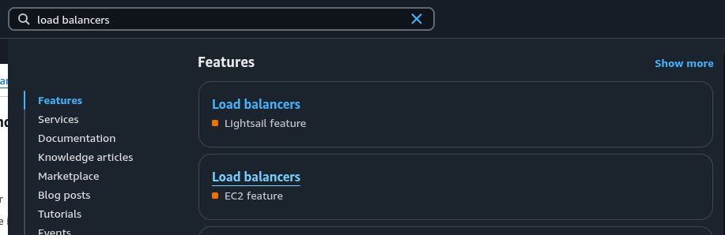
2. Proceed with Create load balancer.

3. Select Application Load Balancer. An Application Load Balancer functions at the application layer, the seventh layer of the Open Systems Interconnection (OSI) model. It works with Amazon EC2 Auto Scaling to improve the availability and scalability of the applications.
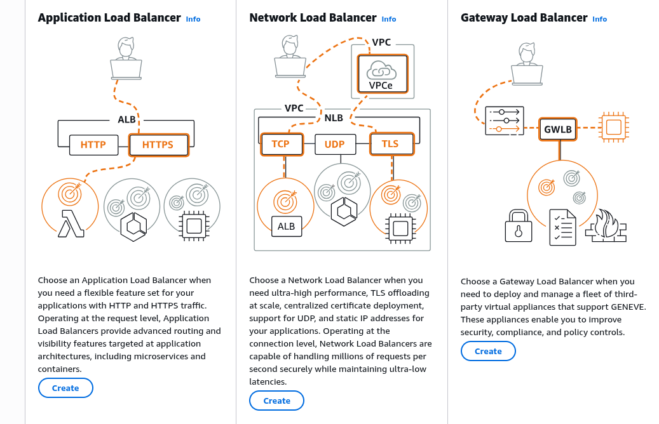
4. Give a Load balancer name.
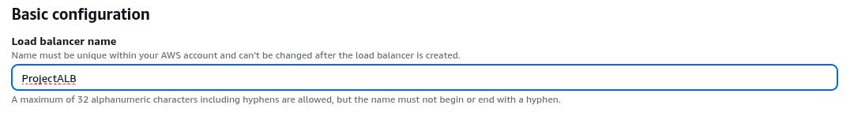
5. Select the VPC and two public subnets.
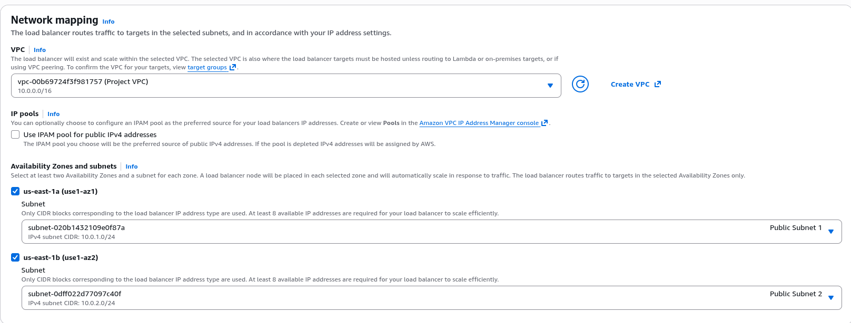

6. Select the existing secutity group for Load Balancer. The security group for the Application Load
Balancer (ALB-SG) allows inbound traffic on ports 80 (HTTP) and 443 (HTTPS) from the internet.
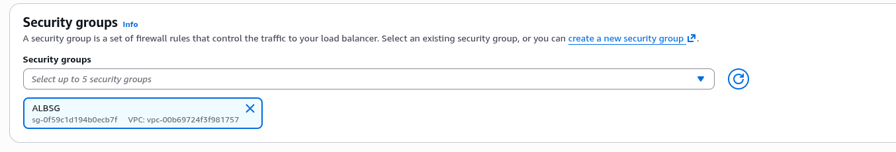
7. Proceed with create target group.
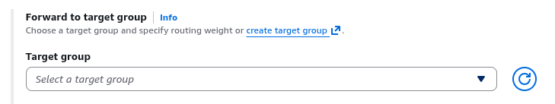
8.. Give a Target group name.

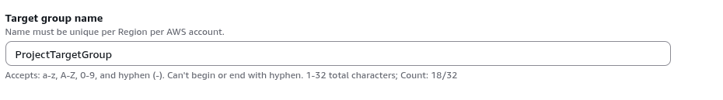
9.. Select the VPC for the target group.
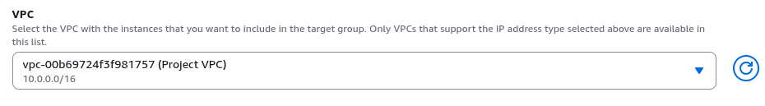
10. For Target type select Instances.
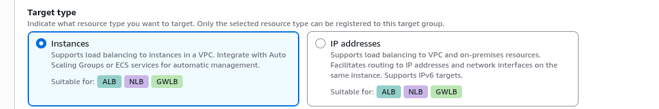

11. Proceed with Create target group.
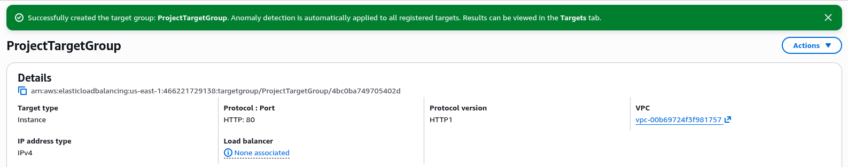
Congratulations ! Target Group is created successfully.

12. Return to the Load Balancer creation tab. Select the newly created target group.
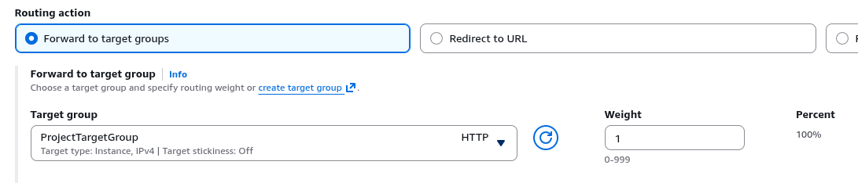
13. Proceed with Create load balancer.

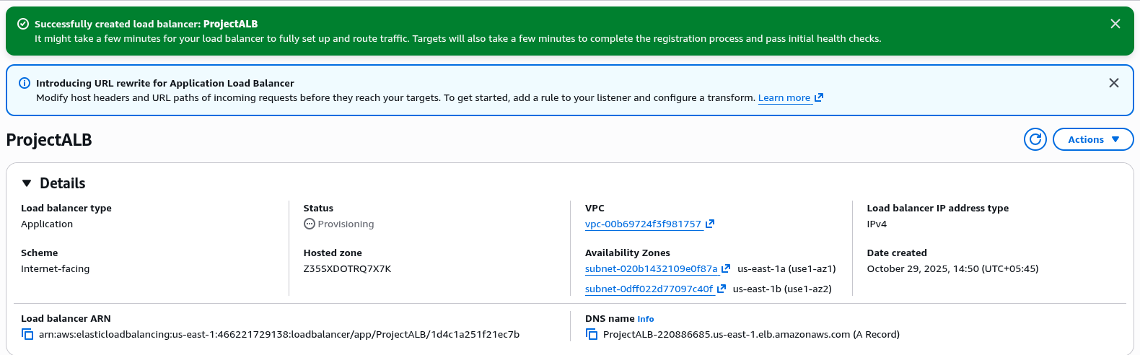
Congratulations ! Application Load Balancer is created successfully.

Creating the Application Server in an Auto Scaling Group

Figure 5: Creating Auto Scaling Group

The Auto Scaling Group (ASG) is deployed across two private subnets and integrated with the previously created Application Load Balancer (ALB). The launch template includes the necessary PHP application resources. The ASG uses a target tracking scaling policy to automatically adjust capacity based on demand. The security group for the ASG allows inbound connections on ports 80 (HTTP) and 443 (HTTPS) only from the security group of the ALB (ALB-SG), ensuring secure communication between the load balancer and the instances.

Step By Step Guide
Note: All the other options not shown in this documentation are set to default.
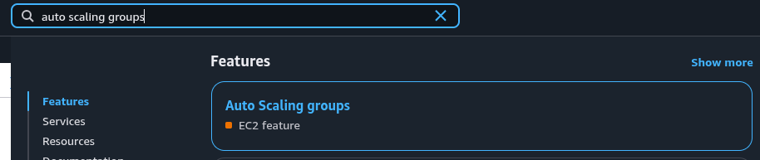
1. Search for auto scaling groups and select Auto Scaling groups with EC2 feature.
2. Proceed with Create Auto Scaling group.
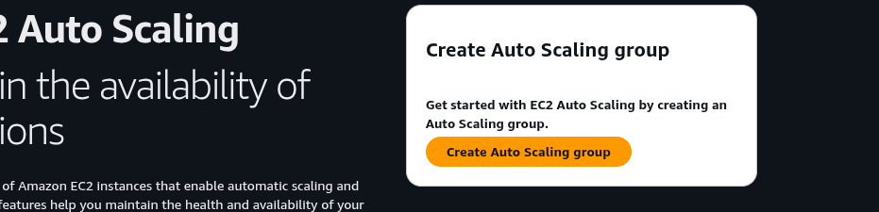

3. Give a Auto Scaling group name.
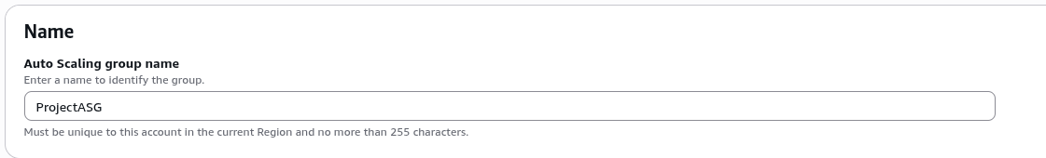
4. Select the Launch template. The selected EC2 launch template named Example-LT has PHP application resources built into it.
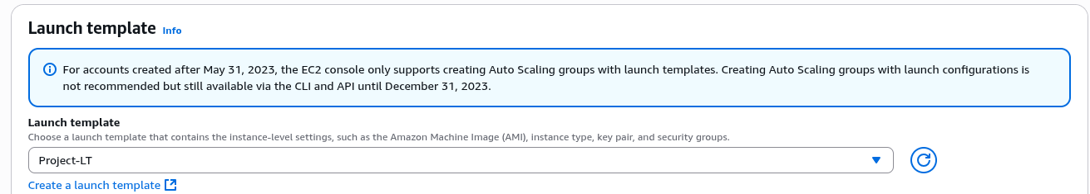
5. Proceed with Next.
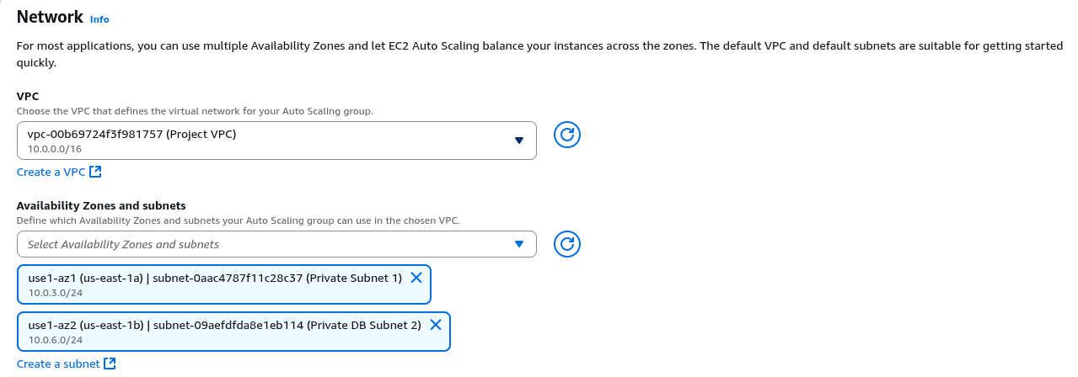
6. Select the VPC and two private subnets created for the web application.

7. With Balanced best effort turned on proceed with Next.
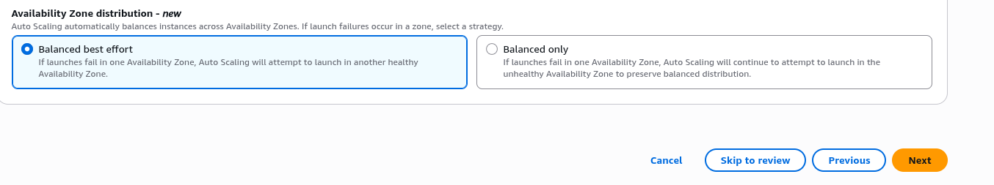
8. For Load balancing set to Attach to an existing load balancer and select Existing load balancer target grop.
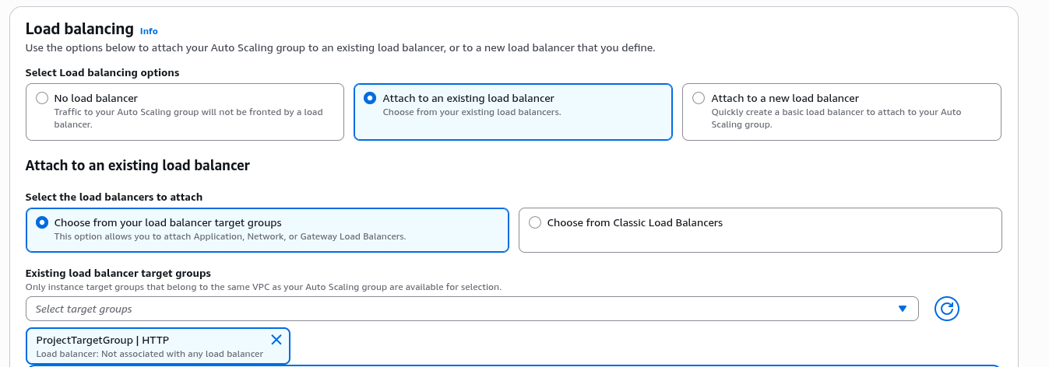
9. Select Turn on Elastic Load Balancing health checks. Set the Health check grace period to 300 seconds.
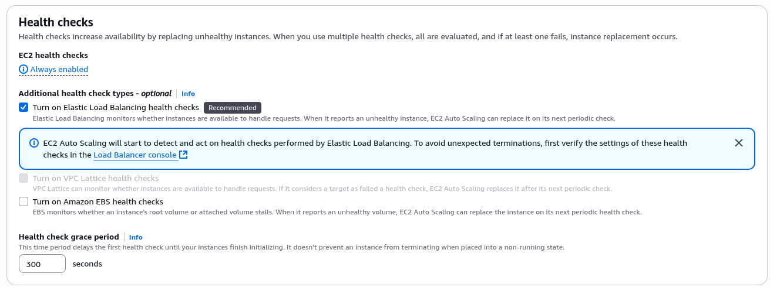
10. Proceed with Next.
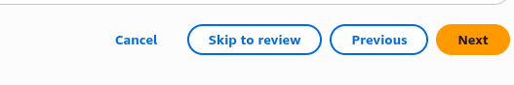

11. In Group size section set Desired capacity to 2.
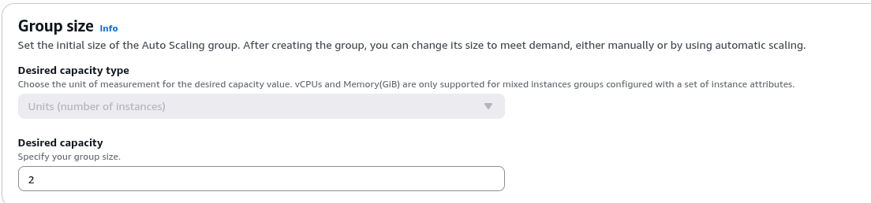
12. For Scaling limits set Min desired capacity to 2 and Max desired capacity to 6.
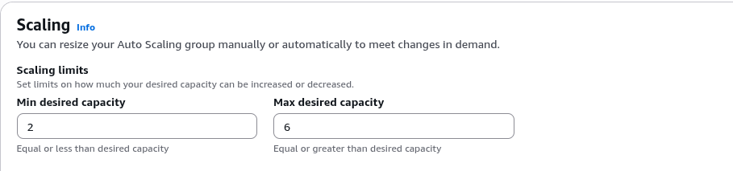
13. Select Target tracking scaling policy. For Metric Type choose Average CPU utilization. Set Target value to 25 and Instance warmup to 30 seconds.
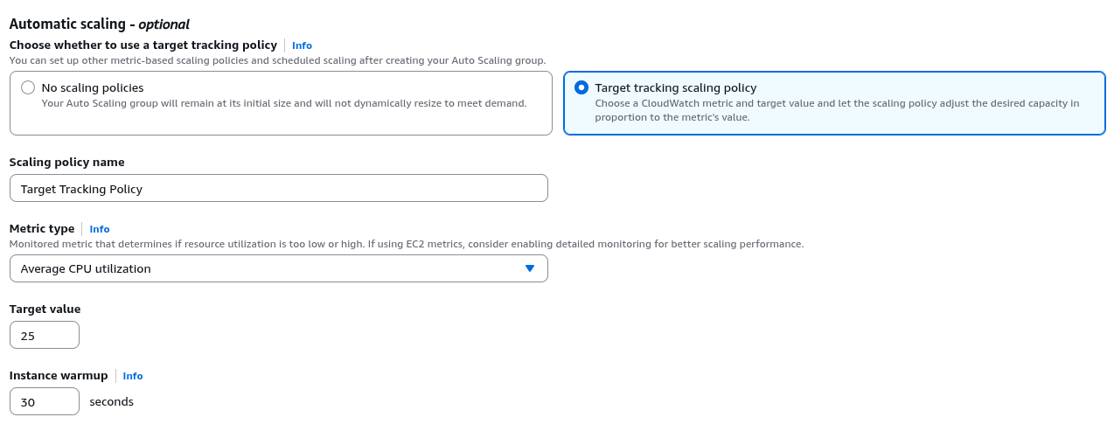
14. Proceed with Next until review section is reached.

15. Review and proceed with Create Auto Scaling group.
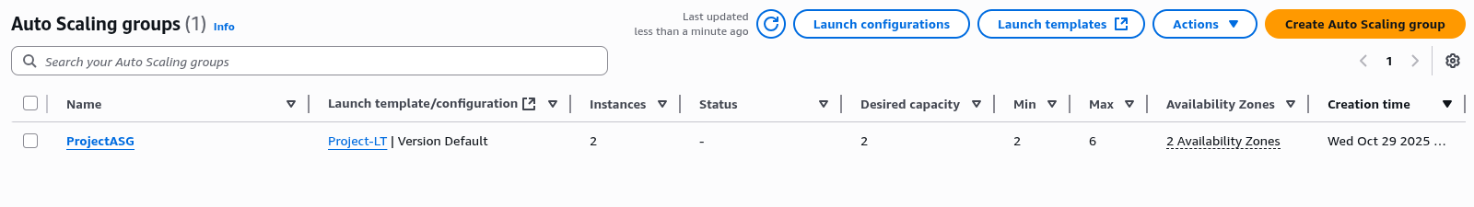
Congratulations ! Auto Scaling group is created successfully.

16. Once Auto Scaling group is created, it launches EC2 instances to suffice the desired number of instances.
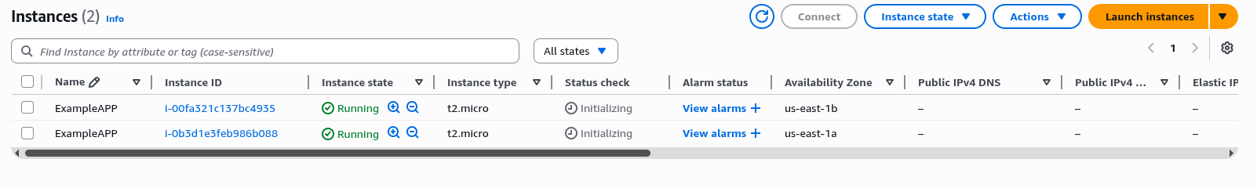
17. To test if the web application is working and deployment is successful copy the DNS name of Load Balancer.
18. Open new tab in browser, paste the DNS name, and open the website.
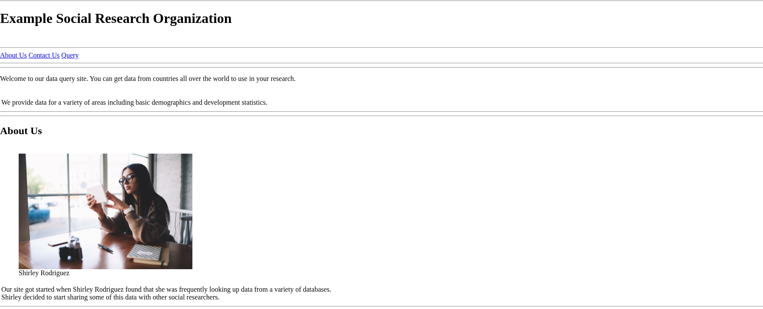
Congratulations ! Deployment is successful.

Importing Data into an RDS MySQL Database

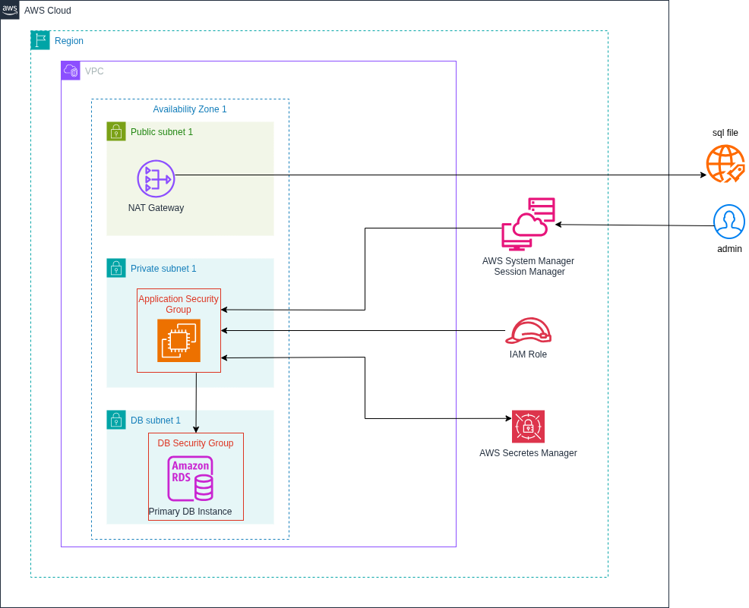
Figure 6: Importing data into an RDS MySQL database

AWS Systems Manager Session Manager is used to log in to one of the running instances in the Auto Scaling Group. The SQL file containing the data is downloaded from the internet. Since the instance resides in a private subnet, it accesses the internet through a NAT Gateway. The database credentials are securely retrieved from AWS Secrets Manager, and a connection is established to the RDS MySQL database instance to import the data.

Step By Step Guide

1. To import data to RDS MySQL database, connection is required. Open any one of the running EC2 instance that belongs to Auto Scaling Group created earlier.
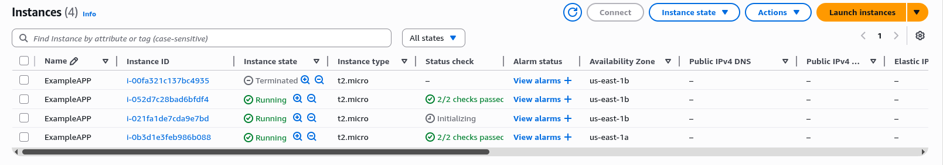
2. Click Connect.

3. Open Session Manager and click Connect.
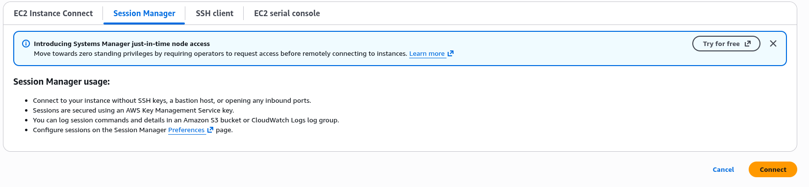
4. Once the Session Manager shell is open, login as ec2-user. Use the following commands.
→ sudo su
→ su ec2-user
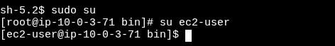

12. Open the RDS MySQL database instance and copy the endpoint.
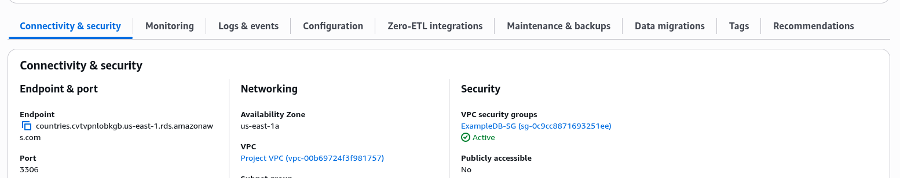
13. To get the database credentials open the Secretes Manager.
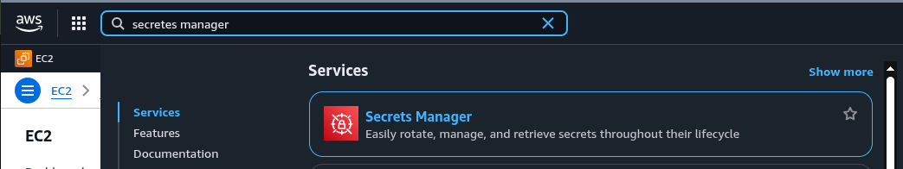
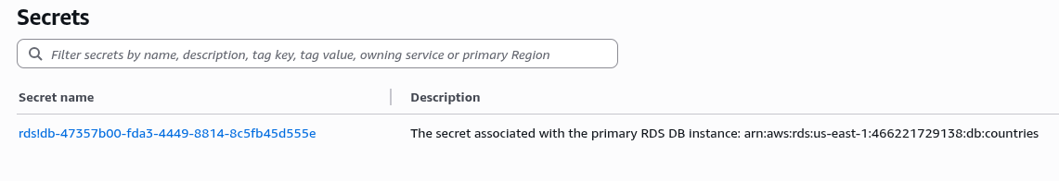
14. Select the secret associated with the primary RDS DB Instance.

15. Click Retrieve secret value. Copy username and password.
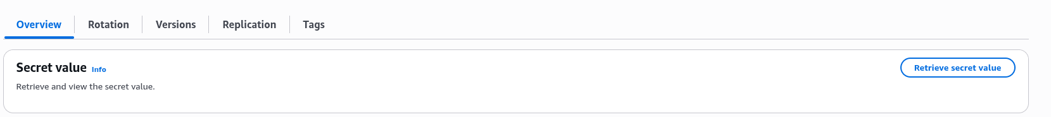
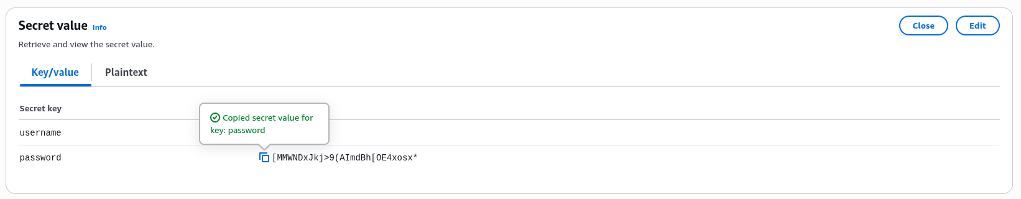
16. Go back to Session Manager shell and run the commands.
→ mysql -u admin -p --host <RDS-DB endpoint>
→ show databases;
→ create database countries;
→ exit
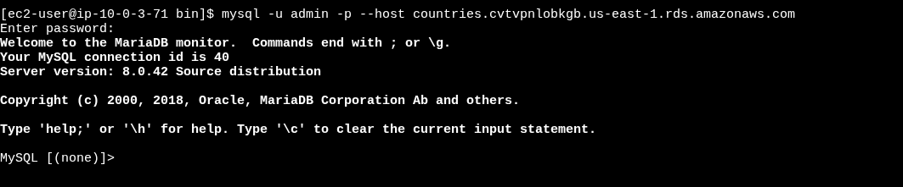
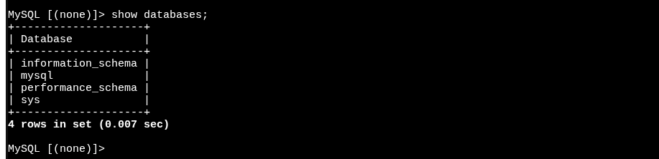
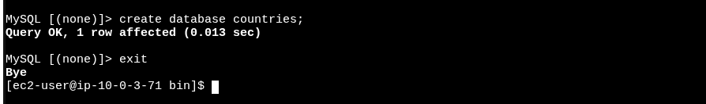
17. Download the sql file. Run the command.
→ cd
→ wget < link to the sql file >
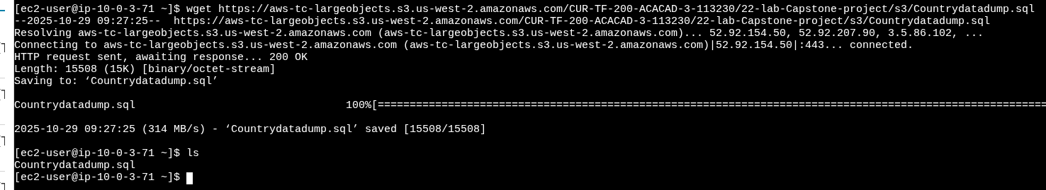
18. Import the data from sql file to the database. Run the command.
→ mysql -u admin -p --host <endpoint> <database> < <file.sql>
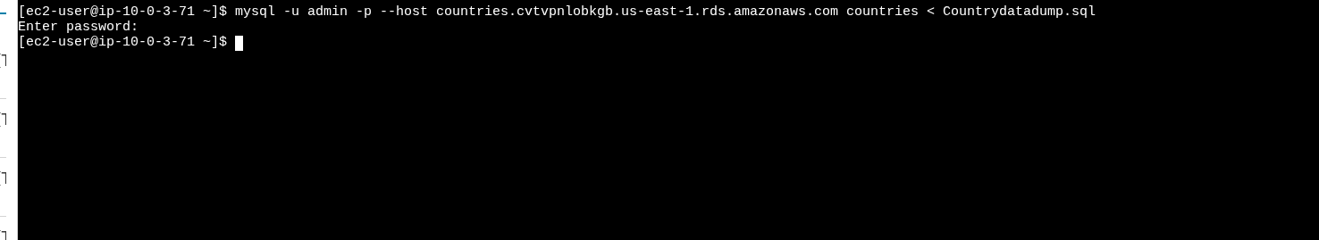
Congratulations ! Data is imported successfully.

19. To test, there is Query functionality in the web application.
20 . Opening the Query page.
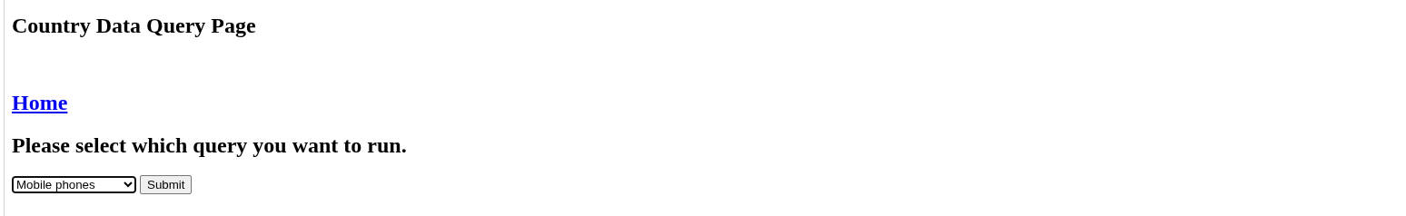
21. Submitting the query.

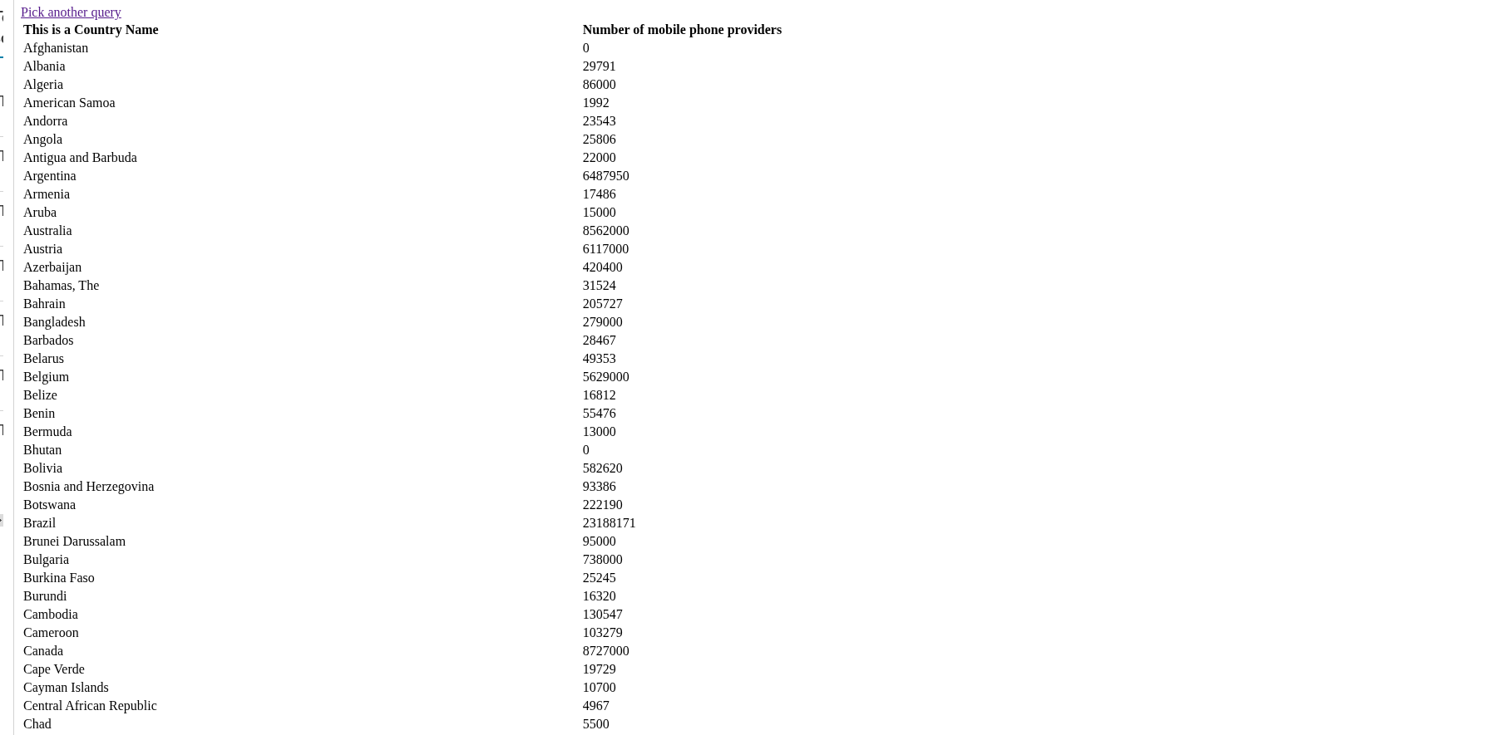
Congratulations ! Data is visible in the website.

