Understanding VPC
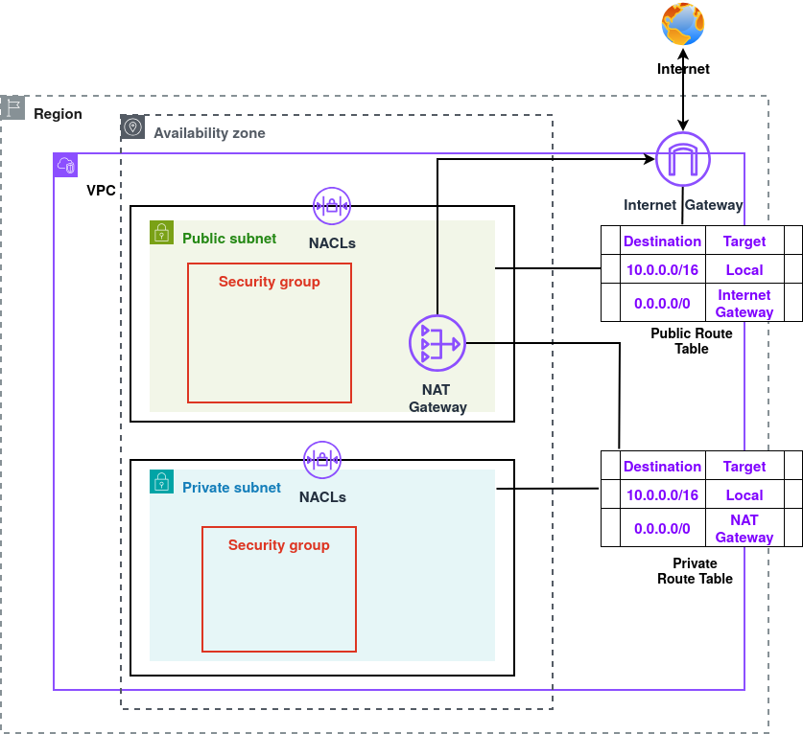
Figure 1: VPC Demonstration

With Amazon Virtual Private Cloud (Amazon VPC), we can deploy AWS resources inside a logically isolated network that we fully control. This environment resembles a traditional on-premises network, complete with subnets, IP addressing, routing, gateways, NAT, firewalls, access control lists, interfaces, endpoints, and more.

Amazon VPC is highly scalable and offers advanced capabilities such as VPC peering, traffic mirroring, transit gateways for hub-and-spoke architectures, VPN connectivity, and VPC Flow Logs for capturing detailed information about IP traffic moving in and out of network interfaces.

Core Components of VPC
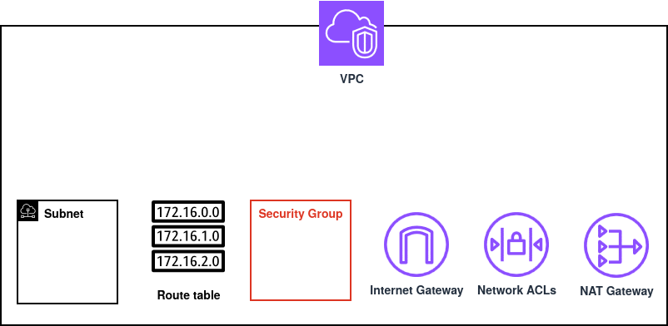

Figure 2: Core Components of VPC
Internet Gateway
A gateway that enables communication between VPC and the public internet.

Subnets
Logical subdivisions of a VPC that separate resources into public or private network segments.

Route Table
A set of rules that determines how traffic is directed within the VPC and to external networks.

NAT Gateway
A managed service that allows instances in private subnets to access the internet without
exposing them publicly.

Security Groups
Stateful virtual instance-level firewalls that control inbound and outbound traffic for individual AWS resources.

Network ACLs (NACLs)
Stateless, subnet-level firewalls that filter inbound and outbound traffic using ordered rules.

VPC
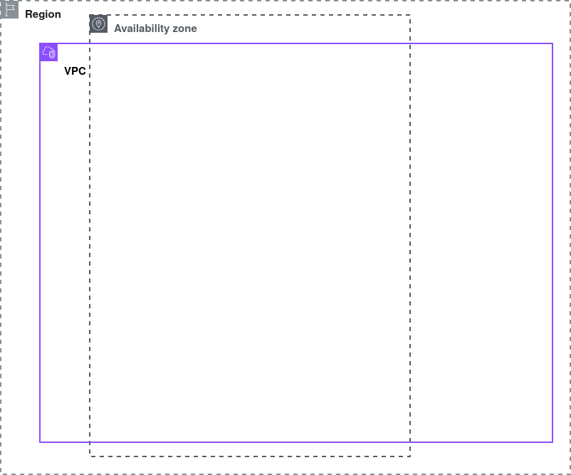

VPC is Region specific and can span across multiple Availibility Zones. The size of VPC is determined by the range of private IP addresses called a CIDR block. CIDR block size must be between /16 and /28. In each VPC 5 IP addresses are reserved, first 4 IP addresses and last one IP address of the CIDR block.

In the VPC with CIDR block 10.0.0.0/16, reserved IP addresses are:
IP Address | Reserved For
10.0.0.0 | Network Address
10.0.0.1 | VPC Local Router
10.0.0.2 | DNS Resolution
10.0.0.3 | Future Use
10.0.255.255 | Network Broadcast Address

Internet Gateway
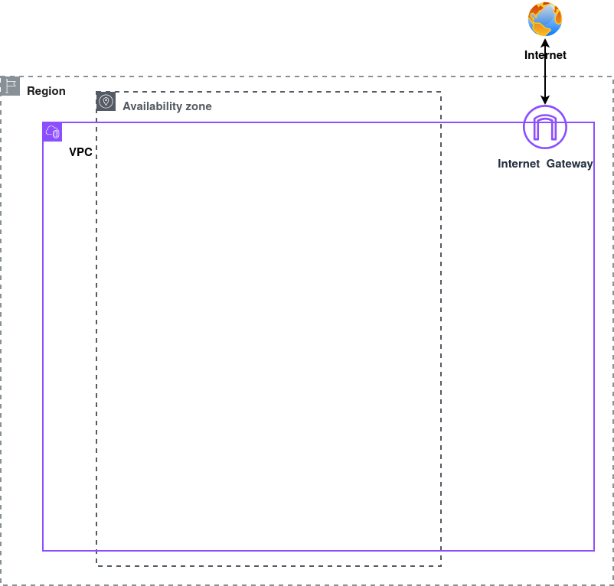

An Internet Gateway (IGW) enables resources in public subnets of a VPC to connect to the internet. It acts as the bridge between VPC and external networks. If we imagine our VPC as a house, the IGW is the front door that opens to the outside world. Only the public subnets, like rooms meant for visitors can use this door. Private subnets, on the other hand, are like private rooms with no direct access to the front door, keeping their traffic isolated and secure.

Subnets

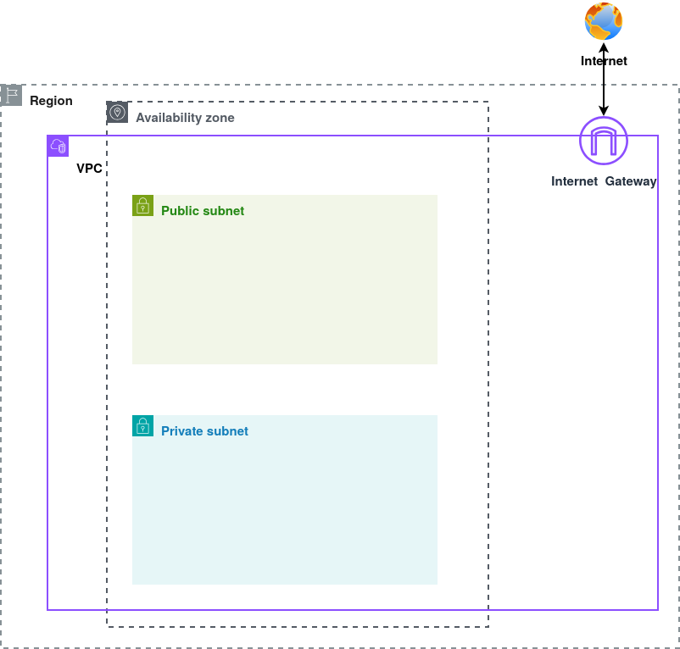
A VPC can be divided into multiple subnets, and each subnet exists within a single Availability Zone (AZ). The CIDR block of subnets must be smaller than that of VPC and CIDR block of subnets should not overlap. Subnets fall into two main categories:
- Public subnets are configured to route traffic through the Internet Gateway, allowing resources inside them to be reachable from the internet. Instances in these subnets have private IP for local communication and often receive public IP addresses for direct communication from the internet.
- Private subnets, on the other hand, have no direct internet access, keeping their resources isolated from external traffic. Instances in these subnets have private IP. They use a NAT Gateway or NAT Instance to make secure outbound connections while blocking unsolicited inbound traffic.

Route Table
A route table controls how network traffic moves within a VPC and beyond it. Each subnet is associated with a route table that guides packets on where to go. Each route table contains routes that define where traffic should be directed. It is a best practice to create separate route table for each subnet.

Public Route Table
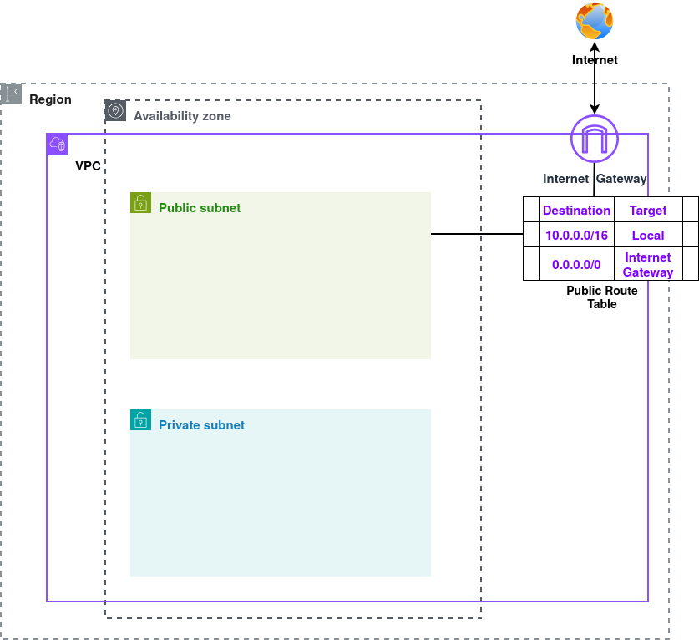
Public subnet is associated with Public Route Table with followng routes:
Destination | Target
10.0.0.0/16 | local
0.0.0.0/0 | Internet Gateway

The first route enables local communication within the VPC. The second route allows instances in the subnet to access the internet through the Internet Gateway, which is what makes the subnet public.
Private Route Table
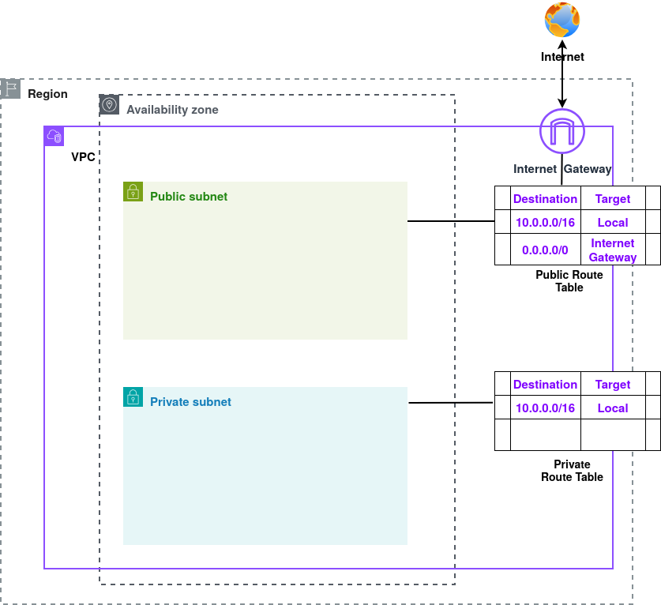
Private subnet is associated with Private Route Table with following routes:
Destination | Target
10.0.0.0/16 | local

The route enables only local communication within the VPC. The instances in the subnet associated with this route table is not publicly reachable. They use a NAT Gateway or NAT Instance to make secure outbound connections while blocking unsolicited inbound traffic.

NAT Gateway

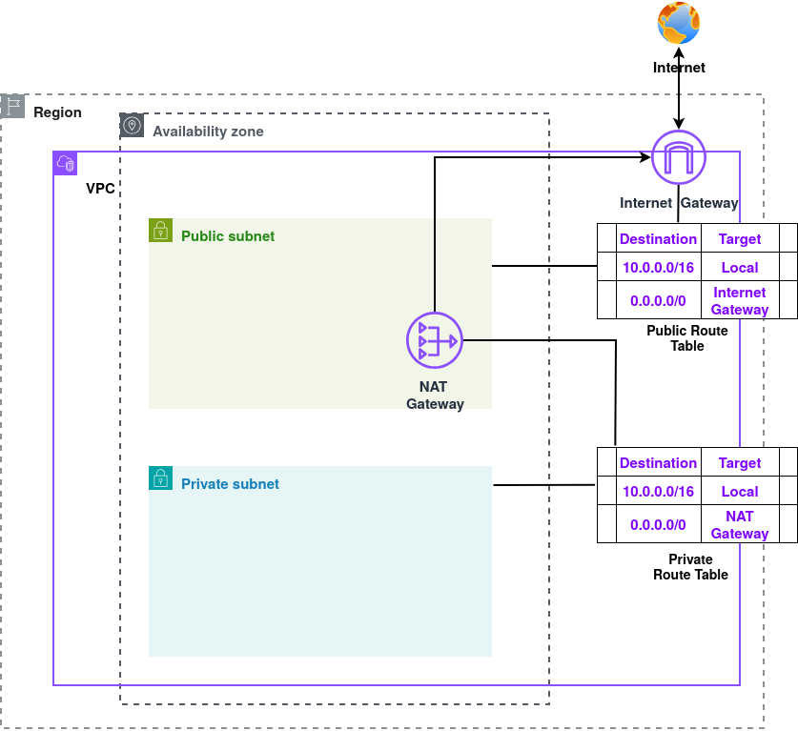
A NAT Gateway allows resources in private subnets to access the internet for outbound traffic while blocking any unsolicited inbound traffic. NAT Gateway is fully managed by AWS, it automatically scales and remains highly available without requiring manual maintenance. NAT Gateway uses Elastic IP address that is static, public IPV4 address.

Routes in Private Route Table can be updated as:
Destination | Target
10.0.0.0/16 | local
0.0.0.0/0 | NAT Gateway

Updated route allows instances in private subnet to access the internet but connections must always be initiated from within the private instances.

Security Group
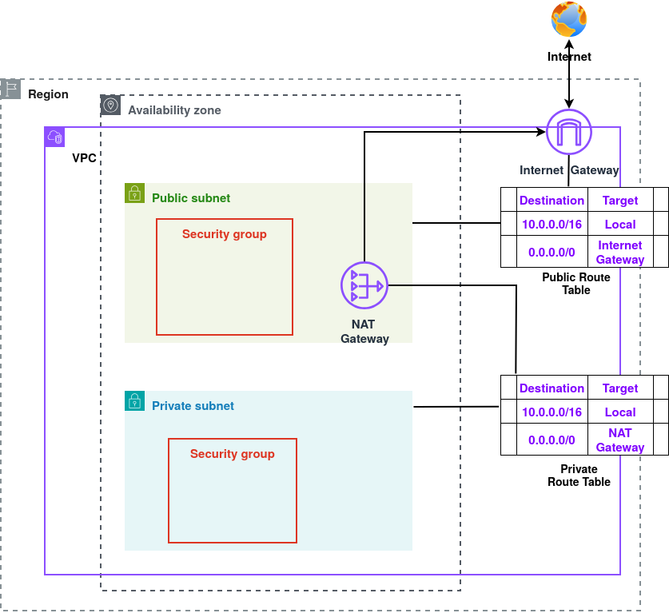
A Security Group acts as a virtual firewall that controls inbound and outbound traffic for each instance in a VPC. Security groups are stateful, meaning that if an incoming connection is allowed, the corresponding outbound response is automatically permitted.

Example Inbound Rule
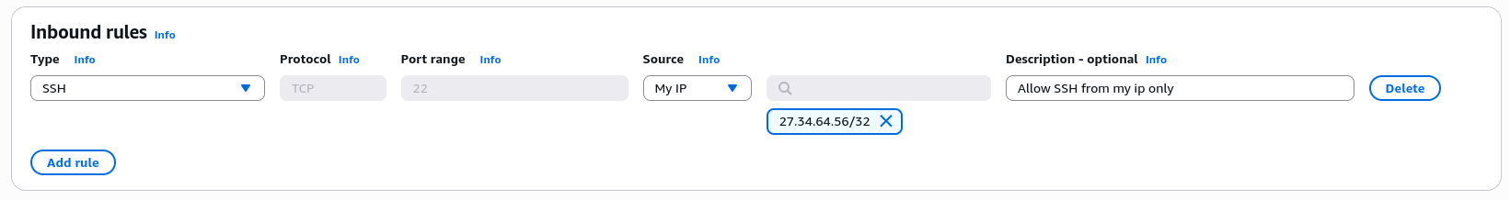
Instances with this security group allow only SSH connection from the given IP address.

Network ACLs

Network ACLs (NACLs) provide security at the subnet level. NACLs are stateless, meaning inbound and outbound rules must be explicitly defined.
Example Inbound and Outbound Rules
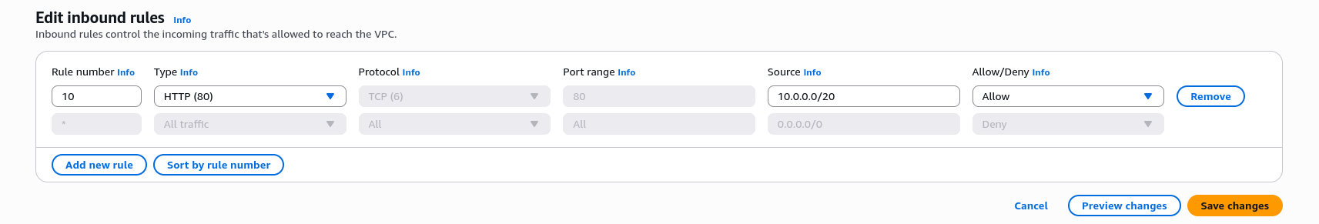
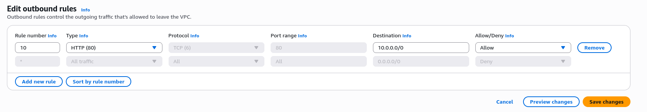
These inbound and outbound rules allow only http inbound traffic and outbound traffic.

Step By Step Guide

1. In the AWS management console search for vpc and select it.
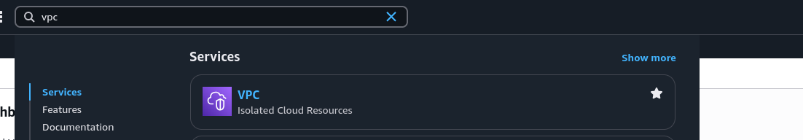
2. Proceed with Create vpc.
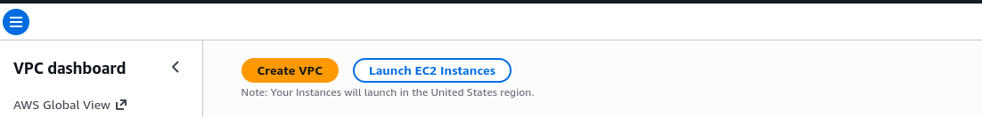
3. Select VPC and more option.
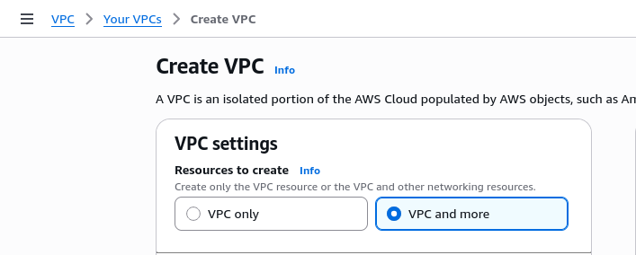

4. Select Auto-generate and give a name.
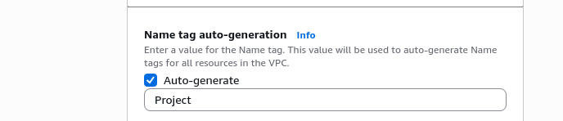

5. Determine and enter the size of IPv4 CIDR block.
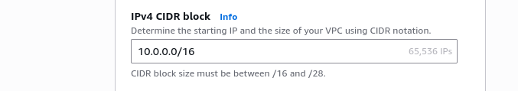

6. Select No IPv6 CIDR block and Default in Tenancy section.
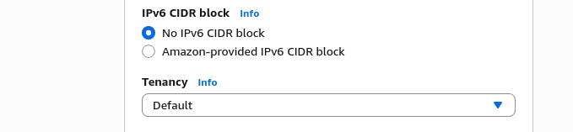

7. Set Number of Availability Zone 1 for now.
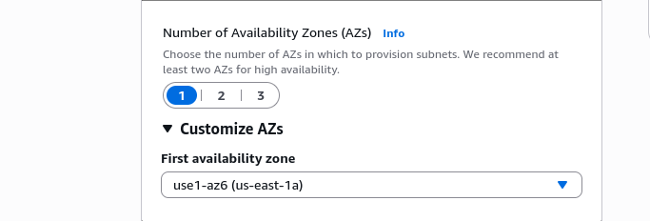

8. Set Number of public subnets and private subnets to 1. Give the CIDR block to each subnets without overlapping.
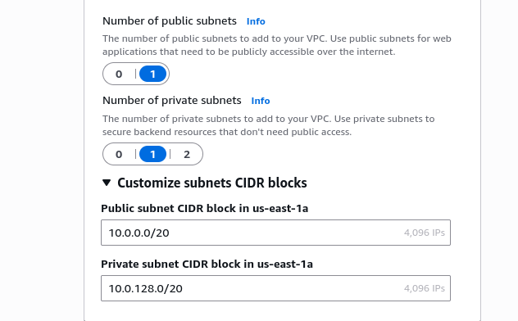

9. In NAT gateway section select In 1 AZ and appropriate AZ.
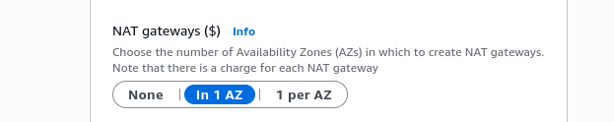

10. For VPC endpoints select None.
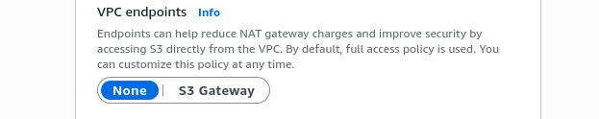

11. Enable DNS hostnames and DNS resolution both. DNS Resolution allows the VPC to resolve domain names. DNS Hostnames gives instances DNS names that we can use to connect to them. Proceed with Create VPC.

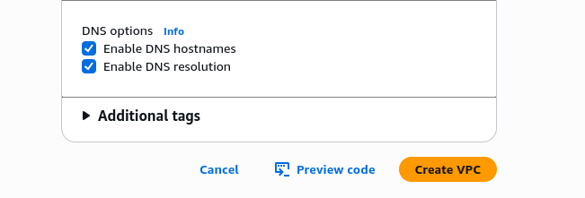

12. Wait until Create VPC workflow is completed.
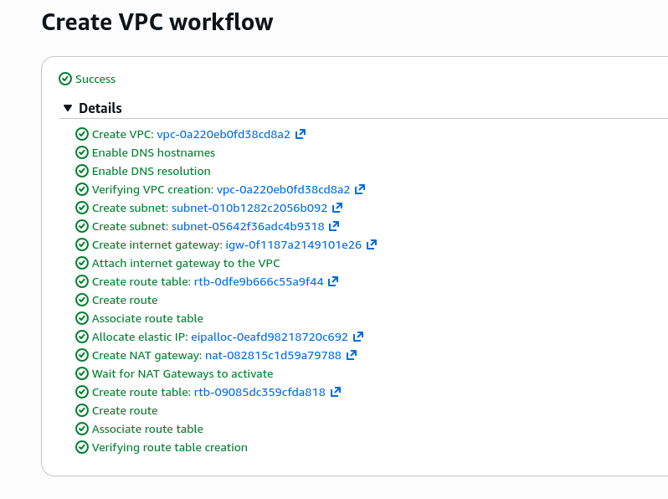

13. Proceed with View VPC.

14. View the Resource map.
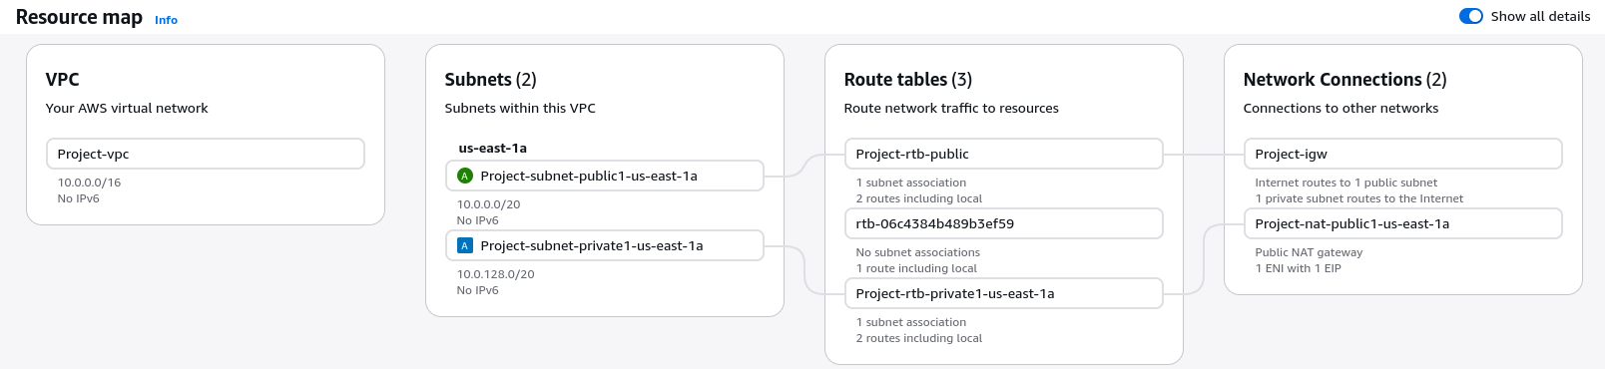
Congratulations ! VPC is created successfully.

15. Let’s create a Security group. From the left pannel in Security section select Security groups.
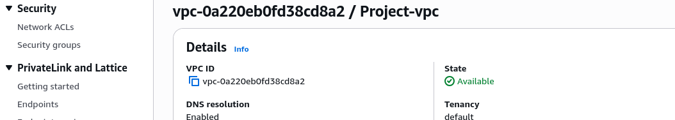

16. Proceed with Create security group.
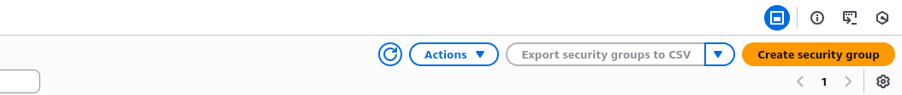
17. Give security group name, description and select the vpc.

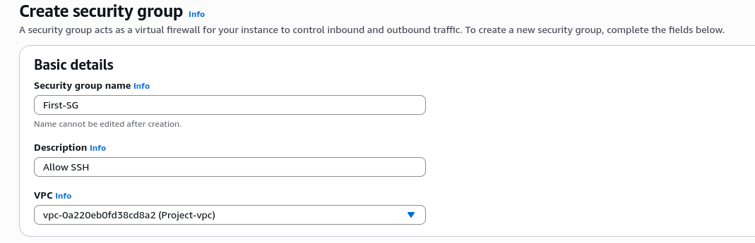

18. In Inbound rules section add this rule. This allows only SSH connection from the given IP address.

19. Proceed with Create security group.
Congratulations ! Security group is created.
Note:
SGs are stateful: Return traffic for allowed connections is automatically permitted. All rules are evaluated together: There’s no rule order; every inbound (or outbound) rule is checked. Traffic is allowed if any rule matches: As soon as a packet matches a rule, it’s permitted. Implicit deny: Any traffic that doesn’t match any rule is automatically blocked.

20. To create Network ACLs, from Security section in left pannel select Network ACLs.
21. Proceed with Create network ACL.
22. Enter the name and select the vpc for the ACL. Proceed with Create network ACL.
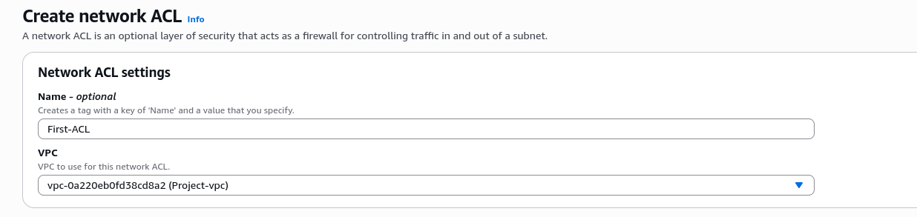
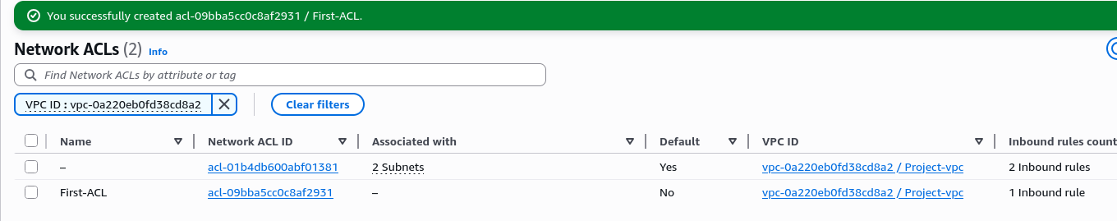
23. Select the created NACL and add the folloing Inbound and Outbound rules. These rules allow inbound as well as outbound SSH and HTTP traffic.
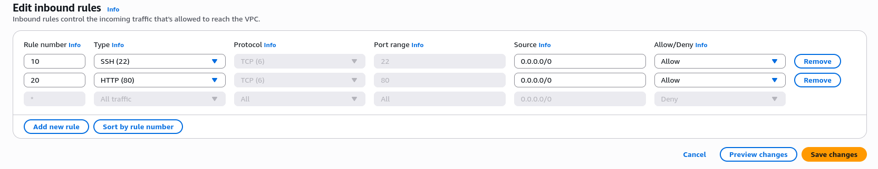
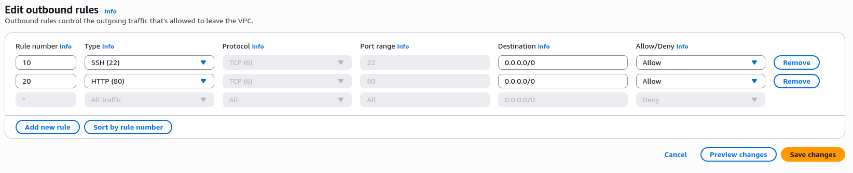
Congratulations ! NACL is created.
Note:
NACLs are stateless and have ordered rules numbered from lowest to highest. When traffic hits a subnet, AWS scans the rules in ascending order. The first rule that matches the traffic is applied, and no further rules are checked.

