Vim: Text Editor
We must learn at least one text editor that can be used from a text-only shell prompt and be confident in editing text-based configuration files from a terminal window, through remote SSH logins, or via a web console. Learning vim is a great choice, as it enables you to edit files on a server without a GUI.
Vim is almost always installed in the server. If not, install using your respective package manager.
1. Update the system and install vim
→ sudo pacman -Suyy && sudo pacman -S vim
2. open a file for editing using following command:
→ vim filename
The vim editor works with data in a memory buffer. If you start vim without specifying a filename, or if the file doesn’t exist, vim opens a new buffer area for editing. If you specify an existing file on the command line, vim reads the entire file’s contents into a buffer. Any changes made in the buffer are written to the file only when you run the write command.

Operation Modes in Vim
Vim has several modes of operation including command mode, insert mode, visual mode, and extended command mode.
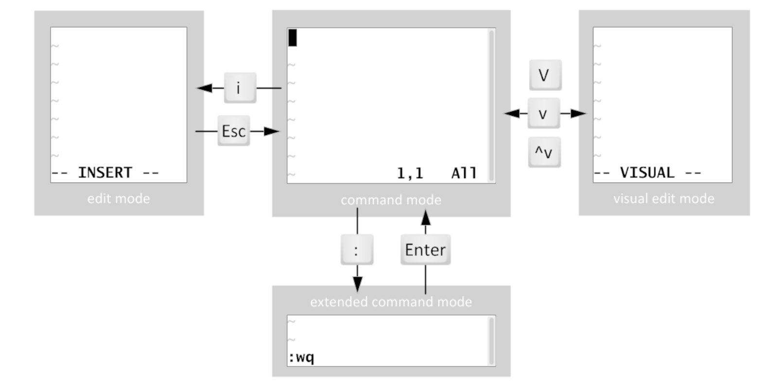
Figure 1: Operation modes in vim

When you first open Vim, it starts in command mode, which is used for navigation and other text manipulation.
Access specific editing functionality:
- An i keystroke enters insert mode, where all text typed becomes file content. Pressing Esc returns to command mode.
- A : keystroke begins extended command mode for tasks such as writing the file and quitting the Vim editor.
- A v keystroke enters visual mode, where multiple characters may be selected for text manipulation. Shift+V is used for multiline and Ctrl+V for block selection. The same keystroke used to enter visual mode (v, Shift+V or Ctrl+V) is used to exit.
If you get lost, just press Esc to get in command mode.

-------------------------------------------------------------------------------------------------------

Insert Mode
Command | Description
i | Insert text before the current cursor (Enter Insert Mode)
Esc | Return to Command Mode from Insert or other modes
------------------------------------------------------------------------------------------------------------------------

Command Mode
Navigation:
To move cursor you can use arro keys or following keys:
Command | Description
h | Move cursor left one character
j | Move cursor down one line
k | Move cursor up one line
l | Move cursor right one character

To move around within large text files
Command | Description
PageDown / Ctrl+F | Move forward one screen of data
PageUp / Ctrl+B | Move backward one screen of data
G | Move to the last line in the buffer
numG | Move to the line number num in the buffer
gg | Move to the first line in the buffer

Text Editing Manipulation:
Command | Description
x | Deletes the character at the current cursor position
dd | Deletes the entire line at the current cursor position
dw | Deletes the word at the current cursor position
d$ | Deletes from the current position to the end of the line
J | Joins the current line with the next one (removes line break)
u | Undoes the previous edit command

Text Appending and Replacing:
Command | Description
a | Appends data after the current cursor position
A | Appends data at the end of the line at the current cursor position
r | Replaces the character at the cursor with a specified character
R | Overwrites text at the cursor position until you press Esc

Copying and Pasting:
Command | Description
y | Yank (copy) the selected text
p | Paste the yanked or deleted text after the cursor
Searching String
Command | Description
/string_to_search | Searches forward for the specified string in the file
------------------------------------------------------------------------------------------------------------------------

Extended Command Mode

File Commands:
Command | Description
:q! | Quit without saving changes
:w | Write (save) the current file
:wq | Write and quit
:x | Write if changes were made, then quit
:q | Quit (only if no unsaved changes)
:w <file> | Write the current file as a different file (save as)
:e <file> | Edit (open) a different file
:n | Move to the next file in the argument list
:prev | Move to the previous file in the argument list

Buffer Window Management:
Command | Description
:ls or :buffers | List open buffers
:b <n> | Switch to buffer number n
:bd | Delete a buffer
:sp | Open a file in a horizontal split
:vsp | Open a file in a vertical split
:tabnew | Open a file in a new tab

Search and Replace:
Command | Description
:s/old/new/ | Replace first occurrence on the current line
:s/old/new/g | Replace all occurrences on the current line
:%s/old/new/g | Replace all in the entire file
:%s/old/new/gc | Replace with confirmation

Navigation:
Command | Description
:1 | Go to line 1
:n | Go to line number n
:$ | Go to the last line
:/pattern | Search for pattern
Configuration & Settings:
Command | Description
:set number | Show line numbers
:set nonumber | Hide line numbers
:set paste | Paste mode (disables auto-indent)
:set ignorecase | Case-insensitive search
:syntax on | Enable syntax highlighting
:colorscheme <name> | Change color scheme

Others:
Command | Description
:!<cmd> | Run a shell command (e.g. :!ls)
:source <file> | Source a Vim script or config file
:history | Show command history
:echo <expr> | Evaluate and show a Vim expression
------------------------------------------------------------------------------------------------------------------------

Visual Mode
Command | Description
v | Enter Character-wise Visual Mode
V | Enter Line-wise Visual Mode
Ctrl+v | Enter Block-wise Visual Mode (Visual Block)

Below are commonly used commands in Visual mode for each of these:
Navigation (Works in all Visual modes):
Command(s) | Description
h, j, k, l | Move cursor left, down, up, right
w, e, b | Move forward by word, to end of word, back by word
0, ^, $ | Start of line, first non-blank character, end of line
gg, G | Go to start (gg) or end (G) of the file

Common Commands (after selecting in any Visual mode):
Command | Description
d | Delete selected text
y | Yank (copy) selected text
c | Change (delete + insert)
~ | Toggle case of selected text
u | Lowercase selected text
U | Uppercase selected text
> | Indent selection right
< | Indent selection left
= | Auto-indent selection
: | Run an Ex command on selected lines (:'<,'>s/foo/bar/g)
gU | Uppercase selection (alternate)
gu | Lowercase selection (alternate)
J | Join selected lines
! | Filter through external command (!sort to sort lines)
------------------------------------------------------------------------------------------------------------------------

