Screenshot 1 – Build failure

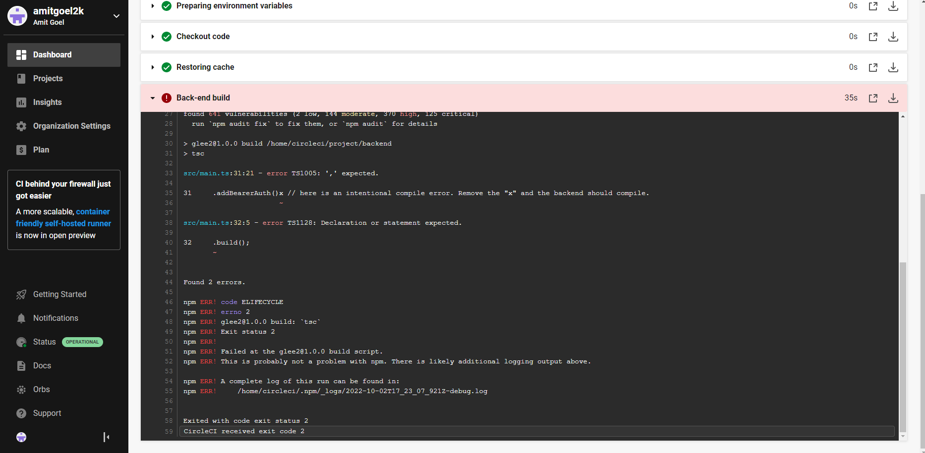

Screenshot 2 – Test failure

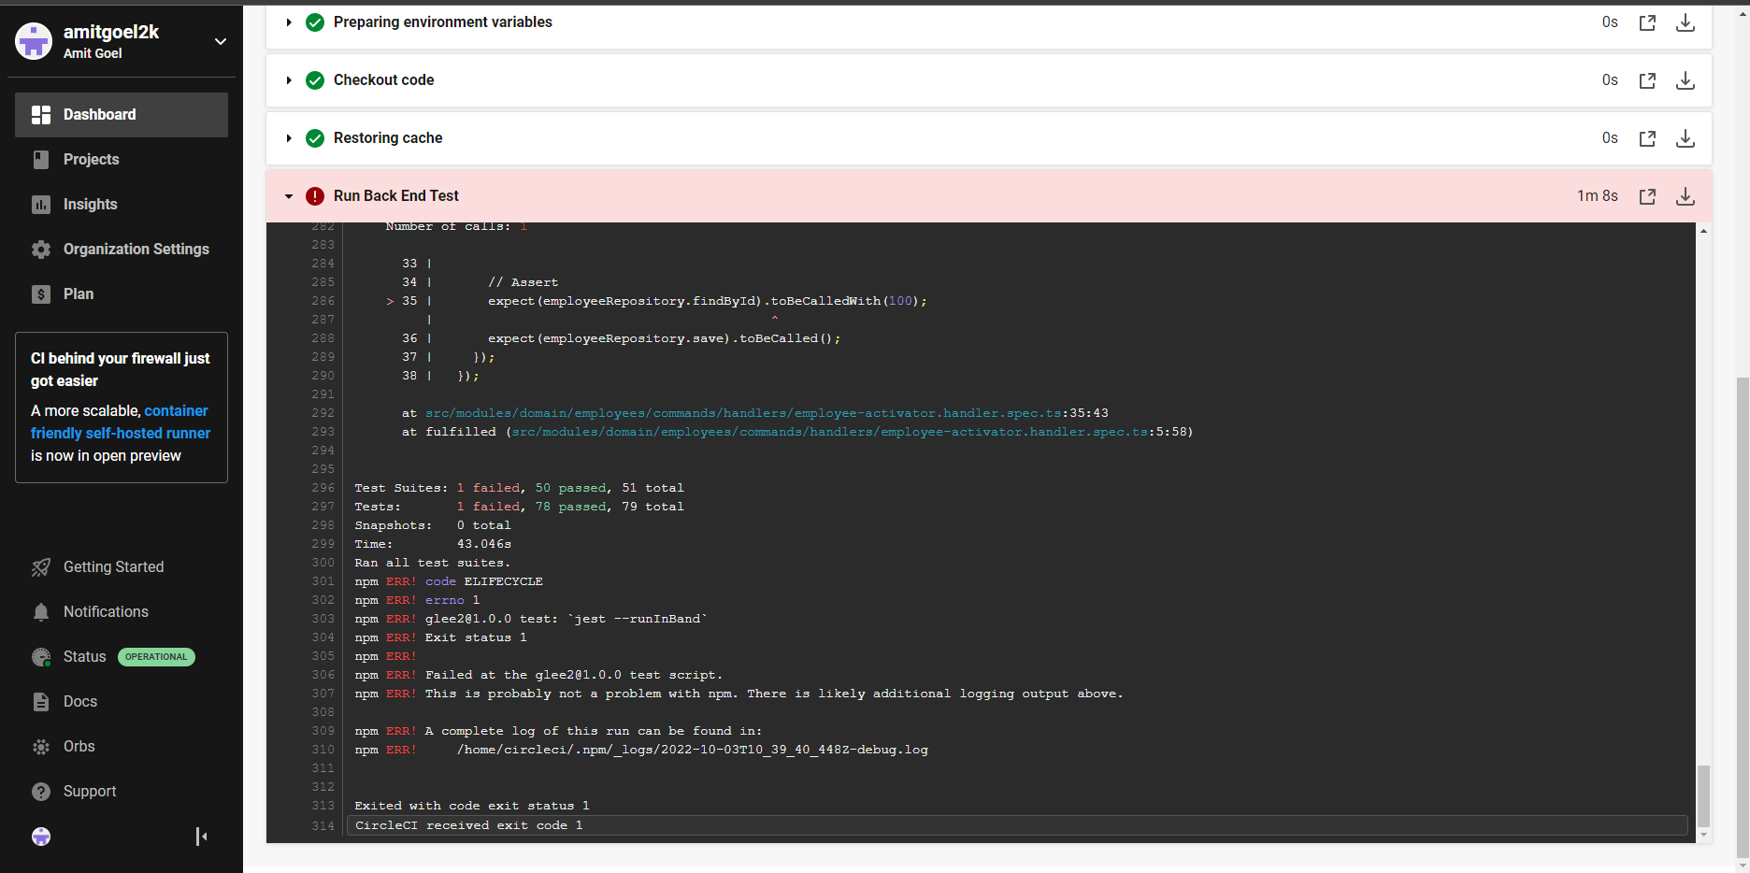

Screenshot 3 – Failure due to Critical Vulnerability

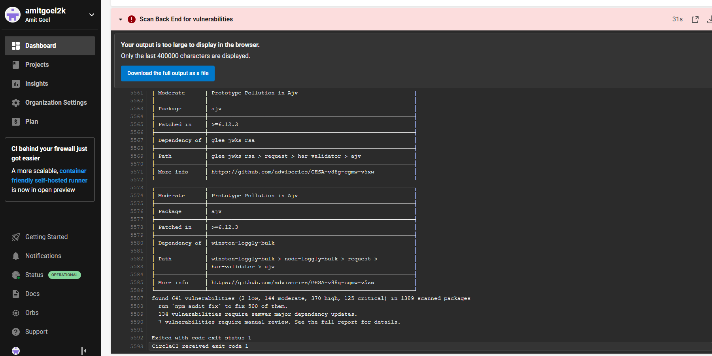

Screenshot 4 – Email alert for failed pipeline

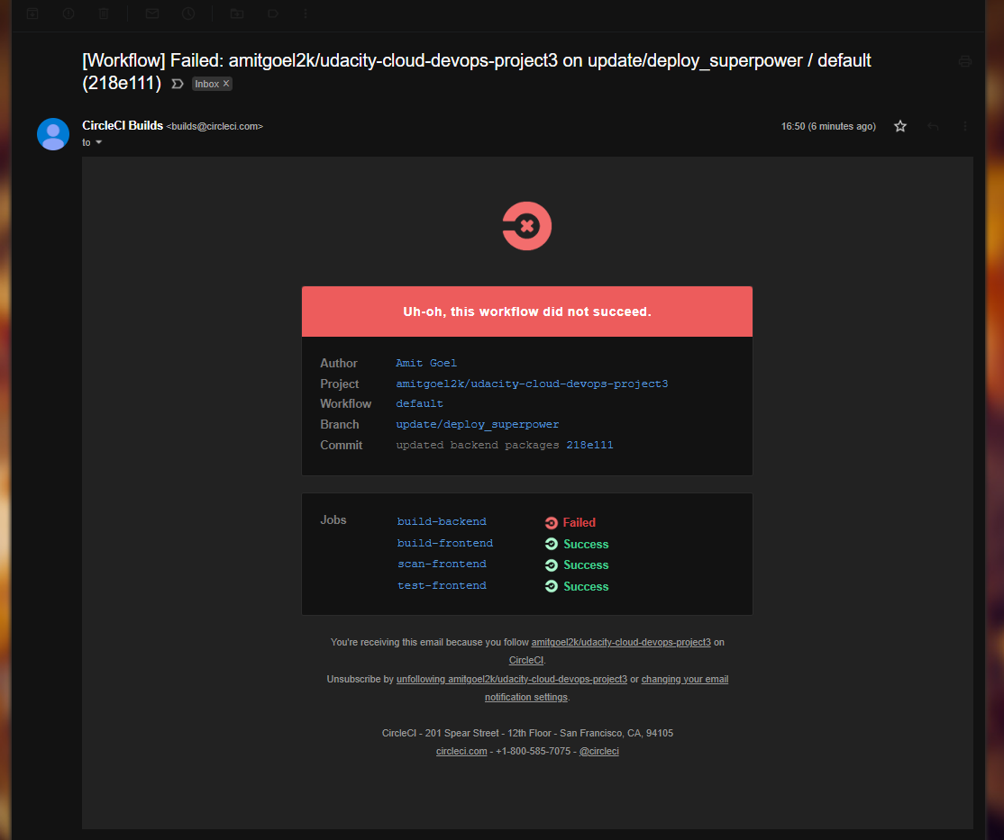

Screenshot 5 – Deploy infrastructure failure

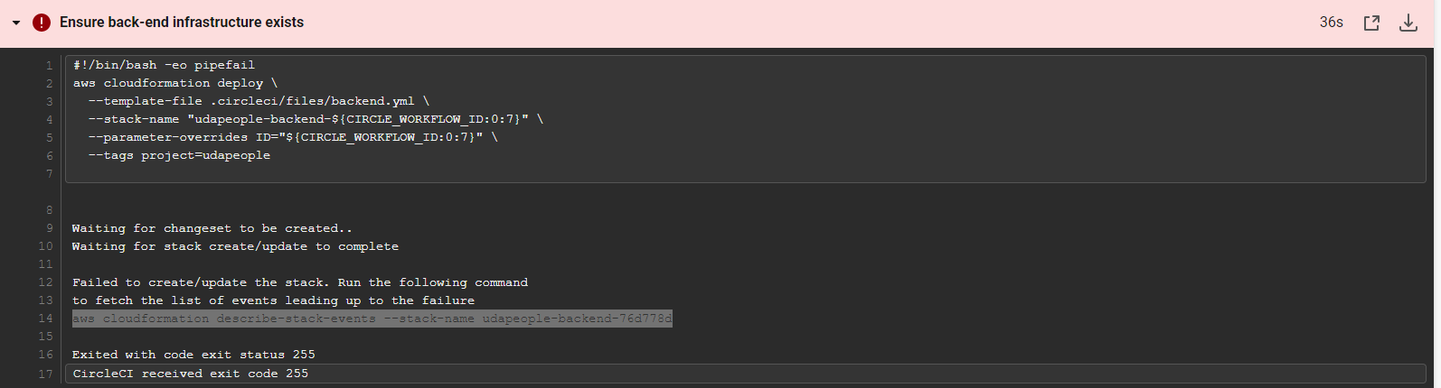

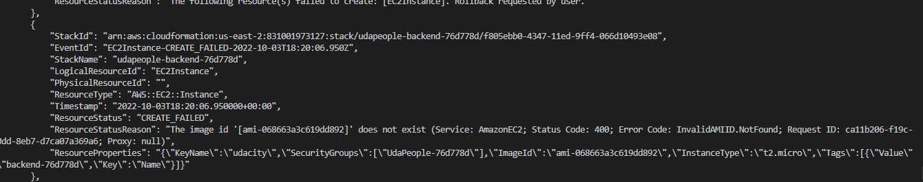

Screenshot 6 – Failed smoke test

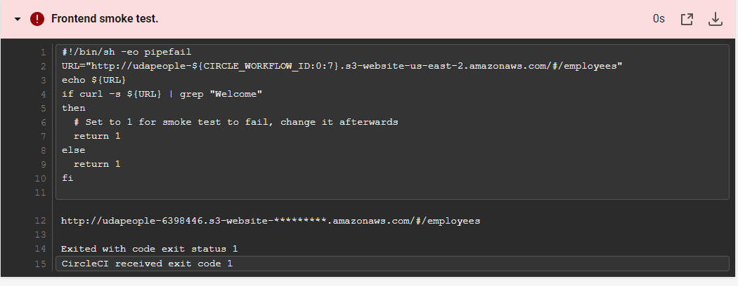

Screenshot 7 - Rollback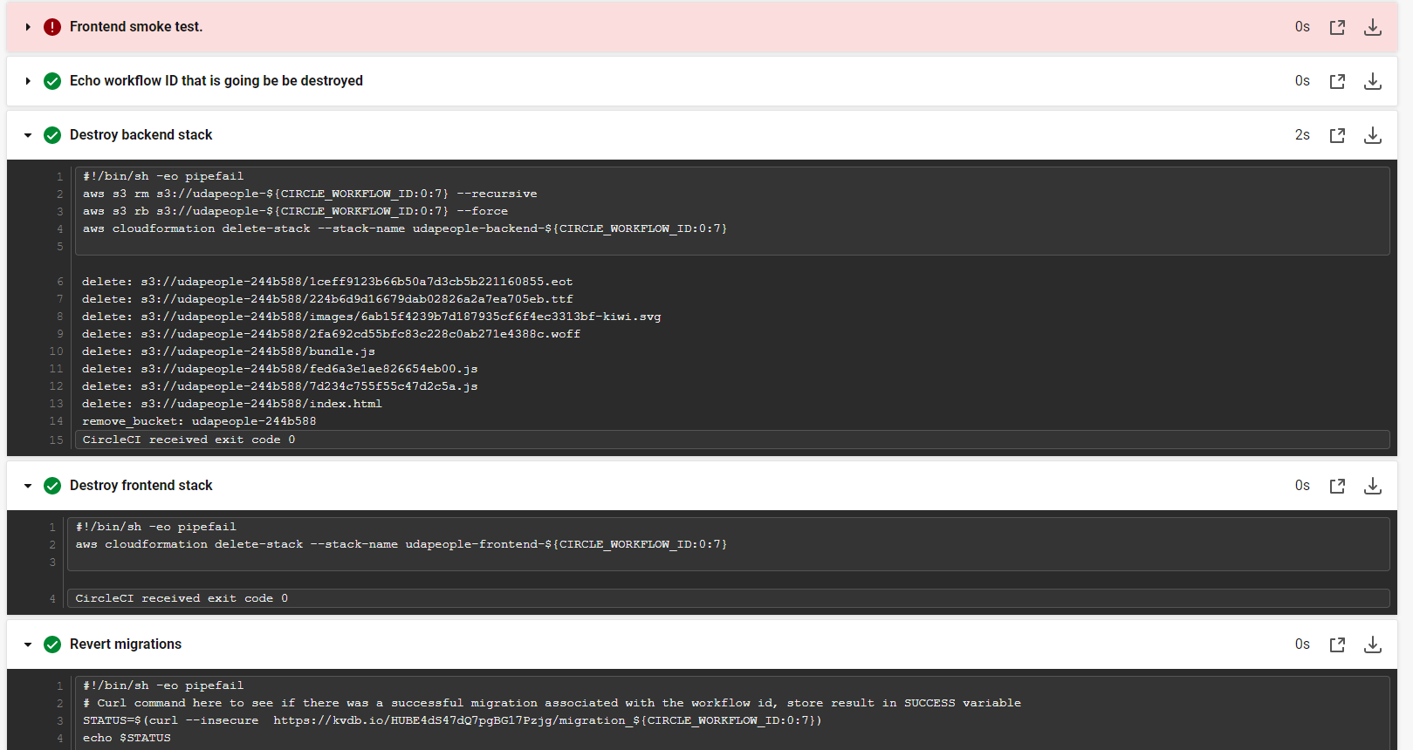

Screenshot 8 – Promotion Phase

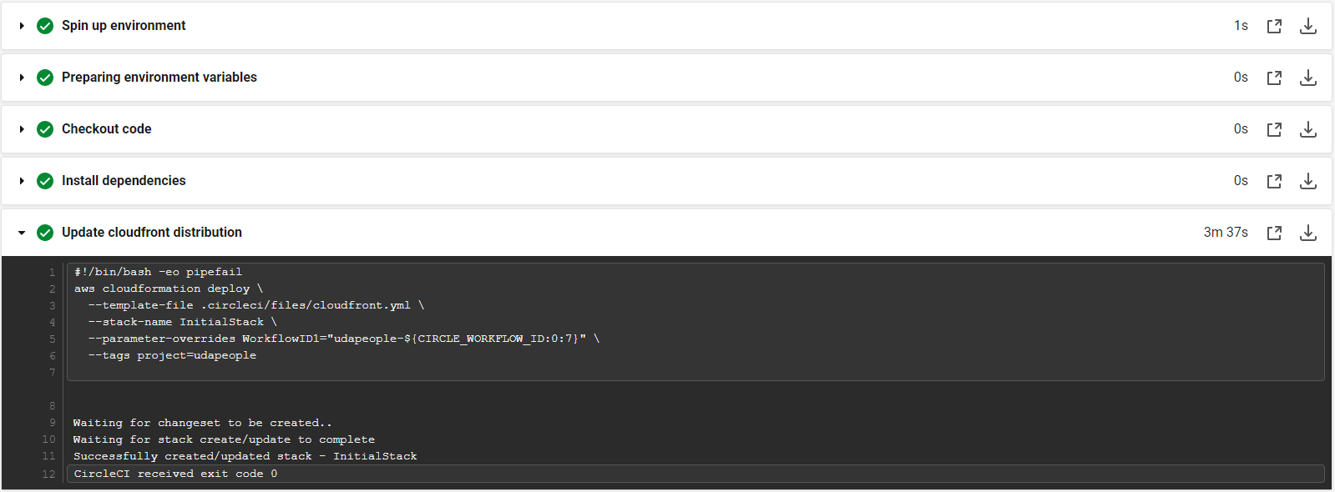

Screenshot 9 – Clean-up Job

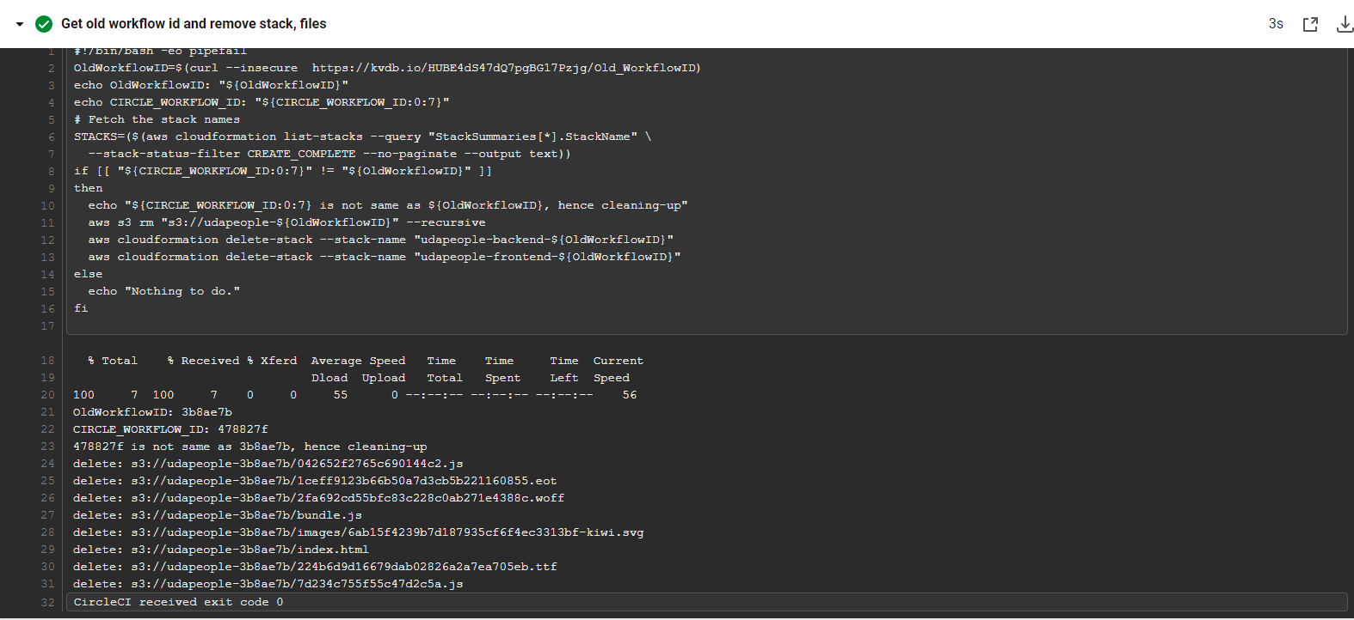

Screenshot 10 – Deployment running only from except master

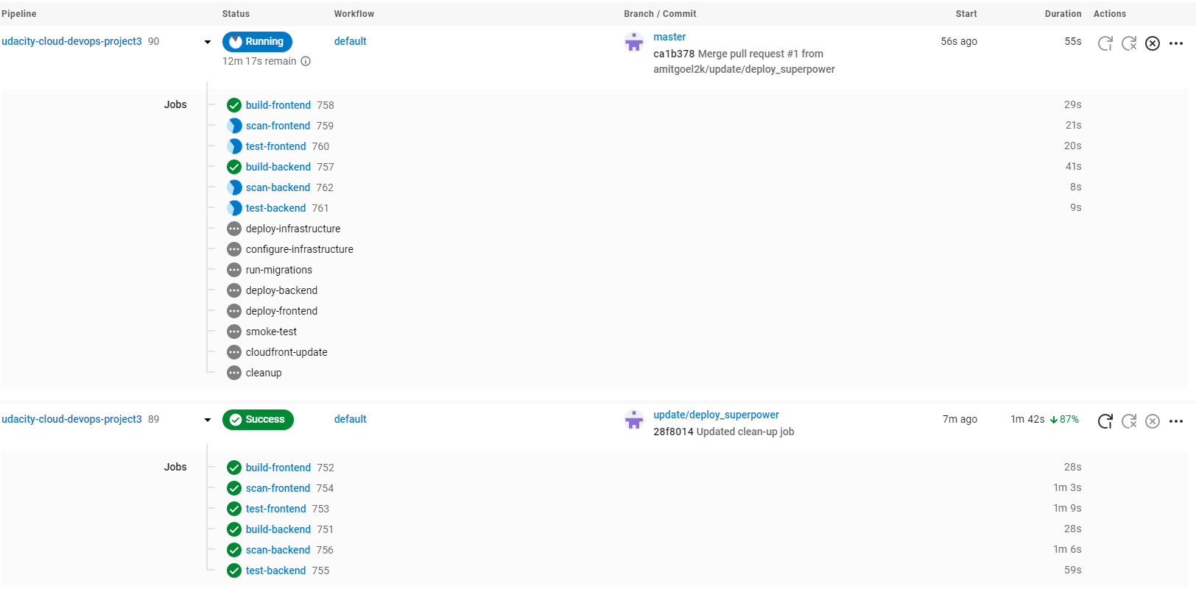

Screenshot 11 – URL showing Memory Free graph

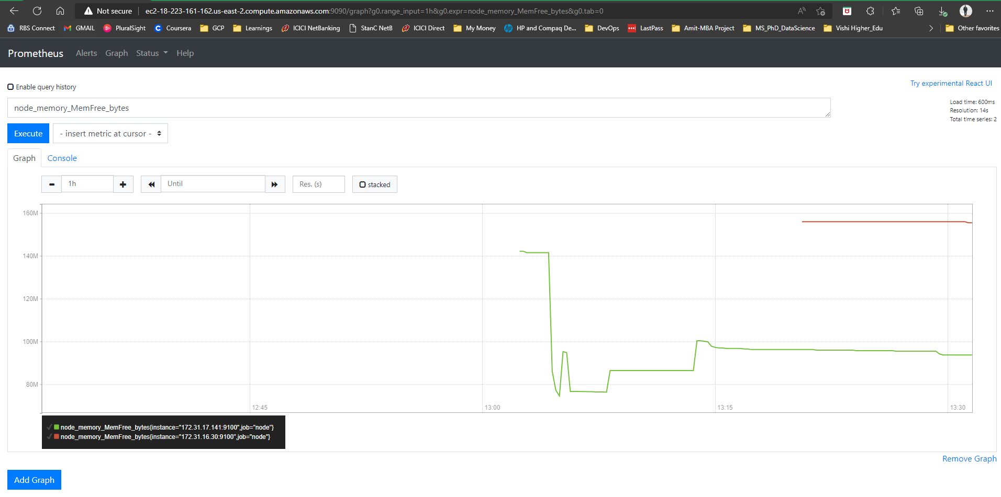

Screenshot 12 – Alert via Prometheus