GitHub URL [URL 01] - <https://github.com/amitgoel2k/udacity-cloud-devops-project3>

S3 Bucket URL [URL 02] - [Welcome (udapeople-478827f.s3-website.us-east-2.amazonaws.com)](http://udapeople-478827f.s3-website.us-east-2.amazonaws.com/#/employees)

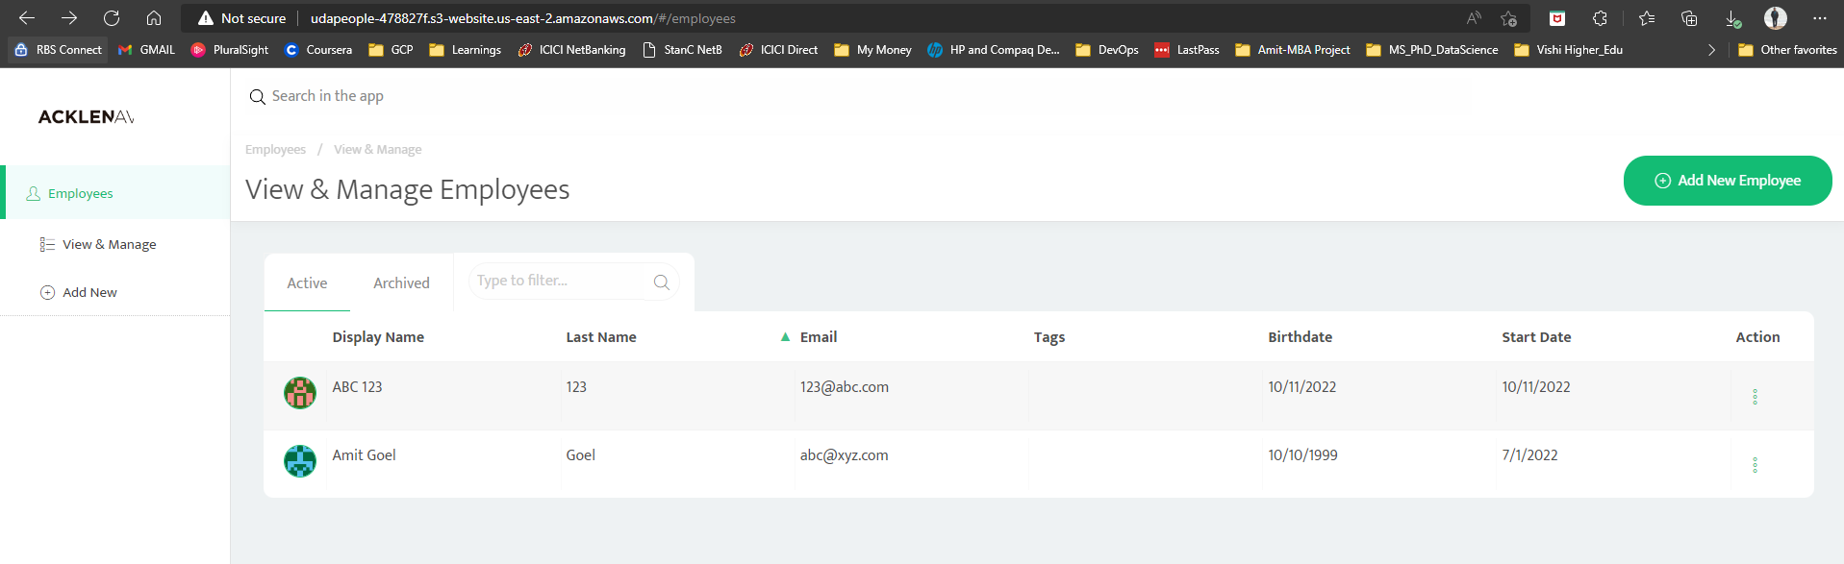

CloudFront. **[URL03] –** [Welcome (d3vppspxhtxwm5.cloudfront.net)](http://d3vppspxhtxwm5.cloudfront.net/#/employees)

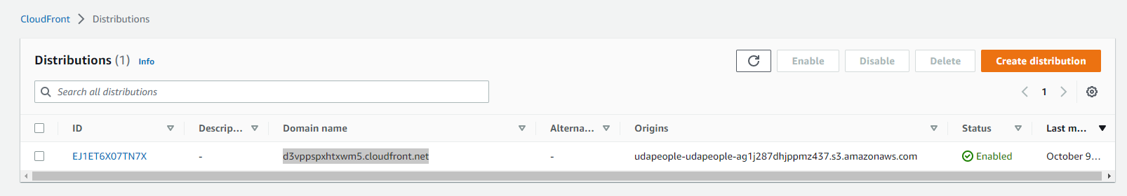

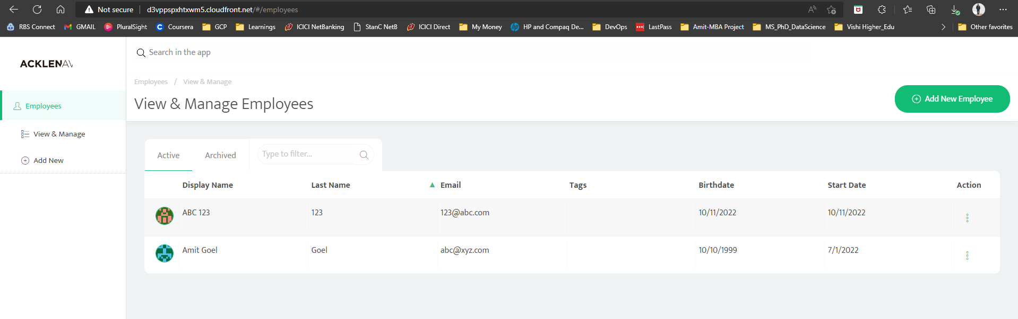

**Backend URL [URL04] -** [18.222.210.29:3030/api/status](http://18.222.210.29:3030/api/status)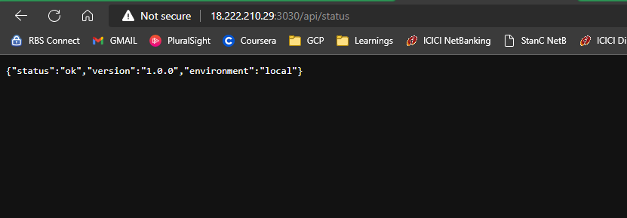

**URL05_SCREENSHOT -** [Prometheus Time Series Collection and Processing Server (ec2-18-223-161-162.us-east-2.compute.amazonaws.com)](http://ec2-18-223-161-162.us-east-2.compute.amazonaws.com:9090/targets)

