Screenshots

1. CircleCI pipeline

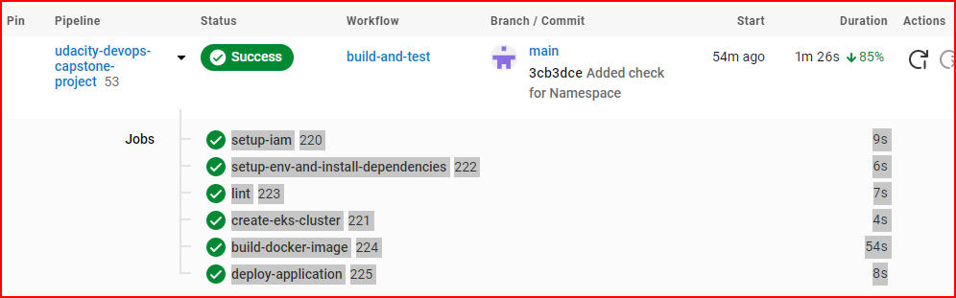

1. Failed lint in previous run

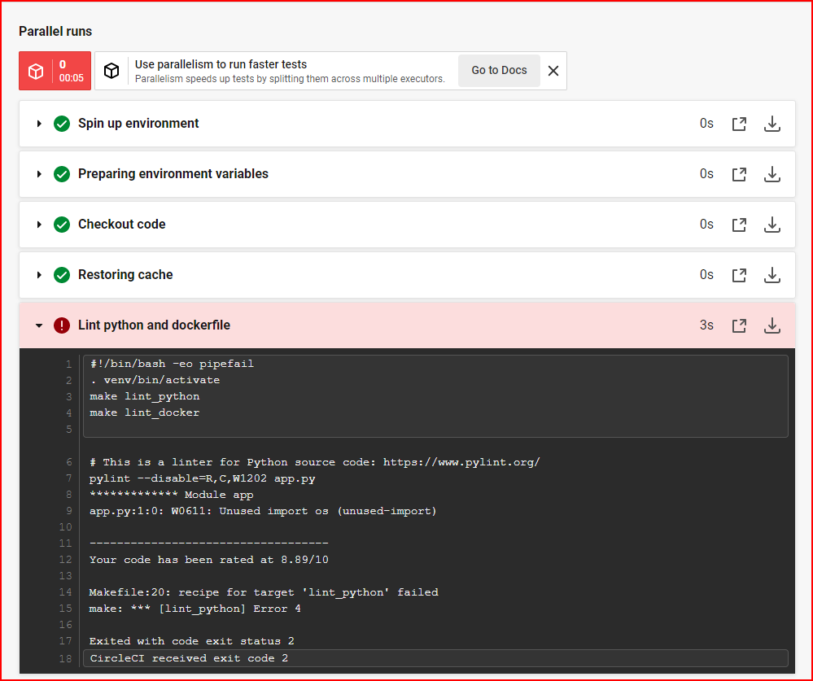

1. Successful lint

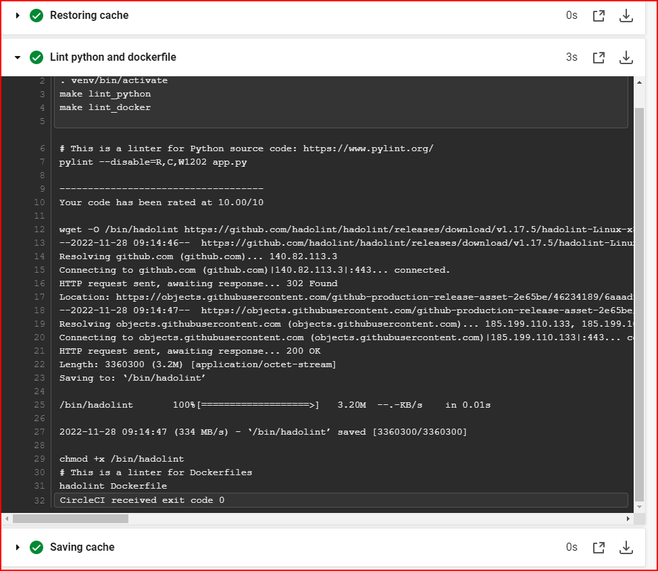

1. Container Image in DockerHub

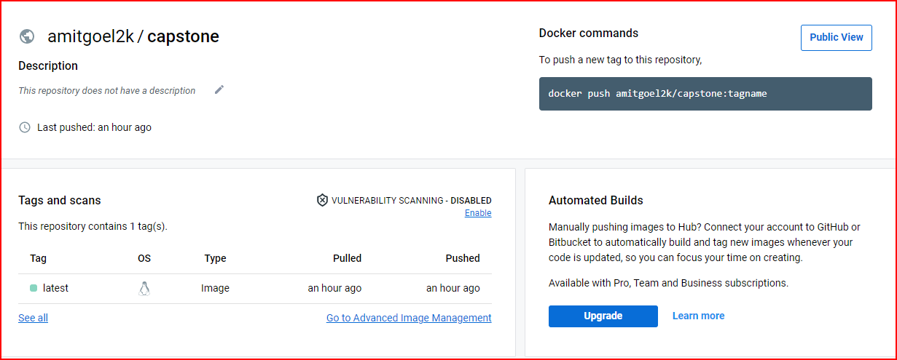

1. AWS CloudFormation Stacks

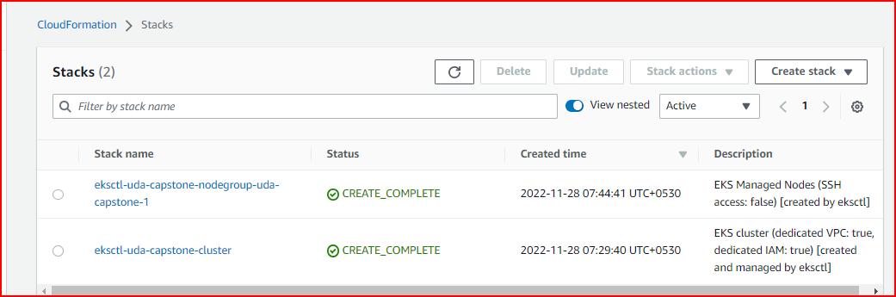

1. AWS EC2 instances

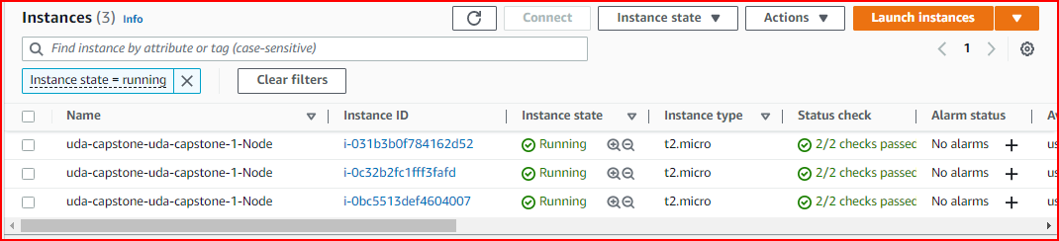

1. Application
2. Kubernetes Cluster

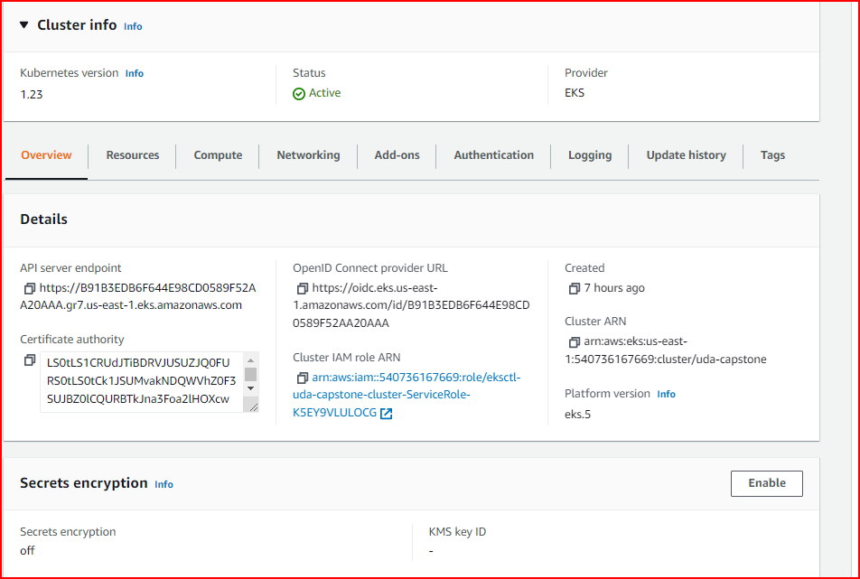

1. kubectl get pods



1. kubectl describe deployment

