**Demonstrated that you can read and write to the primary database – us-east-1a**

**DATABASE|UDACITY1|PRIMARY**

**Create the Table**

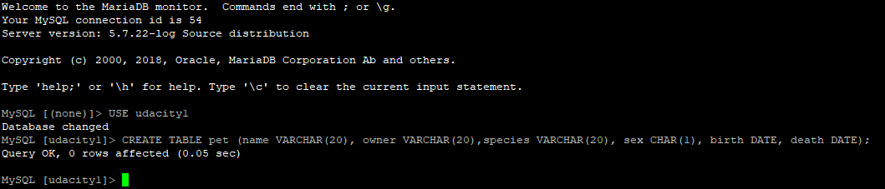

**CREATING THE TABLE**

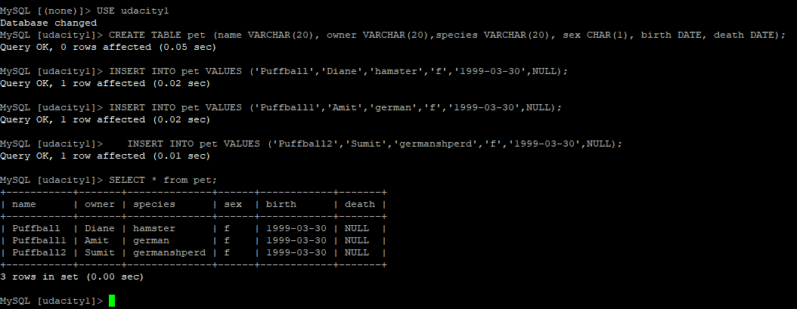

DATABASE|UDACITY1 – CLOUDWATCH Metrix.

