**Demonstrated that you can only read from the read replica database– us-west-1a**

**DATABASE|UDACITY1|REPLICA**

**CONNECTING TO THE REPLICA OF DB**

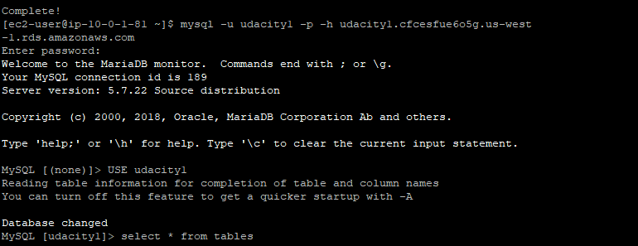

**TABLES CREATED AT PRIMARY DATABASE IS REPLICAED**



DATABASE|REPLICA – Not able to write only able to read.

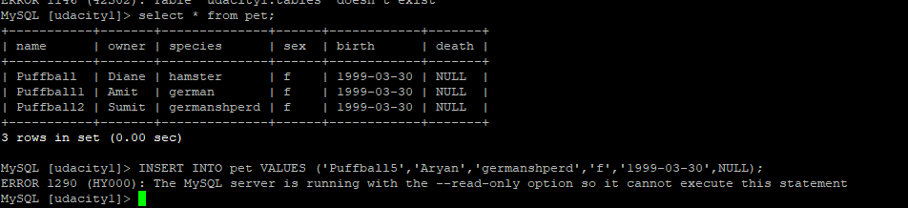

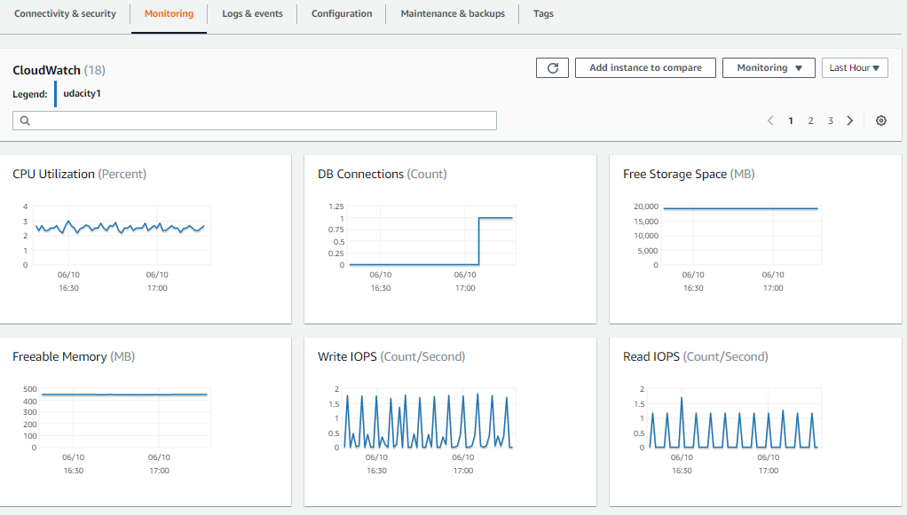

**SCREENSHOT OF THE CONFIGRATION BEFORE PROMOTING THE REPLICA**

