**Demonstrated that you can read and write the promoted database in the standby region**

**DATABASE|UDACITY1|AFTER PROMOTION**

**RECONNECTING AFTER PROMOTING**

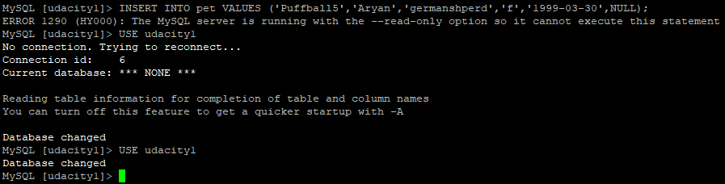

**ABLE TO READ FROM DB**

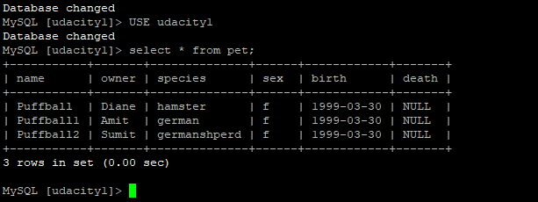

**ABLE TO WRITE ROWS TO THE TABLES IN DATABASE AFTER PROMOTING**

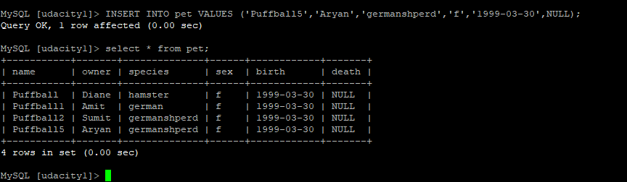

**SCREENSHOT OF THE CONFIGRATION AFTER PROMOTING THE REPLICA**

