1. **Create S3 Bucket : Created the S3 bucket with the name “udacity-project1-deploy-static-website”**

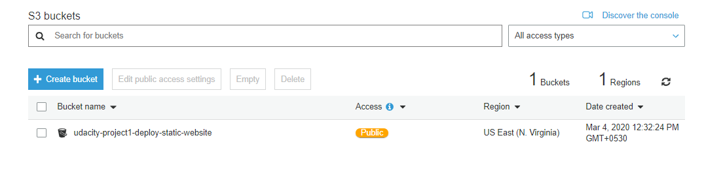

1. **Upload Project files into the S3 bucket.**

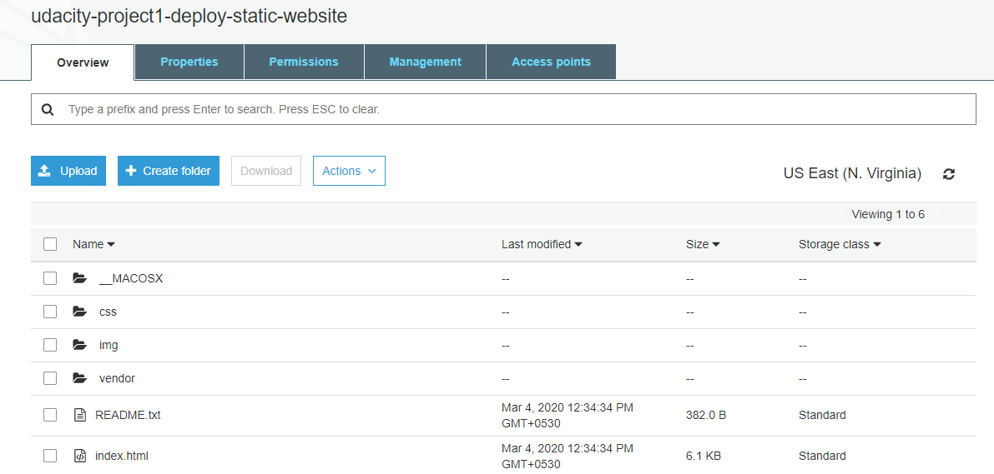

1. **Secure the S3 bucket via IAM**

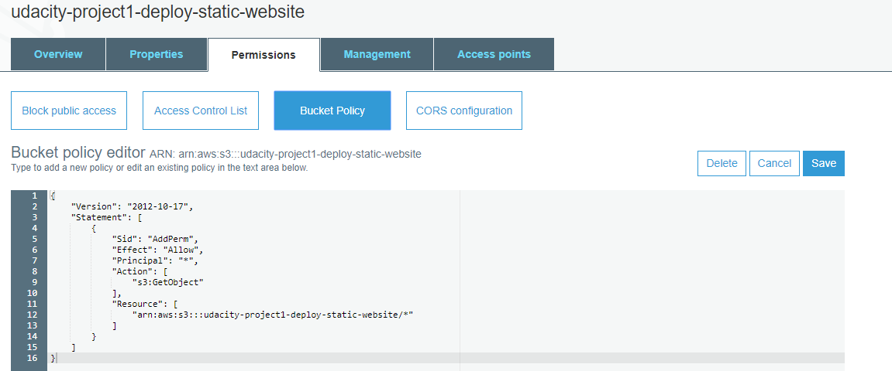

1. **Configure S3 Bucket**

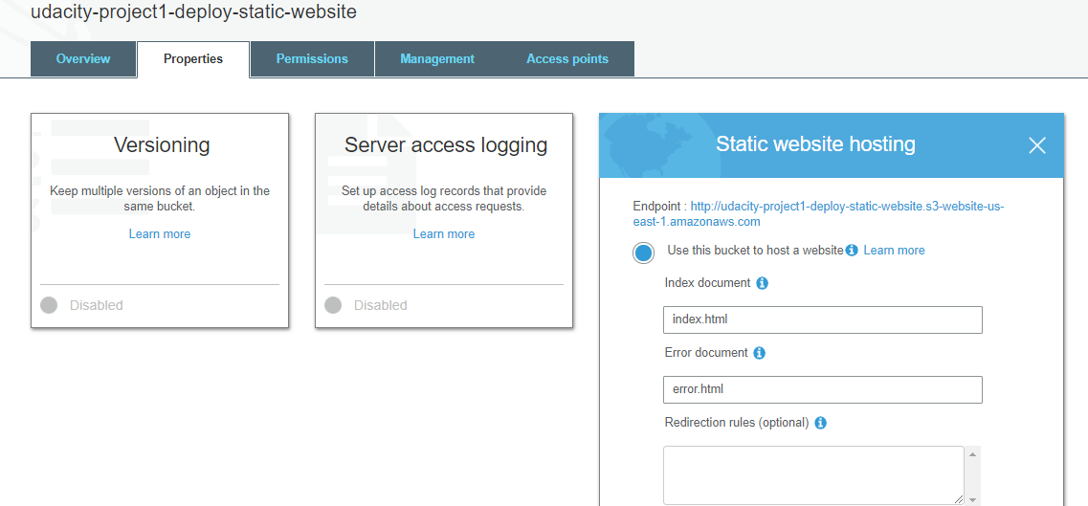

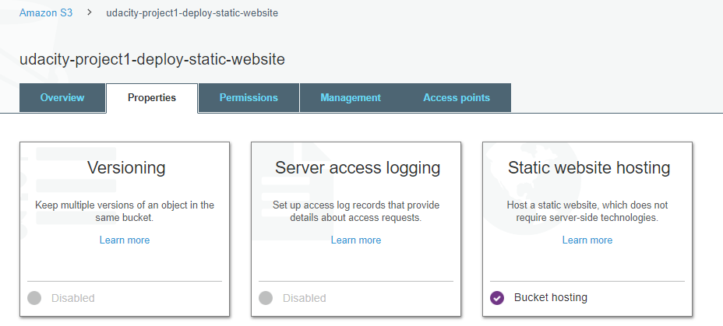

1. **Distribute website via cloud front**

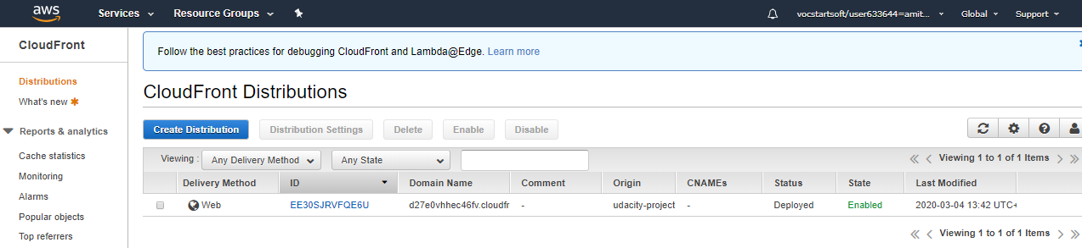

1. Travel Blog Website (Website display in Browser)

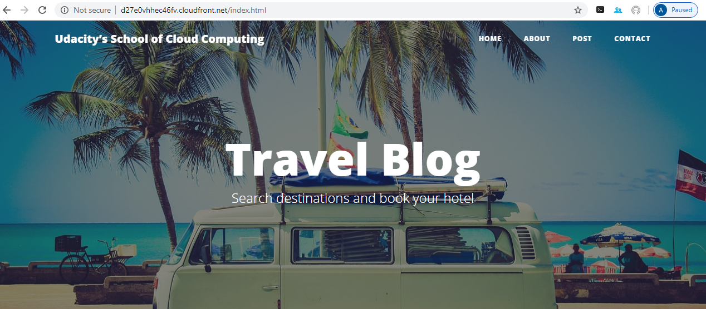

1. **Customization**

