**Refactor Udagram app to Micro-services**

#### **Overview of the Project Tasks :** You have to start with the "Udagram - photo sharing" Monolith application and divide the application into smaller (micro)services. Each microservice must run in a separate Docker container. These containers (and ReplicaSets) have to be managed by using the Kubernetes cluster. You have to demonstrate the ability to independently scale-up, release, and deploy the project using Kubernetes, and TravisCI.

### A. Steps to Follow

* Divide the application into smaller services
* Containerize the application, create the Kubernetes resource, and deploy it to Kubernetes cluster.
* Implement automatic continuous integration (CI) and continuous delivery (CD) using Travis CI.
* Extend the application with deployments and be able to do rolling-updates and rollbacks

B. Dependencies

**Cloud Services**

* Amazon Web Services - Relational Database Services - PostgreSQL
* Amazon Web Services S3 - Resource hosting and deployments
* Amazon Web Services - IAM account [applicable only if you host your project on the cloud

The following cloud services are optional to use:

* AWS CloudFront - CDN for SPA
* AWS EKS - Backend API
* AWS DynamoDB - Persistent Datastore
* AWS Cognito - User Authentication
* AWS CloudWatch - Performance and Health checks

Please submit your project with the following:

* Screenshot of TravisCI which shows the successful build and deploy steps
* The public GitHub repo and the docker hub images
* Screenshot of kubectl get pod which shows all running containers
* Screenshot of the application

1. **DOCKER IMAGES for the Project. (Docker Hub Snapshot)**

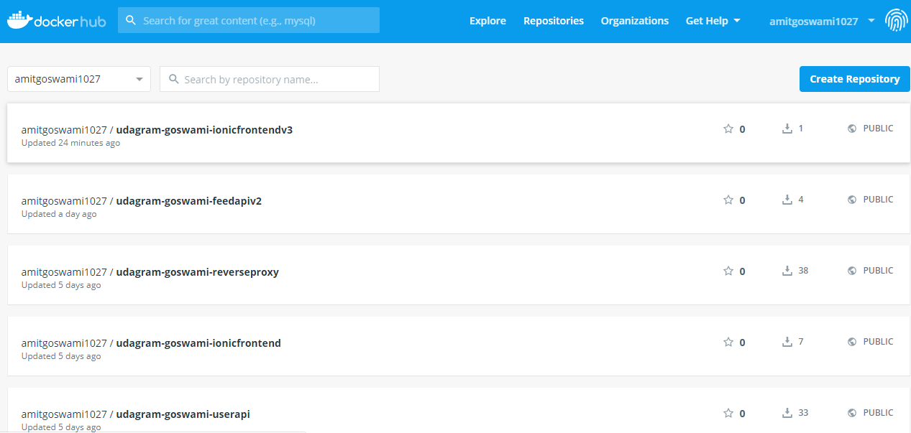

1. **Screenshot of all the services running**

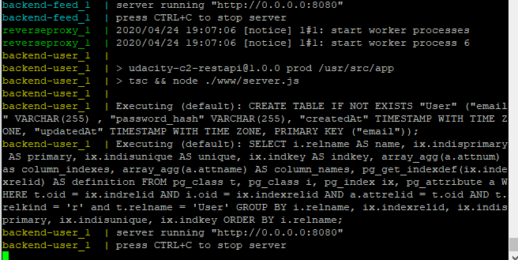

1. **KOBS Kubernetes cluster Details:**

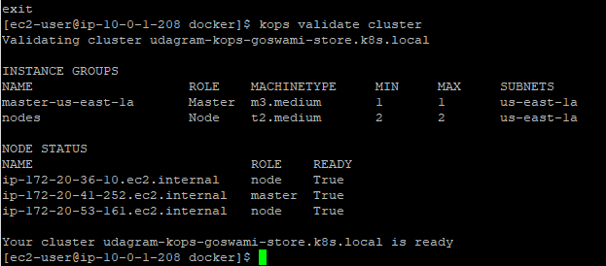

1. **kubectl get secrets**

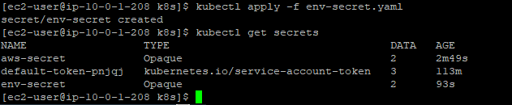

1. **kubectl get pods**

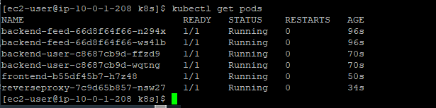

1. **kubectl get services**

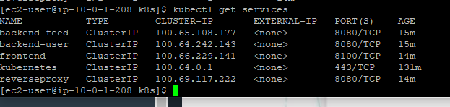

1. **kubectl get deployments**

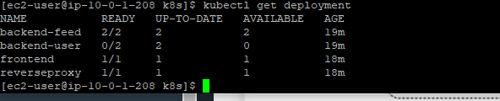

1. **Kubectl get deployments (Scaling it to three pods)**

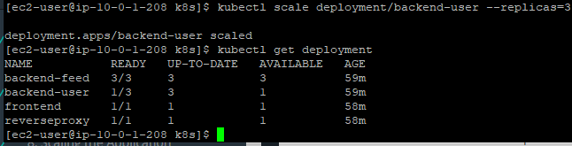

1. **Kubectl get pods**

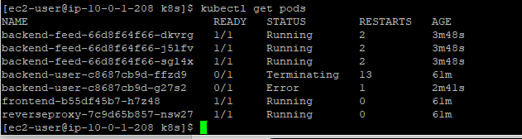

**Screenshot of the application**

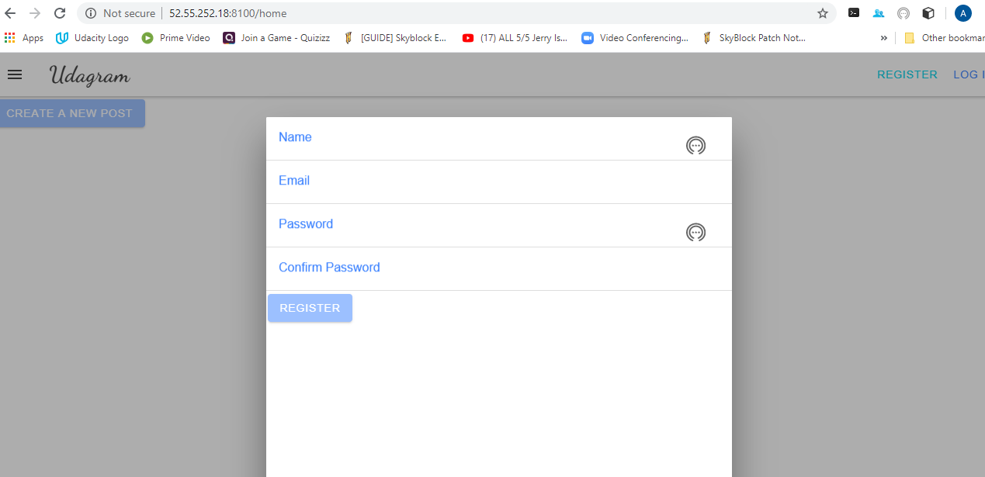

**Screenshot of github**

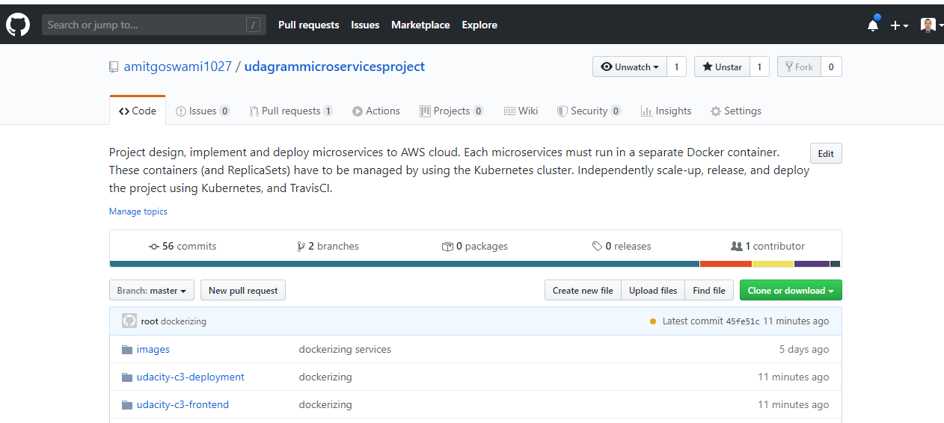

**Screenshot of the travis UI**

